**Safepay Wallet Application**



**Team Members :**

|  |  |
| --- | --- |
| Full Name | Employee Id |
| Samayamanthula Sri Harsha | 46022101 |

Capgemini India Technology Services

Rajiv Gandhi Info Tech Park, Phase 3, Hinjewadi, Pune, Maharashtra 411057

**Introduction:**

Safepay is created to allow user to make Electronic Transactions.

**Functional Requirements:**

The functional requirements of the project are:

**For the Admin:**

* Add an Account
* Delete an Account
* View Accounts

**For the User:**

* Login/Register
* Show Balance
* Deposit Money
* Withdraw Money
* Fund Transfer
* View Transactions
* Edit Profile

**Services**

* **Login Service:** Allows User to login to his/her Account.
* **Register Service:** Allows User to Create an Account.
* **Edit Service:** Allows User to Edit his/her Account.
* **Delete Service:** Allows Admin to delete users Account from database.
* **Deposit Service:** Allows User to Deposit money into his Account
* **Withdraw Service:** Allows User to Withdraw money from his Account
* **Transfer Service:** Allows User to Transfer money from his Account to other Account
* **Transactions Service:** Allows User to View All the Transactions done on the Account

**Overall Architecture Diagram:**

Login Service

Register Service

Edit Service

Delete Service

DATABASE

User Interface

Show Balance Service

Controller

Deposit Service

Withdraw Service

Fund Transfer Service

View Transactions Service

**Overall Entity Relationship Diagram:**

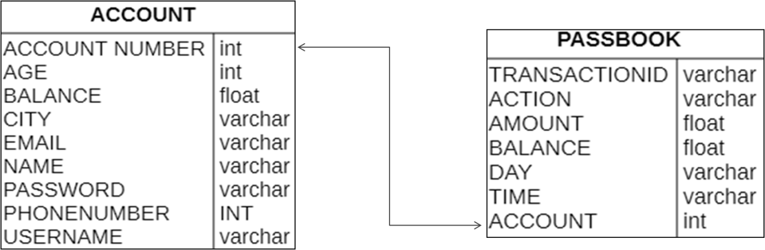

­­­ **Class Diagrams**

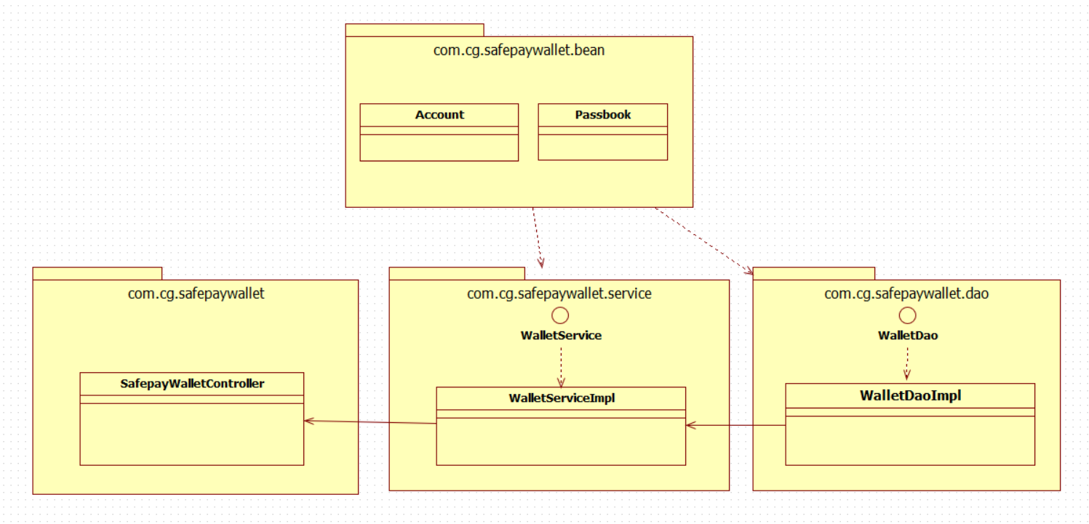

**Activity Diagrams**

**Login:**

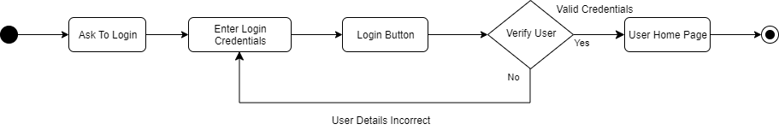

**Registration:**

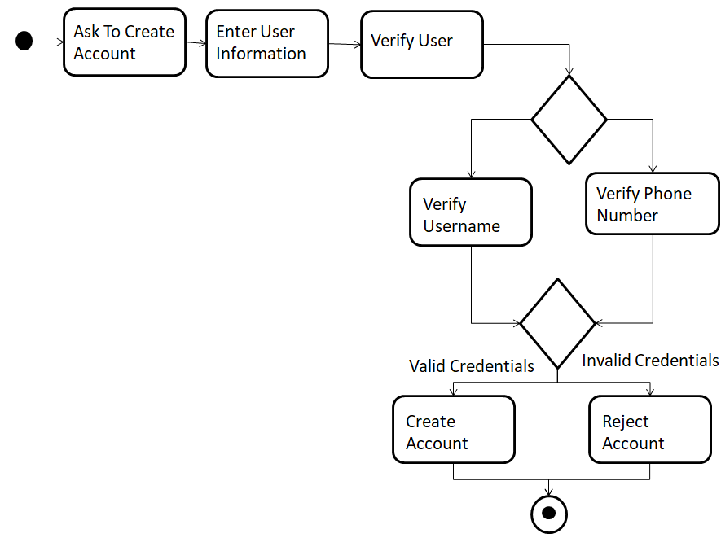

**Deposit:** 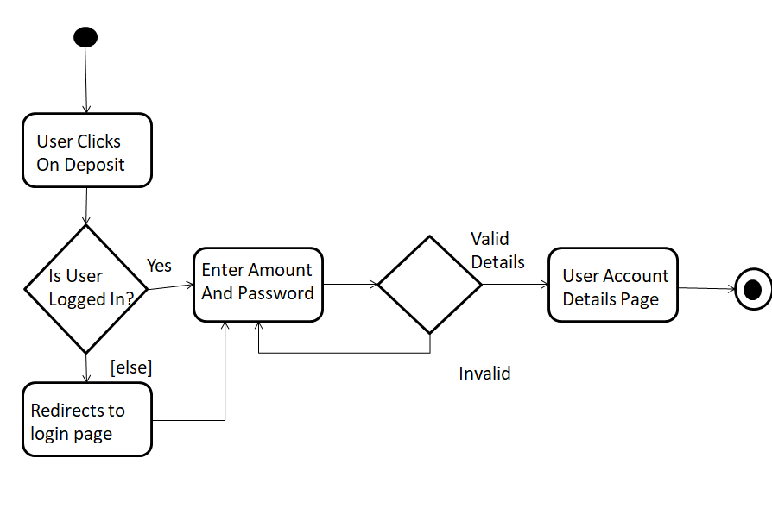

**Withdraw:**

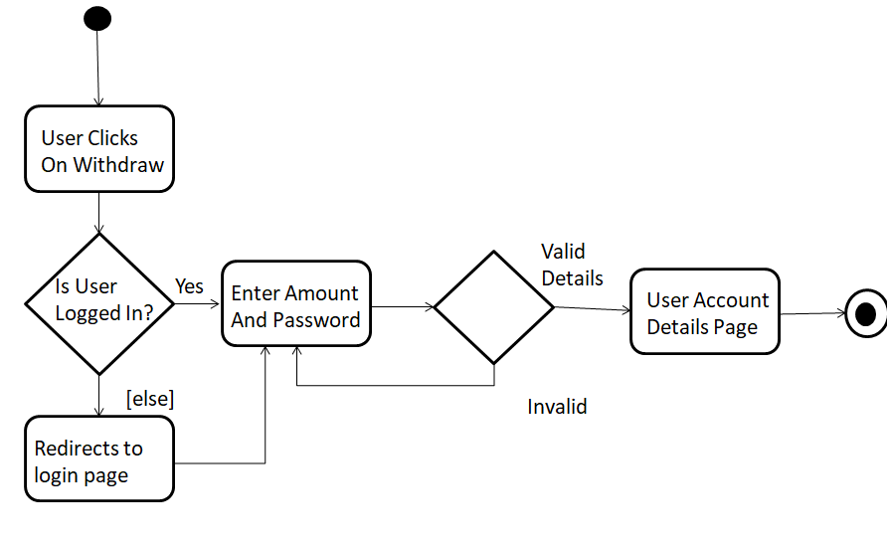

**Fund Transfer:**

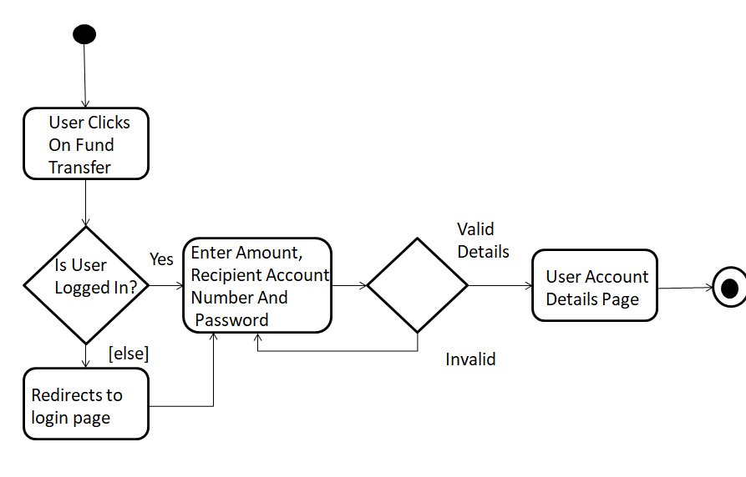

System Requirements

Below is a list of the minimum Hardware and Software requirements to access Great Outdoors website.

**Operating System:**

* Windows 7 and above.
* Mac OSX 10.8, 10.9, 10.10 or 10.11
* Android 3 and onwards.

**Hardware:**

* Processor (CPU) with 2 gigahertz (GHz) frequency or above
* A minimum of 4 GB of RAM
* Monitor Resolution 1024 X 768 or higher (For better view)
* A minimum of 5 GB of available space on the hard disk
* Internet Connection Broadband (high-speed) Internet connection with a speed of 2 Mbps or higher
* Keyboard and a Mouse or some other compatible pointing device

**Browsers:**

* Chrome* 58+
* Microsoft Edge* 20+
* Mozilla Firefox 40+
* Internet Explorer 11+ (Windows only)
* Safari 6+ (MacOS only)
* Android* 3+

*\**Google Chrome version 42+ and Microsoft Edge do not support NPAPI-type plug-ins, including Java plug-ins and many media browser plug-in.

*Users using unsupported browsers may experience issues submitting forms, placing orders, purchasing, updating details and transaction management threads.*

**Browser Configuration:**

Your browser must be configured as follows:

* **Strongly Recommended--**add [www.greatoutdoors.com](http://www.greatoutdoors.com/) to trusted sites.
* JavaScript must be enabled
* CORS must be configured properly
* Cookies must be enabled.
* Pop-up windows must be enabled.

**Software:**

* Java — to view and interact with all available blackboard applications.
* Eclipse — Eclipse workbench was used to run JDK (write, compile and run the code).
* Visual Studio Code — for writing codes for frontend using angular, VS Code was used as a workbench.