
Soundarya Educational Trust(Regd.) SOUNDARYA INSTITUTE OF MANAGEMENT AND SCIENCE
Soundarya Nagar, Sidedahalli, Nagasandra Post, Bengaluru, Karnataka 560073
(Recognized by Govt. of Karnataka & Affiliated to Bangalore University)
Accredited by NAAC “B++ “ Grade



Name of the Program:

Academic Year:

Semester:

BU Examination month & year:

- Overall Summary
Date of Declaration of Result:

Category | Students Appeared | Passed with Distinction (85%–100%) | Passed with First Class (60%–85%) | Passed with Second Class  (50%–60%) | Passed with Pass Class (40%–<50%) | Total Passed | Total Failed | Pass Percentage
Boys | 50 | 2 | 40 | 1 | 0 | 43 | 7 | 86.0%
Girls | 30 | 7 | 23 | 0 | 0 | 30 | 0 | 100.0%
Total | 80 | 9 | 63 | 1 | 0 | 73 | 7 | 91.25%
- Top Performers

Rank | Name | Registration No. | Marks Obtained | Percentage
I | Nainika | U03KU23S0113 | 670 | 89.33%
II | Rekha V | U03KU23S0063 | 660 | 88.0%
III | Nandini | U03KU23S0079 | 657 | 87.6%

- Subject-wise Analysis (Including Languages)

Sl.No | Subjects/ Title of the Paper | Section | Faculty Name | No. of Students Passed | No. of Students Failed | No. of Students Absent | Centum | Pass Percentage | Topper Percentage
1 | Kannada | A | mjb | 66 | 1 | 0 | 0 | 98.51% | 98.0%
2 | ADA |  |  | 77 | 3 | 0 | 0 | 96.25% | 91.0%
3 | Internet Technologies |  |  | 79 | 0 | 0 | 0 | 100.0% | 96.0%
4 | Software Engineering |  |  | 79 | 1 | 0 | 0 | 98.75% | 93.0%
5 | ADA Lab |  |  | 80 | 0 | 0 | 5 | 100.0% | 100.0%
6 | Internet Technologies Lab |  |  | 80 | 0 | 0 | 12 | 100.0% | 100.0%
7 | Personal Wealth Management |  |  | 80 | 0 | 0 | 0 | 100.0% | 95.0%

- Performance Analysis by Demographics

S. N O | Discipline | Total Number of Students Appeared:
 |  | Category | General |  |  | EWS (Out of  General) |  |  | SC |  |  | ST |  |  | OBC |  |  | TOTAL
 |  |  | Male | Female | Trans  Gender | Male | Female | Trans  Gender | Male | Female | Trans  Gender | Male | Female | Trans  Gender | Male | Female | Trans Gender | Male | Female | Transge nder
 |  | Total | 10 | 2 | 0 |  |  |  | 4 | 3 | 0 | 1 | 0 | 0 | 35 | 25 | 0 | 50 | 30 | 0
 |  | PWD
 |  | MM
 |  | OM
 |  | Total Number of Students Passed/Awarded Degree:
 |  | Total | 8 | 2 | 0 |  |  |  | 4 | 3 | 0 | 1 | 0 | 0 | 30 | 25 | 0 | 43 | 30 | 0
 |  | PWD
 |  | MM
 |  | OM
 |  | Out of Total, Number of Students Passed with 60% or above:
 |  | Total | 7 | 2 | 0 |  |  |  | 4 | 3 | 0 | 1 | 0 | 0 | 30 | 25 | 0 | 42 | 30 | 0
 |  | PWD
 |  | MM
 |  | OM
*PwBD- Persons with Benchmark Disabilities (Out of Total), MM-Muslim Minority(Out of Total), OM-Other Minority(Out of Total)

- Subject-wise Centum Achievers

Sl. No | Name | Registration No. | Subject Name

Head of Department Quality Controller Controller of Examination

IQAC - Coordinator Principal

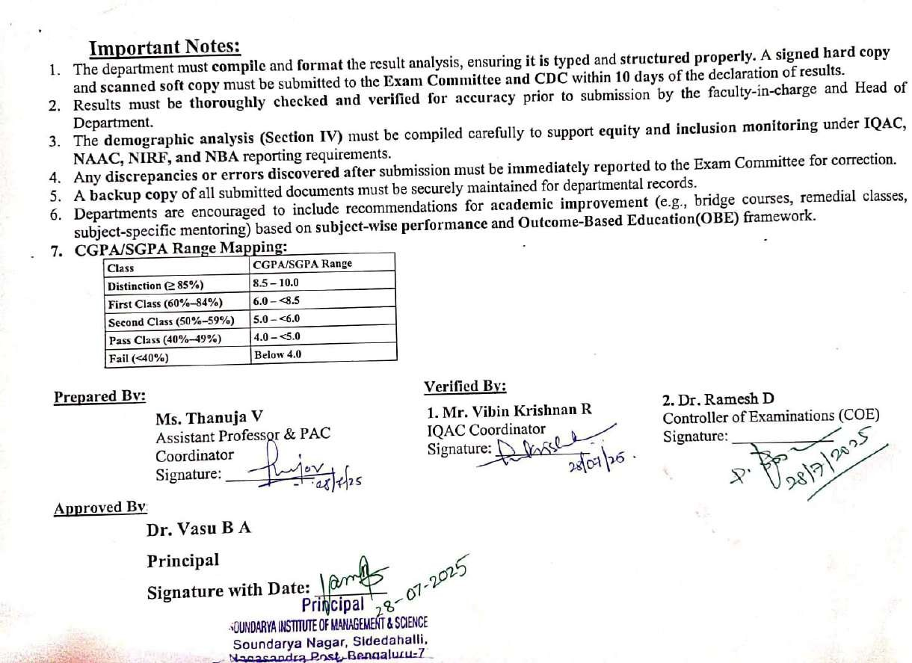

5

