Student Attendance Management System
Software Architecture and Design (SAD) Specification
PES University · Version 1.0 · 9 November 2026
Prepared following IEEE 1016-2009 (Software Design Descriptions) and ISO/IEC/IEEE 42010 (Architecture Description)
Item | Value
System | Student Attendance Management System (SAMS), a web application
Repository | github.com/Harsha-Kamaraj/Student-Attendance-Management-System (main branch)
Related documents | SRS v2.0, Security Requirements Specification, Use Case Flow, Test Plan v2.0, BL-01 decision log, BL-05 permission matrix
Technology | Python 3.14, Django 5.2, PostgreSQL 18, Bootstrap 5.3 (served locally), Playwright for browser tests

Contents
1. Introduction
1.1 Purpose
1.2 Scope
1.3 Definitions and Acronyms
1.4 References
1.5 Overview
2. Stakeholders and Concerns
3. Architectural Goals and Constraints
4. Architectural Pattern
4.1 Why this pattern
4.2 Alternatives considered
5. Component View
5.1 Components and Implementation
6. Data View
7. Deployment View
8. Security Architecture
9. Requirements Traceability
10. Detailed Design
10.1 Sequence Diagrams
10.2 API Design
10.3 Error Handling Protocols
11. Design Changes Since Part 1

1. Introduction

1.1 Purpose
This document describes the architecture and detailed design of SAMS: the architectural pattern, the components and how they work together, the data, the deployment, the security architecture, the API, the error-handling rules and the traceability from the requirements in the SRS to the design. It is the reference for developers, testers and evaluators, and it records how the implemented design relates to the original Part 1 design.

1.2 Scope
The design covers every requirement of SRS v2.0: functional requirements FR-01 to FR-24, non-functional requirements NFR-01 to NFR-15, the attendance rules AR-01 to AR-14 and the security requirements SEC-01 to SEC-32. It describes the system as built on the main branch on 9 November 2026.

1.3 Definitions and Acronyms
Term | Meaning
MTV | Model–Template–View, Django's form of the Model–View–Controller pattern.
ORM | Object–relational mapper: Django models generate parameterised SQL for PostgreSQL.
Middleware | Code that runs on every request before and after the view (security, sessions, CSRF, login and OTP gates).
Service | A Python module holding business rules (for example attendance.services.submit_attendance), called by views and commands.
TOTP | Time-based one-time password (RFC 6238) used by authenticator apps.
PRG | Post/Redirect/Get: a successful POST redirects, so refreshing never resubmits.
CSRF | Cross-site request forgery; every state-changing request carries a token.
Other terms | As defined in SRS section 1.3 (session, subject offering, threshold, semester classes, UC, FR, NFR, SEC, D-nn).

1.4 References
- Software Requirements Specification (SRS) v2.0, 9 November 2026.
- Security Requirements Specification: assets, threats, OBJ-01 to OBJ-06, SEC-01 to SEC-32.
- Use Case Flow document and use case diagram (UC-01 to UC-14).
- Test Plan Document v2.0: security validation and traceability.
- BL-01 decision log (D-01 to D-28) and BL-05 permission matrix.
- IEEE Std 1016-2009; ISO/IEC/IEEE 42010:2022; Django 5.2 documentation.

1.5 Overview
Section 2 lists stakeholders and their concerns. Section 3 states the goals and constraints. Section 4 explains the architectural pattern. Sections 5 to 7 give the component, data and deployment views. Section 8 is the security architecture and section 9 the traceability. Section 10 is the detailed design: sequence diagrams, API design and error handling. Section 11 records how the design changed after Part 1.

2. Stakeholders and Concerns
Stakeholder | Main concerns | Addressed in
Admin | Complete control of accounts and classes; safe recovery; clear audit trail. | Sections 5, 8, 10.1 (SD-3)
Faculty | Fast, reliable marking; only their own classes; reminders for unmarked classes. | Sections 5, 10.1 (SD-2)
Students | Accurate percentages; privacy; knowing how many classes they need. | Sections 6, 8
Developers | Clear structure, testability, one place for each rule. | Sections 4, 5, 9
Evaluators | Traceability to requirements; justified choices; security. | Sections 4, 8, 9, 11
Institution | Data protection, availability during class hours, low running cost. | Sections 7, 8

Viewpoints used: logical/component (section 5), information (section 6), deployment (section 7), security (section 8) and interaction (section 10.1).

3. Architectural Goals and Constraints
- Correctness first: attendance percentages are always calculated from saved records with one set of formulas (AR-09 to AR-11, NFR-15).
- Security by default: every request passes login, two-factor and role checks on the server (SEC-01, SEC-10, SEC-29).
- Consistency: a save, its audit entry and any notification commit together or not at all (NFR-10, SEC-21).
- Performance: 95% of requests within 2 seconds for 50 concurrent users and a year of data (NFR-01, NFR-08).
- Maintainability: a small team can understand and test every rule; every change runs the full suite in CI (NFR-09).
- Constraints: Python and Django, PostgreSQL, a single server for the course deployment, no external CDN at run time, IST for all dates, two statuses only (AR-05), six periods per day.

4. Architectural Pattern
SAMS is a layered, server-rendered monolith built on Django's Model–Template–View (MTV) pattern. Each request flows down through the layers and back; a layer only calls the layer below it, and business rules live in the service layer so that views, scheduled commands and tests all use the same code.
Layer | Responsibility | Implemented by
Presentation | HTML pages, forms, role-based sidebar, buttons; no business rules. | templates/, static/css, static/js, accounts/templatetags/ui.py
Request handling | Routing, security headers, sessions, CSRF, login and OTP gates, forced password change, restore maintenance. | config/urls.py, Django and app middleware
Application (views) | Check permission and scope, validate forms, call services, choose the response. | apps/*/views.py, forms.py, decorators.py
Domain services | Business rules: marking, corrections, calculations, notifications, schedules, backups, credentials. | services.py, calculations.py, permissions.py, schedule.py, credentials.py, otp.py
Data access | Models, constraints and transactions; parameterised SQL through the ORM. | apps/*/models.py, migrations
Persistence | Relational storage with constraints and an append-only audit table. | PostgreSQL 18

4.1 Why this pattern
- One database transaction can cover attendance, its audit entry and its notifications, which a distributed design could not guarantee simply.
- Server-rendered pages keep every permission check on the server and need no separate API security layer or JavaScript framework.
- Django supplies proven authentication, CSRF protection, sessions, the ORM and migrations, so the team's effort goes into the attendance rules.
- A single deployable unit suits a three-person team, a course timeline and one institution's load (NFR-08).

4.2 Alternatives considered
Alternative | Reason not chosen
Microservices | Network calls and separate databases would make atomic marking + audit + alerts hard; far more operational work for no benefit at this scale.
Single-page app + REST API | Doubles the code (client and API), moves validation to two places and adds token handling; server pages already meet NFR-01 and NFR-12.
NoSQL database | Attendance is relational (students, sections, sessions) and needs unique constraints and transactions.

5. Component View
Figure 1 is the logical component diagram from the Part 1 design. Table 5.1 maps each logical component to the code that implements it and adds the components introduced since (shown in the Notes column).
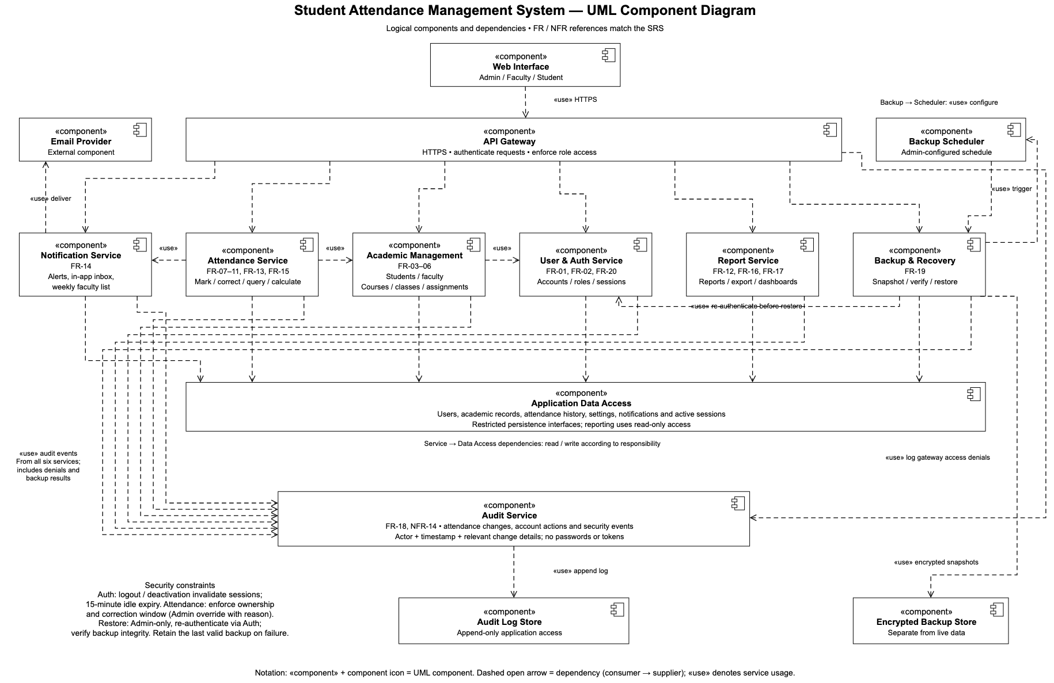
Figure 1. UML component diagram: logical components and their dependencies (Part 1 design).

5.1 Components and Implementation
Component | Implementation | Responsibility | Requirements / notes
Web Interface | templates/, static/, ui template tags | Pages for each role; sidebar shows only permitted pages; buttons for every action. | NFR-07, NFR-12; redesigned 9 Nov (D-28)
API Gateway | Django URL dispatcher + middleware stack | HTTPS, security headers, session, CSRF, login required, OTP gate, forced password change, restore maintenance lock. | SEC-01, SEC-09, SEC-19, SEC-29
User & Auth Service | apps/accounts (views, services, otp, credentials, permissions) | Accounts, login, lockout, two-factor codes, password reset requests, emailing login details, permission matrix and scope. | FR-01, FR-02, FR-20, FR-21, FR-24
Academic Management | apps/academics (views, planning_views, forms) | Students, faculty, subjects, sections, enrolments, teaching assignments, timetable, semester classes. | FR-03 to FR-06, FR-22, FR-23 (timetable added D-24, D-25)
Attendance Service | apps/attendance (services, corrections, calculations, schedule, history and report views) | Marking, correction window, history, search, calculations, classes-needed advice, today's classes. | FR-07 to FR-11, FR-15, FR-18, FR-22, FR-23
Report Service | apps/attendance/report_views.py, dashboards in apps/accounts/views.py | Reports, CSV and PDF export, role dashboards. | FR-12, FR-16, FR-17
Notification Service | apps/notifications (services, views, weekly command) | Below-threshold detection, in-app and email alerts with classes needed, faculty list and Monday email. | FR-13, FR-14, AR-13, AR-14
Backup & Recovery | apps/backups (services, snapshots, storage, locks) | Encrypted snapshots, import, validation, restore with safety backup. | FR-19, NFR-13, SEC-20, SEC-26
Backup Scheduler | run_scheduled_backups management command (cron) | Runs due backups; retries after failure. | FR-19
Audit Service | apps/audit (record, AuditEntry) | Append-only log of attendance changes, account actions and security events; database triggers block update and delete. | FR-18, NFR-14, SEC-16, SEC-21, SEC-22
Application Data Access | Django ORM models | Single access path to PostgreSQL with constraints. | NFR-05, NFR-10
Email Provider | SMTP via Django mail (settings from .env) | Delivers alerts, login details, codes and weekly emails. | FR-14, FR-24

6. Data View
All data lives in one PostgreSQL database. Percentages are never stored; they are calculated from attendance records on each request (AR-09 to AR-11). Key entities:
Entity (app) | Key fields | Rules and constraints
User (accounts) | username, role, email, password hash, must_change_password, failed_login_count, locked_until, otp fields | Role is Admin, Faculty or Student; lockout after 5 failures; only hashes stored.
OTPBackupCode / OTPEmailCode | user, code_hash, used_at, expires_at | Codes stored as hashes; single use; email codes expire after 10 minutes.
Student / Faculty (academics) | user (1:1), roll_number or faculty_id, full_name, home_section / department | Unique roll number and faculty ID.
Section, Subject | class_name, name, year; code, name | Unique section name per year; unique subject code.
TeachingAssignment | section, subject, faculty, planned_sessions | One per section and subject; planned_sessions 1–500 or blank.
Enrollment | student, assignment, subject | One section per subject per student (D-19).
TimetableSlot | assignment, weekday, period | Unique per class, day and period; weekday Mon–Sat; period 1–6; clashes rejected in the form.
AttendanceSession (attendance) | assignment, date, period, recorded_by, recorded_by_code | Unique class + date + period (AR-06); period 1–6.
AttendanceRecord | session, student, status | One per student per session; status P or A only.
AttendanceThreshold, CorrectionWindow | value; days | Threshold 1–100 (default 75); window 0–30 days (default 2).
Notification, ShortageFlag, WeeklyShortageEmail (notifications) | recipient, title, body, read_at; student, subject; faculty, week_start | One flag per student and subject (or overall); one email per faculty per week.
AuditEntry (audit) | timestamp, actor, action, target, old/new value, reason, is_admin_override | Append-only: database triggers reject update, delete and truncate.
Backup, BackupSchedule (backups) | kind, status, checksum, size, row_counts; enabled, time, next_run_at | Files encrypted with Fernet; checksum verified before restore.

7. Deployment View
Node | Runs | Connections
User device | Any supported browser (Chrome, Edge, Firefox, Safari). | HTTPS to the application server.
Application server | Django under a WSGI server (gunicorn in production; runserver in development), static files served locally. | PostgreSQL (TCP 5432), SMTP (587, TLS), backup directory.
Database server | PostgreSQL 18. | Accepts connections only from the application server.
Scheduler | cron or Task Scheduler running run_scheduled_backups and send_weekly_shortage_emails. | Same code and database as the application.
Backup storage | Private directory (BACKUP_DIRECTORY) holding encrypted files. | Read/written only by the application user.
Email provider | SMTP service (Gmail in the project setup). | Outbound only.
CI (GitHub Actions) | Lint, format, Django checks, migration check and the full test suite with PostgreSQL 18. | Runs on every push and pull request.

Configuration (database URL, secret key, SMTP, site URL, backup key, debug flag) is read from environment variables or a .env file that is never committed. /health/ returns JSON status for monitoring and reports 503 while the database is unavailable or a restore holds the maintenance lock.

8. Security Architecture
Security is layered so that no single control is relied on alone (defence in depth). The trust boundary is the application server: everything from the browser is untrusted and checked on the server.
Layer | Mechanism | Requirements
Transport | HTTPS in production; secure and HTTP-only cookies; login links built from the configured HTTPS site URL, never the request host. | SEC-19, SEC-09
Authentication | Django authentication with salted PBKDF2 password hashes; generic error; lockout after 5 failures for 15 minutes; temporary passwords must be changed at first login. | SEC-02 to SEC-06
Two-factor login | OTPRequiredMiddleware allows only OTP pages until a TOTP, emailed or backup code is accepted; codes hashed; 5 wrong codes lock; session id rotated on success. | SEC-29 to SEC-32
Sessions | 15-minute idle expiry; logout and deactivation end sessions on the server. | SEC-08, SEC-15
Authorization | Role matrix (PERMISSIONS) checked by @requires / @role_required on every view; scope functions (visible_assignments, visible_students, visible_attendance_records) limit faculty and students to their own data; denials logged. | SEC-10 to SEC-14
Input and output | Django forms validate type, length and range; ORM uses parameterised SQL; templates escape output; CSRF tokens on every POST; clickjacking protection; CSV formula cells neutralised. | SEC-17, SEC-18, SEC-24
Integrity and audit | Attendance, audit and alerts saved in one transaction; AuditEntry append-only with database triggers; correction window enforced on the server in IST. | SEC-21, SEC-23, NFR-14
Data protection | Backups encrypted with authenticated encryption and checksums; restore requires the Admin to re-enter their password and keeps a safety backup. | SEC-20, SEC-26
Privacy | Students see only their own data; alerts go only to the student; emailed addresses masked in logs; no secrets or stack traces in pages, logs or audit (sensitive_variables). | SEC-12, SEC-25, SEC-27
Configuration | Secrets in .env only; DEBUG off in production; demo accounts refused when DEBUG is off. | SEC-28

9. Requirements Traceability
Requirements | Component | Main modules / views
FR-01, FR-20 | User & Auth | accounts.views login/logout, accounts.services.check_login, forgot_password
FR-02, NFR-04 | User & Auth | accounts.permissions (PERMISSIONS, requires, visible_*), templatetags/ui sidebar
FR-03, FR-04 | Academic Management | academics.views student_* and faculty_*
FR-05, FR-06 | Academic Management | academics.views subject_*, section_*, enrollment_*, class_assign
FR-07 | Attendance | attendance.views.attendance_mark, attendance.services.submit_attendance
FR-08, FR-18 | Attendance, Audit | attendance.corrections, correction_views, attendance_changes, audit.services.record
FR-09, FR-11, NFR-15 | Attendance | attendance.calculations.student_attendance_summary, attendance_summary view
FR-10, FR-15 | Attendance | attendance.history_views.attendance_history, history_forms
FR-12, FR-16 | Report | attendance.report_views (report, CSV, PDF)
FR-13, FR-14 | Notification | notifications.services.evaluate_students, shortage_list_for, weekly email command
FR-17 | Report | accounts.views dashboard_admin / dashboard_faculty / dashboard_student
FR-19, NFR-13 | Backup & Recovery | backups.services, snapshots, storage; run_scheduled_backups
FR-21 | User & Auth | accounts.otp, accounts.middleware.OTPRequiredMiddleware, otp_* views
FR-22 | Academic, Attendance | academics.planning_views.timetable, TimetableSlot, attendance.schedule.today_overview
FR-23 | Academic, Attendance, Notification | planning_views.semester_plan, calculations.AttendanceOutlook, classes_needed
FR-24 | User & Auth | accounts.views.account_send_credentials, credentials.deliver_login_details
NFR-01, NFR-08 | All | Indexed queries, aggregate counts in two queries per student; verification/performance.py
NFR-02, NFR-03, NFR-11 | Security layers | Section 8
NFR-05, NFR-10 | Data access | Model constraints, transactions, select_for_update in services
NFR-06 | Deployment | /health/ endpoint, verification/availability.py
NFR-07, NFR-12 | Web Interface | templates, theme.css, nav.js; verification/browser_check.py
NFR-09 | All | Layered modules, ruff, GitHub Actions CI
NFR-14 | Audit | apps/audit

10. Detailed Design

10.1 Sequence Diagrams
SD-1 shows the two-step login. The password and the one-time code are checked separately; until the code is accepted, middleware allows only the OTP pages and Log out.
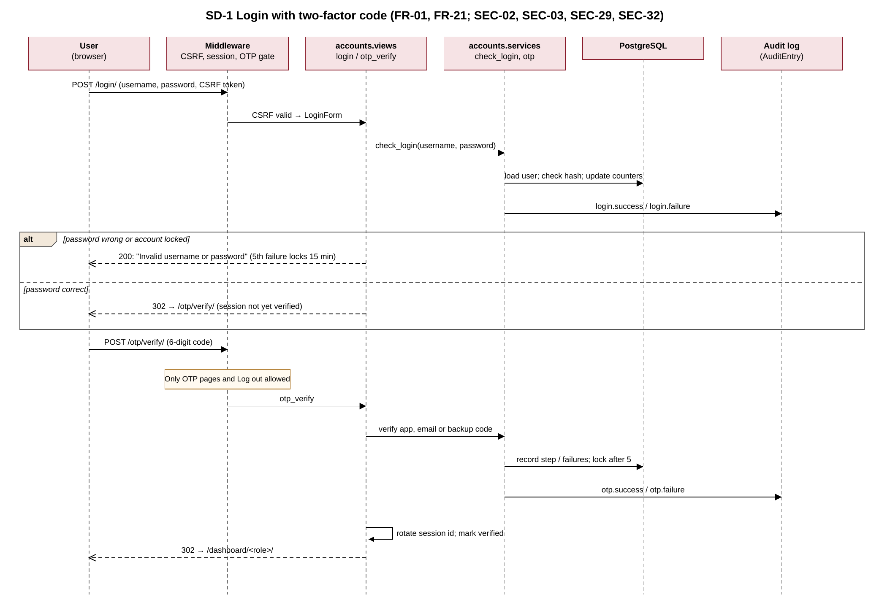
Figure 2. SD-1 Login with two-factor code.
SD-2 shows a faculty member saving attendance. The session, records, audit entry and any new low-attendance flags and notifications are written in one transaction; email is sent only after the commit, and an email failure never undoes the save.
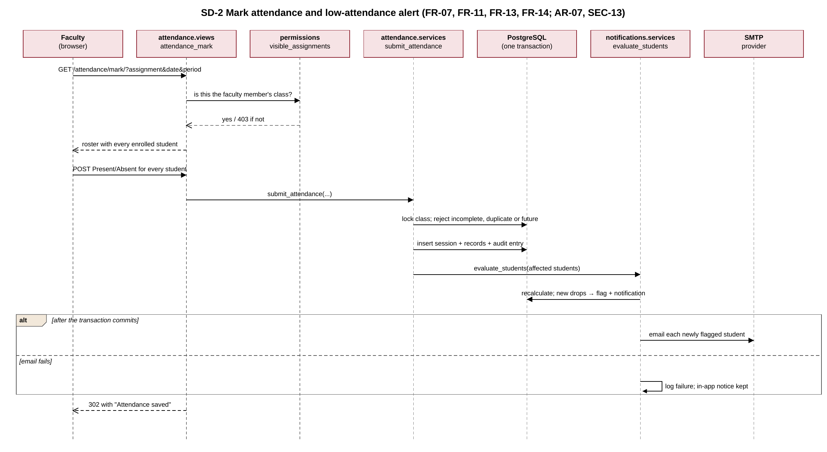
Figure 3. SD-2 Mark attendance and low-attendance alert.
SD-3 shows a restore. The Admin re-authenticates, the encrypted file is verified before anything changes, a safety backup is taken, and the data is replaced in one transaction.
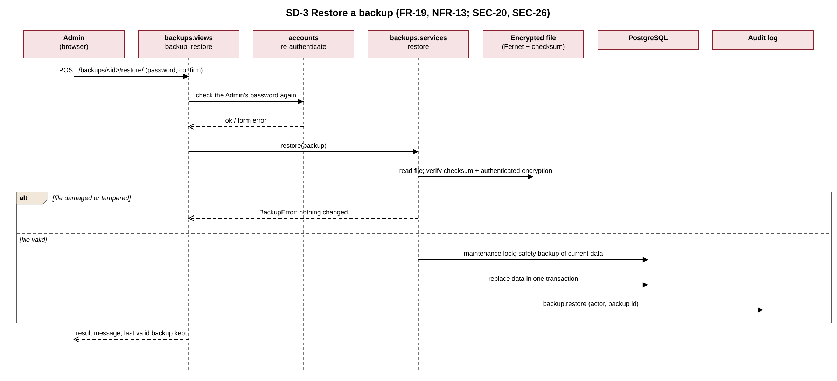
Figure 4. SD-3 Restore a backup.

10.2 API Design
SAMS exposes a server-rendered HTTP interface rather than a JSON API. Its conventions:
- Resource-style URLs: /students/, /students/<id>/, /students/<id>/edit/; actions as sub-paths (deactivate, restore).
- GET never changes data. Every change is a POST with a CSRF token; successful POSTs redirect (PRG).
- Access is declared on each view with @requires(permission) or @role_required(role) and checked again by scope functions inside the view.
- Responses: HTML pages; text/csv and application/pdf for exports; application/octet-stream for encrypted backups; JSON for /health/.
- Status codes: 200 OK; 302 redirect after success or to login/OTP; 400 invalid form (errors shown on the page); 403 not permitted (logged); 404 not found or outside scope; 405 wrong method; 503 health unavailable.
- Dates are ISO (YYYY-MM-DD) in query strings and IST on screen; filters are query parameters so results can be bookmarked.
Table 10.2 lists all 72 endpoints, generated from the URL configuration and the view decorators.
Method | Path | Access | Purpose
GET | /health/ | Public | Liveness check for monitoring: JSON {status: ok}, or 503 while the database is unavailable or a restore is running.
GET | / | Public | Public landing page with a link to log in.
GET, POST | /login/ | Public | Username and password form; generic error on failure; lockout after 5 failures.
POST | /logout/ | Any signed-in user | Ends the session on the server (CSRF-protected POST).
GET, POST | /password/change/ | Any signed-in user | Change own password; forced first after a temporary password.
GET, POST | /password/forgot/ | Public | Ask the Admins to reset a forgotten password; same reply for unknown usernames.
GET | /profile/ | Any signed-in user | Read-only account, college and role details for the signed-in user.
GET | /dashboard/ | Any signed-in user | Redirects to the dashboard for the user's role.
GET | /dashboard/admin/ | Admin | Totals, shortage summary, reset requests and today's classes across the college.
GET | /dashboard/faculty/ | Faculty | Teaching totals, next-class reminder, unmarked classes and today's classes.
GET | /dashboard/student/ | Student | Overall attendance, subjects below threshold and each enrolled subject.
GET | /users/ | Admin | All accounts with reset, resend and OTP-reset actions.
GET, POST | /users/create/ | Admin | Create another Admin account with a temporary password.
POST | /users/<int:pk>/reset-password/ | Admin | Issue a new temporary password; emailed to the owner when possible.
POST | /users/<int:pk>/resend-login/ | Admin | Reissue login details while the temporary password is unused.
POST | /users/<int:pk>/send-login/ | Admin | Email the temporary password just shown; saves a changed address.
GET, POST | /users/<int:pk>/reset-otp/ | Admin | Reset another user's two-factor login after re-entering the Admin password.
GET, POST | /otp/setup/ | Any signed-in user | First-login authenticator setup with QR code, then backup codes.
GET, POST | /otp/verify/ | Any signed-in user | Enter the authenticator, emailed or backup code after the password.
POST | /otp/email/ | Any signed-in user | Email a one-time code (10 minutes, single use, max 3 per 15 minutes).
GET | /sections/ | Admin | Classes and sections.
GET, POST | /sections/create/ | Admin | Create a section.
GET | /sections/<int:pk>/ | Admin | Section roster, subjects and teachers.
GET, POST | /sections/<int:pk>/edit/ | Admin | Edit a section.
GET, POST | /sections/<int:pk>/delete/ | Admin | Delete an unused section (confirm, then POST).
GET, POST | /sections/<int:pk>/enroll/ | Admin | Enrol students in a subject offered in the section.
GET, POST | /sections/<int:pk>/classes/add/ | Admin | Offer a subject in the section with a teacher.
GET, POST | /sections/<int:pk>/classes/<int:assignment_pk>/teacher/ | Admin | Change the teacher of a subject offering.
GET | /my-classes/ | Faculty | Faculty's own sections, subjects and student counts.
GET, POST | /timetable/ | Admin | Weekly timetable: add a class by day and period; clashes rejected.
POST | /timetable/<int:pk>/remove/ | Admin | Remove a timetable class.
GET, POST | /semester-classes/ | Admin | Set classes planned this semester for each subject offering.
POST | /sections/<int:pk>/enrollments/<int:enrollment_pk>/remove/ | Admin | Remove a student's enrolment.
GET | /faculty/ | Admin | Faculty records.
GET, POST | /faculty/create/ | Admin | Add faculty with a login.
GET | /faculty/<int:pk>/ | Admin | Faculty details and assignments.
GET, POST | /faculty/<int:pk>/edit/ | Admin | Edit faculty.
POST | /faculty/<int:pk>/deactivate/ | Admin | Deactivate faculty (blocked while assigned).
POST | /faculty/<int:pk>/reactivate/ | Admin | Reactivate faculty.
GET, POST | /faculty/<int:pk>/delete/ | Admin | Delete faculty with a reason (confirm, then POST).
GET | /students/ | Admin / Faculty / Student | Students in scope: all for Admin, own classes for Faculty.
GET, POST | /students/create/ | Admin | Add a student with a login.
GET | /students/<int:pk>/ | Admin / Faculty / Student | Student details and enrolments (in scope only).
GET, POST | /students/<int:pk>/edit/ | Admin | Edit a student.
POST | /students/<int:pk>/deactivate/ | Admin | Deactivate a student; history kept.
POST | /students/<int:pk>/reactivate/ | Admin | Reactivate a student.
GET, POST | /students/<int:pk>/delete/ | Admin | Delete a student with a reason (confirm, then POST).
GET | /subjects/ | Admin / Faculty | Subjects in scope.
GET, POST | /subjects/create/ | Admin / Faculty | Create a subject (unique code).
GET | /subjects/<int:pk>/ | Admin / Faculty | Subject details and offerings.
GET, POST | /subjects/<int:pk>/edit/ | Admin / Faculty | Edit a subject (faculty: subjects they teach).
GET, POST | /subjects/<int:pk>/delete/ | Admin | Delete a subject without attendance.
GET, POST | /subjects/<int:pk>/offer/ | Admin | Offer the subject in a section.
POST | /subjects/<int:pk>/offerings/<int:assignment_pk>/withdraw/ | Admin | Withdraw an offering without attendance.
GET | /notifications/ | Student | Student's own alerts, current shortfalls and classes needed; marks alerts read.
GET | /attendance/shortages/ | Admin / Faculty | Students below threshold: all for Admin, own subjects for Faculty.
GET, POST | /attendance/mark/ | Admin / Faculty | Load a roster and save complete attendance for a session.
GET | /attendance/mine/ | Student | Student's own attendance by subject, with filters and class-by-class list.
GET, POST | /attendance/threshold/ | Admin | Set the attendance threshold (1–100%); re-evaluates every student.
GET | /attendance/history/ | Admin / Faculty | Search and filter attendance records in scope.
GET | /attendance/reports/ | Admin / Faculty | Report by scope and date range with totals.
GET | /attendance/reports/export/csv/ | Admin / Faculty | Download the report as CSV (formula cells neutralised; logged).
GET | /attendance/reports/export/pdf/ | Admin / Faculty | Download the report as PDF (logged).
GET | /attendance/records/<int:pk>/changes/ | Admin / Faculty | Change history of one attendance record.
GET, POST | /attendance/records/<int:pk>/correct/ | Admin / Faculty | Correct a record within the window; Admin overrides need a reason.
GET, POST | /attendance/correction-window/ | Admin | Set the faculty correction window (0–30 days).
GET | /backups/ | Admin | Backups, schedule status and actions.
POST | /backups/create/ | Admin | Create an encrypted backup now.
GET, POST | /backups/schedule/ | Admin | Configure the daily backup time.
GET, POST | /backups/import/ | Admin | Import and validate a saved backup file.
GET | /backups/<uuid:pk>/download/ | Admin | Download the encrypted backup file.
GET, POST | /backups/<uuid:pk>/restore/ | Admin | Re-authenticate and restore a validated backup.

10.3 Error Handling Protocols
Principles: fail closed (deny when unsure); validate on the server; make each change atomic so a failure leaves nothing half-saved; tell the user what to do next in plain words; never show stack traces, secrets or other users' data; log every security-relevant failure.
Condition | Detected by | User sees | HTTP | Logged / audited
Invalid or missing form input | Django form validation | The page again with the message beside each field. | 400 | No
Not logged in / OTP not done | LoginRequired and OTP middleware | Redirect to login or the code page. | 302 | No
Action not permitted or outside scope | @requires, scope checks, PermissionDenied | Access denied page with a link to the dashboard. | 403 | access.denied with user and path
Record not found | get_object_or_404 | Not found page. | 404 | No
Wrong HTTP method | require_POST / require_GET | Method not allowed. | 405 | No
CSRF token missing or wrong | CsrfViewMiddleware | Forbidden page; nothing saved. | 403 | Django security log
Wrong password; 5 failures | accounts.services.check_login | "Invalid username or password"; account paused 15 minutes. | 200 | login.failure, login.lockout
Wrong or expired code; 5 failures | accounts.otp | Code error; account locked 15 minutes. | 200 | otp.failure, otp.lockout
Duplicate session or concurrent save | Unique constraints, select_for_update, IntegrityError | "Already saved" message or form error; nothing duplicated. | 400 / 302 | No
Database error during a save | DatabaseError in services | "Could not save, try again"; transaction rolled back. | 500 page or message | Application log
Email provider failure | send_mail exception | In-app notice or on-screen password kept; Send button offered. | 200 | notification.email_failed / credentials.email_failed (no secret text)
Damaged or tampered backup; restore in progress | BackupError, BackupBusy | Clear message; last valid backup kept; pages wait during restore. | 200 / 503 | backup.* with outcome
Unexpected error | Django handler (DEBUG off) | Generic error page without details. | 500 | Application log

11. Design Changes Since Part 1
The architecture and components of the Part 1 design are unchanged. The following refinements and additions were made during Sprints 1 and 2 and are recorded in the BL-01 decision log:
Decision | Change
D-20 to D-22 | Two-factor login added (OTP middleware, codes, backup codes, lockout) — FR-21, SEC-29 to SEC-32.
D-23 | Forgotten passwords handled by an Admin reset instead of self-service reset links — SEC-07.
— | The logical API Gateway is realised by Django's URL dispatcher and middleware stack, not a separate gateway server.
D-24 | Timetable (TimetableSlot) and today's-class reminders on dashboards — FR-22.
D-25 | Semester class totals and classes-needed advice for students and alerts — FR-23.
D-26 | Send login details by email from the temporary-password page — FR-24.
D-27 | Attendance history lists records after the filters are applied.
D-28 | Dashboard counts exclude deactivated students; interface redesign with logo, role-based sidebar and buttons.

