**41. Performance Comparison of PL/SQL Interpreted vs. Native Code**

**CREATE OR REPLACE PROCEDURE longproc IS**

**v_number PLS_INTEGER;**

**BEGIN**

**FOR i IN 1..50000000 LOOP**

**v_number := v_number * 2;**

**v_number := v_number / 2;**

**END LOOP;**

**END longproc;**

**/**

**BEGIN**

**longproc;**

**END;**

**/**

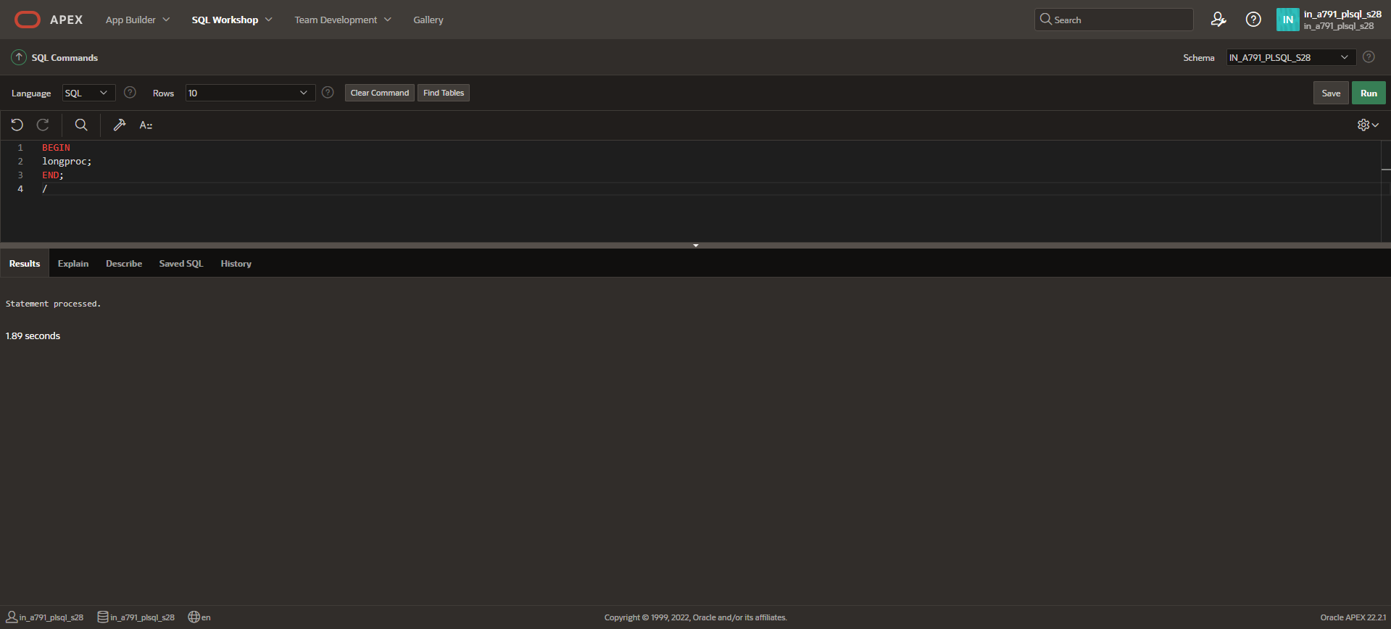

**ALTER SESSION SET PLSQL_CODE_TYPE = NATIVE;**

**CREATE OR REPLACE PROCEDURE longproc IS**

**v_number PLS_INTEGER;**

**BEGIN**

**FOR i IN 1..50000000 LOOP**

**v_number := v_number * 2;**

**v_number := v_number / 2;**

**END LOOP;**

**END longproc;**

**/**

**BEGIN**

**longproc;**

**END;**

**/**

