FORM 1  THE PATENTS ACT 1970 (39 of 1970) and  THE PATENTS RULES, 2003  APPLICATION FOR GRANT OF PATENT  (See section7, 54 and 135 and sub‐rule (1) of rule 20) |  |  |  |  |  |  |  |  |  |  |  |  |  |  |  |  |  |  | (FOR OFFICE USE ONLY)
 |  |  |  |  |  |  |  |  |  |  |  |  |  |  |  |  |  |  | Application No.
 |  |  |  |  |  |  |  |  |  |  |  |  |  |  |  |  |  |  | Filing date:
Amount of Fee
paid:
 |  |  |  |  |  |  |  |  |  |  |  |  |  |  |  |  |  |  | CBR No:
 |  |  |  |  |  |  |  |  |  |  |  |  |  |  |  |  |  |  | Signature:
1.APPLICANT’S REFERENCE / IDENTIFICATION NO.(AS ALLOTTED BY OFFICE)
2.TYPE OF APPLICATION [Please tick (✓) at the appropriate category]
Ordinary(✓) |  |  |  |  |  | Convention() |  |  |  |  |  |  |  |  |  |  | PCT‐NP( ) |  |  |  |  |  |  |  |  |  |  | PPH ( )
Divisional( ) |  | Patent of  Addition ( ) |  |  |  | Divisional  ( ) |  |  |  | Patent of  Addition( ) |  |  |  |  |  |  | Divisional ( ) |  |  |  |  |  | Patent of Addition ( )
3A. APPLICANT(S)
Name in Full |  |  |  | Gender  (optional,  for  individuals) |  |  |  | Nationality |  |  |  |  |  |  | Country of  Residence |  |  |  | Age  (optional,  for natural  persons) |  |  | Address of the Applicant
Saveetha Institute of MedicalAndTechnicalSciences |  |  |  | Prefer notto disclose |  |  |  | Indian |  |  |  |  |  |  | India |  |  |  | - Prefer not  to disclose |  |  | House No. |  |  |  |  |  | Saveetha Institute of MedicalAndTechnicalSciences
 |  |  |  |  |  |  |  |  |  |  |  |  |  |  |  |  |  |  |  |  |  | Street |  |  |  |  |  | Saveetha Nagar,Thandalam
 |  |  |  |  |  |  |  |  |  |  |  |  |  |  |  |  |  |  |  |  |  | City |  |  |  |  |  | Chennai
 |  |  |  |  |  |  |  |  |  |  |  |  |  |  |  |  |  |  |  |  |  | State |  |  |  |  |  | TamilNadu
 |  |  |  |  |  |  |  |  |  |  |  |  |  |  |  |  |  |  |  |  |  | Country |  |  |  |  |  | India
 |  |  |  |  |  |  |  |  |  |  |  |  |  |  |  |  |  |  |  |  |  | Pin code |  |  |  |  |  | 602105
 |  |  |  |  |  |  |  |  |  |  |  |  |  |  |  |  |  |  |  |  |  | Email(OTP verification mandatory will be  redacted) |  |  |  |  |  | patents.sdc@saveetha.com
 |  |  |  |  |  |  |  |  |  |  |  |  |  |  |  |  |  |  |  |  |  | Contact  Number(OTP verification mandatory will be  redacted) |  |  |  |  |  | 9884293869
3B. CATEGORY OF APPLICANT [Please tick (✓)at the appropriate category]

Natural Person ( ) |  |  |  |  | Other than Natural Person ( ) |  |  |  |  |  |  |  |  |  |  |  |  |  |  |  |  |  |  |  | Educational institution ()
 |  |  |  |  | Small Entity ( ) |  |  |  |  |  |  |  | Startup ( ) |  |  |  |  |  |  | Others ( )
4. INVENTOR(S) [Please tick(✓) at the appropriate category]
Are all the inventor(s) sameas the applicant(s) named above? |  |  |  |  |  |  |  |  | Yes ( ) |  |  |  |  |  |  |  |  |  |  |  |  |  | No(✓)
If“No”, furnish the details of the inventor(s)

Name in Full |  |  | Gender  (Optional,  for  individuals) |  |  |  | Nationality |  |  |  |  | Country of  Residence |  |  |  |  |  | Age  (Optional,  for natural  persons) |  |  |  | Address of the Applicant
Mr. Harsha Kyle R |  |  | Male |  |  |  | Indian |  |  |  |  | India |  |  |  |  |  | - Prefer not  to disclose |  |  |  | House No. |  |  |  |  | Saveetha Institute Of MedicalAndTechnicalSciences
 |  |  |  |  |  |  |  |  |  |  |  |  |  |  |  |  |  |  |  |  |  | Street |  |  |  |  | Saveetha Nagar,Thandalam
 |  |  |  |  |  |  |  |  |  |  |  |  |  |  |  |  |  |  |  |  |  | City |  |  |  |  | Chennai
 |  |  |  |  |  |  |  |  |  |  |  |  |  |  |  |  |  |  |  |  |  | State |  |  |  |  | TamilNadu
 |  |  |  |  |  |  |  |  |  |  |  |  |  |  |  |  |  |  |  |  |  | Country |  |  |  |  | India
 |  |  |  |  |  |  |  |  |  |  |  |  |  |  |  |  |  |  |  |  |  | Pin code |  |  |  |  | 602105
 |  |  |  |  |  |  |  |  |  |  |  |  |  |  |  |  |  |  |  |  |  | Email(OTP verification mandatory will beredacted) |  |  |  |  | patents.sdc@saveetha.com
 |  |  |  |  |  |  |  |  |  |  |  |  |  |  |  |  |  |  |  |  |  | Contact  Number(OTP verification mandatory will beredacted) |  |  |  |  | 9884293869
Mrs.Uma Priyadarsini P.S |  |  | Female |  |  |  | Indian |  |  |  |  | India |  |  |  |  |  | - Prefer not  to disclose |  |  |  | House No. |  |  |  |  | Saveetha Institute Of MedicalAndTechnicalSciences
 |  |  |  |  |  |  |  |  |  |  |  |  |  |  |  |  |  |  |  |  |  | Street |  |  |  |  | Saveetha Nagar,Thandalam
 |  |  |  |  |  |  |  |  |  |  |  |  |  |  |  |  |  |  |  |  |  | City |  |  |  |  | Chennai
 |  |  |  |  |  |  |  |  |  |  |  |  |  |  |  |  |  |  |  |  |  | State |  |  |  |  | TamilNadu
 |  |  |  |  |  |  |  |  |  |  |  |  |  |  |  |  |  |  |  |  |  | Country |  |  |  |  | India
 |  |  |  |  |  |  |  |  |  |  |  |  |  |  |  |  |  |  |  |  |  | Pin code |  |  |  |  | 602105
 |  |  |  |  |  |  |  |  |  |  |  |  |  |  |  |  |  |  |  |  |  | Email(OTP verification mandatory will beredacted) |  |  |  |  | patents.sdc@saveetha.com
 |  |  |  |  |  |  |  |  |  |  |  |  |  |  |  |  |  |  |  |  |  | Contact  Number(OTP verification mandatory will beredacted) |  |  |  |  | 9884293869
Dr Ramya Mohan |  |  | Female |  |  |  | Indian |  |  |  |  | India |  |  |  |  |  | - Prefer not  to disclose |  |  |  | House No. |  |  |  |  | Saveetha Institute Of MedicalAndTechnicalSciences
 |  |  |  |  |  |  |  |  |  |  |  |  |  |  |  |  |  |  |  |  |  | Street |  |  |  |  | Saveetha Nagar,Thandalam
 |  |  |  |  |  |  |  |  |  |  |  |  |  |  |  |  |  |  |  |  |  | City |  |  |  |  | Chennai
 |  |  |  |  |  |  |  |  |  |  |  |  |  |  |  |  |  |  |  |  |  | State |  |  |  |  | TamilNadu
 |  |  |  |  |  |  |  |  |  |  |  |  |  |  |  |  |  |  |  |  |  | Country |  |  |  |  | India
 |  |  |  |  |  |  |  |  |  |  |  |  |  |  |  |  |  |  |  |  |  | Pin code |  |  |  |  | 602105
 |  |  |  |  |  |  |  |  |  |  |  |  |  |  |  |  |  |  |  |  |  | Email(OTP verification mandatory will beredacted) |  |  |  |  | patents.sdc@saveetha.com
 |  |  |  |  |  |  |  |  |  |  |  |  |  |  |  |  |  |  |  |  |  | Contact  Number(OTP verification mandatory will beredacted) |  |  |  |  | 9884293869
5. Title of the Invention

5.TITLE OFTHE INVENTION
KYOMA: A LOCAL AI-ENABLED INTERACTIVE DESKTOP COMPANION FOR INTELLIGENT COMPUTER AUTOMATION
6.AUTHORISED REGISTERED PATENT  AGENT(S) |  |  |  |  |  |  |  |  |  |  |  |  |  |  |  | IN/PA No.
 |  |  |  |  |  |  |  |  |  |  |  |  |  |  |  | Name
Mobile No.(OTP
Verification mandatory will be redacted)
7.ADDRESS FOR SERVICE OF APPLICANT IN INDIA |  |  |  |  |  |  |  |  |  |  |  |  |  |  |  | Name |  |  |  |  |  | Saveetha Institute of Medical and Technical Sciences
 |  |  |  |  |  |  |  |  |  |  |  |  |  |  |  | Postal Address |  |  |  |  |  | SaveethaNagar,Thandalam,Chennai -602105
 |  |  |  |  |  |  |  |  |  |  |  |  |  |  |  | Telephone No. |  |  |  |  |  | 04426801580
 |  |  |  |  |  |  |  |  |  |  |  |  |  |  |  | Mobile No.(OTP  Verification mandatory will be redacted) |  |  |  |  |  | 9884293869
 |  |  |  |  |  |  |  |  |  |  |  |  |  |  |  | Fax No.
 |  |  |  |  |  |  |  |  |  |  |  |  |  |  |  | E‐mail ID(OTP  Verification mandatory will be redacted) |  |  |  |  |  | patents.sdc@saveetha.com
8.IN CASE OF APPLICATION CLAIMING PRIORITY OF APPLICATION FILED IN CONVENTION COUNTRY, PARTICULARS OF CONVENTION APPLICATION PARTICULARS OF CONVENTION APPLICATION
Country | Application  Number |  |  |  | Filing date |  |  |  |  |  | Name of the  applicant |  |  |  |  |  |  |  |  |  | Title of the  invention |  |  |  |  | IPC (as classifiedin the  Conventioncountry)
9.IN CASE OF PCT NATIONAL PHASE APPLICATION, PARTICULARS OF INTERNATIONAL APPLICATIONFILED UNDER PATENT CO‐OPERATION TREATY (PCT)
International application number |  |  |  |  |  |  |  |  |  |  |  |  |  | International filing date
10.IN CASE OF DIVISIONAL APPLICATION FILED UNDER SECTION 16,PARTICULARS OF ORIGINAL (FIRST) APPLICATION
(FIRST) APPLICATION
Original (first) application No. |  |  |  |  |  |  |  |  |  |  |  |  |  | Date of filing of original (first) application
11.IN CASE OF PATENT OF ADDITION FILED UNDER SECTION 54, PARTICULARS OF MAIN APPLICATION OR PATENT
OR PATENT
Main application/patent No. |  |  |  |  |  |  |  |  |  |  |  |  |  | Date of filing of main application
12.DECLARATIONS

(i)Declaration by the inventor(s)
(In case the applicant is an assignee: The inventor(s) may sign herein below or the applicant may
upload the assignment or enclose the assignment with this application for patent or send the assignment by post/electronic transmission duly authenticated within the prescribed period).

We, the above named inventor(s) is/are the true& first inventor(s) for this Invention and declare that the applicant(s) herein is/are my/our assignee or legal representative.

Saveetha Institute of Medical and TechnicalSciences

(ii)Declaration by the applicant(s)in the convention country
(In case the applicant in India is different than the applicant in the convention country: the applicant in the convention country may sign herein below or applicant in India may upload the assignment from the applicant in the convention country or enclose the said assignment with this application for patent or send the assignment by post/electronic transmission duly authenticated within the prescribed period)

I/We, the applicant(s) in the convention country declare that the applicant(s) herein is/are my/our assignee or legal representative.
(a) Date
(b) Signature(s)
(c) Name(s) of the signatory

iii)Declaration by the applicant(s)
We the applicant(s) hereby declare(s) that: ‐

√ | We are in possession of the above‐mentioned invention.
√ | The provisional/complete specification relating tothe inventionis filedwith this application.
X | The invention as disclosed in the specification uses the biological material from India and the necessary permission from the competent authority shall be submitted by us before the grant of patent to us.
√ | There is no lawful ground of objection(s) to the grant of the Patent to us.
X | We are the true & first inventor(s).
√ | We are the assignee or legal representative of true &first inventor(s).
X | The application or each of the applications, particulars of which are given in Paragraph‐8, was the first application in convention country in respect of our invention(s).
X | I/We claim the priority from the above mentioned application(s) filed in convention country and state that no application for protection in respect of the invention had been made in a convention country before that date by us or by any person from which We derive the title.
X | My/Our application in India is based on international application under Patent Cooperation Treaty (PCT) as mentioned in Paragraph‐9.
X | The application is divided out of our application particulars of which is given in Paragraph‐10and pray that this application may be treated as deemed to have been filed on ________ under section 16 of the Act.
X | The said invention is an improvement in or modification of the invention particulars of which are given in Paragraph‐11.
13. FOLLOWINGARE THE ATTACHMENTS WITHTHE APPLICATION
(a) Form 2
Item |  | Details | Fee | Remarks
Complete/provisional specification) |  | No. of pages :5
No. of Claim(s) |  | No. of claims: 5  and No. of pages: 1
Abstract |  | No. of pages: 1
No. of Drawing(s) |  | No. of drawings: 2  No. of pages: 2
# Incaseofacomplete specification,iftheapplicantdesirestoadoptthedrawingsfiledwithhis
Provisionalspecification as thedrawingsorpartofthedrawingsforthecompletespecificationunder rule13(4), thenumberofsuch pages filedwiththeprovisionalspecificationarerequiredto be mentioned here.
(b)Completespecification(inconformationwiththeinternationalapplication)/asamendedbeforetheInternational PreliminaryExamination Authority (IPEA), as applicable(2copies).

(c)Sequencelisting in electronic form

(d)Drawings(inconformationwiththeinternationalapplication)/asamendedbeforetheInternational
PreliminaryExamination Authority (IPEA), as applicable(2copies).

(e)Priority document(s) or a request to retrieve the priority document(s) from DAS (Digital Access Service)iftheapplicanthadalreadyrequestedtheofficeoffirstfilingtomakethepriority document(s) available toDAS.

(f)Translationofprioritydocument/Specification/InternationalSearchReport/InternationalPreliminaryReport on patentability.

(g)Statement and Undertaking Form 3

(h)DeclarationofInventorshiponForm5

(i)Power ofAuthority

(j)

Totalfee ……….…………. Date…………......on………….………….………….………….

Weherebydeclarethattothebestofmy/ourknowledge,informationandbeliefthefact and mattersstatedherein arecorrectandI/Werequestthatapatentmaybegrantedtousfor the said invention.

Dated this day of 2026

To

The Controller of Patents

The Patent Office, at Chennai
India

FORM 5
THE PATENTS ACT, 1970
(39 of 1970)
and
THE PATENTS RULES, 2003
Declaration as to Inventorship
[See Section 10 (6); rule 13(6)]

1. Name of the Applicant (s). | Saveetha Institute of Medical and TechnicalSciences
hereby declare that the true and first inventor(s) of the invention disclosed in the complete specification filed in pursuance of my/our application numbered dated is/ are
2. Inventor (s)

(a) Name : Mr. Harsha Kyle .R
(b) Nationality : Indian
(c) Address : Saveetha Institute of Medical and Technical Sciences
(d) Saveetha Nagar, Thandalam, Chennai - 602 105, Tamil Nadu, India.

(a) Name : Mrs.Uma Priyadarsini P.S
(b) Nationality : Indian
(c) Address : Saveetha Institute of Medical and Technical Sciences
(d) Saveetha Nagar, Thandalam, Chennai - 602 105, Tamil Nadu, India.

(a) Name :Dr Ramya Mohan
(b) Nationality : Indian
(c) Address : Saveetha Institute of Medical and Technical Sciences
Saveetha Nagar, Thandalam, Chennai - 602 105,TamilNadu,India.

Dated this ……………………. day of ……………20……

Signature:
Name of the Signatory:

3. Declaration to be given when the application in India is filed by the applicant(s) in the convention country:

We the applicant(s) in the convention country hereby declare that our right to apply for a patent in India is by way of assignment from the true and first inventor(s)

Dated this ……………………. day of ……………20……

Signature:
Name of the Signatory:

4. Statement (to be signed by the additional inventor(s) not mentioned in the application form)

I/We assent the invention referred to in the above declaration, being included in the complete specification filed in pursuance of the stated application

Dated this ……………………. day of ……………20……

Signature of the additional inventors:
Name:

To
The Controller of Patents,
The Patent Office,
at

FORM - 2
THE PATENTS ACT, 1970
(39 OF 1970)
&
THE PATENTS RULES, 2003
COMPLETE SPECIFICATION
(see Section 10 & rule 13)
1.TITLE OF THE INVENTION: KYOMA: A LOCAL AI-ENABLED INTERACTIVE DESKTOP COMPANION FOR INTELLIGENT COMPUTER AUTOMATION
2. APPLICANT:
S.No | NAME | NATIONALITY | ADDRESS
1 | Saveetha Institute of Medical and TechnicalSciences | INDIAN | SaveethaNagar,Thandalam,Chennai -602105,TamilNadu,India
3. PREAMBLE TO THE DESCRIPTION:
The following specification describes the invention and how it is to be performed.
4.COMPLETESPECIFICATION
The following specification particularly describes the invention and the manner in which it is to be
performed.-----------------Separatesheet isattached---------------------------
5.DESCRIPTION
Separate sheetisattached
6.CLAIMS
Separatesheetisattached

DATE:
SIGNATURE:

NAME
- ABSTRACTOFTHEINVENTION
Separatesheetisattached--
Note:-
Repeatboxesinncase ofmorethanone entry.
Tobesignedbytheapplicant(s)orbyauthorizedregisteredpatentagentotherwisewhere mentioned.
Tic(√)/cross(x)whicheverisapplicable/notapplicableindeclarationinpara-9.
NameoftheInventorandapplicantshouldbegiveninfull,familynameinthebeginning.
CompleteaddressoftheinventorandapplicantshouldbegivenstatingthepostalIndexno./code,stateand country,Strike outthecolumn whichis/are not applicable

FORM 3
THE PATENTS ACT, 1970
(39 of 1970)
and
THE PATENTS RULES, 2003

STATEMENT AND UNDERTAKING UNDER SECTION 8
(See sub-rule (2) and (3) of Rule 12)

1. Name of the applicant(s). |  |  | Saveetha Institute of Medical and TechnicalSciences
2. Name, address and nationality of the jointapplicant. |  |  | hereby declare:  (i) that I/We who have made the application for patent number in India, dated alone/jointly with  (ii) that I/We have not made any application for thesame/substantially the same invention outside India  Or  (iii) that I/We have made for the same/ substantially same invention, application(s) for patent in the other countries, the particulars ofwhich are given below:
Name of the  country | Date of  application | Application  No. |  | Status of the  application | Date of  publication | Date of disposal
3. Name and address of the assignee |  |  | (i) that the rights in the application(s) filed in India has/have beenassigned to ………………………………  ………………………………………………………………………  …………………………………………………  (ii) that I/We undertake that upto the date of grant of the patent bythe Controller, I/We would keep him informed in writing regardingthe details of corresponding applications for patents filed outsideIndia in accordance with the provisions contained in section 8 andrule 12.  Dated this………day of……….20…...
4. To be signed by the applicant or hisauthorized registered patent agent. |  |  | Signature
5. Name of the natural person who hassigned.

To
The Controller of Patents,
The Patent Office,
at

FORM 9
THE PATENTS ACT, 1970
(39 of 1970)
and
THE PATENTS RULES, 2003
Request for Publication
[See Section 11A (2); rule 24A]

1. Name address and Nationality of the Applicant (s). | Saveetha Institute of Medical and Technical SciencesSaveetha Nagar,  Thandalam, Chennai - 602 105,TamilNadu,India.  Indian  hereby request for early publication of my/our application for  Patent No  Dated under Sec 11A (2) of the act.  Dated this……. day of ……….20….
2. To be signed by the Applicant or his authorized registered patent agent. | (Signature)
3. Name of the natural person who has signed.
To
The Controller of Patents,
The Patent Office,
at

KYOMA: A LOCAL AI-ENABLED INTERACTIVE DESKTOP COMPANION FOR INTELLIGENT COMPUTER AUTOMATION
ABSTRACT

Kyoma is a local AI-enabled physical desktop companion designed to assist users in controlling and interacting with a computer through natural-language commands. The system comprises an embedded companion device having a microcontroller, microphone, visual display and audio output, together with a local AI processing engine and computer automation subsystem running on a connected computing device. User voice commands are captured by the companion device and processed by the local AI engine to identify the intended operation and select an appropriate automation function. The selected function performs the requested computer operation and the resulting processing or execution state is communicated back to the physical companion device. The OLED display and speaker provide corresponding visual and audio feedback, such as listening, processing, success or error states. The system provides a physical, interactive and privacy-oriented method for performing supported computer automation using local AI processing.

Date :
Signature :
Name : Saveetha Institute of Medical and Technical Sciences

KYOMA: A LOCAL AI-ENABLED INTERACTIVE DESKTOP COMPANION FOR INTELLIGENT COMPUTER AUTOMATION
PREAMBLE TO THE DESCRPTION
THE FIELD OF INVENTION
The present invention relates to the field of artificial intelligence, human-computer interaction, embedded systems and computer automation. More particularly, the invention relates to a physical desktop companion device integrated with a local AI processing engine for receiving natural-language commands, performing supported computer operations and providing corresponding visual and audio feedback.

BACKGROUND OF THE INVENTION
Conventional computer interaction mainly depends on keyboards, mice and graphical user interfaces. Software-based voice assistants can provide natural-language interaction, but their feedback is generally limited to the computer or audio output and many systems depend on remote cloud services. This can introduce privacy concerns, network dependency and latency. There is therefore a need for a compact physical companion device that can work together with a host computer and a local AI engine to receive user commands, perform supported computer automation tasks and provide an independent physical indication of the current system state.
SUMMARY OF THE INVENTION

The present invention, Kyoma, comprises an integrated physical companion device and a local AI processing engine executing on a computing device to automate supported computer operations. The visual display physically represents graphical status expressions corresponding to listening, processing, success, or error states. Natural-language requests are converted into structured tool requests, which are run through predefined computer automation functions. Feedback states are transmitted back to the microcontroller over a communication interface to update the display and speaker output.

Date :
Signature :
Name : Saveetha Institute of Medical and Technical Sciences
KYOMA: A LOCAL AI-ENABLED INTERACTIVE DESKTOP COMPANION FOR INTELLIGENT COMPUTER AUTOMATION
COMPLETE SPECIFICATION
Kyoma is a local AI-enabled physical desktop companion and personal butler that interacts with a host computer to understand natural-language commands, perform supported computer automation tasks, and provide synchronized visual and audio feedback through a dedicated physical device.
Core Technological Components:
· Physical companion device comprising an embedded microcontroller, visual display, audio input interface, audio output interface, speaker, and communication interface.
· In one implementation, the embedded controller may be an ESP32 or ESP32-S3, the visual display may be an OLED display, the audio input may use an I2S MEMS microphone, and the audio output may use a MAX98357A I2S amplifier connected to a speaker.
Key Functional Features:
· Speech processing and natural-language intent detection performed locally on the host computing device.
· Structured tool and function calling to execute supported computer automation operations.
· Physical visual and audio feedback synced with processing states (listening, thinking, executing, speaking, success, and error).
Security and Standards:
· Privacy-oriented design through local-first processing on the host computing device, reducing reliance on remote cloud-based AI services.
Example Operation:
A working example, a user says "Kyoma, increase the volume." The I2S MEMS microphone captures the command, and the host computer processes the speech input using the local AI engine. The engine identifies the intent as a volume-control operation and selects the corresponding function. The automation subsystem changes the system volume, and the computer communicates the result back to Kyoma. The OLED display changes to a success state and the speaker provides an audio response..

Date :
Signature :
Name : Saveetha Institute of Medical and Technical Sciences
KYOMA: A LOCAL AI-ENABLED INTERACTIVE DESKTOP COMPANION FOR INTELLIGENT COMPUTER AUTOMATION
DESCRIPTION
The physical desktop companion device integrates visual, audio, and computational components to facilitate intuitive control of a computer. The microcontroller communicates with the host computer over a wired or wireless communication interface to transmit audio signals captured by the microphone and receive status updates. The local AI engine running on the host computer translates natural-language commands into structured requests. The visual display shows graphical status expressions representing active states (such as listening, thinking, or success/error results) to provide immediate physical visual feedback matching the processing state.

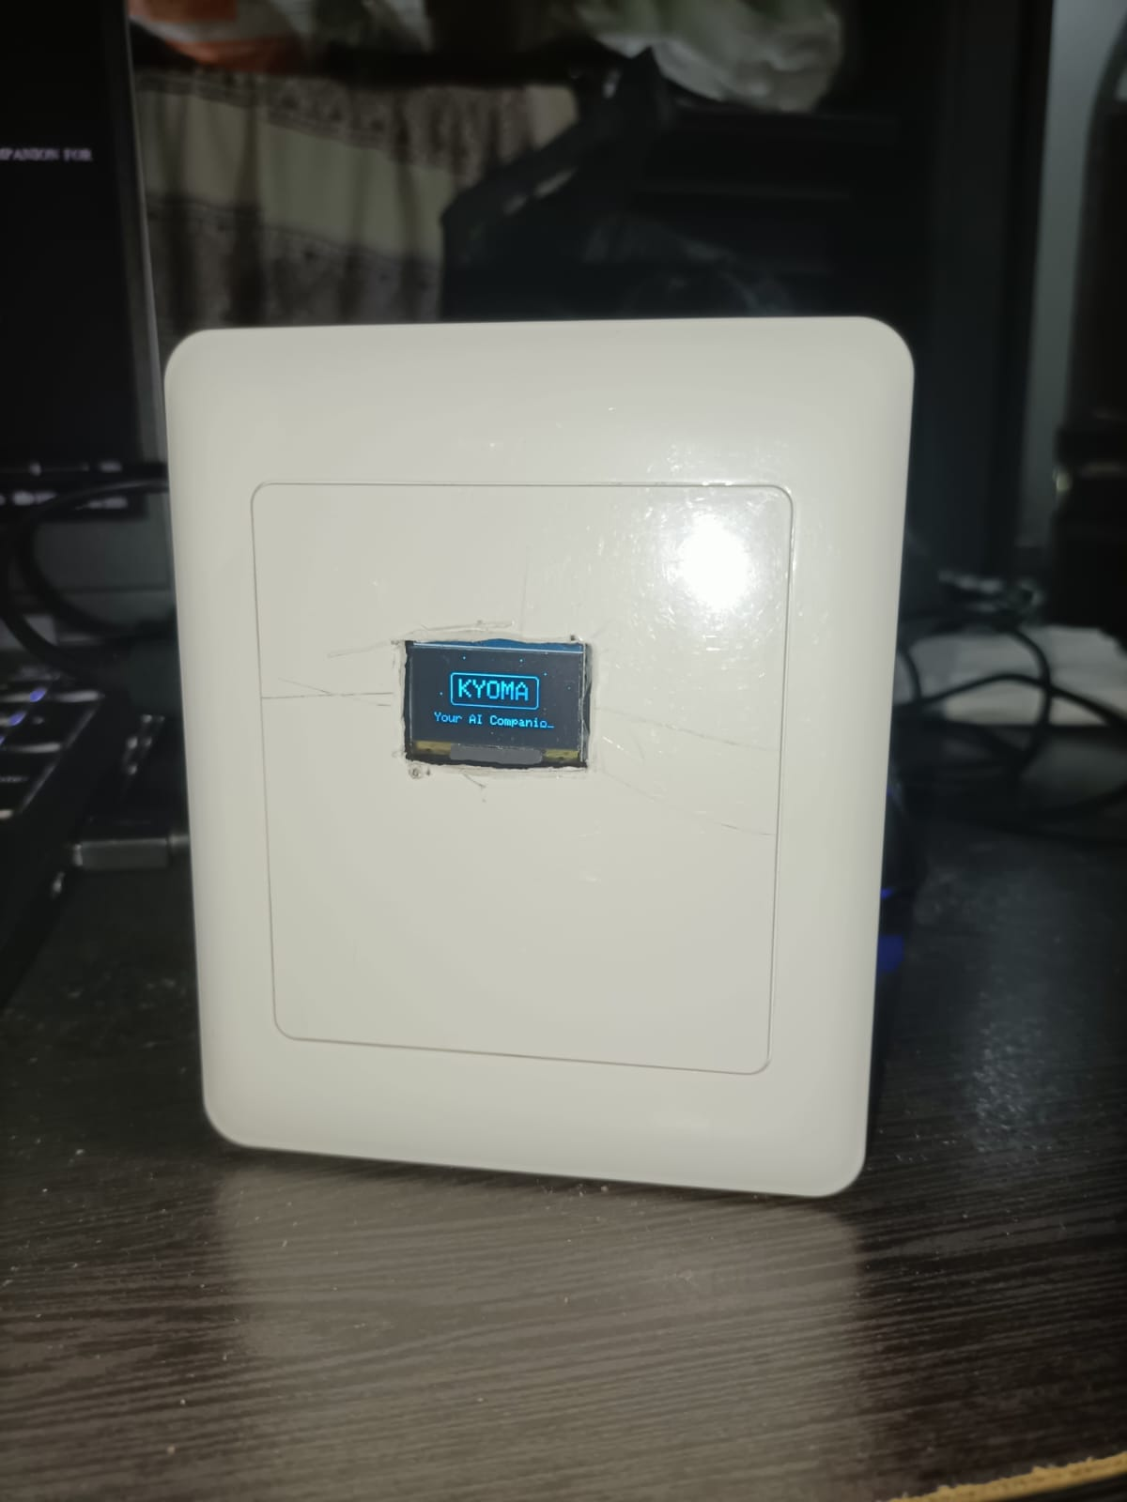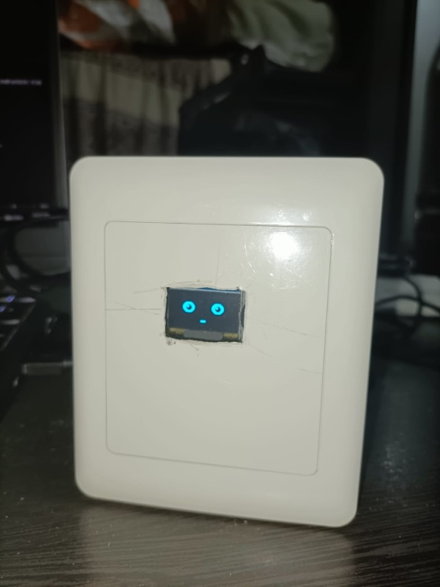
KYOMA: A LOCAL AI-ENABLED INTERACTIVE DESKTOP COMPANION FOR INTELLIGENT COMPUTER AUTOMATION

Date :
Signature :
Name : Saveetha Institute of Medical and Technical Sciences

KYOMA: A LOCAL AI-ENABLED INTERACTIVE DESKTOP COMPANION FOR INTELLIGENT COMPUTER AUTOMATION
Data
CLAIM

WE CLAIM
- 1. A local AI-enabled interactive desktop companion system comprising a computing device, a local AI processing engine executing on the computing device, a computer automation subsystem, and a physical embedded companion device communicatively coupled to the computing device, the physical companion device comprising an embedded microcontroller, an audio input interface, an audio output interface, a speaker and a visual display, wherein the local AI processing engine is configured to process a natural-language user command, identify an intended computer operation, select an associated automation function, cause the computer automation subsystem to perform the computer operation, and communicate an interaction or execution state to the physical companion device for providing corresponding visual and/or audio feedback.
- 2. The system as claimed in claim 1, wherein the physical companion device comprises an ESP32 or ESP32-S3 microcontroller, an OLED visual display, an I2S MEMS microphone, and an audio amplifier coupled to the speaker.
- 3. The system as claimed in claim 1, wherein the physical companion device is configured to change a visual interaction state on the display and/or provide audio feedback according to a processing state or execution result received from the local AI engine, including listening, processing, executing, speaking, successful completion and error states.
- 4. The system as claimed in claim 1, wherein the local AI processing engine converts the natural-language user command into a structured tool or function request comprising an identified operation and associated parameters, and provides the structured request to the computer automation subsystem for execution.
- 5. The system as claimed in claim 1, wherein the local AI processing engine performs natural-language processing, intent detection and tool/function selection on the computing device, and supported computer automation operations are performed without requiring remote cloud-based AI inference.

Date :
Signature :
Name : Saveetha Institute of Medical and Technical Sciences

FORM 18  THE PATENTS ACT1970  (39 of1970)  &  THE PATENTS RULES, 2003  REQUEST/EXPRESSREQUESTFOR EXAMINATION OF APPLICATION FOR PATENT  [See SECTION 11B and rule 20(4) (ii), 24B(1)(i)] | (FOR OFFICE USE ONLY)
 |  | RQ No.
 |  | Filing date:
 |  | Amount of Fee paid:
 |  | CBR No:
 |  | Signature:
APPLICANT(S)/OTHER INTERESTED PERSON
2. I/Wehereby request thatmy/our application for patent no ----- filed on --- for the invention titled KYOMA: A LOCAL AI-ENABLED INTERACTIVE DESKTOP COMPANION FOR INTELLIGENT COMPUTER AUTOMATION sections 12 and 13 ofthe Act.
or
. I/We ---------hereby requestthat my/our application for patent no.-------filed on---------for ------------the---------invention titled basedon PatentCooperation Treaty (PCT) application no………………..…. dated…………………..made incountry ………..shall beexamined under sections 12 and 13 of the Act, immediately without waiting for the expiry of 31 months as specified in rule 20(4)(ii).
3. I/We the interested person request for the examination of the application no..------- dated --------filed by the applicant --------titled----------- -shall be examined under sections 12 and 13 of the Act.
As an evidence of my/our interest in the application for patent following documents are submitted.
----------------------------------------------------------------------------------------------
ADDRESS FOR SERVICE
Saveetha Institute Of Medica lAnd Technical Sciences Saveetha Nagar,
Thandalam, Chennai - 602 105,TamilNadu,India.
Dated this
To
The Controller of Patents
The Patent Office at Chennai
`
To be signed by the applicant(s) or by his/ their authorized registered patent agent

