Week 6 — AI Agent Integration with Google Antigravity IDE

Team Members: Harsha Sri Neeriganti, Sayush Maharjan
Project: WeatherTwin AI

Summary
The objective of this phase was to extend the WeatherTwin capstone project by integrating an AI agent layer using the Google Antigravity IDE. This transformation upgrades the existing weather dashboard into an intelligent decision-support application capable of autonomous reasoning, tool selection, and multi-step workflow execution.
Agent Tools Implementation
The following tools were developed in agent/tools.py to provide the agent with functional capabilities. All tools follow a standardized JSON response format for seamless LLM processing.
# | Tool | Functionality
1 | get_current_weather | Fetches real-time weather via WeatherAPI.
2 | get_weather_forecast | Returns hourly forecasts for a specified duration (N hours).
3 | get_historical_analysis | Performs statistical analysis on local CSV datasets.
4 | predict_weather_bert | Provides BERT-based classification for weather conditions.
5 | compare_cities | Conducts side-by-side weather comparisons between two locations.

Technical Specifications
Agent Runner:
- Pattern: ReAct (Reason + Act).
- LLM: Groq API — llama-3.3-70b-versatile.
- Constraints: Maximum of 5 steps per query to ensure efficiency.
- Output: Generates a final answer accompanied by a detailed "Reasoning Trace" (Thought → Action → Observation).
Application Modes:
The Streamlit interface supports two distinct operational modes:
- BERT Forecast Mode: Direct BERT classification on historical data without agent intervention.
- Live Weather Mode: Full agent activation with multi-step tool usage and visible reasoning traces.

User Interface & Experience
The integrated dashboard features several key UI components designed for clarity and interactivity:
- Chat Interface: Clean user/AI bubble dialogue.
- Agent Trace Expander: A transparency feature allowing users to view the AI's step-by-step logic.
- Quick Action Chips: Pre-set queries for common activities (e.g., Beach Day, Hiking Trip, Ski Conditions).
- Visualisations: Interactive weather maps with city markers and a 12-hour forecast dock.
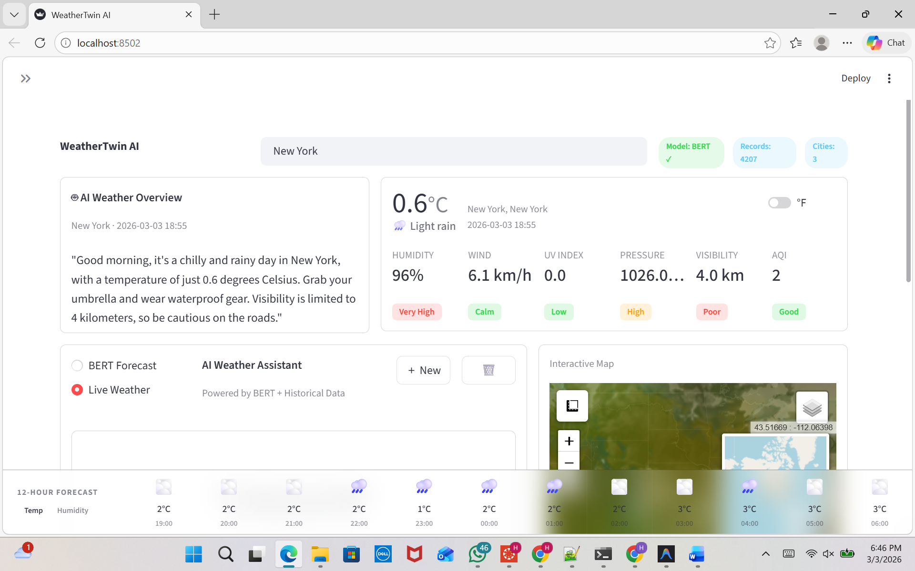

Interaction Analysis
The following logs demonstrate the agent's ability to handle varying levels of query complexity:
Multi-Step Reasoning (Activity Recommendation):
- Query: "Can I go hiking in San Francisco this weekend?"
- Tools Used: get_current_weather, predict_weather_bert.
- Outcome: The agent identified a "Negative" weather prediction (90.8% confidence) and advised the user to postpone the trip based on data rather than just current conditions.
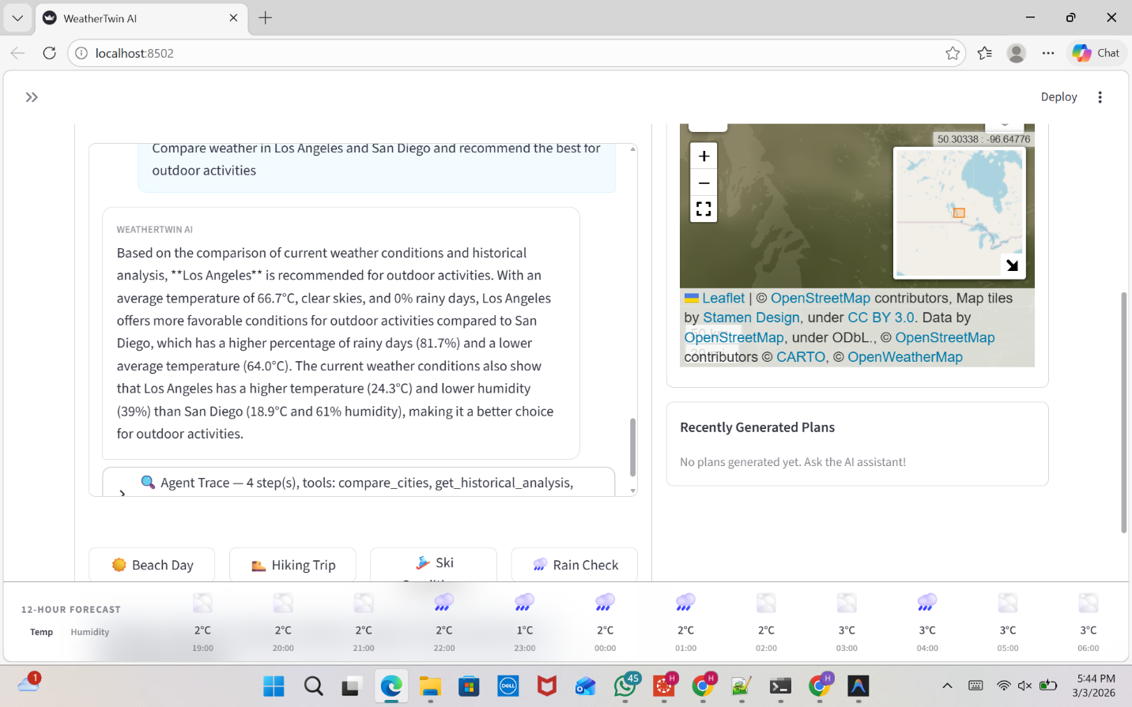

Complex Comparison:
- Query: Comparing LA vs. San Diego for outdoor activities.
- Tools Used: compare_cities (triggering 4 nested tool calls).
- Outcome: Provided a data-driven recommendation for Los Angeles based on a significantly lower percentage of rainy days compared to San Diego's historical data (81.7%).

7. Evaluation & Performance
Scenario | Complexity | Response Time | Quality Assessment
Current Weather | Simple | ~3s | Accurate; real-time.
Recommendations | Medium | ~5s | Contextual; data-grounded.
Multi-City Comparison | Complex | ~6s | Comprehensive; high utility.

Strengths:
- Grounds answers in real-time data from WeatherAPI.
- The Reasoning Trace serves as a built-in debugging and trust-building tool.
- Modular tool design allows for easy addition of new features.
Limitations & Future Work:
- Model Refinement: The BERT model currently uses a sentiment-based classifier; moving to weather-specific labels would improve nuance.
- Data Expansion: Historical data is currently limited to three California cities.
- Units: Occasional inconsistency in temperature units (°F vs °C).
- Optimization: Implementing caching for intermediate tool results to reduce API latency.
Setup & Technology Stack
- Frontend: Streamlit, Folium (Maps), Plotly.
- AI/ML: Groq (Llama 3.3), BERT (distilbert-base-uncased).
- Data Sources: WeatherAPI.com, OpenWeatherMap, Local CSVs.

Github link: https://github.com/Harsha-Sri24/DataScienceCapstone/tree/main/Week-6
Demo Video link: https://drive.google.com/file/d/1ZIxZJZBqhN9NKkUsSSOrXI8CdceK8EMX/view?usp=sharing

