CS 5577- INTERNET OF THINGS
MINI-PROJECT 4: Secure IoT Monitoring System with ESP32 and Web Dashboard

GROUP 5:
Thanmai Gottumukkala
Harsha Sri Neeriganti
Vijaya Lakshmi Atluri
1.Project Overview:
This mini project is about creating a secure IoT system to monitor temperature and humidity using an ESP32 with a DHT11 sensor. The ESP32 collects sensor readings, encrypts them, and sends the data to a web server every 10 seconds. The server stores this encrypted information in a database and displays it on a web dashboard, showing real-time readings through dynamic graphs. Users can also search for past data based on specific thresholds, but access to the dashboard requires secure login with hashed passwords. Overall, the system focuses on security, real-time monitoring, and user authentication, with an optional feature to show local weather information from an external API.

2. Environmental Setup:
1. ESP32 Side
- IDE: Arduino IDE or PlatformIO.
- Libraries:
  - DHT sensor library – to read temperature and humidity from DHT11.
  - WiFi.h – to connect ESP32 to Wi-Fi.
  - HTTPClient.h – for HTTP POST requests to the server.
  - AESLib.h – for AES encryption of sensor data.
2. Web Server Side (Python Flask)
- Python Version: 3.9+ recommended.
- Frameworks & Libraries:
  - Flask – lightweight web framework.
  - Flask-Session – for session management (login state).
  - Werkzeug – for password hashing (generate_password_hash, check_password_hash).
  - sqlite3 or SQLAlchemy – for database management.
  - pycryptodome – for AES encryption/decryption.
  - requests – optional, for API calls to external weather services.
  - flask-cors – optional, if dashboard and API are on different origins.
3. Frontend / Dashboard
- Libraries & Tools:
  - Chart.js – for dynamic graphs.
  - Bootstrap 5 – for styling and responsive layout.
  - jQuery or vanilla JS – for AJAX calls to fetch real-time data.
4. Database
- SQLite – simple embedded database.
- Tables:
  - users – stores hashed usernames and passwords.
  - sensor_data – stores encrypted temperature, humidity, and timestamps.

3. Requirements:
ESP32 Overview:
The ESP32 serves as the client in this system, continuously collecting temperature and humidity data from the DHT11 sensor. After connecting to Wi-Fi, it takes the sensor readings, encrypts them using AES-128, and sends the secured data to the web server every 10 seconds via HTTP POST. This process ensures that the data is protected during transmission.
On the Arduino Serial Monitor screenshot below , you can observe the ESP32 showing the Wi-Fi connection, the live sensor readings, the encrypted values, and messages confirming successful delivery to the server
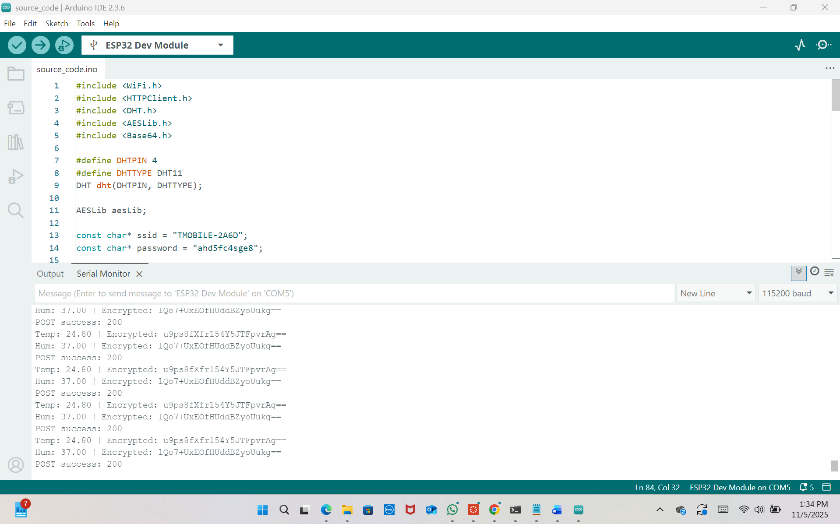

Backend Overview:
The backend acts as the control center of the system, tasked with receiving, processing, and storing data transmitted by the ESP32. Developed using Python Flask, it manages incoming requests, handles the database, and supports the user dashboard.
Receiving Data
The server is set up to listen for HTTP POST requests from the ESP32 at the /api/upload endpoint. Each incoming request carries encrypted temperature and humidity data, accompanied by a timestamp. The backend decrypts this information using the same AES key utilized by the ESP32, ensuring secure communication between the two devices.
Storing Data
After decryption, the readings are saved in a SQLite database. Each record includes temperature, humidity, and the time the data was recorded. This setup enables users to access historical data for analysis or visualization whenever required.

User Authentication
Additionally, the backend oversees a secure login feature for the dashboard. User credentials are securely hashed using generate_password_hash and validated with check_password_hash. Active sessions are managed through Flask sessions to ensure that only authorized users can access the dashboard.
Serving the Dashboard
The server delivers data to the frontend for real-time visualization and historical searches. It responds to AJAX requests from the dashboard, providing the latest 20 readings to keep the graphs actively updated.
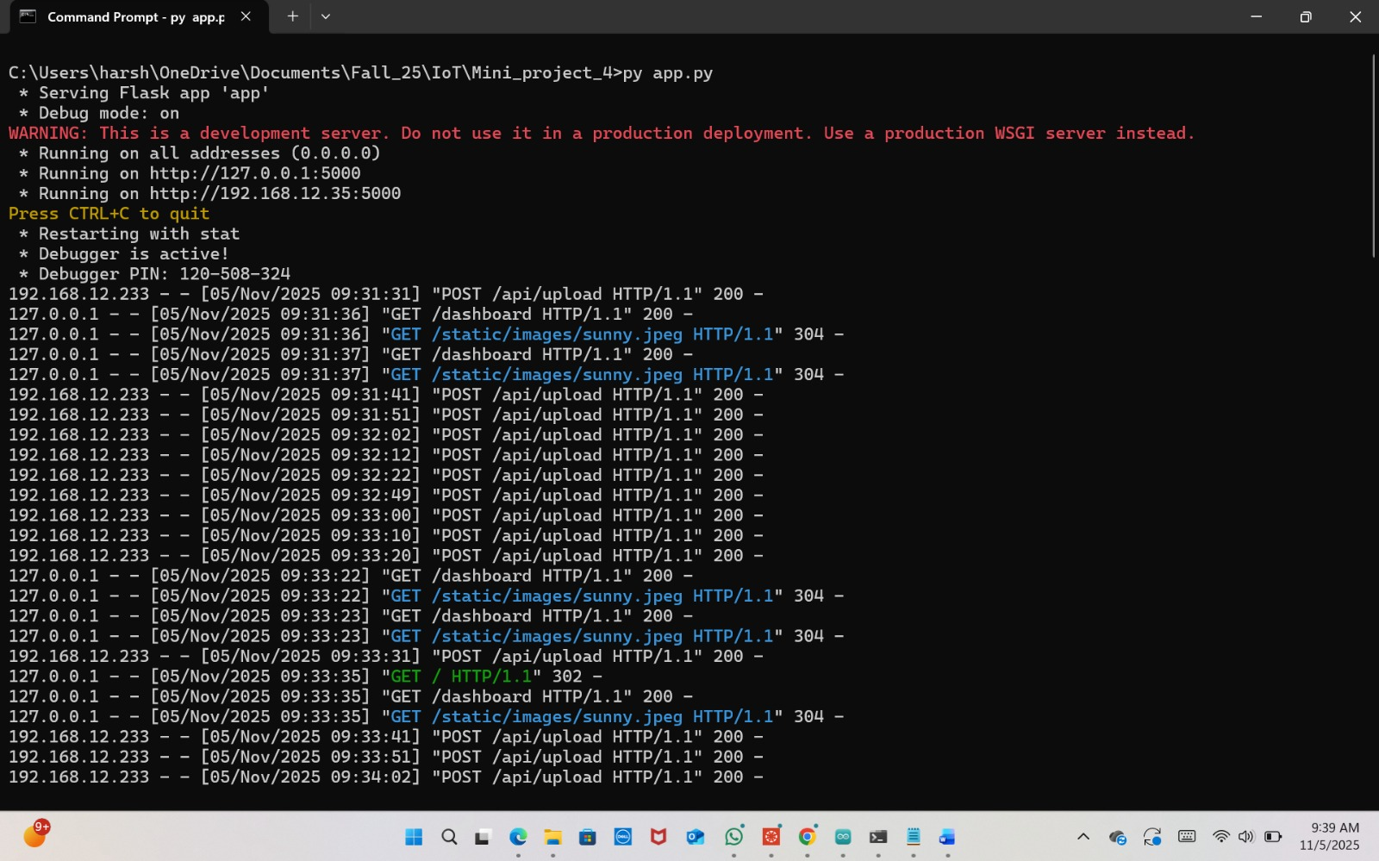

Authentication Pages (Login, Registration, and Password Recovery):
This project features user-friendly and visually attractive authentication pages designed with HTML, Bootstrap, and Flask templates to facilitate login, registration, and password recovery processes.
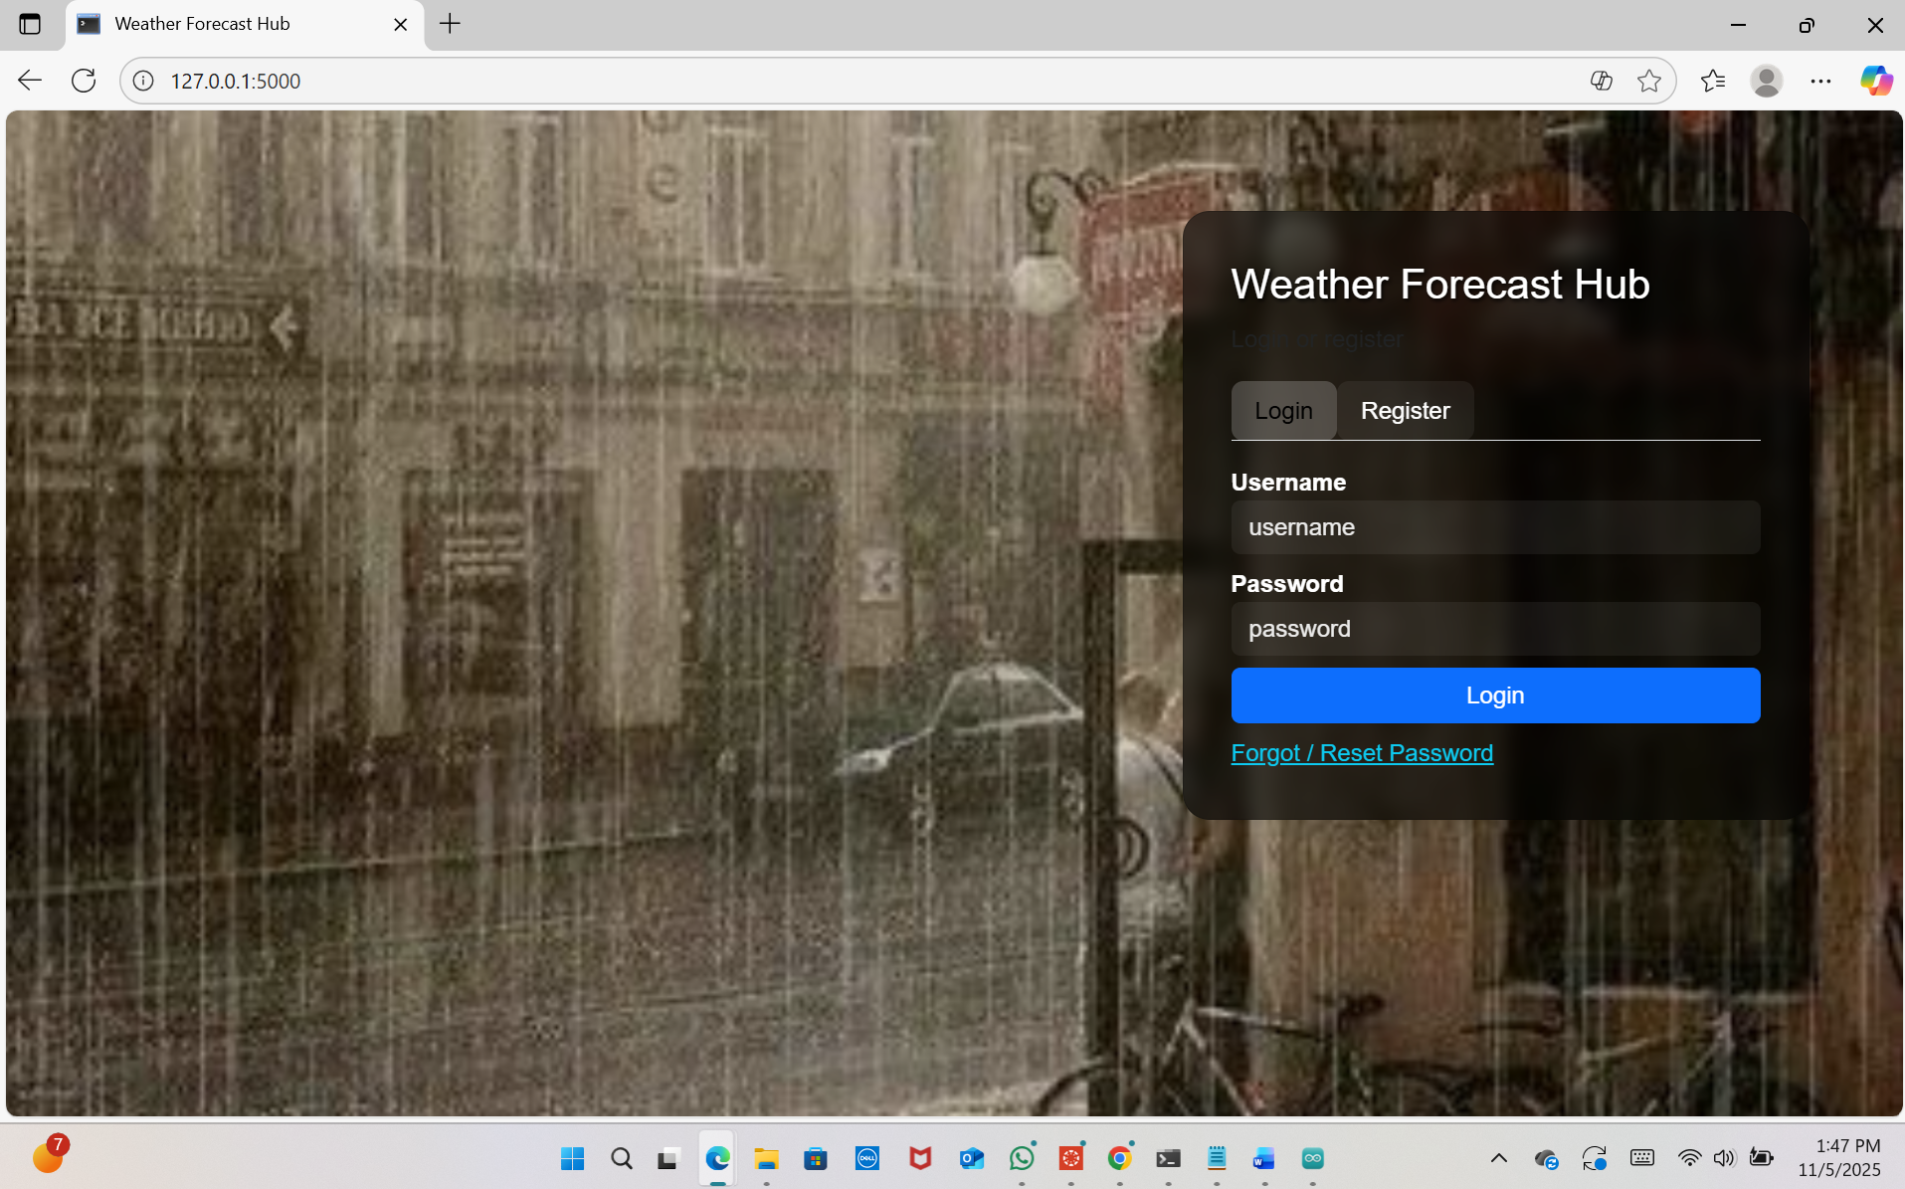

Login & Registration (auth.html)
Users can effortlessly toggle between the login and registration sections on a single page.
Registration: New users can sign up by entering a username, password, confirming it, and selecting a security question along with an answer.
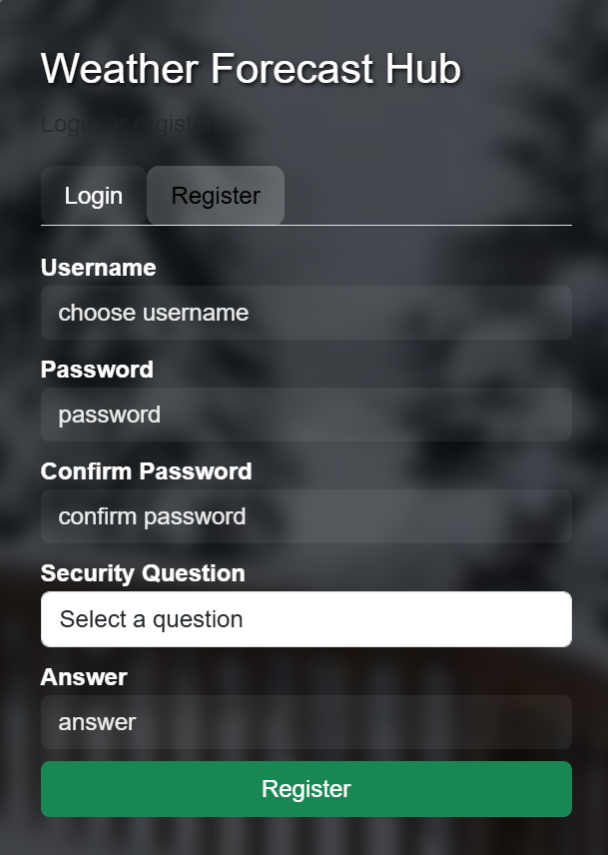
Login: Users input their username and password to gain access to the dashboard. A useful “Forgot/Reset Password” link is available for account recovery.
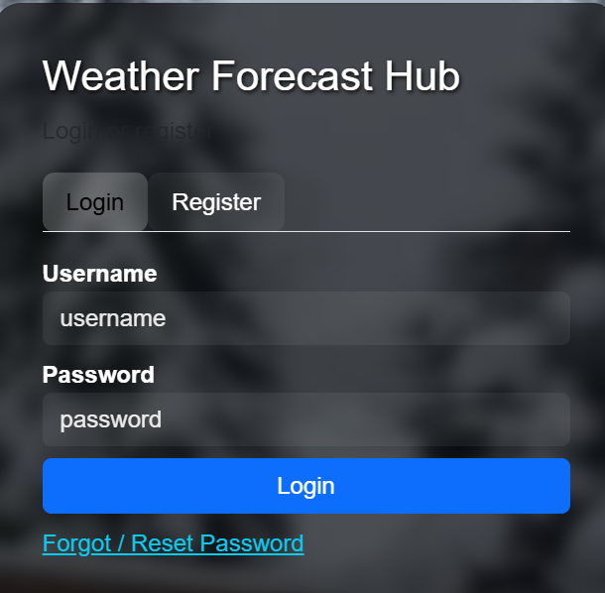
The input fields are presented in a contemporary, semi-transparent card that overlays dynamic background images showcasing various weather conditions such as sunny, rainy, or snowy. Flash messages inform users about successful registrations, login mistakes, or validation problems, ensuring a fluid user experience.
Forgot / Reset Password (forgot.html)
For those who forget their password, this page enables identity verification by asking them to enter their username, choose their security question, and provide the correct answer. After verification, users can create a new password and confirm it. This page maintains a consistent design with dynamic weather backgrounds and a semi-transparent card, ensuring a cohesive experience. A link to return to the login page allows users to easily navigate back.
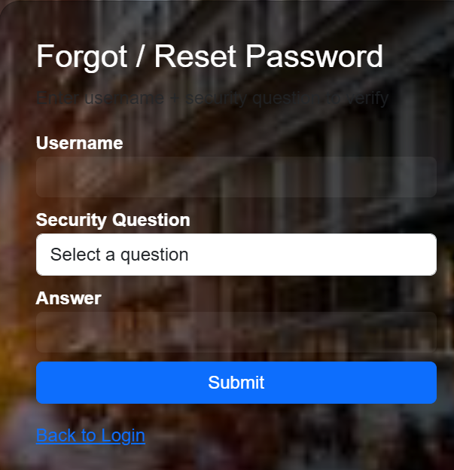
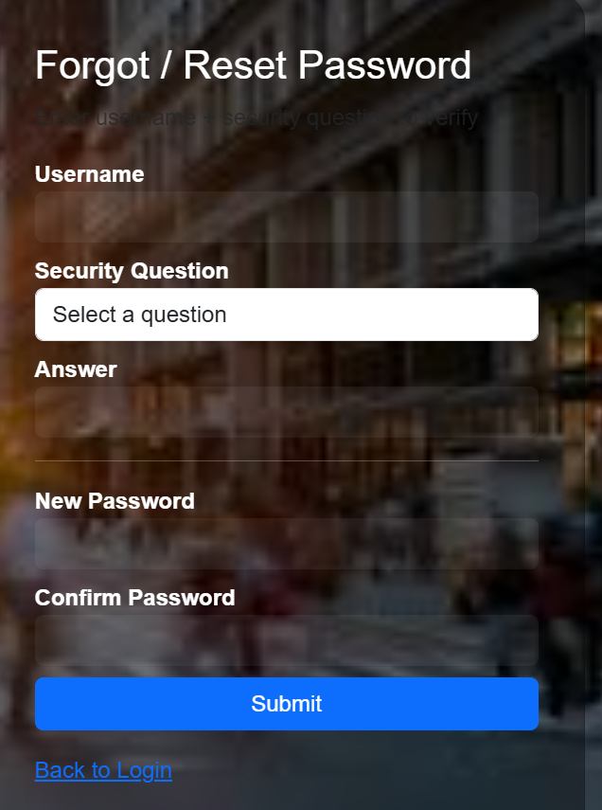

Dashboard / Frontend Overview:
The dashboard is the user-facing interface where users can monitor real-time temperature and humidity data collected by the ESP32. Built with HTML, Bootstrap, JavaScript, and Chart.js, it provides a clean and interactive experience.
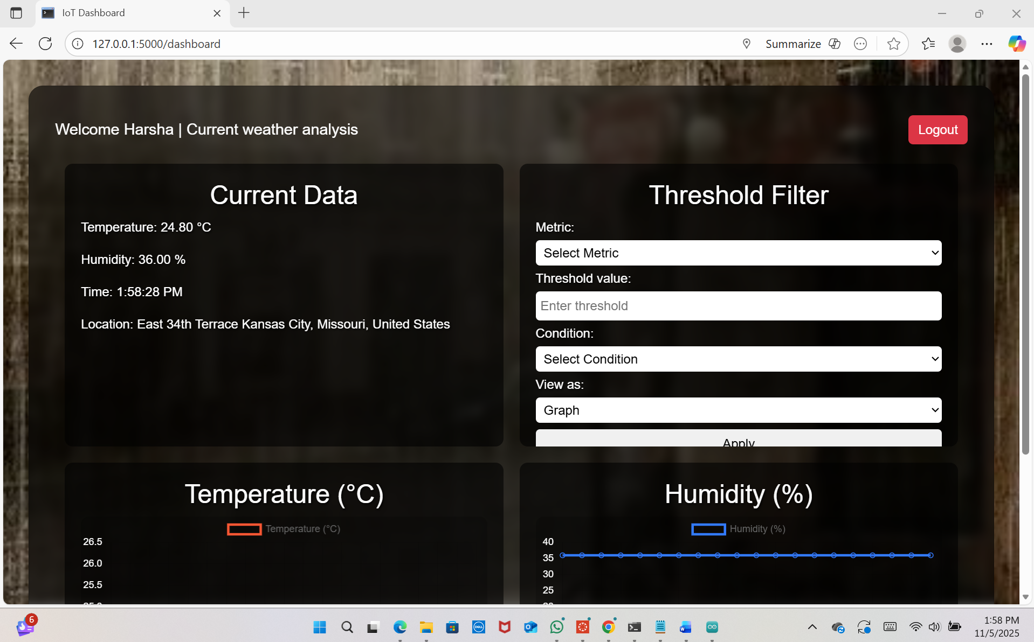
Personalized Welcome Message
After logging in, the dashboard greets the user with a “Welcome, [username]” message at the top of the page. This small addition improves the user experience by making the interface feel more personal and interactive. It also confirms that the user is successfully authenticated and their session is active.
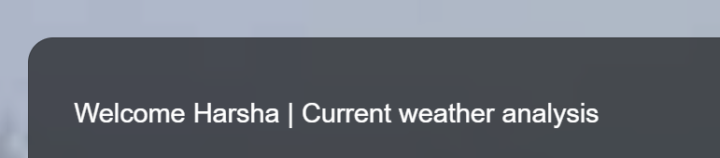
Real-Time Data Display
The latest temperature, humidity, current time and location readings are shown prominently on the dashboard.
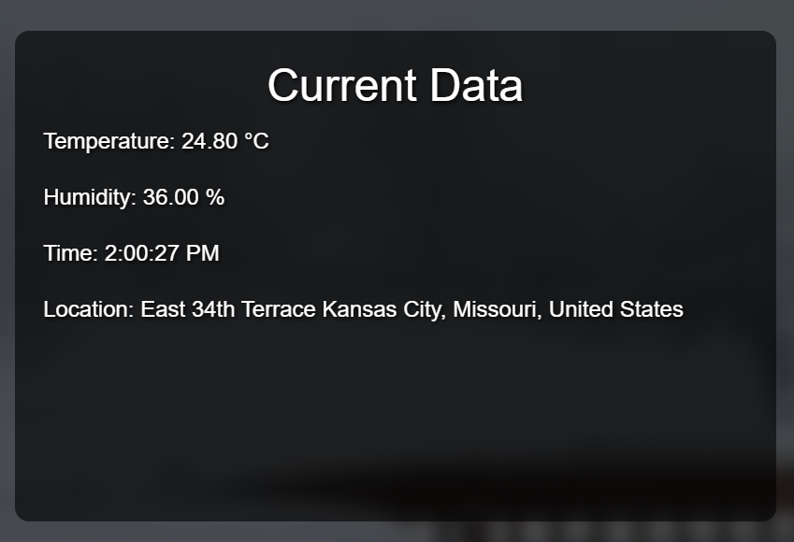
These values update every 10 seconds, matching the ESP32’s data transmission schedule, so users always see the most current information.

Dynamic Graphs
Temperature and humidity trends are displayed using line charts that dynamically update with the latest 20 readings.
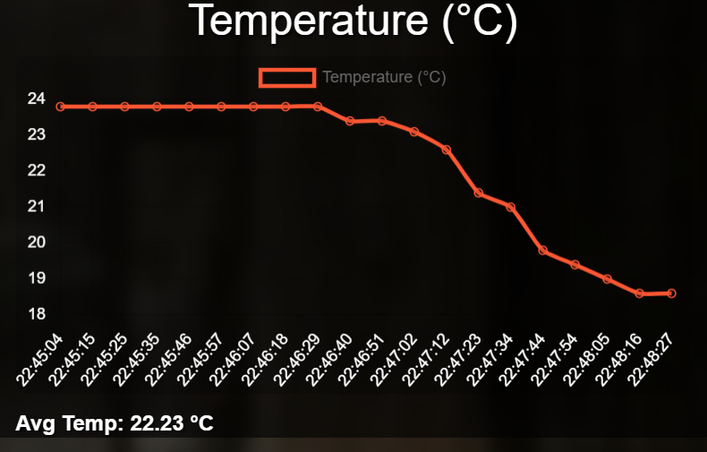
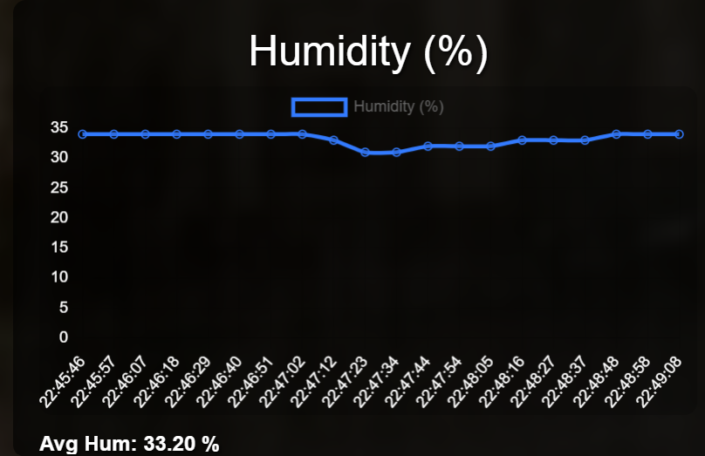

Users can visualize patterns and changes over time without manually refreshing the page and also avg of the 20 metrics readings are also being displayed

Search & Filter Functionality
Users can search historical data based on threshold values (e.g., temperatures above 30°C).
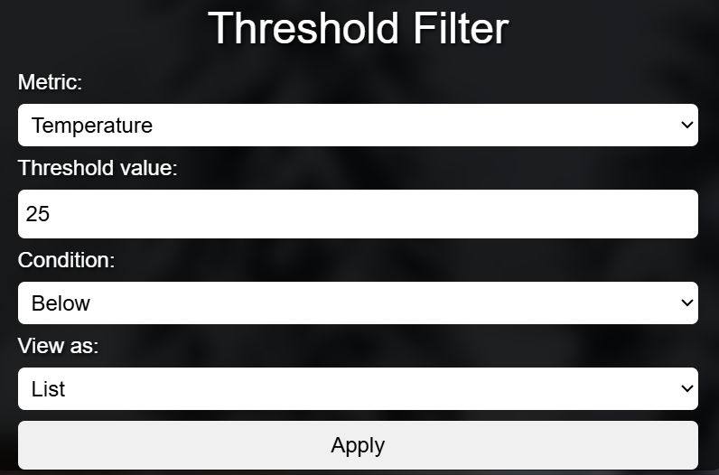
Both list and chart views update according to the search criteria, allowing easy analysis of past readings.

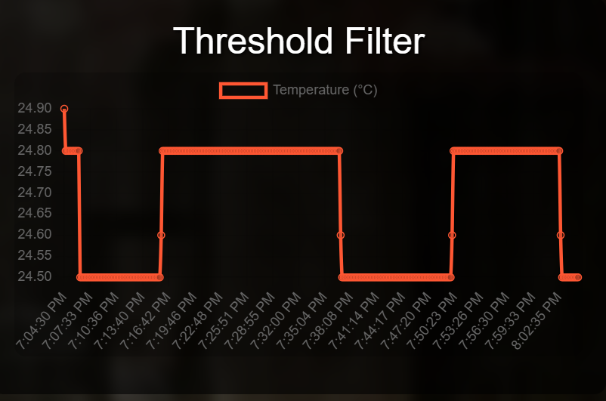

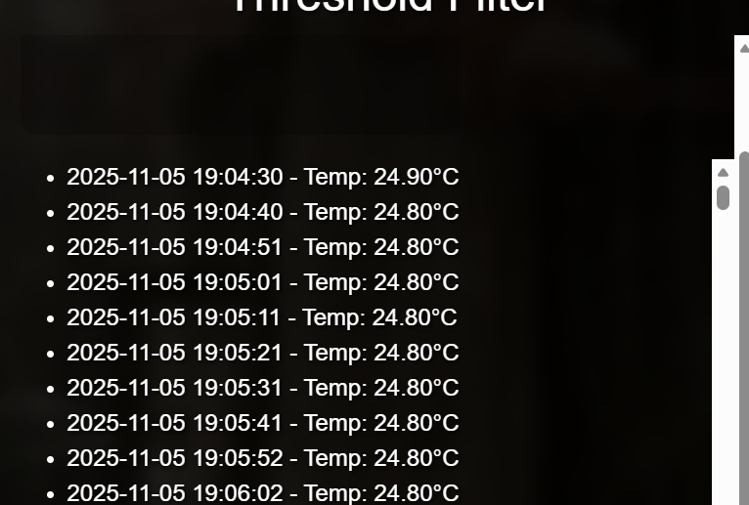

Logout and Navigation
A logout button ensures users can securely end their session.
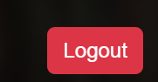
The interface is designed to be intuitive, with clear labels, input fields, and responsive design for different devices.
Extra Credit:
- Registered at WeatherAPI.com and got an API key.

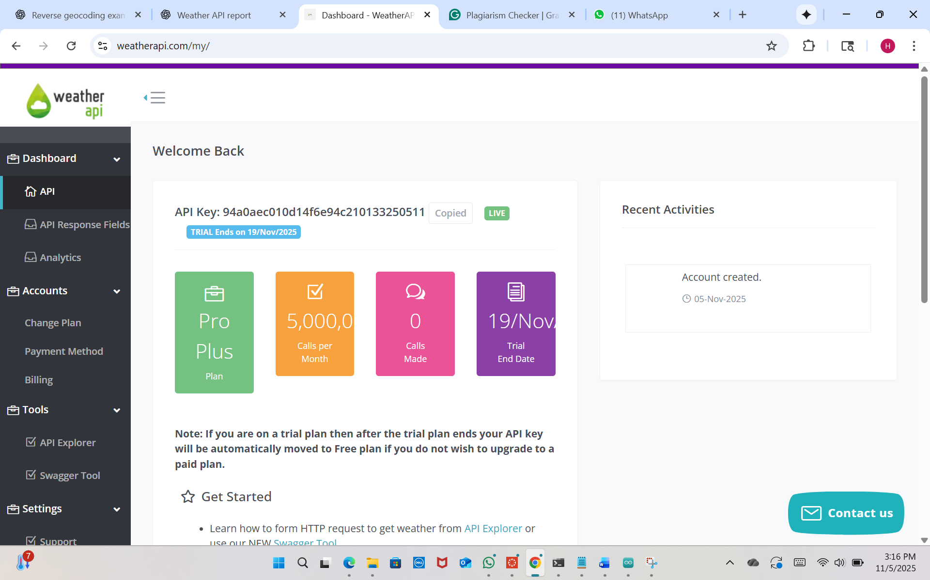
- Created a backend /api/weather to fetch weather securely (API key hidden).
- Proxy accepts city or coordinates and returns current weather.
- Added 10-minute caching to reduce API calls.
- Frontend shows a small card with temperature, humidity, condition/icon, location, and updated time.
Result: Live, secure, and easy-to-read weather display on the webpage
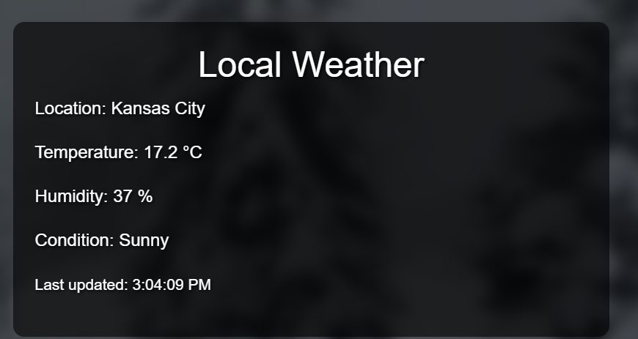
Challenges Faced
While developing this IoT monitoring system, we faced a few key challenges:
- Encryption Issues – Making sure the ESP32’s AES encryption matched the server’s decryption was tricky at first and required careful debugging to fix errors.
- Real-Time Dashboard Updates – Updating charts smoothly without refreshing the whole page was challenging and needed proper AJAX polling to show the latest 20 readings.
- Secure Authentication – Implementing hashed passwords, sessions, and a “Forgot Password” feature securely took extra effort to ensure only authorized users could access the dashboard.
- ESP32 Connectivity – Wi-Fi drops sometimes caused data not to reach the server. Adding retries and confirmations on the Serial Monitor helped.
- User-Friendly Design – Creating a clean, responsive dashboard with dynamic charts, search, and optional weather info required careful integration.
Despite these challenges, the system now works reliably, showing real-time readings, storing data securely, and providing a smooth, interactive user experience.

Future Work:
In the future, this system can be improved by adding multiple ESP32 sensors to monitor different locations, switching to cloud storage for larger datasets and remote access, and including advanced analytics like trend predictions or alerts. The dashboard could be made more mobile-friendly, and security could be enhanced with two-factor authentication or JWT tokens. Additionally, email or push notifications could alert users when reading exceeds limits, and the weather feature could be expanded using multiple APIs for richer information. These upgrades would make the system more scalable, secure, and user-friendly.

Conclusion:
This project successfully created a secure IoT system for monitoring temperature and humidity using an ESP32 and DHT11 sensor. The ESP32 encrypts data and sends it to a Flask-based web server, which stores it securely and provides a real-time dashboard with dynamic graphs and search functionality. The system also includes secure user authentication with login, registration, and password recovery, ensuring only authorized users can access the data. Users can view the latest readings, track trends, and filter historical data, while an optional weather API adds extra context. Overall, the project demonstrates real-time monitoring, data security, and a user-friendly interface, while laying a solid foundation for future improvements such as multiple sensors, cloud storage, alerts, and mobile-friendly dashboards.

