

**The Project Report On**

Automation Testing Using TestNG DemoTour Website

**Presented By**

**Miss Harsha Tayde**

**(Batch-EBEON1021465089)**

**Under the Guidance of**

## Mrs Priyanka Desle Mam

**(Technical Trainer at Edubrigde)**

**INTRODUCTION TO PROJECT**

This Project aims to do overall testing like functional testing, GUI testing on website to check quality of application. It helps to improve quality of website and saves time for manually doing this testing. In this project our main focus is to check functionalities available on website. Also it includes title check and all links count with their working status.

This is Automation Testing Project using TestNG framework in the project I worked different module using Selenium WebDriver ,it is complete automation testing of each module .also in this project I used different annotation .The Demoguru99 is open source testing site used for different purpose of testing ,using Java I created the source code.

#### Software Requirements

Operating System :- Window 10

Browser:- Latest version of Google Chrome IDE :- Eclipse IDE

Front-end:- Java & TestNG

## TC1-: To launch the browser

System.*setProperty*("webdriver.chrome.driver", "C:\\Users\\Darshu\\Desktop\\New folder\\chromedriverupdate.exe");

w= **new** ChromeDriver();

Tc2-:Open the url

w.get("http://demo.guru99.com/test/newtours/index.php");

w.manage().window().maximize();

Tc3-Click on register button and do registration

w.findElement(By.*linkText*("REGISTER")).click();

//TC-4. Fill Register form and click on sumbit button

w.findElement(By.*name*("firstName")).sendKeys("Harsha");

w.findElement(By.*name*("lastName")).sendKeys("Tayde");

w.findElement(By.*name*("phone")).sendKeys("8806789238");

w.findElement(By.*name*("userName")).sendKeys("harsha@27");

w.findElement(By.*name*("address1")).sendKeys("Shiv nagar");

w.findElement(By.*name*("city")).sendKeys("Telhara");

w.findElement(By.*name*("state")).sendKeys("Maharashtra");

w.findElement(By.*name*("postalCode")).sendKeys("444108");

//for drop down

Select s =**new** Select(w.findElement(By.*name*("country")));

// s.selectByValue("BAHAMAS");

//or

s.selectByIndex(15);

//or

//s.selectByVisibleText("BAHAMAS");

w.findElement(By.*name*("email")).sendKeys("harsha@27");

w.findElement(By.*name*("password")).sendKeys("12345678");

w.findElement(By.*name*("confirmPassword")).sendKeys("12345678");

w.findElement(By.*name*("submit")).click();

System.***out***.println("Registraion successfully now you can login");

w.close();

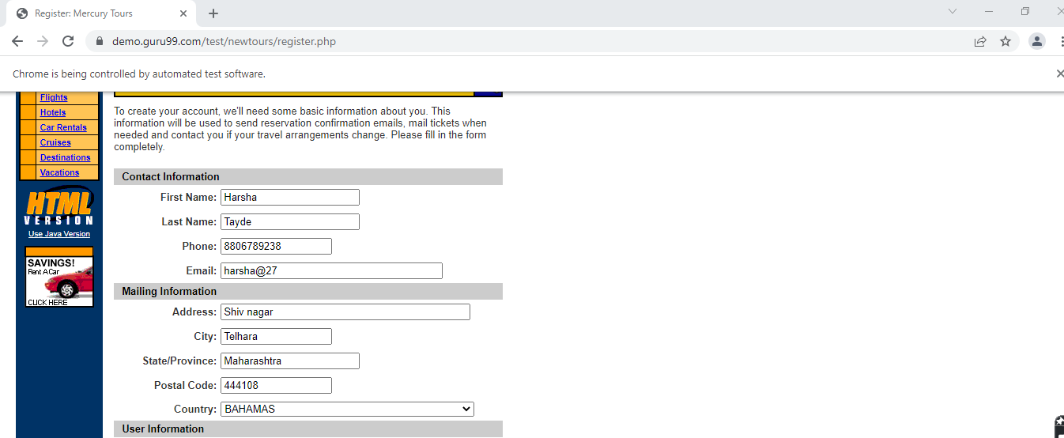

Output

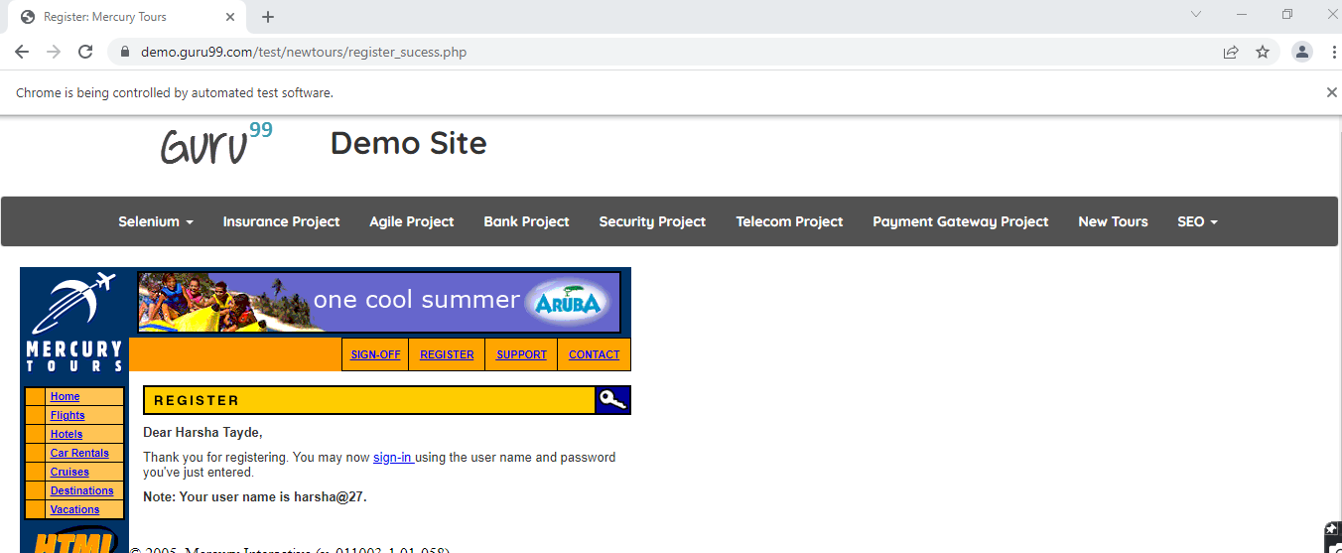

Tc4-Login with valid credential

w.findElement(By.*name*("userName")).sendKeys("harsha@27");

//7.Enter Valid password

w.findElement(By.*name*("password")).sendKeys("12345678");

//8.Click on submit button

w.findElement(By.*name*("submit")).click();

System.***out***.println("Login Successfully");

w.close();

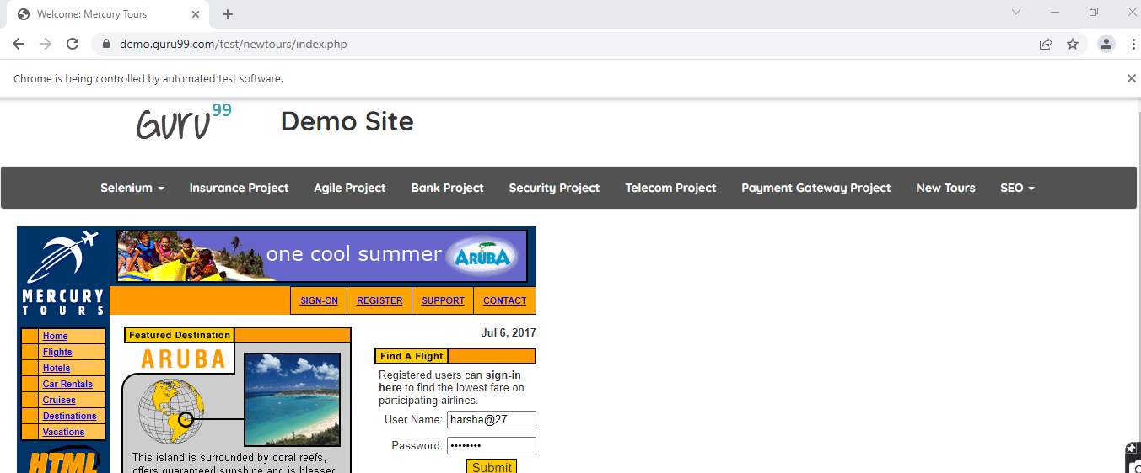

Output

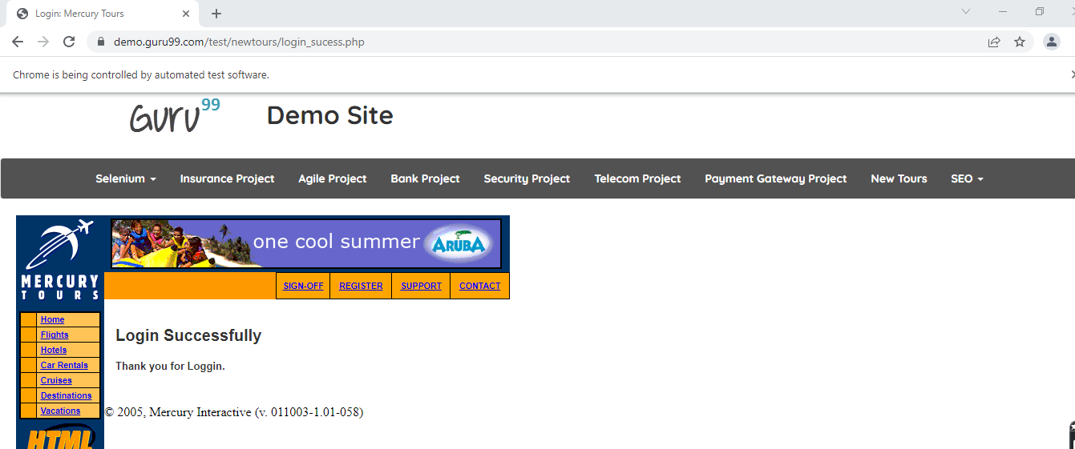

Tc5-Register on insurance module

//click on register

w.findElement(By.*xpath*("/html/body/div[3]/a")).click();

//title

Select t=**new** Select( w.findElement(By.*id*("user_title")));

t.selectByValue("Miss");

//first name

w.findElement(By.*id*("user_firstname")).sendKeys("Neha");

//sirname

w.findElement(By.*id*("user_surname")).sendKeys("rathi");

//userphone

w.findElement(By.*id*("user_phone")).sendKeys("9876546789");

//for year

Select t1=**new** Select(w.findElement(By.*id*("user_dateofbirth_1i")));

t1.selectByValue("1941");

//for month

Select t2=**new** Select(w.findElement(By.*id*("user_dateofbirth_2i")));

t2.selectByValue("11");

//for date

Select t3=**new** Select(w.findElement(By.*id*("user_dateofbirth_3i")));

t3.selectByValue("20");

//radio button

w.findElement(By.*id*("licencetype_f")).click();

//licence period

Select t4=**new** Select(w.findElement(By.*id*("user_licenceperiod")));

t4.selectByValue("3");

//occuption

Select t5=**new** Select(w.findElement(By.*id*("user_occupation_id")));

t5.selectByValue("12");

//address streat

w.findElement(By.*id*("user_address_attributes_street")).sendKeys("Ram Nagar Thane");

//city

w.findElement(By.*id*("user_address_attributes_city")).sendKeys("Thane");

//country

w.findElement(By.*id*("user_address_attributes_county")).sendKeys("India");

//Postel Code

w.findElement(By.*id*("user_address_attributes_postcode")).sendKeys("444238");

//email

w.findElement(By.*id*("user_user_detail_attributes_email")).sendKeys("harshatayde27@gmail.com");

//password

w.findElement(By.*id*("user_user_detail_attributes_password")).sendKeys("271197");

//confirmpassword

w.findElement(By.*id*("user_user_detail_attributes_password_confirmation")).sendKeys("271197");

//click on submit

w.findElement(By.*name*("submit")).click();

Tc5-Login with registered mail-Id and password on insurance module

w.findElement(By.*id*("email")).sendKeys("harshatayde27@gmail.com");

w.findElement(By.*id*("password")).sendKeys("271197");

w.findElement(By.*name*("submit")).click();

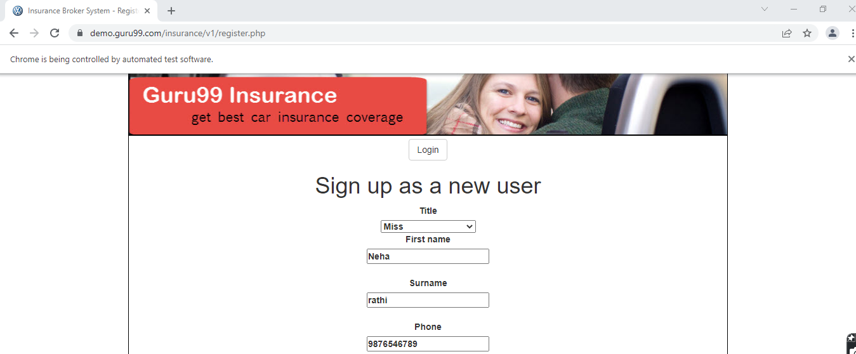

Output

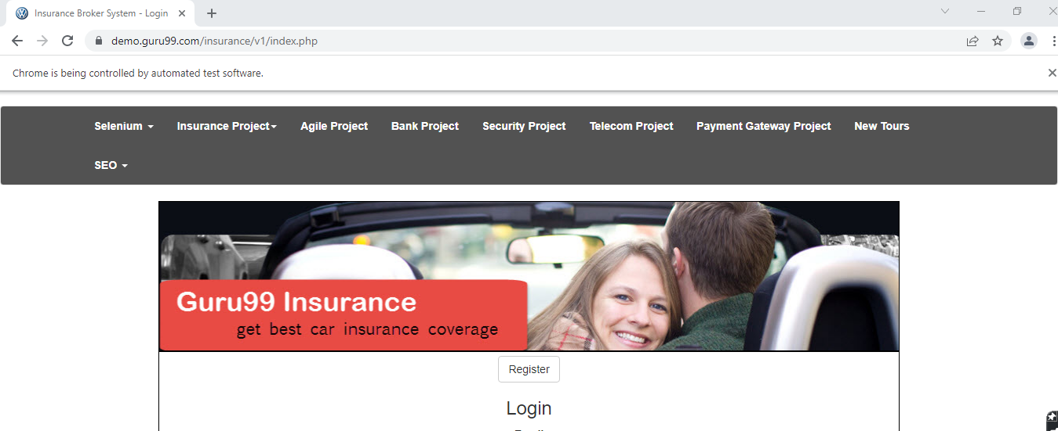

Tc6- After login with registered mail-Id and password logout on insurance module

w.findElement(By.*xpath*("/html/body/div[3]/form/input")).click();

w.close();

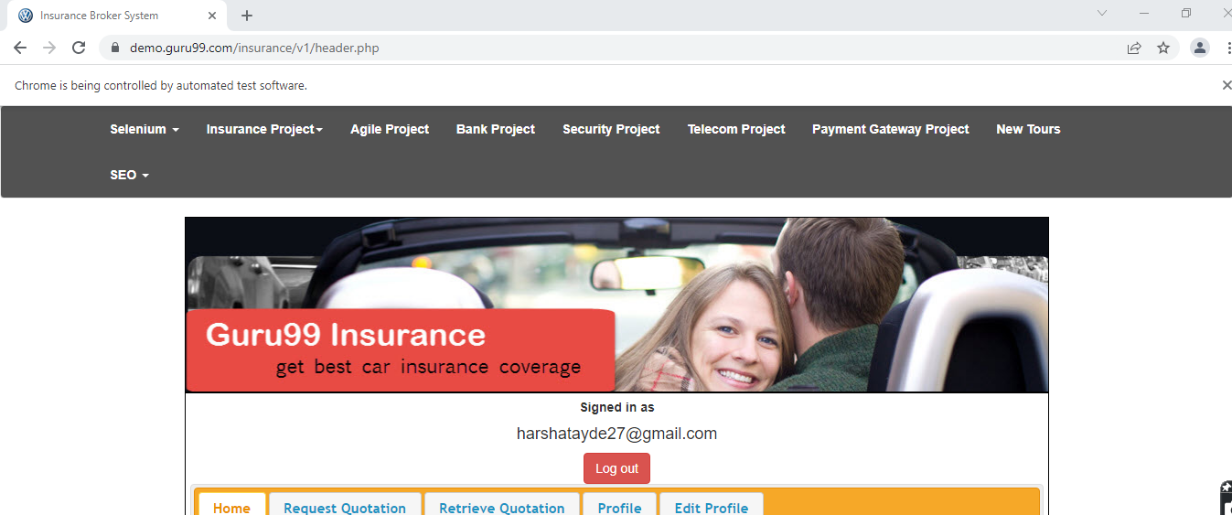

Tc6- click on telecom then back to home click on payment getaway click on new tour module

w.manage().window().maximize();

//click on telecom Project

w.findElement(By.*linkText*("Telecom Project")).click();

w.navigate().back();

Thread.*sleep*(1000);

//click on Payment Gatway

w.findElement(By.*linkText*("Payment Gateway Project"))

.click();

w.navigate().back();

//click on new tour

w.findElement(By.*linkText*("New Tours")).click();

System.***out***.println("Project Sucessfully Run");

w.close();

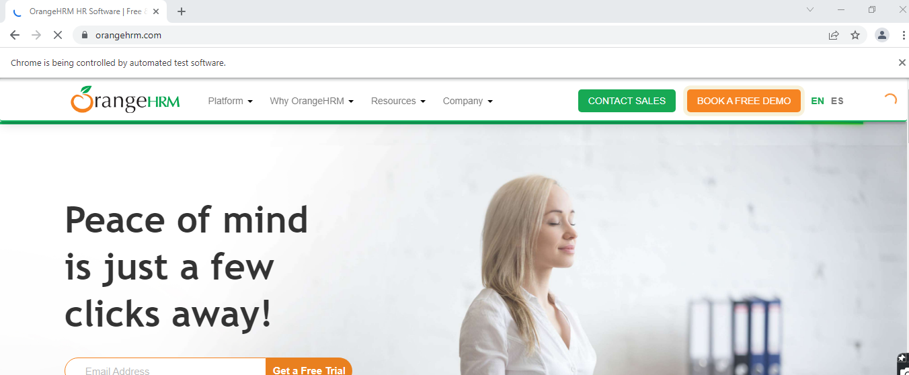

Tc7- Navigate between the demo tour and orange HRM module

w.get("https://demo.guru99.com/test/newtours/index.php\r\n");

//Navigate to orange HRM

w.navigate().to("https://www.orangehrm.com/");

//check the current url of demoguru

w.getCurrentUrl();

System.***out***.println(w.getCurrentUrl());

//then refresh the page

w.navigate().refresh();

//navigate to perious web page

w.navigate().forward();

w.navigate().back();

Tc7- Book a flight on demotour

w.findElement(By.*linkText*("Flights")).click();

//click on radio button

w.findElement(By.*xpath*("/html/body/div[2]/table/tbody/tr/td[2]/table/tbody/tr[4]/td/table/tbody/tr/td[2]/table/tbody/tr[5]/td/form/table/tbody/tr[2]/td[2]/b/font/input[2]")).click();

Select s =**new** Select(w.findElement(By.*name*("passCount")));

//select departing form

s.selectByValue("3");

Select s1=**new** Select(w.findElement(By.*name*("fromPort")));

s1.selectByValue("New York");

//select on month

Select s2=**new** Select(w.findElement(By.*name*("fromMonth")));

s2.selectByValue("6");

//select to date

Select s3=**new** Select(w.findElement(By.*name*("toDay")));

s3.selectByValue("8");

//select arrving

Select s4=**new** Select(w.findElement(By.*name*("toPort")));

s4.selectByValue("Portland");

//return month

Select s5=**new** Select(w.findElement(By.*name*("toMonth")));

s2.selectByValue("7");

//return date

Select s6=**new** Select(w.findElement(By.*name*("toDay")));

s2.selectByValue("9");

//preferance

w.findElement(By.*xpath*("/html/body/div[2]/table/tbody/tr/td[2]/table/tbody/tr[4]/td/table/tbody/tr/td[2]/table/tbody/tr[5]/td/form/table/tbody/tr[9]/td[2]/font/font/input[2]")).click();

Select s7=**new** Select(w.findElement(By.*name*("airline")));

s7.selectByVisibleText("Pangea Airlines");

//click on contiue button

w.findElement(By.*xpath*("/html/body/div[2]/table/tbody/tr/td[2]/table/tbody/tr[4]/td/table/tbody/tr/td[2]/table/tbody/tr[5]/td/form/table/tbody/tr[14]/td/input")).click();

System.***out***.println("Your flight booking successfully");

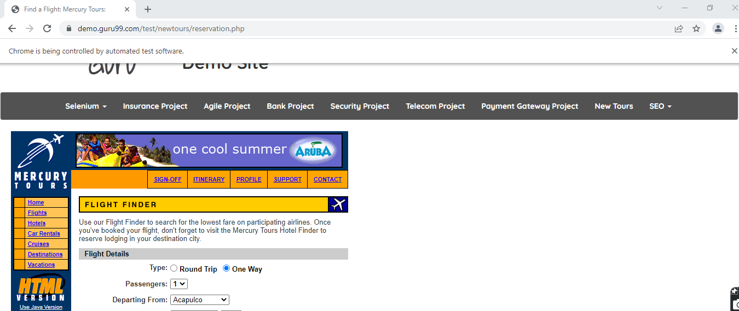

Output

