**19CSE446 - INTERNET OF THINGS**



**PROJECT REVIEW -1**

**Smart Environmental Regulation for Oyster Mushroom Farming in Warm Climates**

**Course Faculty :** Dr V Ananthanarayanan sir

**Mentor :** Dr Amit Agarwal sir

**STUDENT DETAILS:**

|  |  |  |
| --- | --- | --- |
| **S.NO** | **STUDENT NAME** | **ROLL NUMBER** |
| 1. | Nerella Geetha Krishna | CB.EN.U4CSE21040 |
| 2. | Tangudu Harsha Vardhan | CB.EN.U4CSE21062 |
| 2. | Nirupam Abhijith | CB.EN.U4CSE21243 |

1. **Model Overview:**

This project brings exciting for mushroom lovers and farmers alike! It's like having a tiny, super-smart helper in your mushroom farm, constantly checking on the temperature, humidity, and even the amount of carbon dioxide in the air. By using sensors and clever computer programs, this project can automatically adjust things to create the perfect environment for your mushrooms to grow big, strong, and delicious. This not only helps you grow more mushrooms, but also saves on resources and makes the whole process less work! So, instead of constantly running around checking on things, you can focus on other aspects of your farm or simply enjoy the satisfaction of watching your mushrooms thrive.

1. **Sensor Placement Model:**

We are carefully placing sensors throughout the mushroom growing area to make sure the environment is consistent everywhere. Sensors are placed every 10 feet to track changes across the room, and we are even adding CO2 sensors at different heights to check on the carbon dioxide levels. This extra care ensures that all the mushrooms get the perfect conditions they need to grow healthy and strong!

1. **Control Unit Design:**

PID (Proportional-Integral-Derivative) control is a powerful method widely used in various industries for regulating the behaviour of systems

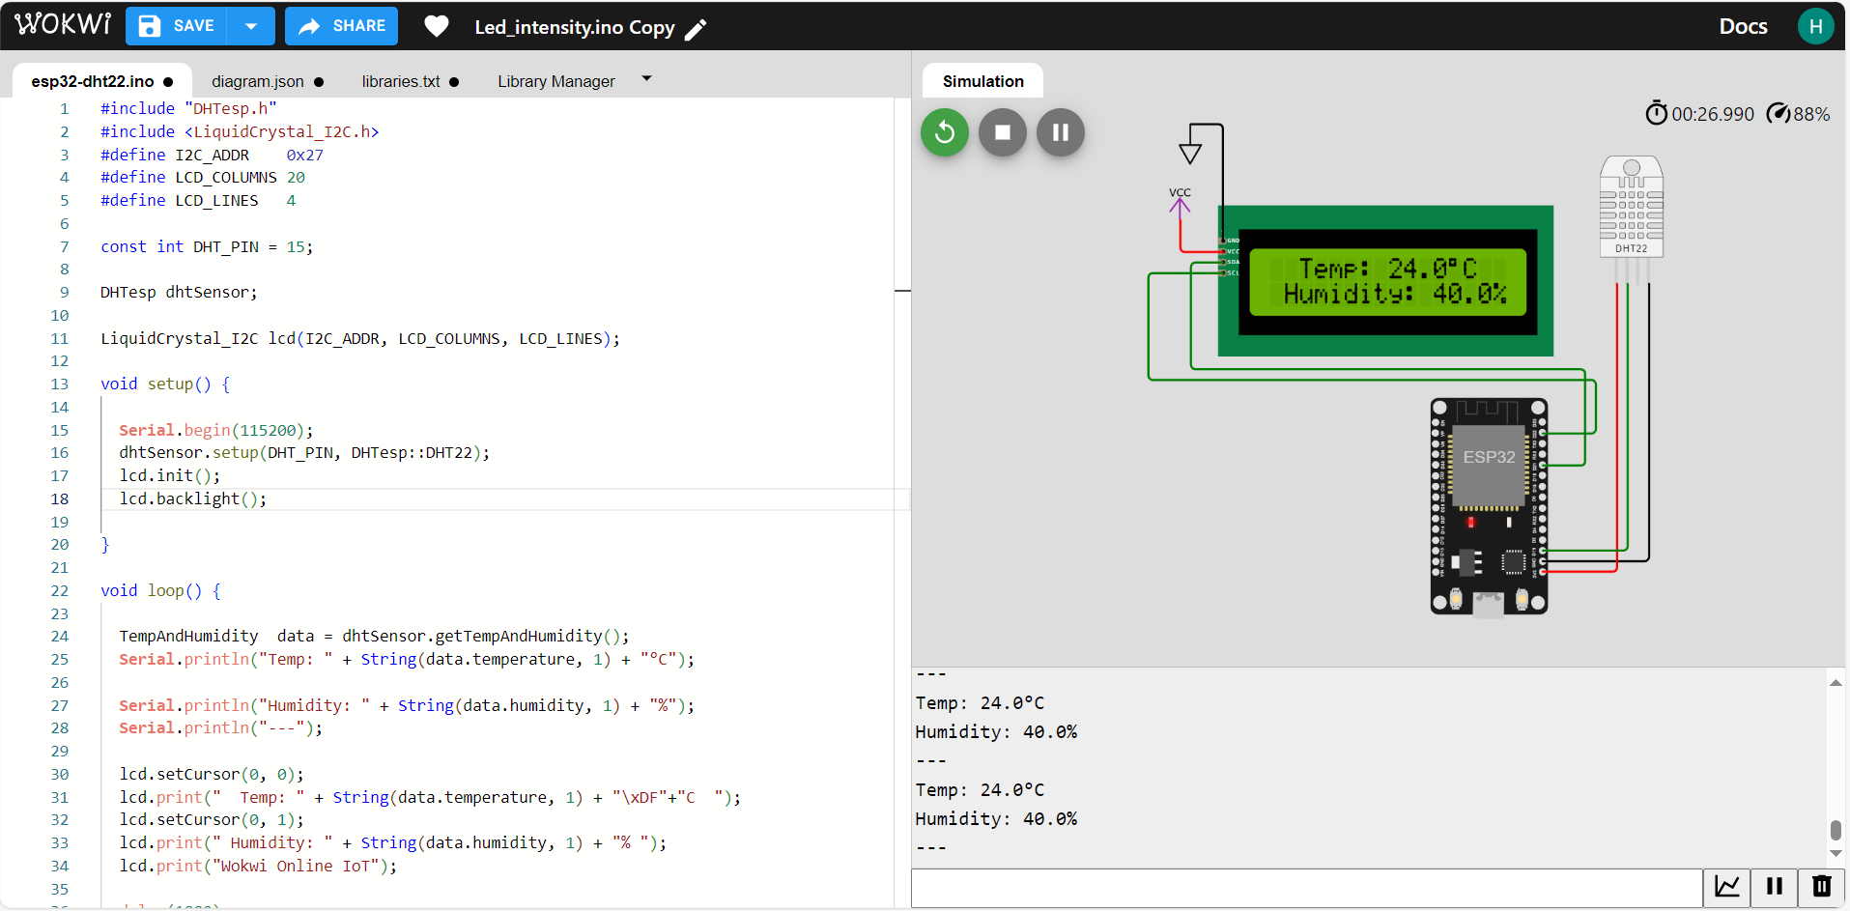

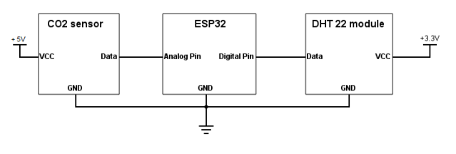

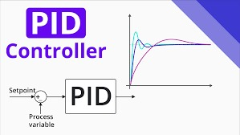

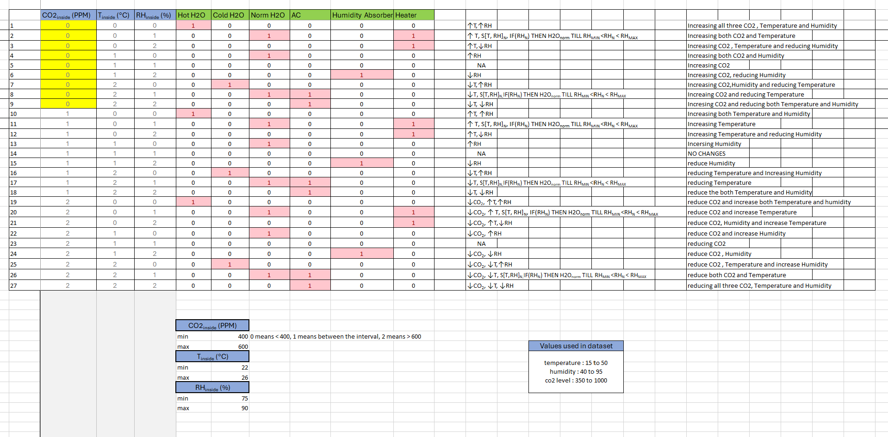

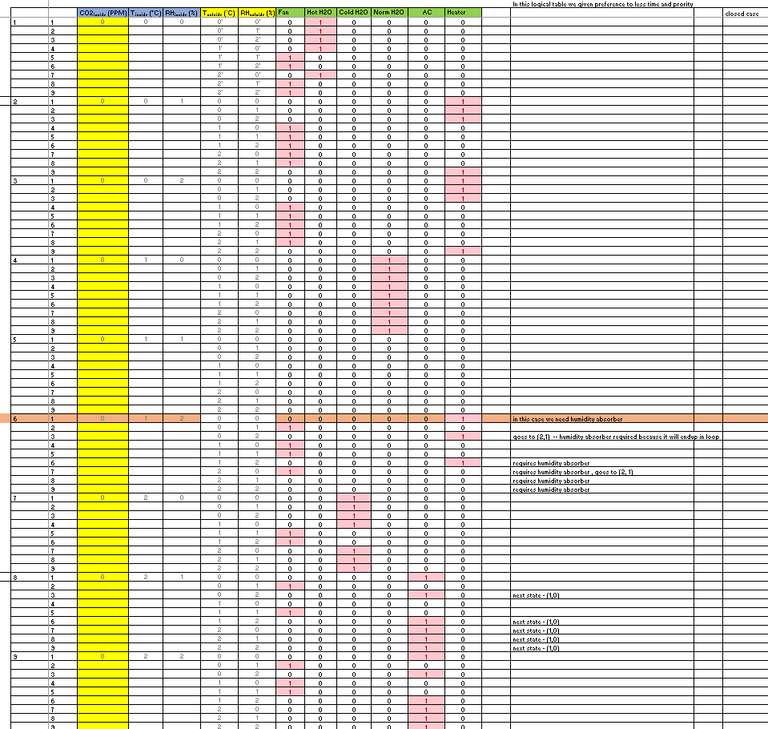

1. **Communication Technologies used in the project:**

* **ESP32 S3 Microcontroller:**

This cost-effective and low-power microcontroller serves as the central processing unit for the IoT system. With built-in Wi-Fi and Bluetooth capabilities, the ESP32 S3 enables seamless communication between sensors, actuators, and the central control unit. It facilitates data collection, processing, and transmission, acting as the primary interface between the cultivation environment and the control infrastructure.

* **Wi-Fi Router:**

Utilizing existing Wi-Fi routers within the cultivation facility, this component provides connectivity between the ESP32 S3 microcontroller and the backend infrastructure. By establishing a wireless network, the Wi-Fi router enables real-time data sharing and remote monitoring capabilities, ensuring seamless integration with the cloud-based server and user interface devices.

* **User Interface Devices (Smartphone / Web Design):**

Smartphones serve as intuitive user interfaces for monitoring and controlling the mushroom cultivation environment. By installing the dedicated application, users can access live data, historical analysis, and actionable insights related to temperature, humidity, and CO2 levels. Additionally, the application enables remote control of actuators and provides alerts for any deviations from optimal growing conditions, empowering users to make informed decisions and optimize cultivation outcomes.

* **Cloud-Based Server:**

The cloud-based server acts as the backbone of the IoT infrastructure, facilitating data collection, storage, processing, and visualization. It receives sensor data from the ESP32 S3 microcontroller via MQTT protocol, aggregates and analyses the data to derive meaningful insights, and serves this information to the user interface devices in real-time. By leveraging cloud computing resources, the server ensures scalability, reliability, and security, enabling seamless integration with multiple users and IoT endpoints while maintaining robust data management practices.

**Communication Protocols used in the project:**

* **Wi-Fi:**

Wi-Fi technology is essential for establishing wireless connectivity within the mushroom cultivation environment. The ESP32 microcontroller, with its built-in Wi-Fi capabilities, serves as the primary communication gateway between sensors, actuators, and the backend server. Wi-Fi enables seamless data transmission, control commands, and system monitoring, facilitating real-time adjustments to environmental parameters.

* **MQTT Protocol:**

MQTT (Message Queuing Telemetry Transport) protocol is employed for efficient and reliable communication between distributed devices in the IoT ecosystem. MQTT's lightweight nature and publish-subscribe architecture make it well-suited for resource-constrained environments like mushroom cultivation facilities. Sensors, control units, and other devices publish data to designated topics, while subscribers, such as the backend server, receive and process this data in near real-time. MQTT ensures minimal overhead, reduced network congestion, and reliable message delivery, enhancing the responsiveness and scalability of the system.

* **HTTP:**

HTTP (Hypertext Transfer Protocol) technology serves as a communication interface between the mobile application and the backend server. The mobile application utilizes HTTP requests to send commands, queries, and data to the server, which processes the requests and responds accordingly. JSON (JavaScript Object Notation) format is commonly used for data interchange due to its lightweight and human-readable structure. HTTP facilitates remote monitoring, control, and data retrieval, empowering users to interact with the mushroom cultivation system from anywhere with internet connectivity.

1. **Selection of hardware components in the solution.**

* **CO2 Sensor (Sensirion SCD41):**
* **Function:** Measures the concentration of carbon dioxide (CO2) in the air.
* **Features:**
  + **Accuracy:** ±30 ppm or ±3% of reading (whichever is greater).
  + **Measurement Range:** 0-5000 ppm.
  + **Selectivity:** Highly selective to CO2, minimizing interference from other gases.
  + **Calibration:** Factory-calibrated with long-term stability, reducing maintenance needs.

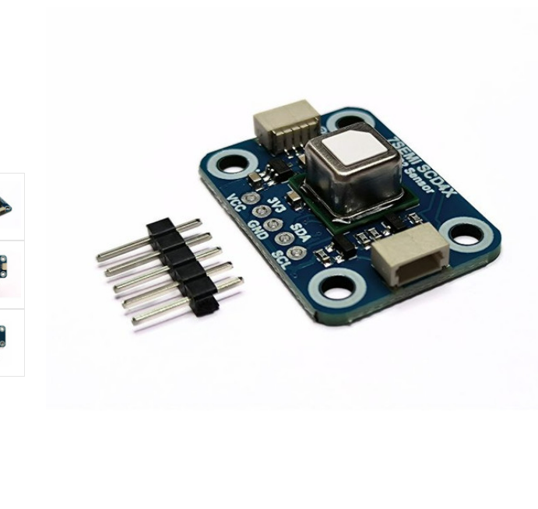

* **Temperature and Humidity Sensor (Sensirion SHT25):**
* **Function:** Measures both temperature and relative humidity simultaneously.
* **Features:**
  + **Temperature:**
    - Measurement Range: -40°C to +125°C.
    - Accuracy: ±0.3°C at +25°C.
  + **Humidity:**
    - Measurement Range: 0% to 100% RH.
    - Accuracy: ±2% RH at 25°C and 75% RH.
  + **Compact Size:** Small footprint, suitable for space-constrained applications.
  + **Low Power Consumption:** Minimizes energy usage, ideal for battery-powered devices.

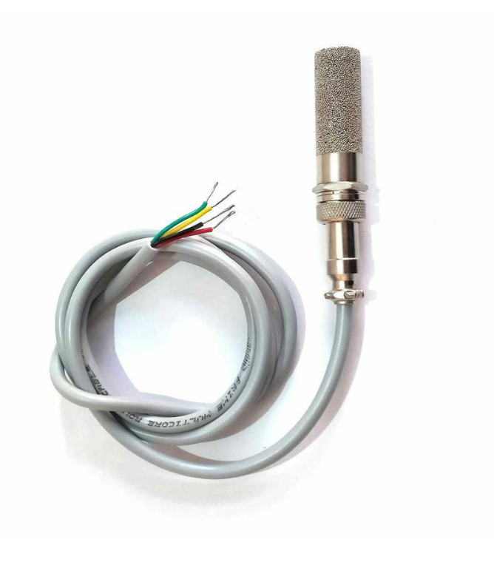

* **Control Unit (ESP32 S3):**
* **Function:** Acts as the brains of the system, processing sensor data, controlling actuators, and communicating with other devices.
* **Features:**
  + **Microcontroller:** Powerful dual-core processor enables real-time data processing and control tasks.
  + **Wi-Fi and Bluetooth:** Provides wireless connectivity for data transmission and remote control (if desired).
  + **Analog-to-Digital Converters (ADCs):** Allows direct connection to analog sensors like the SHT25.
  + **Low Power Consumption:** Suitable for battery-powered applications or projects with limited power budgets.
  + **Programmable:** Supports various programming languages and libraries for versatile control logic implementation.

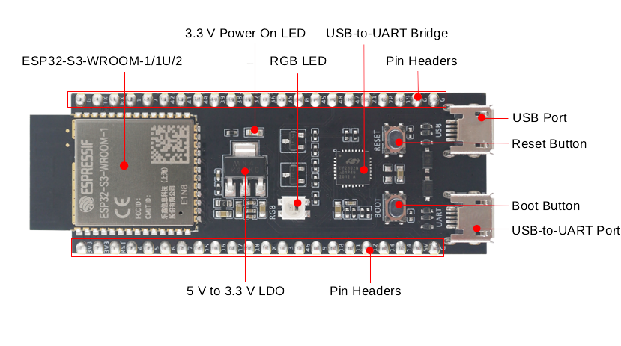

1. **Deployment Level Diagram**

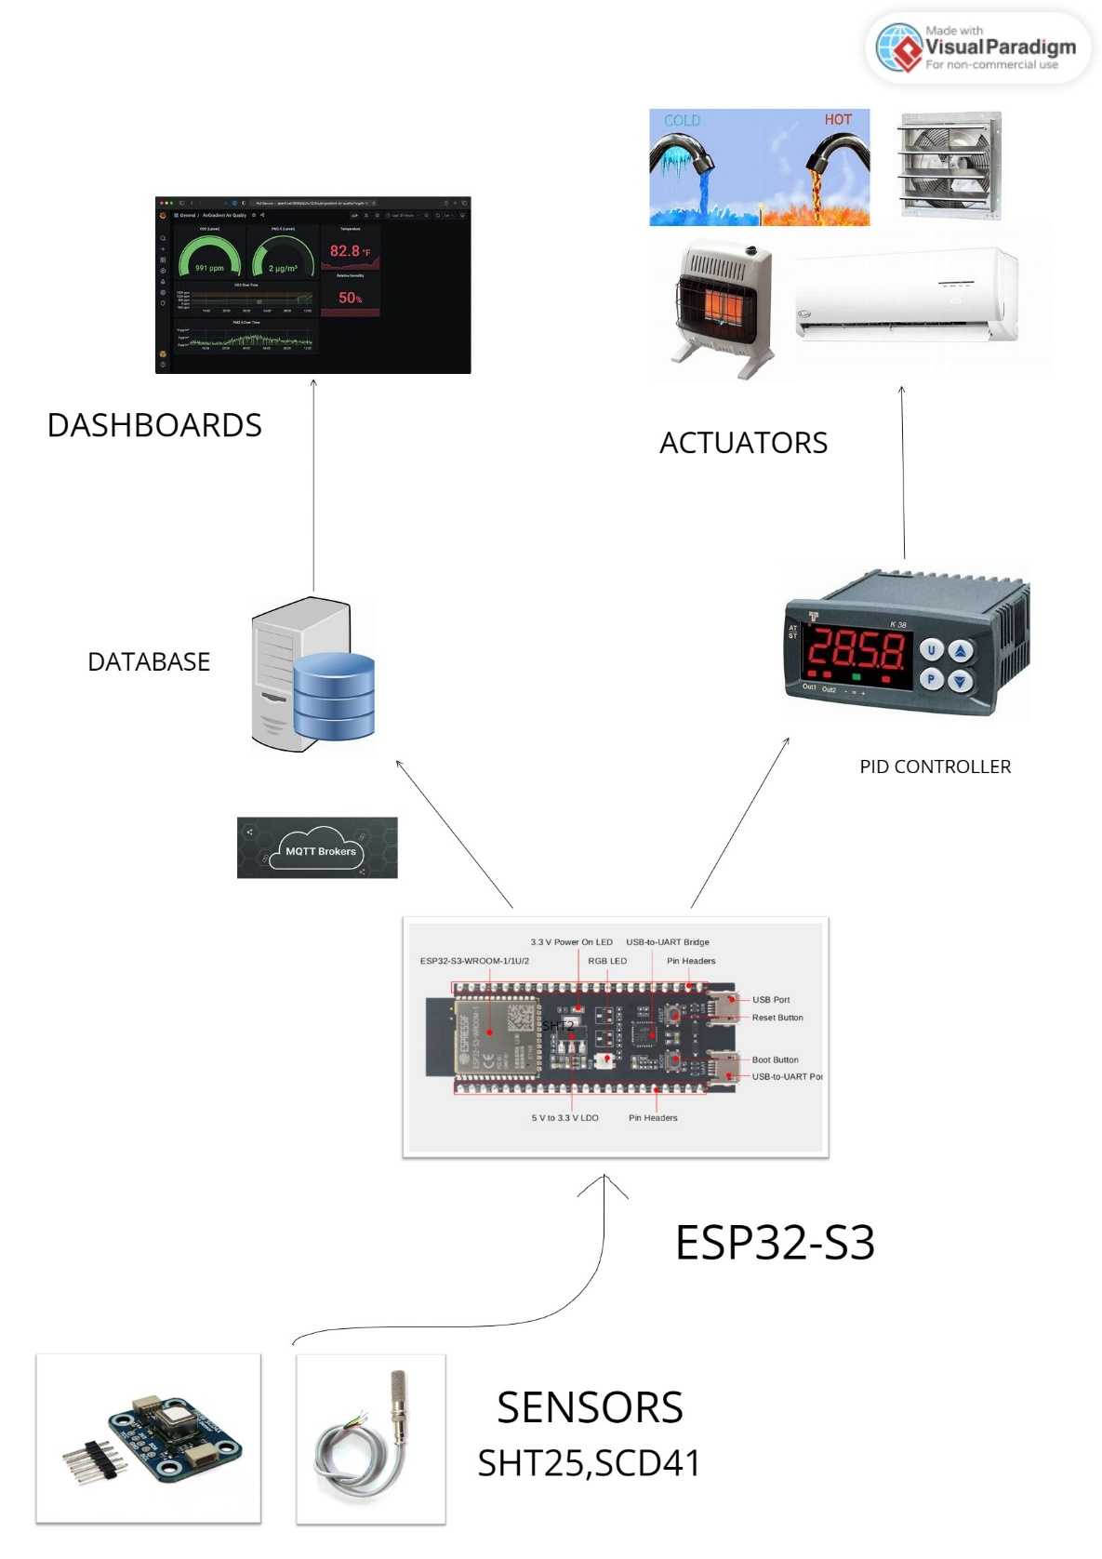

1. **Flowchart of Software Process**

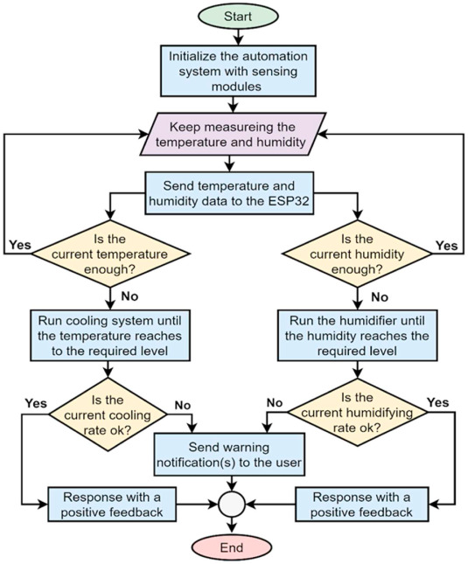

1. **Data Analystics in edge and cloud**

**Data Collection and Storage:**

Sensor data, including temperature, humidity, and CO2 levels, is collected in real-time from deployed sensors within the cultivation environment.

The collected data is securely transmitted to the cloud storage infrastructure for long-term retention and analysis.

**Data Cleansing and Pre-processing:**

Raw sensor data may contain outliers, missing values, or errors due to environmental factors or sensor malfunctions.

Pre-processing techniques such as filtering, interpolation, and outlier detection are applied to ensure data quality and consistency.

**Data Analysis:**

Processed sensor data is analyzed to identify patterns, trends, and anomalies that may impact mushroom growth and overall system performance.

Algorithms are employed to detect deviations from optimal environmental conditions, triggering alerts or notifications to stakeholders.

Historical data analysis allows for the identification of seasonal trends, growth patterns, and potential areas for optimization.

**Data Visualization:**

Visualizations such as line charts, heatmaps, and histograms are utilized to present the analyzed data in an intuitive and informative manner.

Daily, weekly, and monthly trends in temperature, humidity, and CO2 levels are visualized to help users understand environmental dynamics and make informed decisions.

Comparative analysis between different cultivation batches or environmental conditions is facilitated through interactive dashboards and customizable visualization options.

1. **Application design with UI (web-pages)**

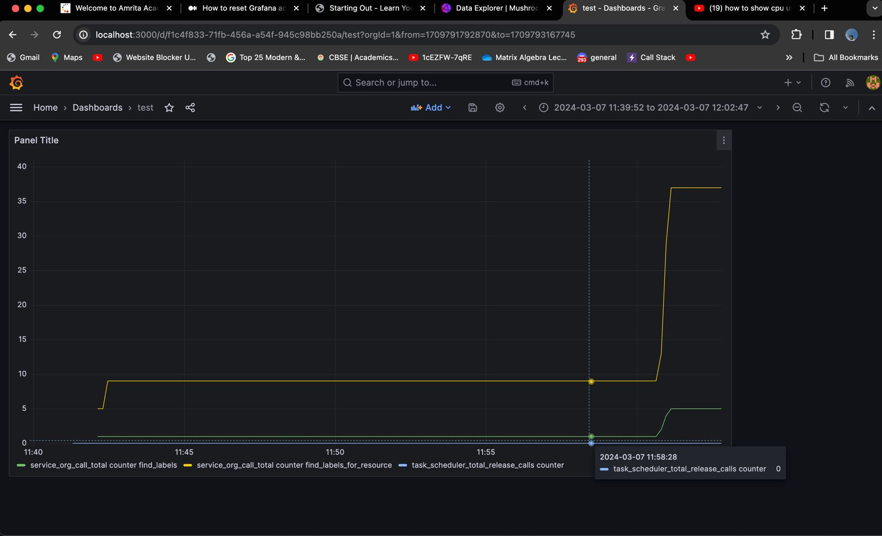

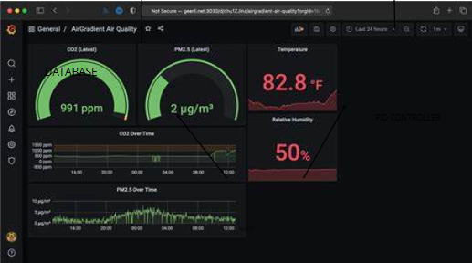

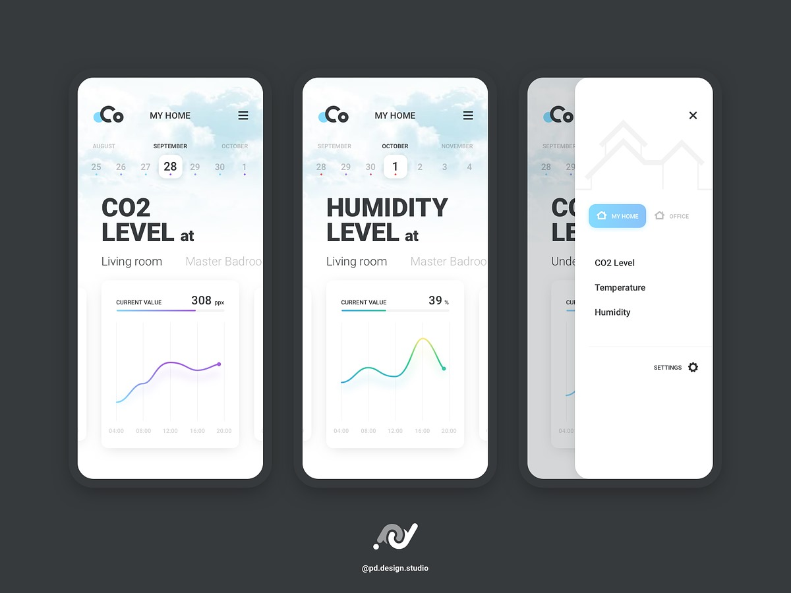

**10.Budget for Case Study Prototype Building**

Hardware Components and Sensors:

Sensirion SCD41 CO2 Sensor: INR 3000

Sensirion SHT25 Humidity/Temperature Sensor: INR 1500

ESP32 S3 Microcontroller: INR 1500

Relay Modules (for actuator control): INR 1000

Connecting Wires and Cables: INR 500

Power Supply Units: INR 1000

Cloud Services:

Utilization of free hosting services like Render or Heroku: No additional cost

Alternatively, utilizing $100 free credits provided by AWS: No additional cost (assuming the project falls within the usage limits)

Total Estimated Budget: INR 8500