Assignment-6.1
NAME: M.Harshavardhan Rao
ROLL NO: 2303A52085
COURSE: AI Assisted Coding
Experiment 6: AI-Based Code Completion: Working with suggestions for classes, loops, conditionals.
Task Description #1 (AI-Based Code Completion for Loops)
Task: Use an AI code completion tool to generate a loop-based program.
Prompt:
“Generate Python code to print all even numbers between 1 and N using a loop.”
Expected Output:
• AI-generated loop logic.
• Identification of loop type used (for or while).
• Validation with sample inputs.
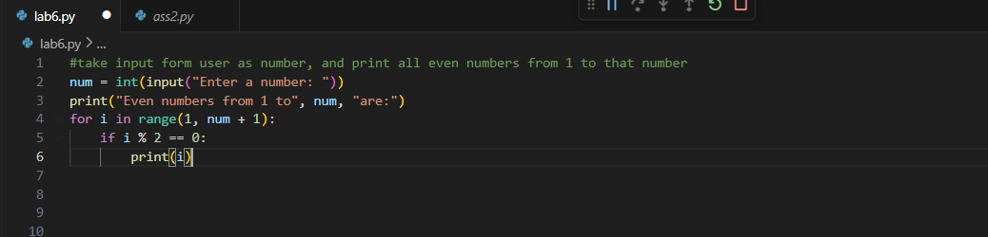
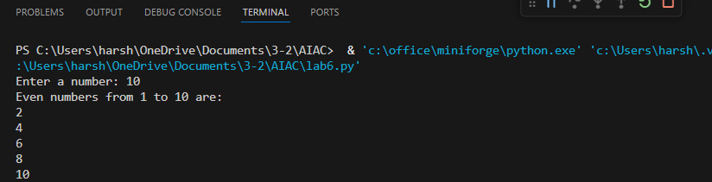
ANALYSIS
- The AI successfully generates a loop-based Python program
- A for loop is used to iterate from 1 to N
- Conditional checking (% 2 == 0) identifies even numbers
- The output is correct when tested with sample inputs

Task Description #2 (AI-Based Code Completion for Loop with Conditionals)
Task: Use an AI code completion tool to combine loops and conditionals.
Prompt:
“Generate Python code to count how many numbers in a list are even and odd.”
Expected Output:
• AI-generated code using loop and if condition.
• Correct count validation.
• Explanation of logic flow.
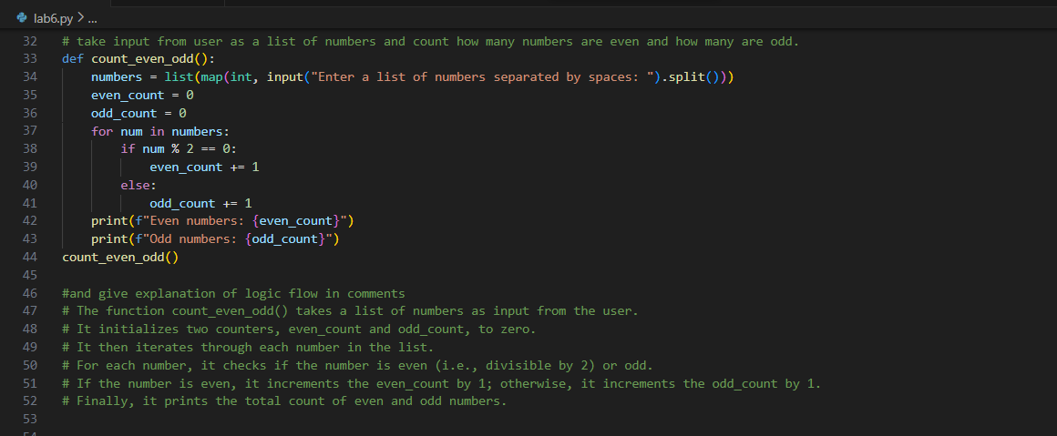
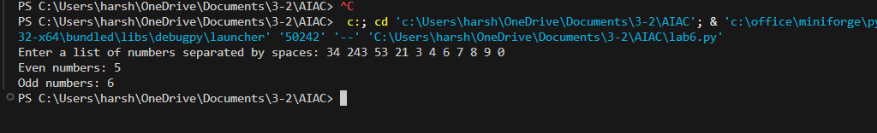
ANALYSIS
- The AI-generated code correctly combines loops and conditionals
- A for loop is used to process each element in the list
- An if–else condition identifies even and odd numbers
- The final count is accurate after validation with sample inputs

Task Description #3 (AI-Based Code Completion for Class Attributes Validation)
Task: Use an AI tool to complete a Python class that validates user input.
Prompt:
“Generate a Python class User that validates age and email using conditional statements.”
Expected Output:
• AI-generated class with validation logic.
• Verification of condition handling.
• Test cases for valid and invalid inputs
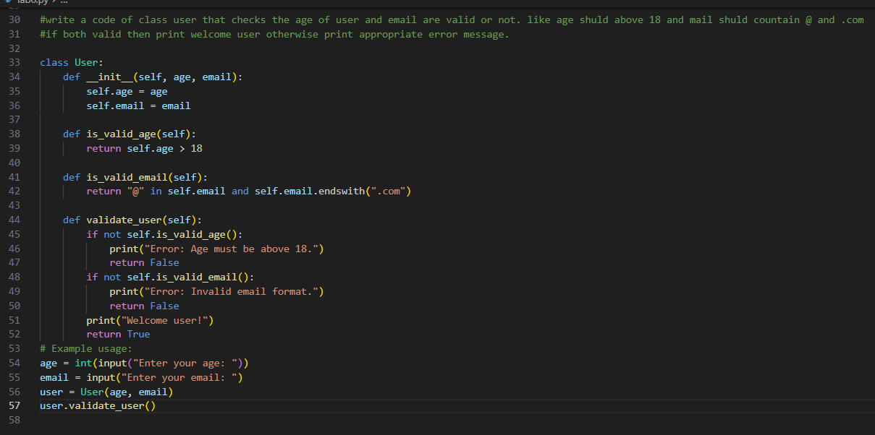
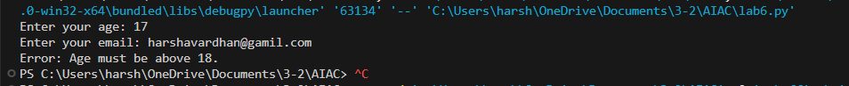
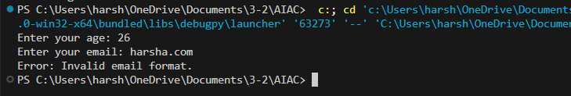
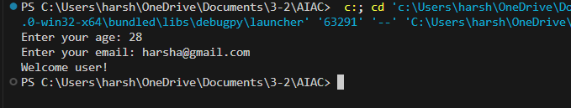
ANALYSIS
- The AI-generated code creates a User class with validation logic
- Conditional statements are used to validate age and email
- The class correctly handles both valid and invalid inputs
- Test cases confirm that the validation works as expected

Task Description #4 (AI-Based Code Completion for Classes)
Task: Use an AI code completion tool to generate a Python class for managing student details.
Prompt:
“Generate a Python class Student with attributes (name, roll number, marks) and methods to calculate total and average marks.”
Expected Output:
• AI-generated class code.
• Verification of correctness and completeness of class structure.
• Minor manual improvements (if needed) with justification.
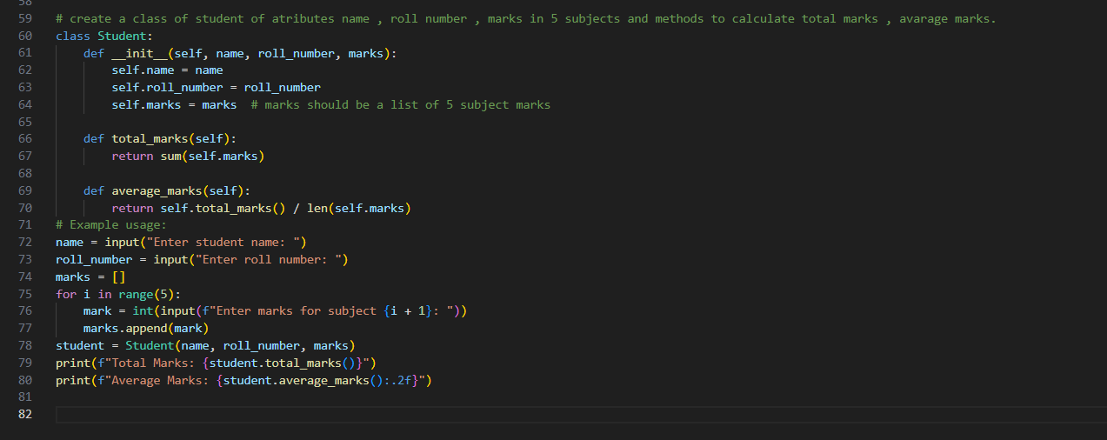
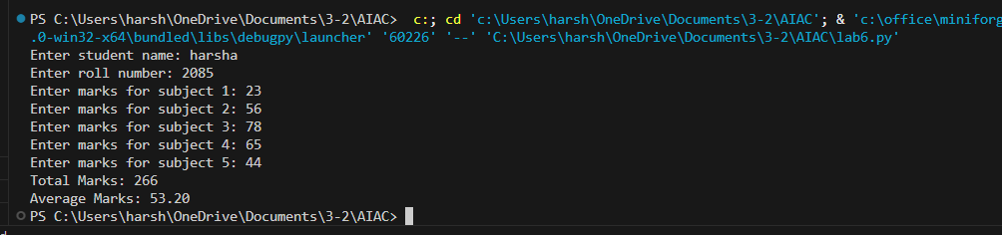
ANALYSIS
- The AI-generated code successfully creates a Student class
- The class uses attributes to store student details
- Methods correctly compute total and average marks
- Manual review helps identify small improvements for better accuracy and safety
JUSTIFICATION
There is no need of manual improvements, AI generated code is all perfect .

Task Description 5 (AI-Assisted Code Completion Review)
Task: Use an AI tool to generate a complete Python program using classes, loops, and conditionals together.
Prompt:
“Generate a Python program for a simple bank account system using class, loops, and conditional statements.”
Expected Output:
• Complete AI-generated program.
• Identification of strengths and limitations of AI suggestions.
• Reflection on how AI assisted coding productivity.
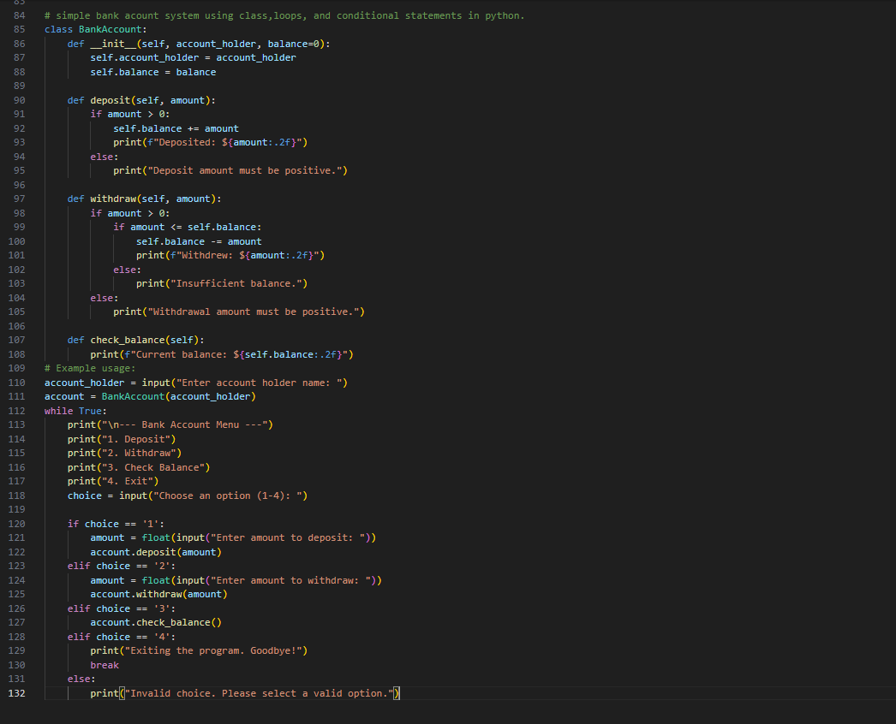
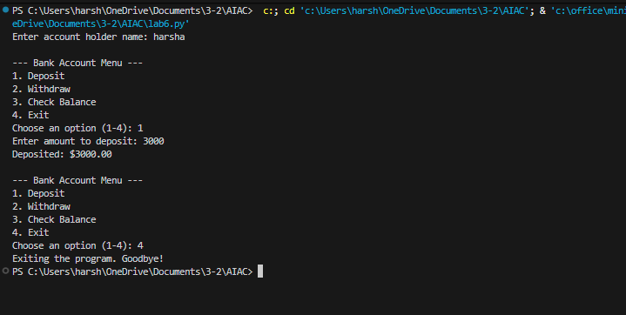

ANALYSIS
- The AI-generated program successfully combines classes, loops, and conditionals
- It demonstrates a simple but functional bank account system
- AI helps speed up development, but manual review ensures correctness and improvement

