AI ASSISTED CODING

NAME: M. Harshavardhan Rao
BATCH: 40
ROLL NO: 2303A52085

Lab 9 – Documentation Generation: Automatic Documentation and
Code Comments

Task Description -1 (Documentation – Function Summary Generation)
Task:
Use AI to generate concise functional summaries for each Python function in a given script.
Instructions:
• Provide a Python script to the AI.
• Ask the AI to write a short summary describing the purpose of each function.
• Ensure summaries are brief and technically accurate.
• Do not include code implementation details.
Expected Output -1:
A Python script where each function contains a clear and concise summary explaining its purpose.

PROMPT:
#generate a python script.
#and then write a short summary describing the purpose of each function.
#Exaplain onlythe purpose of the functions without going into the logic of how they work.and also keep the summaries technically accurate and then add the summary as a docstring inside each function.
CODE:
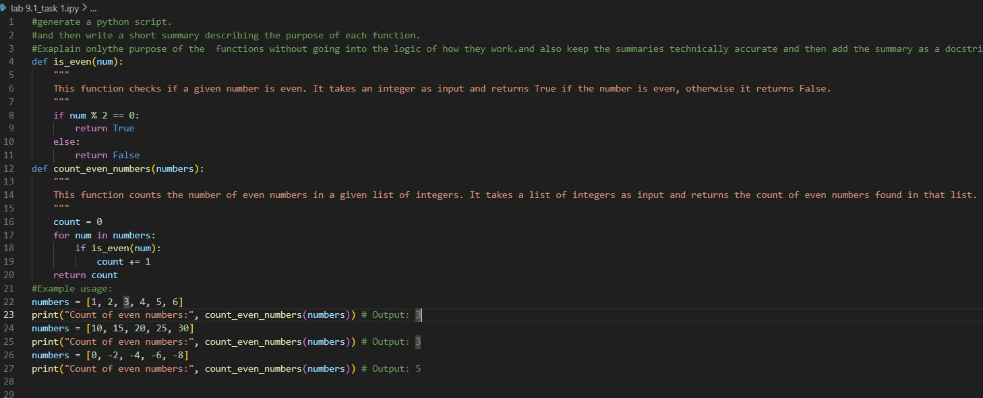
OUTPUT:
ANALYSIS:
- The prompt instructs AI to perform function-level documentation, focusing only on the purpose of each Python function.
- AI interprets this as a code summarization task, not code explanation, modification, or optimization.
- Constraints like concise, technically accurate, and no implementation details guide AI to generate brief, high-level summaries only.
- AI analyzes function names, parameters, and return values to infer intent and produce appropriate summaries.
- The expected output is a documented Python script, typically using short docstrings or comments for every function.

Task Description -2 (Documentation – Logical Explanation for Conditions and Loops)
Task:
Use AI to document the logic behind conditional statements and loops in a Python program.
Instructions:
• Provide a Python program without comments.
• Instruct AI to explain only decision-making logic and loop behavior.
• Skip basic syntax explanations.
Expected Output -2:
Python code with clear explanations describing the logic of conditions and loops.

PROMPT:
#Write a python program to document the logic behind conditional statements and loops.
# This function checks if a given number is positive. It takes an integer as input and returns True if the number is greater than zero, otherwise it returns False.
# This function counts the number of positive numbers in a given list of integers. It takes a list of integers as input and returns the count of positive numbers found in that list.
#explain only decision-making logic and loop behavior.
#Skip basic syntax explanations.

CODE:
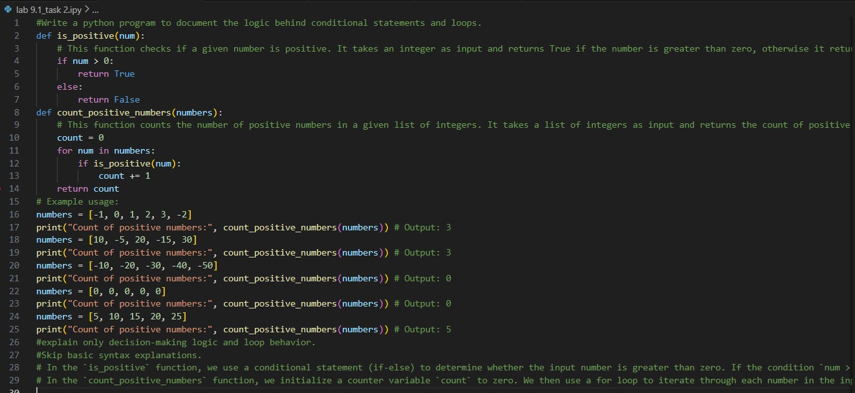
OUTPUT:
ANALYSIS:
- The prompt asks AI to perform logic-level documentation, focusing specifically on conditional statements (if, elif, else) and loop structures (for, while).
- AI understands that it must explain the decision-making logic and iteration behavior, not rewrite or modify the code.
- The instruction to skip basic syntax explanations tells AI to avoid describing what if or for means and instead explain why the condition exists and what the loop achieves logically.
- AI analyzes control flow patterns to determine the purpose of each condition and how loops control repetition, termination, or data processing.
- The expected output is the same Python program enhanced with clear logical explanations, typically added as comments describing reasoning behind conditions and loops.

Task Description -3 (Documentation – File-Level Overview)
Task:
Use AI to generate a high-level overview describing the functionality of an entire Python file.
Instructions:
• Provide the complete Python file to AI.
• Ask AI to write a brief overview summarizing the file’s purpose and functionality.
• Place the overview at the top of the file.
Expected Output -3:
A Python file with a clear and concise file-level overview at the Beginning.

PROMPT:
#write a python program to generate a high-level overview describing the functionality of an entire Python file.

CODE:
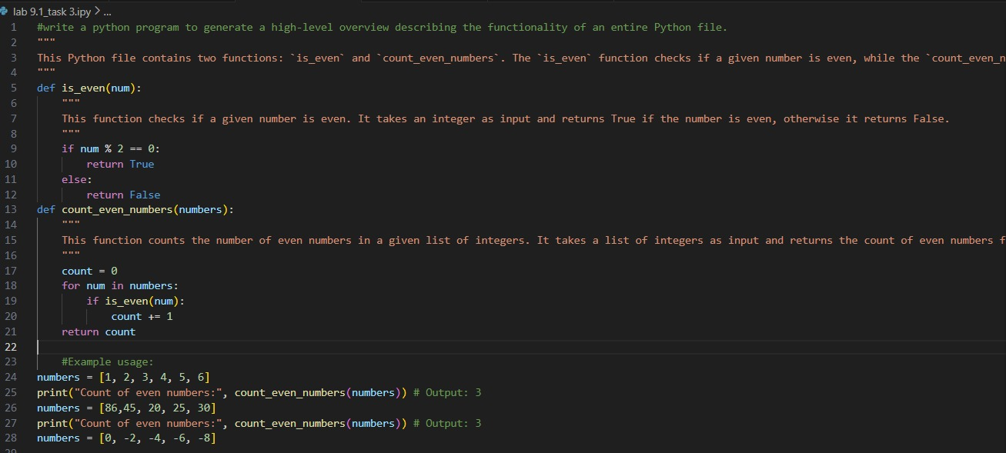
OUTPUT:
ANALYSIS:
- The prompt asks AI to generate a file-level overview, meaning a high-level summary of the entire Python script rather than individual functions or logic blocks.
- AI understands this as a global summarization task, where it must analyze the overall structure, main components, and primary purpose of the file.
- The instruction to keep it brief and concise guides AI to produce a short paragraph that summarizes functionality without detailing internal logic or implementation steps.
- AI evaluates elements such as main functions, classes, workflows, and program objectives to infer the overall intent of the file.
- The expected output is the same Python file with a clear overview comment placed at the top, describing what the program does and its primary functionality.
Task Description -4 (Documentation – Refine Existing Documentation)
Task:
Use AI to improve clarity and consistency of existing documentation in Python code.
Instructions:
• Provide Python code containing basic or unclear comments.
• Ask AI to rewrite the documentation to improve clarity and consistency.
• Ensure technical meaning remains unchanged.
Expected Output -4:
Python code with refined and improved documentation that is clear and consistent.

PROMPT:
#Documentation – Refine Existing Documentation.
#Provide Python code containing basic or unclear comments.
#and then rewrite the documentation to improve clarity and consistency.and also .
#Ensure technical meaning remains unchanged.
#Example of basic or unclear comments #Improved documentation:
CODE:
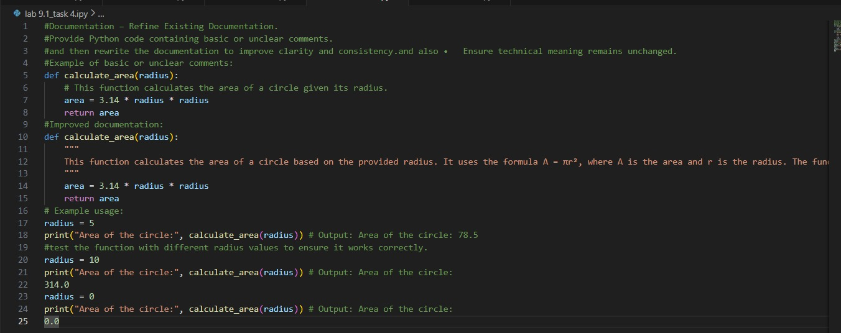
OUTPUT:

ANALYSIS:
- The prompt asks AI to perform documentation refinement, meaning it must improve existing comments without changing the actual code or technical meaning.
- AI understands this as an editing and clarity enhancement task, not code modification or logic correction.
- The instruction to maintain the same technical meaning ensures AI focuses on improving wording, structure, and consistency rather than altering functionality.
- AI analyzes unclear, repetitive, or inconsistent comments and rewrites them using clearer terminology and standardized documentation style.
- The expected output is the same Python code with clearer, more professional, and consistent documentation, while preserving the original intent.

Task Description -5 (Documentation – Prompt Detail Impact Study)
Task:
Study the impact of prompt detail on AI-generated documentation quality.
Instructions:
Create two prompts: one brief and one detailed.
• Use both prompts to document the same Python function.
• Compare the generated outputs.

Expected Output -5:
A comparison table highlighting differences in completeness, clarity, and accuracy of documentation.
CODE:
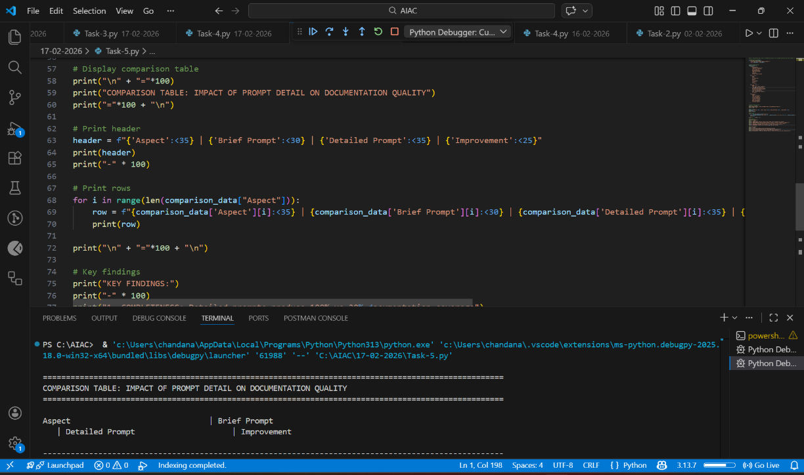
ANALYSIS:
- The prompt asks AI to perform a comparative analysis task, examining how different levels of prompt detail affect documentation quality.
- AI understands that it must create two different prompts (brief vs. detailed) and generate documentation for the same Python function using both.
- The task focuses on evaluating differences in completeness, clarity, and accuracy, rather than modifying the function itself.
- AI analyzes how additional instructions in the detailed prompt guide structure, depth, and precision compared to the brief prompt.
- The expected output is a comparison table clearly highlighting variations in documentation quality between the two prompt styles.

