

### Belagavi PROJECT REPORT

**8th semester, B.E.**

## “GOUSHALA - A LIVESTOCK MANAGEMENT USING AWS IoT”

#### A Project Report submitted to Visvesvaraya Technological University in partial fulfillment of the requirement for the award of degree of Bachelor of Engineering in Electronics and Telecommunication Engineering

Submitted by,

**Anjan D S 4JN19ET004**

**Harsha J Nazre 4JN19ET014**

### R R Shriya 4JN19ET026

**Smriti K Vantkar 4JN19ET028**

**Under the guidance of:**

### Mr. Benak Patel M P, B.E., M.E.,

**Assistant Professor Dept. of ETE**

**Department of Electronics and Telecommunication Engineering Jawaharlal Nehru New College of Engineering**

### SHIVAMOGGA – 577204

**2022-23**

### National Educational Society®

**Jawaharlal Nehru New College of Engineering SHIVAMOGGA – 577204**



### Department of Electronics and Telecommunication Engineering

**CERTIFICATE**

**This is to certify that the project work entitled**

## “GOUSHALA- A LIVESTOCK MANAGEMENT USING AWS IoT”

**Is a bonafide work carried out jointly by**

### Anjan D S 4JN19ET004

**Harsha J Nazre 4JN19ET014**

### R R Shriya 4JN19ET026

**Smriti K Vantkar 4JN19ET028**

These students of 8th semester B.E., Electronics and Telecommunication Engineering under our supervision and guidance towards the partial fulfillment of the requirements for the award of the degree of Bachelor of Engineering in Electronics and Telecommunication Engineering as per the university regulations during the year 2022-23.

|  |  |  |
| --- | --- | --- |
| **………………………….** | **………………………** | **………………………..** |
| Signature of the Guide | Signature of the HOD | Signature of Principal |
| **Mr. Benak Patel M P** | **Dr. Surendra S.** | **Dr. K. Nagendra Prasad** |
| **Asst. Prof., E.T.E.** | **HOD, E.T.E.** | **Principal, JNNCE** |

**Name of Examiners: Signature of Examiners with date: 1. …………………………. ………………………….**

**2. …………………………. ………………………….**

# Abstract

Livestock management is a crucial component of the agricultural business, and using technology to ensure optimal results is becoming increasingly important. Using linked devices and sensors, Amazon IoT delivers a scalable and secure platform for controlling and monitoring livestock. This abstract focuses on some of the most important aspects and benefits of utilizing Amazon IoT for livestock management, such as real-time data collecting, analytics, and remote monitoring. Farmers and ranchers may use Amazon IoT to acquire insights about animal health, behaviour, and general performance, leading to better decision-making and improved results for their livestock operations.

Using the Raspberry Pi, BLE Beacons, and Amazon IoT core, a solution has been given to this problem. This BLE beacon is used to track the animals. This approach is mostly dependent on radio signal technologies like WIFI and RFID. The RSSI (Received Signal Strength Indication) approach is mostly used in BLE for livestock tracking.

By allowing remote monitoring, data-driven decision-making, and automation, utilizing AWS IoT services in livestock management systems has the potential to revolutionize the sector. Livestock managers may maximize resource use, increase animal welfare, and eventually improve the overall productivity and sustainability of livestock-based sectors by using real-time information and sophisticated analytic.

# ACKNOWLEDGEMENT

Firstly, we would like to express our sincere gratitude to the almighty for his solemn presence throughout the project work.

We express our sincere gratitude to **Dr. Surendra S., Professor,** Head of the Electronics and Telecommunication Engineering Department for providing us with adequate facilities, ways and

means by which we are able to complete this project work.

We are deeply indebted to our project coordinators **Mrs. Aparna,** Assistant Professor,Department of Electronics and Telecommunication Engineering and **Mr. Benak Patel,** Asst. Professor, ETE department for providing us with valuable advice and guidance during the course of the study. Without their wise counsel and able guidance, it would have been impossible to complete our project work in this manner.

We would like to express a deep sense of gratitude and thanks profusely to our project guide **Mr. Benak Patel,** Asst. Professor, Department of Electronics and Telecommunication engineering for his proper guidance and valuable suggestions. Without his wise counsel and able guidance, it would have been impossible to complete the project work in this manner.

We would also like to express our special thanks to the Dean Academics **Dr. Manjunatha P** for providing an opportunity to carry out this project work.

We would also like to express our special thanks to the Principal **Dr. K. Nagendra Prasad** for providing an opportunity to carry out this project work.

We would like to extend our heartfelt gratitude to the teaching and non-teaching staff of

**Department of Electronics and Telecommunication Engineering** for their constructive support and co- operation at each and every juncture of the project work.

Finally, we would also like to express our gratitude to **J N N College of Engineering,Shivamogga** for providing us with all the required facilities without which the project work would not have been possible.

Project associates,

**ANJAN D S 4JN19ET004 HARSHA J NAZRE 4JN19ET014 R R SHRIYA 4JN19ET026 SMRITI K VANTKAR 4JN19ET028**

# Table of contents

|  |  |  |  |  |
| --- | --- | --- | --- | --- |
| **Chapter No.** | | | **Title** | **Page No.** |
|  | | | **ABSTRACT** | **i** |
|  | | | **ACKNOWLEDGEMENT** | **ii** |
|  | | | **TABLE OF CONTENTS** | **iii** |
|  | | | **LIST OF FIGURES** | **iv** |
|  | | | **LIST OF ABBREVIATIONS** | **v** |
| **1** |  |  | **PREAMBLE** |  |
|  | 1.1 |  | Introduction | **1** |
|  | 1.2 |  | Literature survey | **2-4** |
|  | 1.3 |  | Problem statement | **4** |
|  | 1.4 |  | Objectives | **5** |
|  | 1.5 |  | Methodology | **6** |
|  | 1.6 |  | Scope of the project | **6** |
|  | 1.7 |  | Organization of the Report | **6** |
| **2** |  |  | **THEORETICAL BACKGROUND** |  |
|  | 2.1 |  | Management of Livestock | **7** |
|  | 2.2 |  | Amazon Web Services using IoT | **8** |

|  |  |  |  |  |
| --- | --- | --- | --- | --- |
|  | 2.3 |  | EMQX Broker | **9** |
| **3** |  |  | **DESIGN AND IMPLEMENTATION** |  |
|  | 3.1 |  | Introduction | **10** |
|  |  | 3.1.1 | System Design | **11** |
|  | 3.2 |  | Block Diagram | **12** |
|  | 3.3 |  | Working Principle | **12-15** |
|  | 3.4 |  | System Flowchart | **16** |
|  | 3.5 |  | Summary | **17** |
| **4** |  |  | **SOFTWARE IMPLEMENTATION** |  |
|  | 4.1 |  | AWS IoT Core | **18** |
|  | 4.2 |  | EMQX | **19** |
|  | 4.3 |  | Paho Javascript | **20** |
|  | 4.4 |  | MQTT Protocol | **20** |
| **5** |  |  | **RESULTS AND**  **DISCUSSION** |  |
|  | 5.1 |  | Results | **21-23** |
|  | 5.2 |  | Societal Benefits | **24** |
| **6** |  |  | **CONCLUSION AND FUTURE SCOPE** |  |
|  | 6.1 |  | Advantages | **25** |
|  | 6.2 |  | Limitations | **26** |
|  | 6.3 |  | Applications | **27** |
|  | 6.4 |  | Conclusion | **28** |
|  | 6.5 |  | Future Scope | **28** |
|  |  |  | **APPENDIX** |  |

**List of Figures**

2.2.1: AWS using IoT

2.2.2: EMQX Model

3.1.1 AWS IoT core services

3.2.1: Block Diagram of Livestock Management

3.1.1: AWS IoT core setup

3.3.1: Message sent from Raspberry Pi to AWS IoT Core via MQTT Protocol

3.4.1: System Flowchart

4.1.1: AWS IoT Core

4.2.1: EMQX

4.4.1: MQTT Protocol

4.5.1: Balena.io

4.5.2: Cloud IoT Provisioning with AWS

5.1.1: Message published on Raspberry Pi

5.1.2: Message received by the subscriber AWS management console

5.1.3: BLE Beacon connected to Raspberry Pi

5.1.4: EMQX MQTT Broker-Client message Pub/Sub

5.1.5: BLE Beacon Distance Measuring

5.1.6: Histogram representing RSSI values vs distance for near objects

5.1.7: Graph representing distance of near objects

5.1.8: Graph representing distance of far objects

5.1.9: Histogram representing RSSI values vs distance for near objects

5.1.10: Table Representation

5.1.11: BLE Interface

# 

# List of Abbreviations

* + - 1. BLE Beacon: Bluetooth Low Energy Beacon
      2. AWS: Amazon Web Services
      3. WIFI: Wireless Fidelity
      4. RFID: Radio Frequency Identification
      5. ZigBee: Zonal Intercommunication Global – Standard
      6. RSSI: Received Signal Strength Indication
      7. MQTT: Message Queuing Telemetry Transport
      8. IoT: Internet of Things
      9. TCP/IP: Transmission Control Protocol/Internet Protocol
      10. HTTPS: Hyper Text Transfer Protocol Secure
      11. WSS: Web Socket Secure
      12. LoRaWAN: Low Range Wide Area Networking
      13. UUID: Universal Unique Identifiers
      14. SCM: Supply Chain Management
      15. SoC: System on Chip
      16. GPU: Graphics Processing Unit
      17. ARM: Advanced RISC Machine
      18. HDMI: High Definition Multimedia Interface
      19. GPIO: General Purpose Inputs and outputs
      20. CSI: Camera Interface
      21. DIS: Display Interface
      22. LNS: LoRaWAN Network Server
      23. Amazon SQS: Amazon Simple Queue Service
      24. Amazon SNS: Amazon Simple Notification Service
      25. Amazon S3: Amazon Simple Storage Service
      26. M2M: Machine to Machine
      27. IAC: Infrastructure as Code
      28. MAC: Media Access Control

## CHAPTER 1

* 1. **Introduction**

# Preamble

The care of livestock is a crucial aspect of animal husbandry. Numerous instances of livestock disappearing and then being discovered dead exist. This is primarily due to handlers' ineffective control of the livestock. We have developed a method to address this issue using the RaspberryPi, BLE Beacons, and AWS IoT core. The cattle are tracked using this BLE beacon. Mostly, this solution is designed based on radio signal technologies such as WIFI, and RFID. Recently, BLE has become the centre of interest for positioning methods due to its low power consumption, cost effective, and deployment flexibility.

The RSSI technology is mostly used by BLE for livestock tracking. It measures the RSSI level of signals sent by fixed BLE beacons in order to calculate the distance between each of them and a mobile device that has to be found. Several RSSI-based positioning methods have been presented in the literature. Using these procedures, an accurate distance is determined in a laboratory setting utilising a precise signal measurement. In fact, this technique uses a radio propagation model for linking RSSI measurement to the position of the mobile device. It requires precise description of the radio propagation environment which is difficult to predict. In addition, BLE signal propagation is highly influenced by interference and obstacle on the environment. In this project, we present our livestock tracking solution which combines and analyses the most accurate and relevant techniques in the literature based on RSSI measurement.MQTT is a data transmission protocol that is widely used in Internet of Things designs that are based on TCP/IP. Because of its minimal bandwidth consumption and suitability for adoption by devices with limited resources, it is preferable to other protocols such as HTTP.

It employs a publish-subscribe paradigm (also known as pub-sub) with three entities: publisher, subscriber, and broker. The former is capable of sending messages on a certain topic. Those communications are received by the broker, who passes them to clients registered to the same subject, known as subscribers. The idea of usingthe MQTT protocol to control an BLE localization system, is quite innovative. AWS IoT Corelets you connect billions of IoT devices and route trillions of messages to AWS services without managing infrastructure. Connect, manage, and scale device fleets easily and reliably without provisioning or managing servers. One can choose preferred communication protocol, including MQTT, HTTPS, MQTT over WSS, and LoRaWAN.

## Literature Survey

* + 1. **Exploring the Suitability of BLE Beacons to Track Poacher Vehicles in Harsh Jungle Terrains**, Karan Juj, Charith Perera, Cardiff University, United Kingdom.

Our overall aim is focused on exploring whether we could use Bluetooth Low Energy (BLE) technology to track poacher vehicles in remote and rural areas such as Sabah, in Malaysia, especially deep inside the jungle terrain with little or no communication technologies exists. Tracking technologies are currently limited to relying on satellites or cellular-towers for environments that do not permit access to these signals, very few viable alternatives exist. This paper explores the use of BLE as a method to track vehicles. It works by mounting Bluetooth beacons beside a road and placing a receiver concealed somewhere inside the vehicle. As the vehicle drives past the beacon, the receiver and beacon are momentarily in range, the receiver then stores a unique ID from the beacon, and when the vehicle is then in an area with GSM signal, an SMS is sent containing the unique IDs of the beacons that have been detected. This project is prototyped and tested in collaboration with the Danau Girang Field Centre in Sabah, Malaysia. The results offer insights for how effective BLE beacons are in a tracking situation for where the beacon and receiver are in range for a short period of time as well as how different obstructions will affect the range and strength of the signal. It is important to note that our objective is not to catch the poacher, instead to understand how they move around within jungle terrain, as we can use such information to develop a comprehensive plan against poaching activities.

* + 1. **Propagation Measurements and Modelling for Monitoring and Tracking in Animal Husbandry Applications**, J. M. R. de S. Neto, J. J. C. Silva, T. C. M. Cavalcanti, D. P. Rodrigues and J. S. da Rocha Neto.

Transmission loss measurements using IEEE 802.15.4 technology are reported in an outdoor environment for application to monitoring and tracking of small ruminants. The simplest possible propagation model is shown to reflect the general features of the measured propagation data. Its absolute accuracy, however, is probably inadequate for use in a location algorithm based on model inversion without optimization of its parameters. Model calibration to reflect inter-site variation of the propagation environment is suggested as a possible way of realizinga location system with useful accuracy and adequate portability.

* + 1. **BLE Beacon Based Patient Tracking in Smart Care Facilities**, Brad Kennedy, Graham W. Taylor, Petros Spachos.

Patient tracking is an important component toward creating smart cities. In this demo we use Bluetooth Low Energy beacons and single board computers to track patients in the emerging field of smart care facilities. Our model utilizes a fixed scanner moving transmitter method for wireless tracking of patients through the facility. The data collected by all scanners is stored within a central database that is designed to be efficiently queried. We show how inexpensive components in conjunction with free open source software can be used to implement a patient tracking system. We focus on the pipeline between acquisition and display of the location data. Additionally, we also discuss the manipulation of the data required for usability, and optional filtering operations that improve accuracy.

* + 1. **Indoor Positioning System for IoT Device based on BLE Technology and MQTT Protocol**, Kais Mekki1, Eddy Bajic, Fernand Meyer.

The arrival of Bluetooth Low Energy (BLE) creates opportunities for great innovations. One possible application is indoor localization. This paper presents a system that can track mobile device and help finding their location within a building perimeter. With the help of BLE beacons that can be deployed in different locations, the position of a mobile device can be estimated using RSSI techniques and trilateration methods. The overall system is controlled using MQTT protocol. Along this paper, we describe our system, the techniques we use, and the experiments we conducted along with the results.

### A Prototype Air Flow Control System for Home Automation using MQTT over WebSocket in AWS IoT Core, Nadia Imtiaz Jaya

Amazon Web Services have recently developed their IoT platform, AWS IoT Core, which integrates all the necessary functions required for developing an IoT system. Our objective in this paper is to explore some of those functions and their integration in our designed project. In light of this, we develop and present a prototype air flow control system for home automationusing AWS IoT Core and MQTT protocol over Websocket server. The advantages obtained in the choice of modules, communication protocols and services are explained in depth. System architecture, its implementation and performance analysis are also presented. Keywords—IoT; AWS IoT Core; MQTT; Websocket server; air flow control; smart home.

## Problem Statement

Our initiative is to solve the issue of inefficient livestock control, which results in cases of cattle going missing and then being found dead. This is mainly because huge livestock herds are challenging to track and manage using conventional techniques. The goal of our project is to create a tracking and management system for herds utilizing the Raspberry Pi, BLE Beacons, and Amazon IoT Core, which can offer a more precise and effective technique for controlling cattle. The management and care of cattle may benefit from this method.

## Objectives

The Objectives and key points of this solution for livestock tracking are:

* + 1. It precisely determines the position of the mobile device by utilizing RSSI and BLE beacon technologies.
    2. To increase the precision of the location estimations, it integrates and examines the most precise and pertinent methodologies in the literature.
    3. It enables simple administration of sizable herds by utilizing the MQTT protocol for remote control of the livestock tracking system.
    4. It makes use of Amazon IoT Core for quick and dependable connectivity, fleet management, and scaling.
    5. It offers end-to-end encryption, mutual authentication, and secure device connections for data transmission.

Overall, this solution has the potential to improve the care and management of livestock by providing a more accurate and efficient method for tracking and managing herds.

## Methodology

The methodology for our project will involve the following steps:

* + 1. List the specifications for the livestock tracking system, such as the kind of cattle to be monitored, the environment in which it will be utilized, and the level of precision that should be wanted in the location estimations.
    2. Choose and set up the solution's hardware and software components, such as the Raspberry Pi, BLE Beacons, and Amazon IoT Core.
    3. To increase the precision of location estimates, create algorithms for estimating the position of mobile devices using RSSI and BLE beacon technologies, and integrate and analyse the most precise and pertinent methodologies in the literature.
    4. Develop the MQTT protocol for remote control of the cattle tracking system, and use Amazon IoT Core for simple and dependable device connection, administration, and scalability.
    5. In a controlled setting, evaluate the solution's accuracy and dependability and make any required improvements to improve its performance.
    6. Install the system in a real-world setting and follow its performance to determine its efficacy in tracking and controlling animals.
    7. Based on the findings of the real-world testing, make any necessary adjustments to the solution.

Overall, this methodology will allow us to develop and implement a reliable and effective solution for tracking and managing livestock.

## Scope of the Project

AWS IoT may be used to monitor individual animals' health and well-being, including vital signs, behaviour, and location. This data may be used to diagnose disease early on, track the spread of infectious diseases, and optimise treatment programmes.

## Organization of the report

Chapter 2: Establishes the theoretical background, exploring relevant concepts, principles, and theories as the foundation of the study.

Chapter 3: Focuses on system design, outlining the methodology used, identifying requirements, specifying system components, and justifying design decisions.

Chapter 4: Details the software implementation phase, covering coding, testing, integration, and addressing challenges encountered during development.

Chapter 5: Presents results and outcomes, analyzing system performance, effectiveness, and impact, including data presentation, statistical analysis, and discussing findings in relation to research objectives. It also acknowledges limitations and suggests future research areas.

**CHAPTER 2**

# Theoretical Background

### Management of Livestock

Livestock management is the practice of caring for and raising domesticated animals, such as cows, pigs, sheep, and chickens, in a way that maximizes their health, welfare, and productivity. It is a critical component of agriculture and food production, providing a vital source of protein and other nutrients to human populations around the world. Animal welfare is the term used to describe the mental and emotional well of animals under human care. It is a crucial factor to take into account when managing livestock since it impacts not only the well being and productivity of the animals but also the quality and safety of the food they produce. For the health and production of animals, proper nutrition is crucial. It entails feeding animals a healthy diet that satisfies their nutritional requirements and promotes growth and development.

Genetic selection and breeding may significantly contribute to enhancing the production and well-being of animals. Breeders may create animals that are more suited to their environment and more effective at turning feed into meat, milk, or eggs by choosing animals with desired qualities including disease resistance, fertility, and growth rate.

For the prevention and control of illnesses in cattle, effective health management procedures are essential. This can involve practise like immunization, bio security, frequent animal monitoring, and the care of ill animals. As it has an impact on the size and productivity of herds and flocks, reproduction is a crucial component of livestock management. The goal of efficient reproductive management is to increase an animal's capacity for procreation while lowering its risk of contracting sickness and other health problems. Understanding and using these ideas allows livestock managers to enhance their animals' health and production while also ensuring that they are handled humanely and sustainably. Efficient livestock management strategies are crucial for addressing the world's rising food demand in an era of rapidly expanding human population.

### Amazon Web Services Using IoT

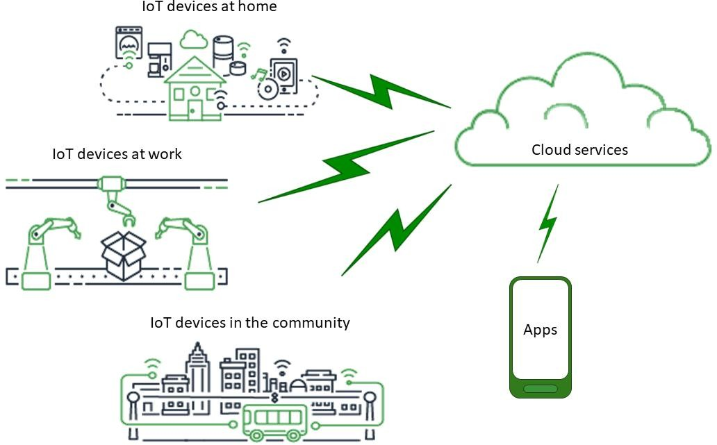

**Fig 2.2.1: AWS using IoT**

Amazon Web Services (AWS) is a cloud computing platform that offers a variety of services, including Internet of Things (IoT) services. Amazon IoT is a platform that allows devices to connect to the cloud, gather and analyse data, and create applications and services based on that data. The network of physical objects, including machines, automobiles, household appliances, and other objects, is referred to as the "Internet of Things." These objects are equipped with sensors, software, and other technologies that allow them to connect and exchange data across a network. IoT devices may be utilised for a variety of purposes, including environmental monitoring, industrial automation, and home automation. For the development of complete Bluetooth Low Energy (BLE) beacon applications, Amazon offers services. Small, battery-operated BLE beacons send data to neighbouring devices using Bluetooth technology. Many uses for them exist, including proximity marketing, asset monitoring, and interior navigation.

### EMQX Broker

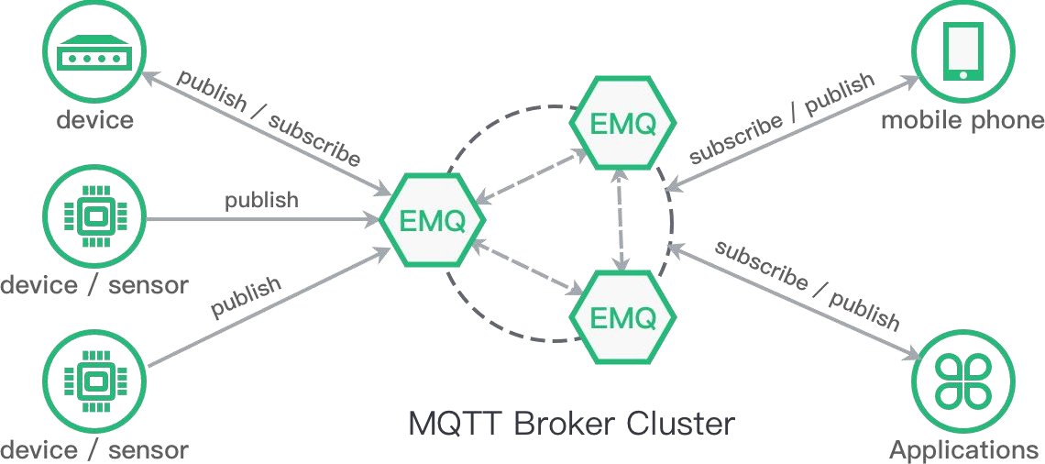

**Fig 2.2.2: EMQX Model**

EMQ X is an open-source, highly scalable, distributed MQTT message broker for IoT, M2M, and mobile applications. In IoT applications where devices have constrained processing power and battery life, MQTT is a messaging protocol that is created to be lightweight and effective. In order to enable millions of concurrent connections and message transfers per second, EMQ X is built to be very scalable. It may be set up on a solitary system or over a network. EMQ X allows automated fail over and clustering, making sure that MQTT clients may connect to a broker even if one or more nodes fail. EMQ X supports widely used security technologies including SSL/TLS encryption, as well as procedures for authentication and authorization. EMQ X allows bridging between several MQTT brokers as well as MQTT 3.1, MQTT 3.1.1, and MQTT 5.0.

Many IoT applications, including smart cities, industrial automation, and home automation, can make use of EMQ X. It offers an effective, scalable, and secure messaging infrastructure that makes it possible for IoT devices to interact with cloud services as well as one another. Moreover, EMQ X makes it simpler to create and manage IoT applications by offering an intuitive interface for managing and watching MQTT connections and messages.

**CHAPTER 3**

# Design and Implementation

### Introduction

Every living creature on this earth has an important role in the ecosystem. Livestock management is a very essential part of animal husbandry. This project attempts to propose an advanced animal track- &-trace Supply-Chain Management (SCM) network for activities and real-time data collection and storage by employing certain Internet of Things' solutions, such as AWS IoT core using BLE Beacon and Raspberry Pi. Bluetooth beacons are hardware transmitters, a class of [Bluetooth Low Energy](https://en.wikipedia.org/wiki/Bluetooth_Low_Energy) (BLE) devices that broadcast their identifier to nearby [portable electronic](https://en.wikipedia.org/wiki/Mobile_computing) devices.

Amazon Web Services has developed AWS IoT Core which is a fully managed IoT cloud platform that lets connected devices to interact with cloud services and other devices securely and conveniently. The Core allows users to easily connect to other AWS services - AWS Lambda, AWS Kinesis, AWS IoT Analytics and many more that provides a range of compute, storage, networking, management, analytics and other capabilities, as shown in Fig 2.1.1. AWS with its huge computing space and variety of processing capabilities provide a low-cost scalable infrastructure as a service model. Its massive global presence with servers scattered widely and pricing policies which include an entry level free tier, charge by usage and literally no fixed charges makes it convenient for start-ups and growing businesses. AWS IoT Core architecture lets users connect to server without the hassle of managing or updating it in addition to providing security and reliability to data transfer. It can support a billion of devices at a time and save its current state as a shadow profile and update it continuously so that users can connect to it even when the device is offline. The Core provides end to end encryption on the data and can control access permission by means of policies. Simple condition matching to control actuators can be done on the data through use of IoT rules and it can also be connected to other services for higher processing. IoT Core supports HTTP, WebSocket, and MQTT- the light weight IoT protocol.

### System Design

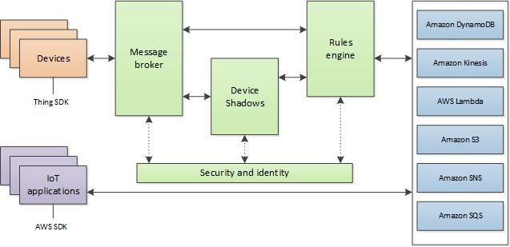

**Fig 3.1.1 AWS IoT core services**

There are various advantages to the proposed animal track-and-trace SCM network that uses Amazon IoT Core and BLE Beacon. It enables real-time livestock tracking and data collecting, which may be utilised for a variety of objectives such as guaranteeing their health and wellbeing, monitoring their movement, and controlling their supply chain. Because the beacon may be connected to the animal and transmit its identity to adjacent devices, it enables for simple and convenient tracking.

A safe and dependable platform for handling and storing the acquired data is provided through the usage of Amazon IoT Core. Moreover, it provides a variety of computation, storage, and networking capabilities, enabling additional data processing and analysis. The Core supports MQTT, a simple IoT protocol that makes it possible for devices to communicate and transmit data quickly.Using Amazon IoT Core and BLE Beacon, the proposed animal track-and-trace SCM network provides a complete solution for monitoring and tracking animals in a supply chain. It enables the collecting and storing of data in real-time and the connection to other services for additional processing and analysis.

### Block Diagram

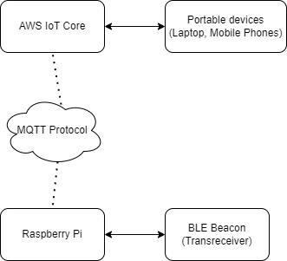

**Fig 3.2.1: Block Diagram of Livestock Management**

### Working Principle

The Raspberry Pi serves as the system's brain in this project. The AWS IoT core is linked to the Raspberry Pi via MQTT, which allows for bidirectional machine-to-machine communication. Furthermore, the raspberry pi is Bluetooth-connected to the BLE Beacon. TheBLE Beacon is used to locate livestock. Bluetooth beacons are a type of Bluetooth Low Energy (BLE) device that broadcasts its identifier to nearby portable electronic devices. When smartphones, tablets, and other devices are in close proximity to a beacon, the technology allows them to perform actions. AWS IoT offers cloud services for connecting your IoT devicesto other devices and AWS cloud services. AWS IoT device software assists you in integrating your IoT devices into AWS IoT- based solutions.

#### AWS IoT Setup

AWS IoT Core supports connections with IoT devices, wireless gateways, services, and apps. Devices connect to AWS IoT Core, so they can send data to and receive data from AWS IoT services and other devices. Apps and other services also connect to AWS IoT Core to control and manage the IoT devices and process the data from IoT solution. This section describes how to choose the best way to connect and communicate with AWS IoT Core for each aspect of your IoT solution.

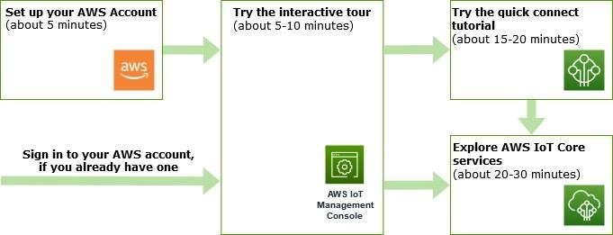

#### Fig 3.1.1: AWS IoT core setup

1. **Connect device to AWS IoT Core Step 1 :- Prepare IoT Device**

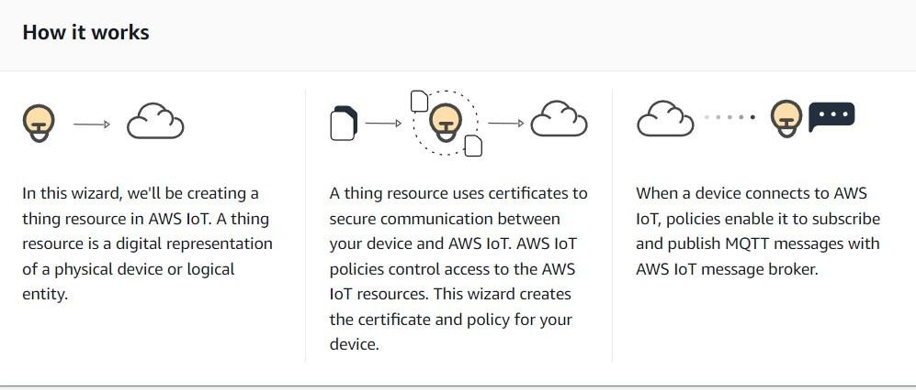

#### Step 2 :- Register and Secure IoT device

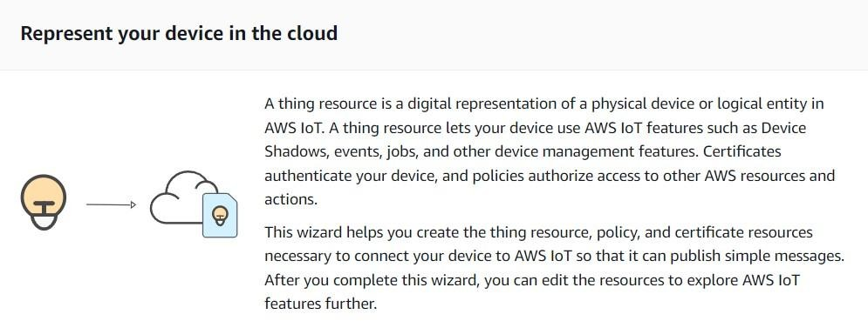

**Step 4 :- Download connection kit**

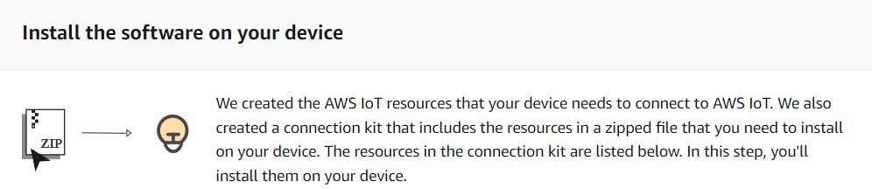

#### Step 5 :- Run Connection Kit

After running the start script, return to this screen to see the messages between your device and AWS IoT. The messages from your device appear in the following list.

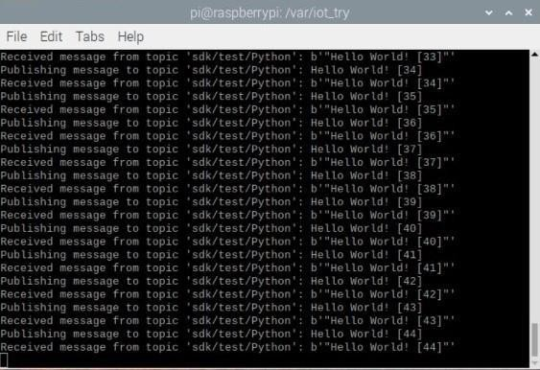

**Fig 3.3.1: Message sent from Raspberry Pi to AWS IoT Core via MQTT Protocol**

### System flowchart

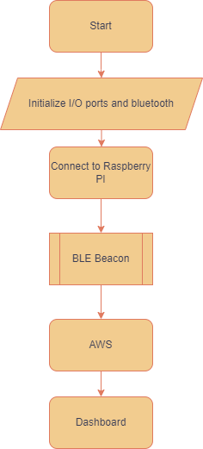

**Fig 3.4.1: System Flowchart**

Temperature, humidity, and other environmental data are gathered by sensors installed in the animal areas. The EMQ X Broker, which serves as a middleman between the devices and the cloud, receives the data after it has been gathered.The data is sent via the MQTT protocol, a lightweight messaging system appropriate for IoT applications. The EMQ X Rules Engine may be used to process and filter data as it comes in. This enables real-time data analysis and the ability to send alerts or notifications when particular criteria are surpassed.Using a technology like Grafana, a dashboard may be developed to display the data collected in real-time. Farmers and managers can use this dashboard.Based on the findings of the study, farmers or managers can take the required steps to improve livestock management, such as revising feeding schedules, changing the environment, or treating any ill animals.

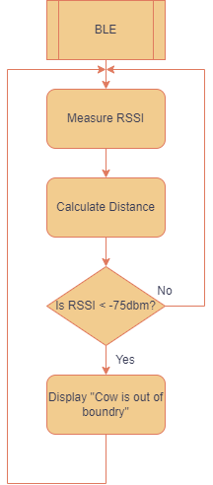

**Fig 3.4.2: BLE Beacon working flowchart**

### Design flow

### 

### Fig 3.5: Design flow

### 3.6 Summary

Using AWS IoT, livestock management involves gathering data from sensors installed in livestock areas, sending the data to AWS IoT Core. The proposed animal track-and-trace SCM network using AWS IoT Core and BLE Beacon offers a comprehensive solution for managing and tracking livestock. It allows for real-time data collection and storage, as well as the ability to connect to other services for further processing and analysis. The use of BLE Beacon allows for easy and convenient tracking, while the use of AWS IoT Core provides a secure and reliable platform for data management.

In order to fulfil the rising demands on farms and enable them to run effectively and precisely using technology, AWS is collaborating with AGCO. Solutions for managing livestock that are IoT-enabled remove uncertainty regarding herd health. Battery-powered sensors that are attached to an animal's collar or tag track its location, temperature, blood pressure, and heart rate while wirelessly transmitting the information to a farmer's device in almost real-time.

**CHAPTER 4**

# Software Implementation

### AWS IoT Core

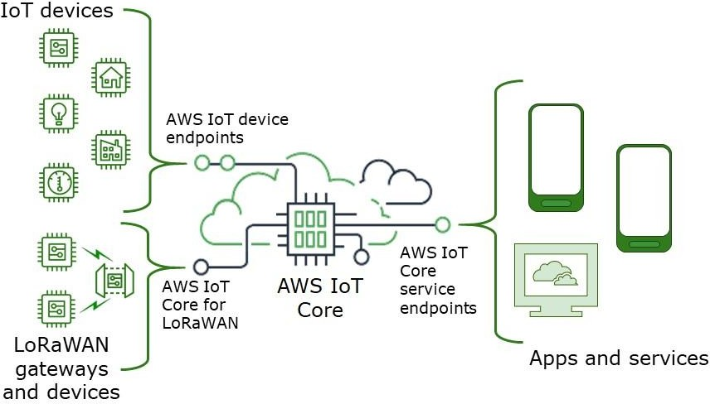

#### Fig 4.1.1: AWS IoT Core

AWS IoT provides the cloud services that connect your IoT devices to other devices and AWS cloud services. AWS IoT provides device software that can help you integrate your IoT devices into AWS IoT-based solutions. If your devices can connect to AWS IoT, AWS IoT can connect them to the cloud services that AWS provides. AWS IoT lets you select the most appropriate and up-to-date technologies for your solution. To manage and support IoT devices in the field, AWS IoT Core supports these protocols:

* [MQTT (Message Queuing and Telemetry Transport)](https://docs.aws.amazon.com/iot/latest/developerguide/mqtt.html)
* [MQTT over WSS (WebSocket’s Secure)](https://docs.aws.amazon.com/iot/latest/developerguide/mqtt.html)
* [HTTPS (Hypertext Transfer Protocol - Secure)](https://docs.aws.amazon.com/iot/latest/developerguide/http.html)
* [LoRaWAN (Long Range Wide Area Network)](https://docs.aws.amazon.com/iot/latest/developerguide/connect-iot-lorawan.html)

The AWS IoT Core message broker supports devices and clients that use MQTT and MQTT over WSS protocols to publish and subscribe to messages. It also supports devices and clients that use the HTTPS protocol to publish messages. AWS IoT Core for LoRaWAN helps you connect and manage wireless LoRaWAN (low-power long-range Wide Area Network) devices. AWS IoT Core for LoRaWAN replaces the need for you to develop and operate a LoRaWAN Network Server (LNS).

### EMQX

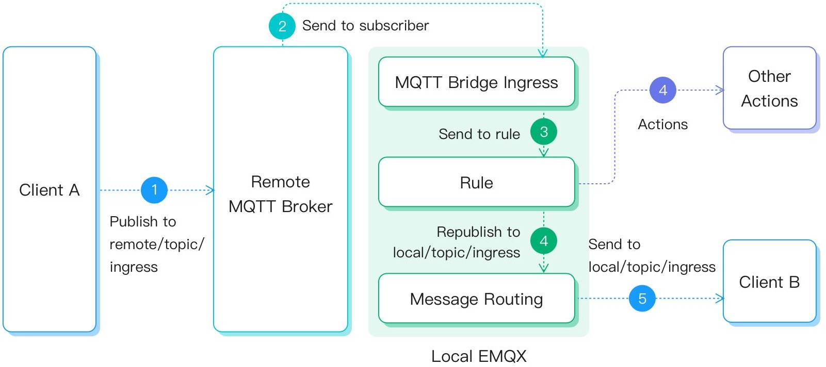

#### Fig 4.2.1: EMQX

EMQ X provides a web-based dashboard for managing and monitoring the broker. It provides real-time metrics, such as message throughput, connection counts, and broker performance. It also provides detailed logs and error messages for troubleshooting and debugging. A distributed MQTT message broker that is open- source and optimized for handling massive IoT applications is called EMQ X. For IoT applications, it offers excellent performance, stability, and scalability, making it a popular option for developers and businesses. The MQTT 5.0, MQTT 3.1.1, and Web Socket protocols are all supported by EMQ X, along with plugins for adding new features. It may be utilized for a variety of IoT applications, including industrial IoT, smart cities, and smart homes. IoT data management is made flexible and customized with EMQ X, which also enables real-time data processing, filtering, and analytics.

### PAHO Javascript

Paho JavaScript is a JavaScript client library for MQTT, a lightweight messaging protocol developed for Internet of Things (IoT) applications. Paho JavaScript is an Eclipse Paho project that provides a simple and user-friendly API for connecting to MQTT brokers and publishing/subscribing to MQTT topics.

Developers may use Paho JavaScript to create web-based IoT apps that connect with MQTT-enabled devices and servers. The library works with a variety of platforms and frameworks and supports both browser-based and Node.js applications. Paho JavaScript adheres to the most recent MQTT 5.0 protocol, which includes capabilities such as Quality of Service (QoS) levels, Last Will and Testament (LWT), and persistent sessions. SSL/TLS encryption is also supported for secure communication. Paho JavaScript is a popular programming language for developing web-based IoT applications that require real-time data transfer and may be used for a variety of IoT use cases such as home automation, industrial automation, and smart cities.

### MQTT Protocol

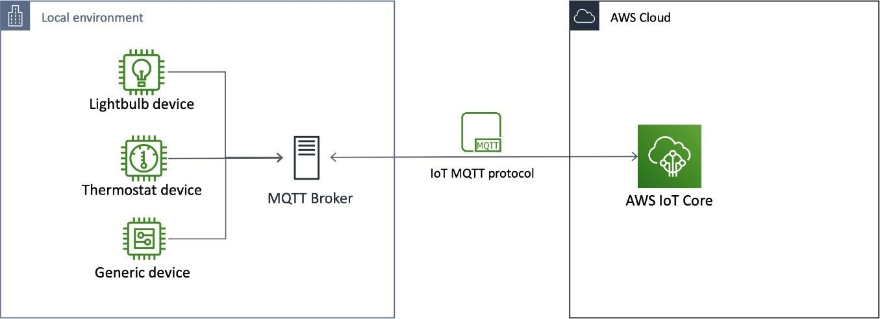

#### Fig 4.4.1: MQTT Protocol

MQTT is an open source protocol that follows publish - subscribe mechanism for many to many distributions as shown in Fig. 3. It is lightweight and bandwidth efficient as it uses a small header and it also has continuous session awareness. It is designed to minimize use of device resources and ensure reliability and varying degrees of service delivery assurance . Using MQTT, the clients do not communicate directly with the endpoint; publish - subscribe mechanism decouples the client (publisher) who is sending the message and another client (subscriber) who is receiving the message. MQTT architecture The MQTT broker connects the publishers and subscribers. It receives all incoming messages from the publishers, filters them and redistributes them accordingly such that only specific clients receive specific messages.

**4.5 Balena IoT Dashboard**

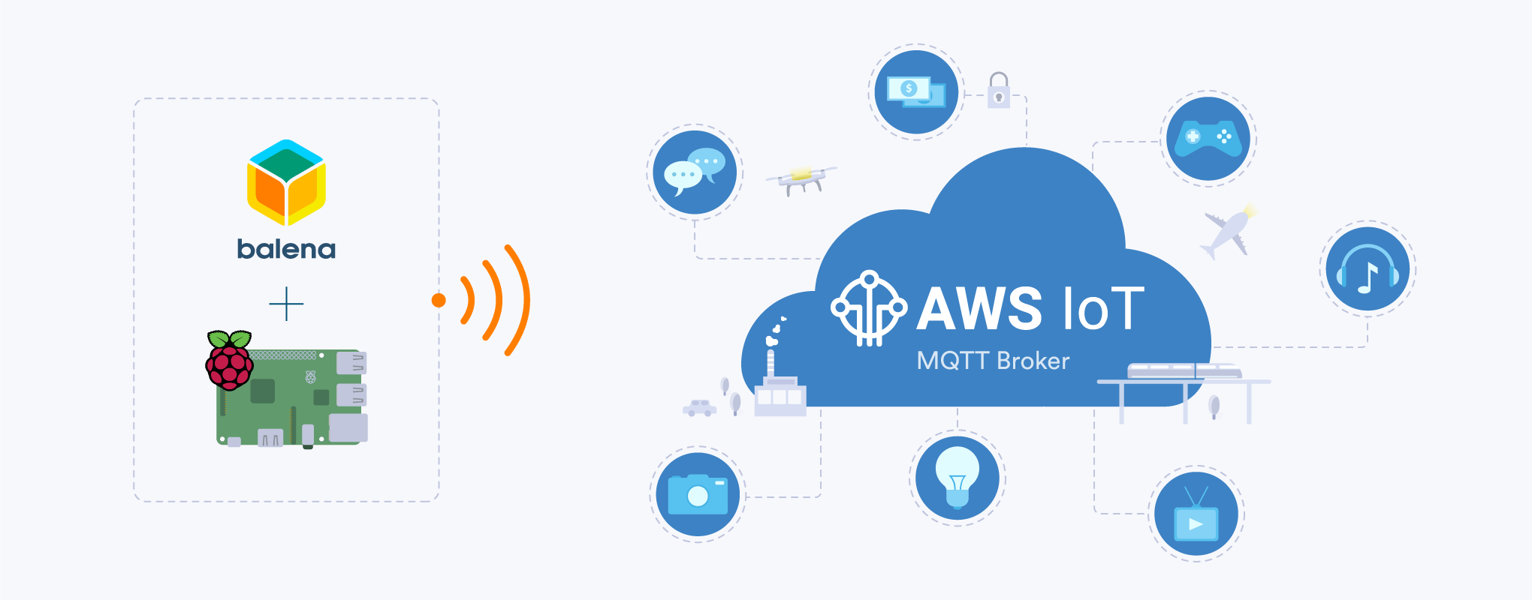

#### Fig 4.5.1: Balena.io

The [AWS IoT](https://aws.amazon.com/iot) platform provides a valuable suite of services to collect, store, and distribute IoT data and actions. Its [IoT Core](https://aws.amazon.com/iot-core) service is the portal for registration and messaging with Internet-connected things. We want to make it easy for balena devices to register and interact with IoT Core.

IoT provisioning tools automate device registration to AWS IoT Core, and leverage balenaCloud and environment variables to store and access the registration credentials. This guide shows how provisioning works and gets project started with the tools in the [aws-iot-provision](https://github.com/balena-io-examples/aws-iot-provision) repository.

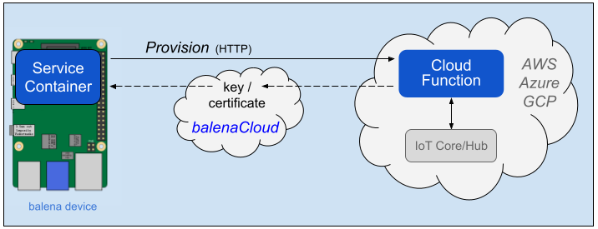

#### Fig 4.5.2: Cloud IoT Provisioning with AWS

Provisioning includes three components:

* ****Service Container**** like [Cloud Relay block](https://github.com/balena-io-examples/cloud-relay) on a device to request the provisioning and use the credential environment variables from balenaCloud
* ****Lambda (cloud) function**** to securely validate device identity and register the device with IoT Core, triggered by an HTTP request ([source code](https://github.com/balena-io-examples/aws-iot-provision/blob/master/index.js))
* ****balenaCloud**** to accept and store the generated key/certificate credentials for the device

**CHAPTER 5**

* 1. **Results**

# Results and Discussion

#### Steps Involved

* Successfully created AWS account.
* AWS IoT Setup Successfully completed.
* Set up a directory to test MQTT publishing.
* Installed pip and the AWS IoT SDK for Python.
* Created an AWS IoT Core policy.
* Created an AWS IoT thing.
* Created a Python Program file to publish the message via Raspberry Pi and AWS IoT Core through MQTT Protocol.
* Tested the Setup.
* Received the message from Raspberry Pi and got the response in AWS Console**.**
* Connected BLE Beacon to Raspberry pi and viewed the MAC Address of BLE Beacon.
* Client-side server is connected successfully.

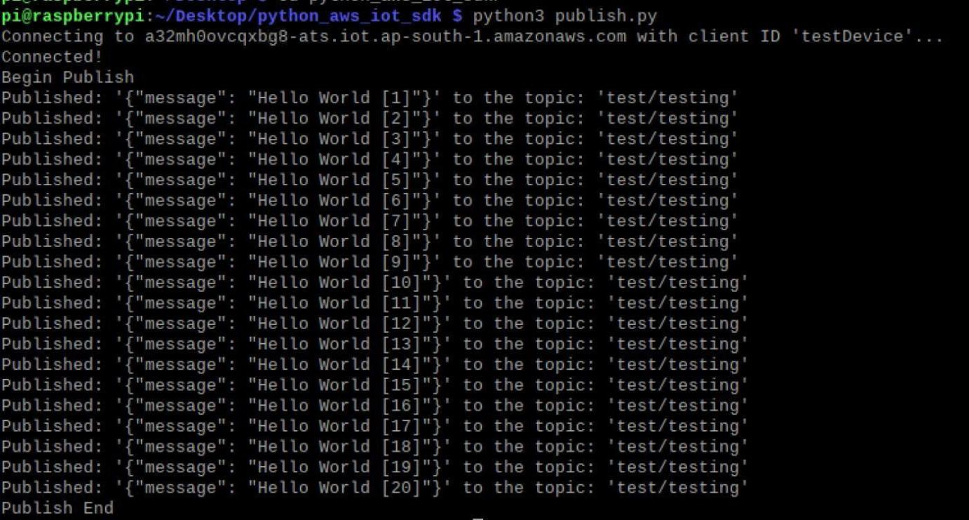

#### Fig 5.1.1: Message published on Raspberry Pi

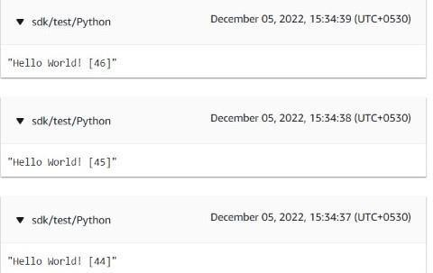

**Fig 5.1.2: Message received by the subscriber AWS management console**



#### Fig 5.1.3: BLE Beacon connected to Raspberry Pi

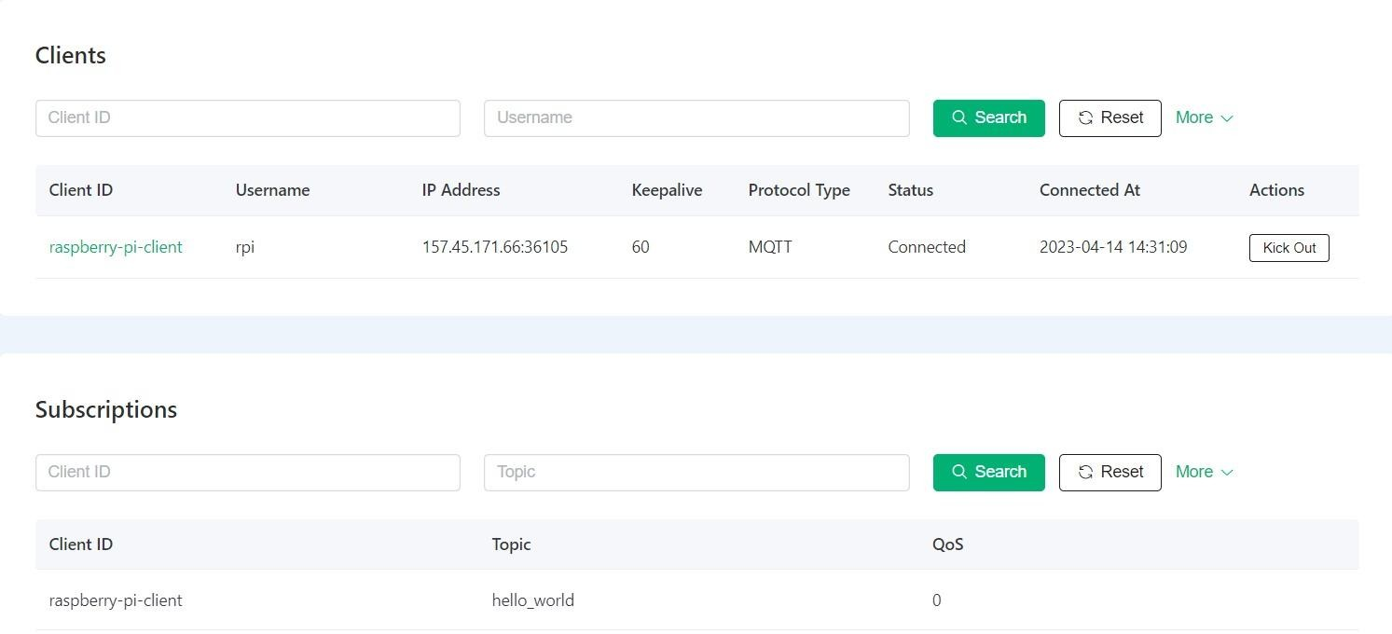

**Fig 5.1.4: EMQX MQTT Broker-Client message Pub/Sub**

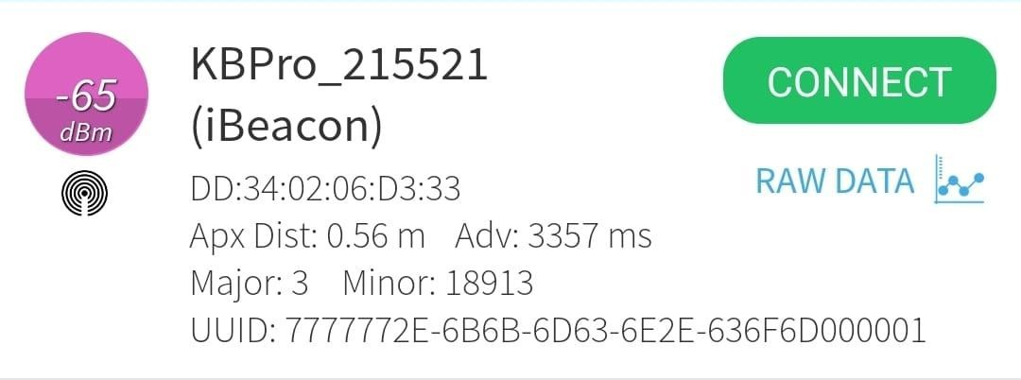

#### Fig 5.1.5: BLE Beacon Distance Measuring

### 

**Fig 5.1.6: Histogram representing RSSI values vs distance for near objects**

### 

**Fig 5.1.7: Graph representing distance of near objects**

### 

**Fig 5.1.8: Graph representing distance of far objects**

### 

### **Fig 5.1.9: Histogram representing RSSI values vs distance for near objects**

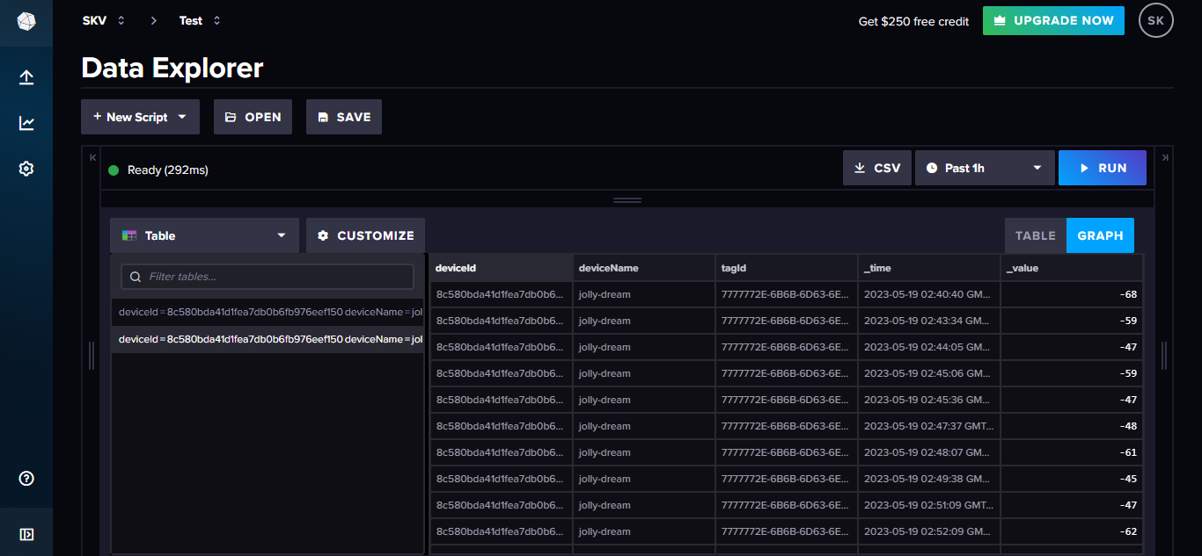

**Fig 5.1.10: Table Representation**

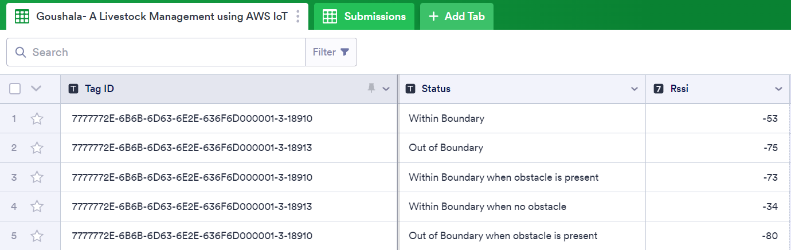

**Fig 5.1.11: BLE Interface**

### **Balena.io Setup**

### Create an InfluxDB Cloud Account

First going to set up the cloud database first, since our project need some information from it later.  
InfluxDB Cloud 2.0 (in public beta at the time of writing) is a Time Series-as-a-Platform database technology.

#### Set up AWS account

First, create an account on the [InfluxDB Cloud 2.0](https://www.influxdata.com/products/influxdb-cloud-2-0/) site, choosing AWS as the cloud provider:

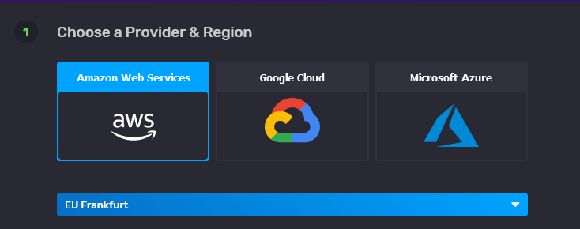

1. Create bucket and token in InfluxDB Cloud

To enable the Raspberry Pi's services to read from and write to the bucket, a token must be created. As long as it is set up to read and write to the bucket that was just established, users can use the same token many times in this situation:

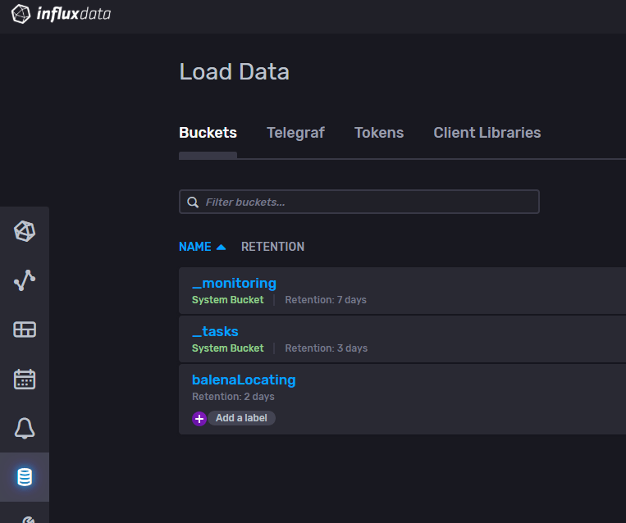 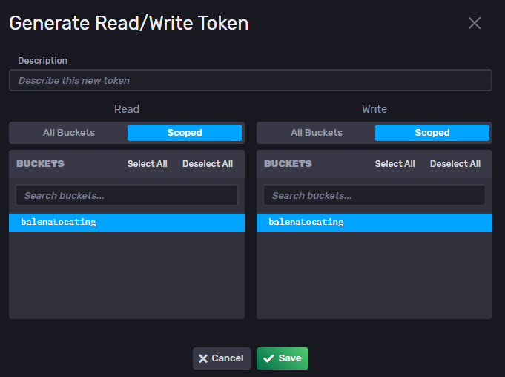

1. Setup the Raspberry Pi

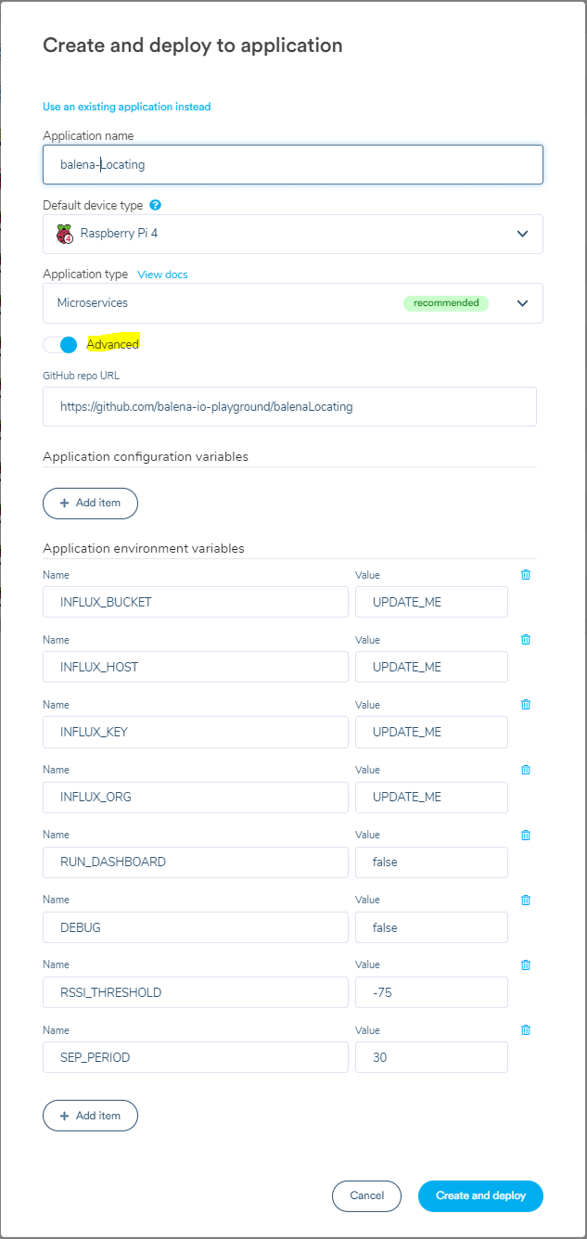

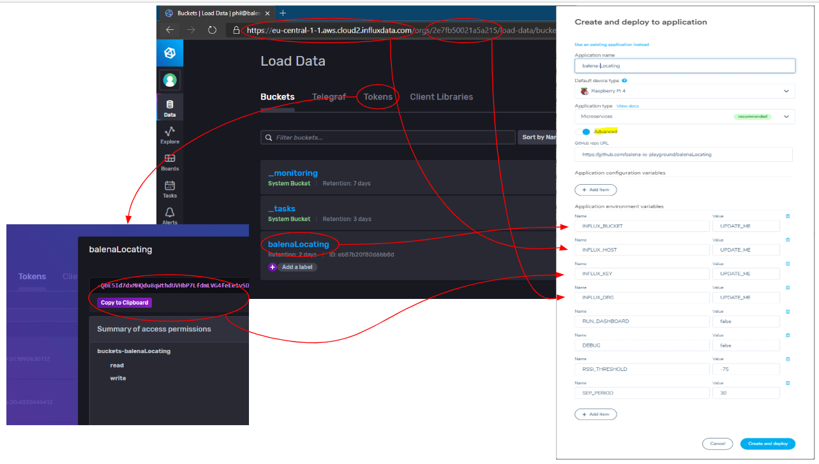

Click Create and Deploy at this point.

By doing this, an application will be generated with all of the code deployed and the device variables created and set!

#### Add a device and download the balenaOS disk image from the dashboard

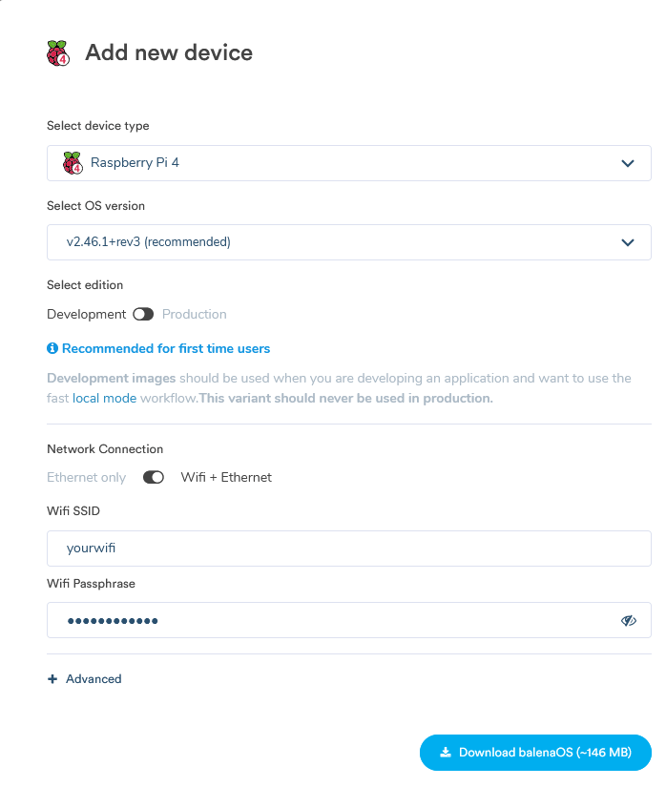

This process generates a customized image that is tailored for the application and device type and, if user requested them, includes network configurations.

#### Flash SD card with the balenaOS disk image and boot the device



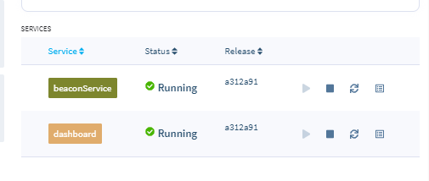

### View the Dashboard

The dashboard is a simple web app which queries the cloud database to find the last time a beacon was detected, and which sensor detected it. To view it, turn on user device’s Public URL:

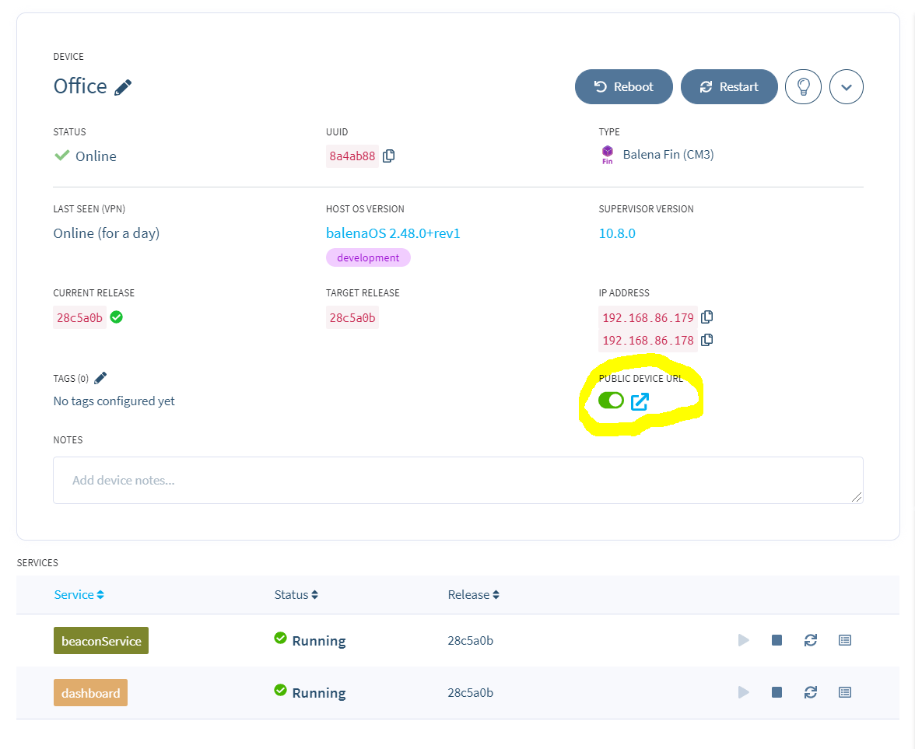

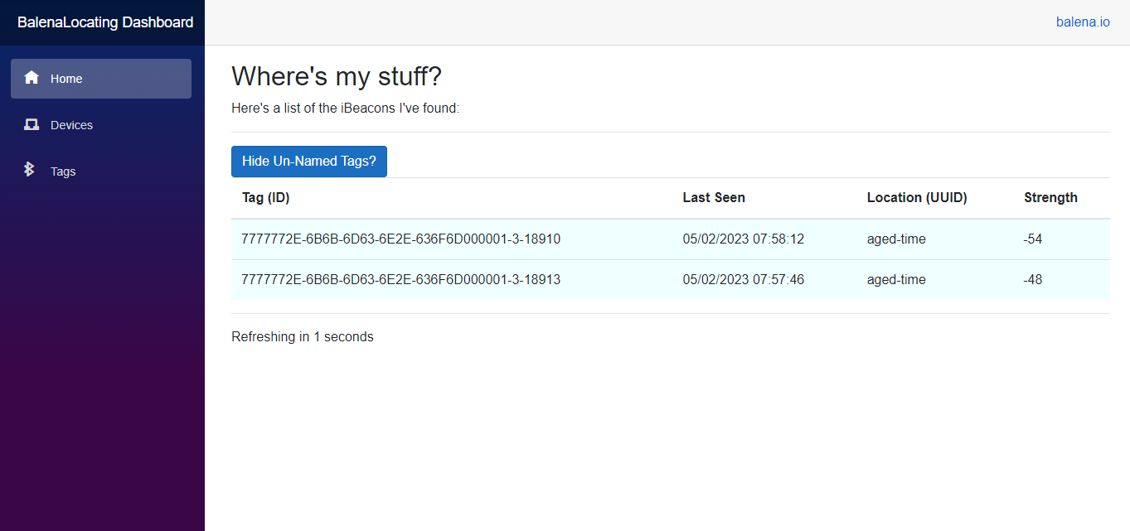

There's a tag on work with the lengthy ID FDA50693-A4E2-4FB1-AFCF-C6EB07647825-10011-10011. while haven't yet given it a name. likewise find that the website provides information about the location, signal strength, and the most recent time it was seen. Maybe don't need to continuously refreshing the browser to see the most recent information because underneath the table is a countdown till the table changes.

The 'place (UUID)' column displays a mapping between the place that each device in the balenaCloud application represents and its UUID. In reality, this location value is just the device's name; I'll teach how to rename a device shortly. The device(s) will initially have names generated by Balena.

* 1. **Societal Benefits**

Animal husbandry includes a critical component called livestock care. There have been several occasions where livestock has vanished and then been found dead. This is primarily a result of the cattle being poorly controlled by the handlers. To solve this problem, we have created a technique. The caretaker's obligation is diminished in this situation. When the herd enters a dangerous area, he may react quickly and bring them back to safety. By enhancing animal health and production, AWS IoT may help increase the supply of high-quality meat, dairy, and other livestock products. In underdeveloped countries, in particular, this can help to improve food security and reduce the risk of food shortages. Farmers can get help from AWS IoT to make the most use of resources like grain, water, and pastureland. This may minimise the impact of animal production on the environment, including greenhouse gas emissions and water use.AWS IoT's real-time monitoring of vital signs, location, and behaviour may help identify animals in need of medical care and ensure that they get it quickly. This has the potential to improve animal welfare and reduce mortality rates, two important social objectives.

**CHAPTER 6**

# Conclusion and Future Scope

### Advantages

* **Improved data collection:** AWS IoT allows for the collection of massive volumes of data from sensors and devices put on animals and their environments. This information may be analyzed in real time, giving farmers insights on animal health, behaviour, and productivity.
* **Remote monitoring:** AWS IoT enables farmers to remotely monitor their animals and their surroundings, decreasing the need for physical inspections and enabling for the discovery of concerns like as disease outbreaks to occur more quickly.
* **Predictive analytics:** Using AWS IoT to analyse data and detect trends, farmers may forecast and avoid problems before they arise. Sensors, for example, may be used to track feed intake and anticipate when an animal will become unwell or give birth.
* **Improved efficiency:** AWS IoT can assist farmers in automating processes such as feeding and watering, lowering labour costs and increasing operational efficiency.
* **Improved animal welfare:** By monitoring vital signs, location, and behaviour in real time, AWS IoT can assist identify animals in need of medical attention and guarantee that they receive prompt treatment. This has the potential to increase animal well being and lower death rates.
* **Environmental monitoring:** AWS IoT may be used to monitor and regulate environmental elements such as temperature and humidity, ensuring that animals are housed in the best possible circumstances. This can assist cattle minimize stress and disease, boosting their health and production.

### Limitations

While using AWS IoT in livestock management has various advantages, there are also restrictions and problems to consider. Here are some of the restrictions:

* **Cost:** Implementing AWS IoT systems can be costly, particularly for small and medium-sized farms. The cost of sensors, devices, and infrastructure might be prohibitively expensive, and there may be continuing expenditures for data storage and processing.
* **Technical expertise:** Setting up and maintaining an AWS IoT system involves specialised technical knowledge, which some farmers may not have or find practicable. This can be a hurdle to adoption, limiting the benefits of these systems to bigger, more technologically advanced farms.
* **Data privacy and security:** Collecting and analysing data from cattle might generate privacy and security concerns. Farmers must ensure that sufficient precautions are in place to protect their animals' privacy and prevent unauthorised access to sensitive data.
* **Connectivity:** AWS IoT requires a consistent and dependable internet connection, which may not be accessible in all places. Poor connection can restrict these devices' use and hinder real-time monitoring and analysis.
* **Compatibility:** AWS IoT may not be suitable for all cattle or farming operations. Different types of sensors and devices may be required for different animal species, and certain agricultural operations may not lend themselves to the deployment of IoT technology.

#### Applications

AWS IoT may be used for livestock management in a variety of ways, some of which are as follows:

* Animal health and behaviour may be monitored using AWS IoT, which provides real-time data on vital signs, mobility, and other parameters. This information may be used to detect early symptoms of disease or damage, allowing farmers to intervene before the situation worsens.
* AWS IoT can assist farms in optimizing breeding cycles and improving reproductive success. Sensors can identify when animals are in heat, allowing farmers to better schedule insemination and enhance the chance of successful fertilization.
* AWS IoT can assist farmers in optimizing their livestock feeding and nutrition programmes. Sensors may be used to monitor feed and water intake, providing data on consumption rates and assisting farmers in making ration adjustments for optimal development and health.
* Web Application Hosting: AWS provides scalable and reliable infrastructure to host web applications. Services like Amazon EC2 (Elastic Compute Cloud), AWS Elastic Beanstalk, and AWS Lambda allow developers to deploy and manage applications easily.
* Data Storage and Management: AWS offers various storage options, such as Amazon S3 (Simple Storage Service) for object storage, Amazon EBS (Elastic Block Store) for block-level storage, and Amazon RDS (Relational Database Service) for managed databases. These services provide durability, scalability, and ease of data management.
* Internet of Things (IoT): AWS IoT services provide a platform for securely connecting and managing IoT devices. AWS IoT Core allows devices to communicate with the cloud, while services like AWS IoT Analytics and AWS IoT Events enable data analysis and automation based on IoT device data.
* Machine Learning: AWS offers a suite of services for machine learning and artificial intelligence (AI). Amazon SageMaker provides a fully managed platform for building, training, and deploying machine learning models. AWS Rekognition offers image and video analysis, while Amazon Comprehend provides natural language processing capabilities.
* DevOps and Continuous Integration/Deployment (CI/CD): AWS provides tools like AWS CodePipeline and AWS CodeDeploy for building automated workflows and managing the continuous integration, delivery, and deployment of applications. Services like AWS CodeCommit and AWS CodeBuild support source code management and build processes.

#### Conclusion

The use of AWS IoT for livestock management has the potential to revolutionize the way farmers manage their cattle. AWS IoT may help farmers optimize their operations, increase animal welfare, and cut costs by giving real-time data on animal health, behaviour, and environmental factors. The benefits of implementing AWS IoT in livestock management include increased production, efficiency, and profitability, as well as decreased environmental impact and increased food security.Implementing AWS IoT in livestock management also has several obstacles and constraints, such as the high cost of installation, the requirement for technical skills, worries about data privacy and security, and the requirement for a dependable internet connection. Despite these obstacles, AWS IoT has enormous potential benefits in livestock management, and the technology is fast expanding. As more farmers utilize these systems and develop experience with them, the benefits are expected to expand and the limits will be addressed. Overall, using AWS IoT in livestock management is a great potential for farmers to better their operations while also contributing to a more sustainable and responsible agricultural industry.

#### Future Scope

AWS IoT may be used with predictive analytics and machine learning algorithms to find trends in animal behaviour, find early indicators of sickness, and improve breeding and feeding practise. Robotic systems may be connected to AWS IoT to automate duties like feeding, cleaning, and monitoring, which lowers labour costs and boosts productivity. AWS IoT can be combined with other cutting-edge innovations like block-chain and precision farming to give a more complete picture of the whole livestock supply chain. AWS IoT may be used to monitor livestock in rural locations as internet connectivity spreads, allowing farmers to grow their businesses and access new markets. AWS IoT may be tailored to match the particular requirements of various livestock species, production methods, and geographical locations, enabling farmers to adjust their management practices to their particular situation.

# References

1.Karan Juj, Charith Perera, “Exploring the Suitability of BLE Beacons to Track Poacher Vehicles in Harsh Jungle Terrains”, Cardiff University, United Kingdom, IEEE-2020.

2.J. M. R. de S. Neto, J. J. C. Silva, T. C. M. Cavalcanti, D. P. Rodrigues and J. S. da Rocha Neto, Ian A. Glover, “Propagation Measurements and Modeling for Monitoring and Tracking in Animal Husbandry Applications”, Department of Electronic & Electrical Engineering University of Strathclyde, Scotland, UK and CAPES Visiting Professor, Universidade Federal de Campina Grande, Campina Grande - PB, Brazil,IEE-2010.

3.Brad Kennedy, Graham W. Taylor, Petros Spachos,”BLE Beacon Based Patient Tracking in Smart Care Facilities”,School of Engineering, University of Guelph, Guelph, ON, N1G 2W1, Canada, Demonstration on Pervasive Computing and Communications 2018.

4.Kais Mekki, Eddy Bajic, Fernand Meyer, “Indoor Positioning System for IoT Device based on BLE Technology and MQTT Protocol”, Research Centre for Automatic Control of Nancy, Campus Sciences, BP 70239, Vandoeuvre, 54506, France, IEEE 5th World Forum on Internet of Things (WF-IoT), 2019.

5.Nadia Imtiaz Jaya,Md. Farhad Hossain, “A Prototype Air Flow Control System for Home Automation using MQTT over Websocket in AWS IoT Core”, Departmentof Electrical and Electronic Engineering Bangladesh University of Engineering and Technology Dhaka-1205, Bangladesh, International Conference on Cyber-Enabled Distributed Computing and Knowledge Discovery-2018

**Appendix**

# Expenditure

|  |  |  |  |
| --- | --- | --- | --- |
| **Sl No.** | **Components** | **No. Of Components** | **Cost** |
| 1. | Raspberry Pi 3 Model B+ | 1 | Rs. 3800 |
| 2. | BLE Beacon | 2 | Rs. 1500 |
|  |  | **Total cost** | Rs.5300 |