List of experiments in computer networks

CSA0726

NAME: K.HARSHA

REG NO.:192212017

Experiment no:6

Configuration of hybrid topologies using packet tracer

### AIM:

Toestablishof hybird topologies using packet tarcer

### REQUIREMENTS:

1. End device-Theyarethedevicesthroughwhichwe can passmessagefromonedevicetoanotherandtheyareinterconnected.
2. Switch/Hub -InterfaceBetweentwodevices.
3. Cable -Usedtoconnecttwodevices.

Procedure:

**STEP**1:Clickonenddevices,select genericPc’s draganddropitonthewindow. Clickon SWITCHdraganddrop iton thewindow.

**STEP**2: Selectthestraightthrough cable andconnect allend devicetoswitch. Assign

the IPaddress for all enddevices.(Doubleclick the enddeviceSelect→

desktop →IPconfigurationstatic)

**STEP**3:NowsettheIPaddresstoHostA(192.168.1.1)instaticmode.Similarlyset

IPaddressforHost B (192.168.1.2)and Host C (192.168.1.3)

**STEP**4:To viewthe IPaddress,give ipconfigcommandin command prompt.Usingping command, wecanestablish communication betweentwo hostdevices.

**STEP** 5: Now display the packet transmission in simulation mode.

hybird topologies

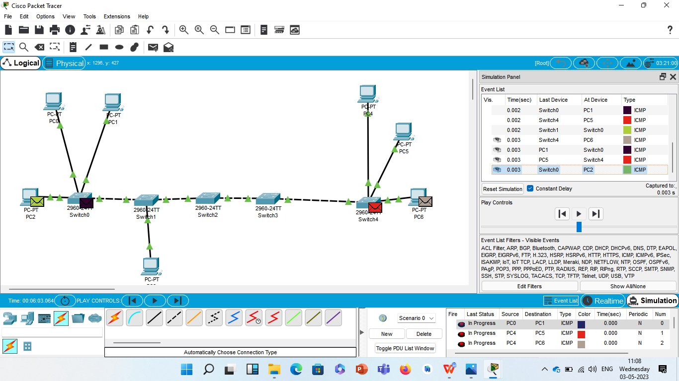

Result:

Configuration of Network hybird topologies using packet tracer verified successfully.