**PICTURE**

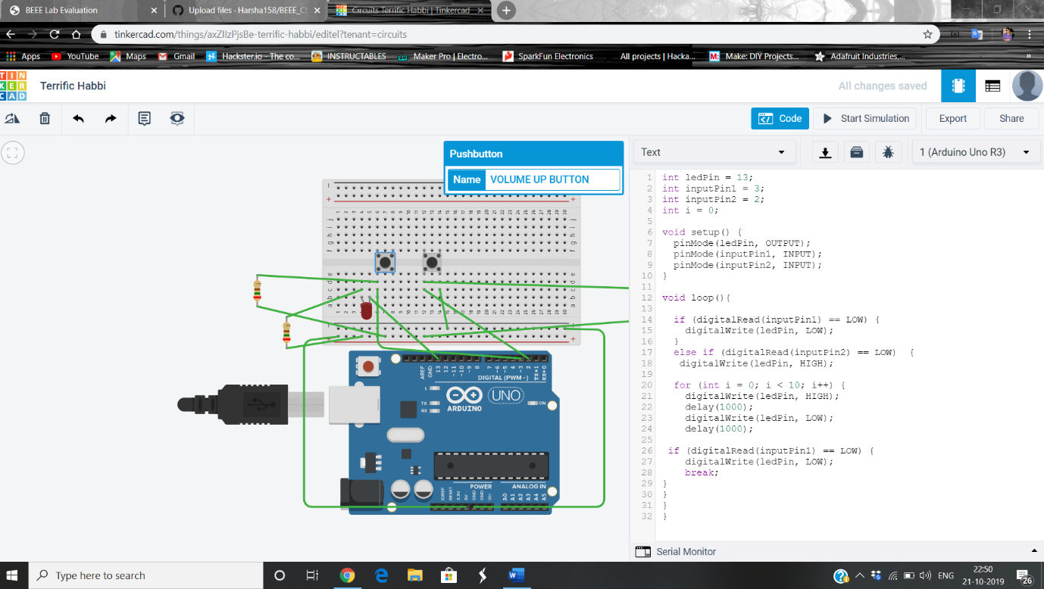

**THEORY**

**A system for car stereo systems such that whenever the increase volume button is pressed, a red background given by red LED blinks the number of times the button is pressed.**

**MATERIALS REQUIRED**

Breadboard Sheet  
Arduino Duemilanove  
2 Push Buttons  
2 10K OHM Resistors - Brown - Black - Orange  
1 560 OHM Resistor Green - Blue - Brown  
1 Red LED  
7 wires

**CODE**

int ledPin = 13;

int inputPin1 = 3;

int inputPin2 = 2;

int i = 0;

void setup() {

pinMode(ledPin, OUTPUT);

pinMode(inputPin1, INPUT);

pinMode(inputPin2, INPUT);

}

void loop(){

if (digitalRead(inputPin1) == LOW) {

digitalWrite(ledPin, LOW);

}

else if (digitalRead(inputPin2) == LOW) {

digitalWrite(ledPin, HIGH);

for (int i = 0; i < 10; i++) {

digitalWrite(ledPin, HIGH);

delay(1000);

digitalWrite(ledPin, LOW);

delay(1000);

if (digitalRead(inputPin1) == LOW) {

digitalWrite(ledPin, LOW);

break;

}

}

}

}