
RAJALAKSHMI INSTITUTE OF TECHNOLOGY
(An Autonomous Institution, Affiliated to Anna University, Chennai)

DEPARTMENT OF CSE (ARTIFICIAL INTELLIGENCE AND MACHINE LEARNING)
ACADEMIC YEAR 2025 - 2026
SEMESTER III
ARTIFICIAL INTELLIGENCE LABORATORY
MINI PROJECT REPORT

REGISTER NUMBER | 2117240030043
NAME | HARSHA LAKSHMI S
PROJECT TITLE | AI AGENT FOR CONNECT-4 GAME USING GAME TREE SEARCH
DATE OF SUBMISSION
FACULTY IN-CHARGE | Mrs. M. Divya

Signature of Faculty In-charge

INTRODUCTION
- The Connect 4 Smart AI Game is an interactive Python-based project that recreates the classic two-player strategy board game — Connect 4 — where a player competes against an intelligent computer opponent.
- It is built using Python’s Tkinter library for the graphical user interface and an AI logic powered by the Minimax algorithm with Alpha–Beta pruning, which allows the computer to make smart and strategic decisions.
- This project demonstrates how artificial intelligence can simulate human-like decision-making in simple, enjoyable games while showcasing problem-solving and logical reasoning.

PROBLEM STATEMENT
- Traditional two-player games like Connect 4 require two human participants, and most basic computer opponents use random or predictable moves that make gameplay uninteresting.
- The problem is to develop an intelligent AI opponent capable of analyzing the current board, predicting future moves, and making strategic decisions to either win or block the opponent’s winning chances — making the game challenging, engaging, and realistic.

GOAL
- To develop an interactive Connect 4 game with a user-friendly graphical interface using Tkinter.
- To implement a smart AI opponent that uses the Minimax algorithm with Alpha–Beta pruning for efficient decision-making.
- To make the AI analyze possible future board states, choose the optimal move, and adapt dynamically to the player’s strategy.
- To detect game outcomes — player win, AI win, or draw — and display a clear, polished message to the user.
- To provide an enjoyable and challenging human vs AI gameplay experience demonstrating the practical use of AI in game design.

THEORETICAL BACKGROUND:
- Connect 4 belongs to the family of combinatorial, deterministic, and perfect-information games — meaning that all players have complete knowledge of the game state at all times.
Such games are ideal for implementing adversarial search algorithms, where each player tries to maximize their own advantage while minimizing the opponent’s
- The Minimax algorithm is a classic decision-making algorithm in artificial intelligence used for turn-based games like Chess, Tic Tac Toe, and Connect 4.
It works by recursively simulating all possible moves for both the AI and the player up to a certain depth.
- The maximizing player (AI) tries to maximize the evaluation score.
- The minimizing player (human) tries to minimize it.
- The algorithm explores a game tree where nodes represent possible board states, and terminal nodes represent win, loss, or draw conditions. By backtracking through the tree, the algorithm chooses the move that ensures the best possible outcome, assuming the opponent also plays optimally.
- Alpha–Beta pruning is an enhancement of the Minimax algorithm that significantly reduces computation time.
It eliminates branches in the game tree that cannot possibly influence the final decision, thereby improving efficiency without affecting accuracy.
This allows the AI to explore deeper levels within the same computation limits, making it “smarter” and more responsive during gameplay.
- Since exploring all possible game states is computationally expensive, the AI uses an evaluation function to assign a numerical score to non-terminal board positions.
The score considers:
- Number of AI’s 2-in-a-row, 3-in-a-row, or 4-in-a-row combinations.
- Blocking potential against the opponent’s similar patterns.
- Preference for center columns, as they offer more chances to connect four.
- These heuristics ensure that the AI not only looks ahead but also makes strategic choices in real-time — balancing offense (winning moves) and defense (blocking player moves).
- Together, the Minimax algorithm, Alpha–Beta pruning, and evaluation function form the core intelligence behind the AI player, allowing it to plan, adapt, and compete effectively against human players.
ALGORITHM EXPLANATION:
- The Minimax algorithm is the core of the Connect 4 AI’s decision-making process. It allows the computer to simulate possible future moves and choose the most optimal one based on a scoring system.
- The game is treated as a two-player zero-sum game, meaning one player’s gain is the other’s loss. The algorithm explores all possible moves up to a specific depth:
- AI’s Turn (Maximizing Player):
The AI tries to choose a move that gives it the highest possible score, aiming to create winning opportunities or strategic advantages on the board.
- Player’s Turn (Minimizing Player):
The player is assumed to make the best counter-move, which reduces the AI’s chances of winning.
- This process continues recursively — simulating alternating turns — until the maximum search depth is reached or a terminal state occurs (win, loss, or draw).
- Each possible board configuration is evaluated using a scoring function, which assigns values based on patterns such as:
- Number of connected pieces (2, 3, or 4 in a row)
- Center column advantage (more control in the middle)
- Blocking opponent’s potential wins
- To improve efficiency, Alpha–Beta pruning is used. It eliminates branches in the search tree that cannot possibly influence the final decision, allowing the AI to think faster and deeper within the same time limit.
- As a result, the AI can predict and react intelligently — blocking the player’s winning moves, setting up traps, and planning multiple steps ahead.

IMPLEMENTATION AND CODE
import tkinter as tk
from tkinter import messagebox
import random
import math

ROWS = 6
COLS = 7
PLAYER = 1
AI = 2
EMPTY = 0

class Connect4Game:
def __init__(self):
self.board = [[EMPTY for _ in range(COLS)] for _ in range(ROWS)]

def reset_board(self):
self.board = [[EMPTY for _ in range(COLS)] for _ in range(ROWS)]

def make_move(self, col, piece):
for r in range(ROWS-1, -1, -1):
if self.board[r][col] == EMPTY:
self.board[r][col] = piece
return True
return False

def undo_move(self, col):
for r in range(ROWS):
if self.board[r][col] != EMPTY:
self.board[r][col] = EMPTY
break

def is_valid_location(self, col):
return self.board[0][col] == EMPTY

def get_valid_locations(self):
return [c for c in range(COLS) if self.is_valid_location(c)]

def winning_move(self, piece):
# Horizontal
for r in range(ROWS):
for c in range(COLS-3):
if all(self.board[r][c+i] == piece for i in range(4)):
return True
# Vertical
for r in range(ROWS-3):
for c in range(COLS):
if all(self.board[r+i][c] == piece for i in range(4)):
return True
# Positive diagonal
for r in range(ROWS-3):
for c in range(COLS-3):
if all(self.board[r+i][c+i] == piece for i in range(4)):
return True
# Negative diagonal
for r in range(3, ROWS):
for c in range(COLS-3):
if all(self.board[r-i][c+i] == piece for i in range(4)):
return True
return False

def is_terminal(self):
return self.winning_move(PLAYER) or self.winning_move(AI) or len(self.get_valid_locations()) == 0

def score_position(self, piece):
score = 0
opp_piece = PLAYER if piece == AI else AI

# Center column priority
center_array = [self.board[r][COLS//2] for r in range(ROWS)]
score += center_array.count(piece) * 3

# Score all directions
for r in range(ROWS):
row_array = [self.board[r][c] for c in range(COLS)]
for c in range(COLS-3):
window = row_array[c:c+4]
score += self.evaluate_window(window, piece)

for c in range(COLS):
col_array = [self.board[r][c] for r in range(ROWS)]
for r in range(ROWS-3):
window = col_array[r:r+4]
score += self.evaluate_window(window, piece)

for r in range(ROWS-3):
for c in range(COLS-3):
window = [self.board[r+i][c+i] for i in range(4)]
score += self.evaluate_window(window, piece)

for r in range(3, ROWS):
for c in range(COLS-3):
window = [self.board[r-i][c+i] for i in range(4)]
score += self.evaluate_window(window, piece)

return score

def evaluate_window(self, window, piece):
score = 0
opp_piece = PLAYER if piece == AI else AI

if window.count(piece) == 4:
score += 100
elif window.count(piece) == 3 and window.count(EMPTY) == 1:
score += 10
elif window.count(piece) == 2 and window.count(EMPTY) == 2:
score += 4

if window.count(opp_piece) == 3 and window.count(EMPTY) == 1:
score -= 80

return score

def get_next_open_row(self, col):
for r in range(ROWS-1, -1, -1):
if self.board[r][col] == EMPTY:
return r
return None

def minimax(self, depth, alpha, beta, maximizingPlayer):
valid_locations = self.get_valid_locations()
terminal = self.is_terminal()

if depth == 0 or terminal:
if terminal:
if self.winning_move(AI):
return (None, 1e6)
elif self.winning_move(PLAYER):
return (None, -1e6)
else:
return (None, 0)
else:
return (None, self.score_position(AI))

if maximizingPlayer:
value = -math.inf
best_col = random.choice(valid_locations)
for col in valid_locations:
row = self.get_next_open_row(col)
self.board[row][col] = AI
new_score = self.minimax(depth-1, alpha, beta, False)[1]
self.board[row][col] = EMPTY
if new_score > value:
value = new_score
best_col = col
alpha = max(alpha, value)
if alpha >= beta:
break
return best_col, value
else:
value = math.inf
best_col = random.choice(valid_locations)
for col in valid_locations:
row = self.get_next_open_row(col)
self.board[row][col] = PLAYER
new_score = self.minimax(depth-1, alpha, beta, True)[1]
self.board[row][col] = EMPTY
if new_score < value:
value = new_score
best_col = col
beta = min(beta, value)
if alpha >= beta:
break
return best_col, value

class Connect4GUI(tk.Tk):
def __init__(self):
super().__init__()
self.title("Connect 4 – Smart AI Edition 🤖")
self.configure(bg="#f0f2f5")

self.game = Connect4Game()
self.turn = PLAYER
self.depth = 4 # AI difficulty level

self.colors = {EMPTY: "white", PLAYER: "yellow", AI: "red"}
self.create_widgets()

def create_widgets(self):
self.canvas = tk.Canvas(self, width=700, height=600, bg="royalblue", highlightthickness=0)
self.canvas.grid(row=0, column=0, columnspan=7, padx=10, pady=10)
self.draw_board()

frame = tk.Frame(self, bg="#f0f2f5")
frame.grid(row=1, column=0, columnspan=7, pady=10)

self.status_label = tk.Label(frame, text="Your turn!", font=("Segoe UI", 12, "bold"), fg="green", bg="#f0f2f5")
self.status_label.grid(row=0, column=0, padx=5)

tk.Button(frame, text="Restart", command=self.restart_game, font=("Segoe UI", 10, "bold"), bg="#e3e3e3").grid(row=0, column=1, padx=10)
tk.Button(frame, text="Let AI Start", command=self.ai_start, font=("Segoe UI", 10, "bold"), bg="#e3e3e3").grid(row=0, column=2, padx=10)

self.canvas.bind("<Button-1>", self.click_column)

def draw_board(self):
self.canvas.delete("all")
for r in range(ROWS):
for c in range(COLS):
x1 = c * 100 + 10
y1 = r * 100 + 10
x2 = x1 + 80
y2 = y1 + 80
color = self.colors[self.game.board[r][c]]
self.canvas.create_oval(x1, y1, x2, y2, fill=color, outline="black", width=2)

def click_column(self, event):
col = event.x // 100
if self.turn == PLAYER and self.game.is_valid_location(col):
self.play_turn(col)

def play_turn(self, col):
self.game.make_move(col, PLAYER)
if self.game.winning_move(PLAYER):
self.update_board()
self.show_game_over("🏆 You win! Great job!", "green")
return
self.turn = AI
self.update_board()
self.status_label.config(text="AI thinking...", fg="red")
self.after(800, self.ai_turn)

def ai_turn(self):
col, _ = self.game.minimax(self.depth, -math.inf, math.inf, True)
self.game.make_move(col, AI)
if self.game.winning_move(AI):
self.update_board()
self.show_game_over("🤖 AI wins! Better luck next time!", "red")
return
self.turn = PLAYER
self.update_board()
self.status_label.config(text="Your turn!", fg="green")

def update_board(self):
self.draw_board()

def restart_game(self):
self.game.reset_board()
self.turn = PLAYER
self.update_board()
self.status_label.config(text="New game! Your turn.", fg="green")

def ai_start(self):
self.restart_game()
self.turn = AI
self.status_label.config(text="AI starts...", fg="red")
self.after(800, self.ai_turn)

def show_game_over(self, message, color):
messagebox.showinfo("🎮 Game Over", f"{message}\nTry again to beat the AI!")
self.status_label.config(text=message, fg=color, font=("Segoe UI", 12, "bold", "italic"))

if __name__ == "__main__":
app = Connect4GUI()
app.mainloop()

OUTPUT
- The output shows the final screen of the Connect 4 – Smart AI Edition game.
- Here, the AI wins, shown by the message “AI wins! Better luck next time!”.
- The game highlights the winning move and displays a clean pop-up message.
- This output proves that the AI makes smart decisions using the Minimax algorithm with Alpha-Beta pruning.

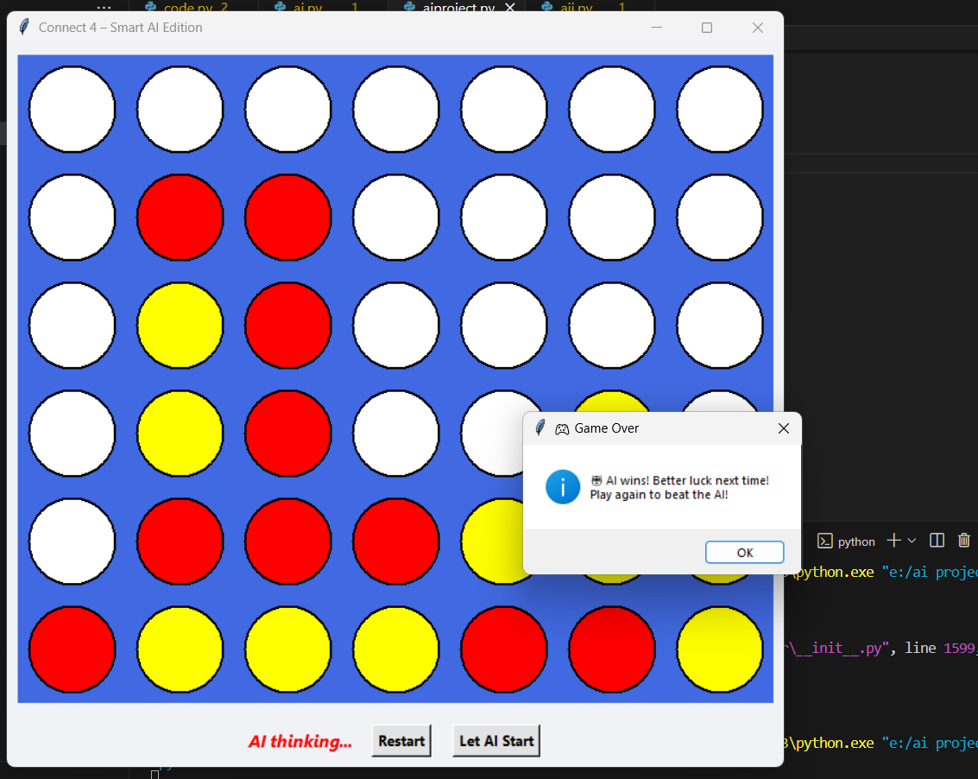

- The output shows the final stage of the Connect 4 – Smart AI Edition game where the player wins.
- The message “You win! Great job! Play again to beat the AI!” appears in a styled pop-up box, celebrating the player’s success.
- It highlights that the player strategically outsmarted the AI, proving the game’s balanced difficulty and intelligent gameplay.

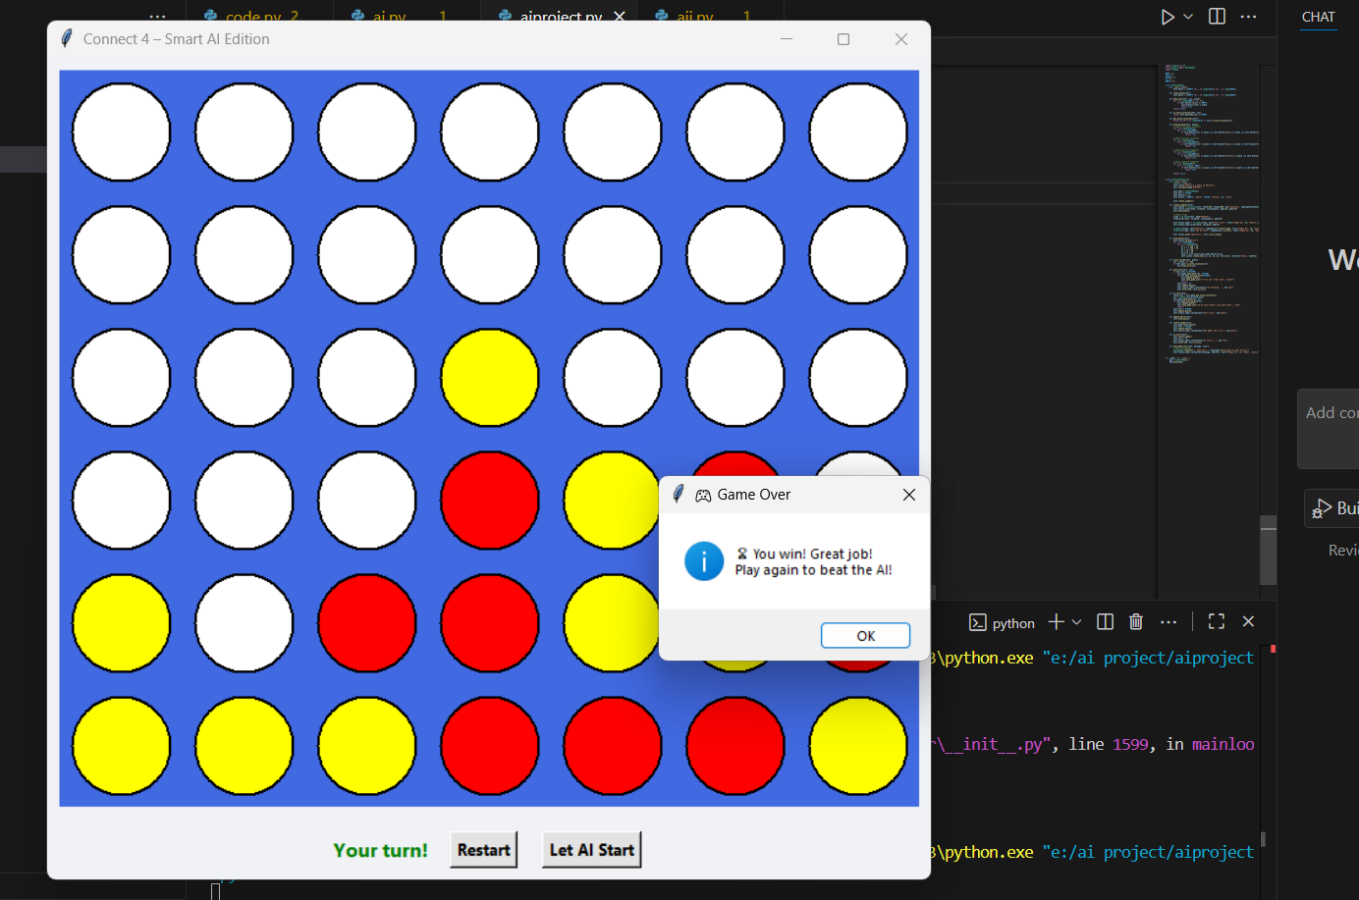

RESULT AND FUTURE ENHANCEMENT
Result
- The Connect 4 – Smart AI Edition project successfully simulates a strategic two-player game between the human and an intelligent AI.
- The AI uses the Minimax algorithm with Alpha-Beta pruning to predict the best possible moves, making the gameplay challenging and realistic.
- The system efficiently detects win, loss, or draw conditions and displays clear pop-up messages such as “AI wins!” or “You win!”.
- Through a colorful and user-friendly GUI, players experience an interactive environment that demonstrates how artificial intelligence can analyze and respond to human actions effectively.
- Overall, the project achieves its goal of combining fun gameplay with AI-based decision-making.
Future Enhancements
- Introduce multiple difficulty levels (Easy, Medium, Hard) by adjusting AI search depth.
- Add multiplayer functionality (local or online) for real-time competition between players.
- Enhance visuals with animations, sound effects, and improved graphics for a better user experience.
- Implement reinforcement learning so the AI can learn from player moves and improve over time.
- Create a mobile and web version of the game to make it more accessible across devices.

Git Hub Link of the project and report | harshalakshmi/CONNECT-4-

References
- Russell, S. & Norvig, P. (2021). Artificial Intelligence: A Modern Approach (4th Edition). Pearson Education.
- GeeksforGeeks — “Minimax Algorithm in Game Theory”
🔗 https://www.geeksforgeeks.org/minimax-algorithm-in-game-theory-set-1-introduction/
- TutorialsPoint — “Python Tkinter GUI Programming”
🔗 https://www.tutorialspoint.com/python/python_gui_programming.htm
- Real Python — “Implementing Minimax and Alpha-Beta Pruning in Python”
🔗 https://realpython.com/
- Stack Overflow Community Discussions on Connect 4 AI Logic and Tkinter Integration
🔗 https://stackoverflow.com/
- GitHub Open-Source Projects — Connect 4 AI Implementations (for reference in logic structuring).
🔗 https://github.com/topics/connect4-ai

