A HIGH LEVEL DESIGN
ON
Relative Importance of Radar Variables for Nowcasting Heavy Rainfall –
A Machine Learning Approach
Submitted in the partial fulfilment of requirements to
CS-454 Project Lab
By
Batch No. 11
GOCHIPATHALA HARSHA VARDHAN (Y22CS057)
IMMADISETTY PAVAN KRISHNA (Y22CS063)

GALANKI CHANDRA SEKHAR (Y22CS047)
R. V. R. & J. C. COLLEGE OF ENGINEERING (Autonomous)
(NAAC ‘A+’ Grade)
Approved by AICTE :: Affiliated to Acharya Nagarjuna University
Chandramoulipuram :: Chowdavaram
GUNTUR – 522019, Andhra Pradesh, India.

Sri R. Mabu Basha Dr. G. Srinivasa Rao Dr. M. Sreelatha
Project Guide Project In-charge Prof. & Head, CSE

CONTENTS | Page No.
Title Page | i
Contents | ii
- Problem Statement | 1
- Functional Requirements | 3
- Basic Architecture  - Components  - Diagram  - Workflow  - Pattern | 6  6  8  9  10
- Non-Functional Requirements | 11
- Technology Stack | 13
- Summary | 14

- Problem Statement

1. Traditional numerical weather prediction (NWP) models face significant difficulties in highly short-term forecasting (nowcasting) of heavy rainfall.
This challenge is primarily due to the rapid evolution of mesoscale convective systems (MCSs). NWP models are hampered by issues like deficiencies in determining initial and boundary conditions, long spin-up times, and challenges in physical parameterization, especially when applied to high spatial and temporal resolutions for heavy rainfall events. As a result, they struggle to provide useful nowcasting products for high-resolution applications such as hydrometeorological modelling in urban areas or catchments.

2. Machine learning (ML) techniques, particularly with remote sensing data like weather radar data, offer significant advantages for high-resolution rainfall nowcasting.
Remote sensing data from weather radars and satellites can provide high spatial and temporal resolutions (e.g., 1 km and 5 min). ML models can be trained on empirical data to interpolate and extrapolate rainfall from new measured input variables, thereby leveraging this detailed information. A growing number of ML methods have shown potential for accurate rainfall nowcasting.

3. To enhance the performance of ML models, it is crucial to quantify the importance of radar variables and identify relevant predictors of rainfall.
Current ML models often select input variables without empirically quantifying their importance based on data evidence before model training. Weather radars are the most commonly used data sources for input variables in rainfall nowcasting ML models. Dual-polarimetric radar systems provide more variables than traditional radar systems, leading to improved accuracy in rainfall estimates. This study specifically aims to use ML regression methods to quantify the relative importance of 17 variables derived from dual-polarimetric weather radar data for nowcasting heavy rainfall in storm cells over the Korean Peninsula.

4. The study adopted a specific categorization of MCS storm cells to better understand their characteristics and relationships with rainfall.
Following the fuzzy logic algorithm for storm tracking (FAST) over the Korean Peninsula, MCS storm cells were categorized into four types: convective cell (CC), mesoscale CC, diagonal squall line (SLD), and parallel squall line (SLP). This categorization is important for investigating and quantifying the relationships between rain rates and the derived dual-polarimetric weather radar variables.

5. The study also aims to develop an application example by coupling recalibrated ML regression models with ML classification models to provide early warnings of heavy rainfall.
This involves predicting locations of storm cells using ML classification models trained with radar variables and topographic variables. The recalibrated ML regression models, using the identified pertinent predictors, are then used to predict rain rates, enabling the issuance of early warnings for areas likely to experience heavy rainfall.

- Functional Requirements

1. Rainfall Nowcasting (ML Regression Models):
- Purpose: The system must be able to predict future rainfall rates for MCS storm cells.
- Inputs:
    - 17 variables derived from dual-polarimetric Doppler radar data (e.g., longest radius (Rmj), shortest radius (Rmn), storm area averaged reflectivity (MeanZ), storm area in km² (Area), storm area volume in km$^3$ (Volume), echo top height (Top), echo bottom height (Base), storm area maximum reflectivity (MaxZ), maximum reflectivity height (MaxZ.g), storm area averaged vertically integrated liquid water (AvgVIL), storm area maximum vertically integrated liquid water (Max VIL), zonal component of cell motion velocity (U), meridional component of cell motion velocity (V), storm propagation direction (Direction), mean rain rate (MeanRR), and top 10% mean rain rate (Top 10%)).
    - Previous timestamp data, specifically 30 or 60 minutes prior to the "now" timestamp.
- Outputs:
    - Mean rain rate (MeanRR) in mm/h at a future timestamp.
    - Top 10% mean rain rate (Top 10%) in mm/h at a future timestamp.
- Modelling Methods:
The system must support the use of five ML regression methods: Lasso, Random Forest Regression (RFR), Linear Support Vector Regression (SVR), Radial Basis Function (RBF) SVR, and Artificial Neural Network (ANN).
- Storm Cell Types:
The models should be calibrated and produce predictions for specific MCS types: Convective Cell (CC), Mesoscale Convective Complex (MCC), Diagonal Squall Line (SLD), and Parallel Squall Line (SLP). The system also pools MCC, SLD, and SLP data for a combined MSL storm type.

2. Variable Importance Assessment:
- Purpose: The system must quantify the relative importance of radar variables for nowcasting heavy rainfall.

3. Storm Cell Location Prediction (ML Classification Models):
- Purpose: The system must predict whether a given location (central pixel of an image patch) will belong to a storm cell of interest after a specified time period (30 or 60 minutes).
- Inputs:
    - Image patches showing the geographic distribution of a storm cell around its central pixel at a previous timestamp. Each pixel in the image patch is assigned a binary value (1 if it belongs to a storm cell, 0 otherwise).
    - 22 variables at the central pixel of the image patch at a previous timestamp: 17 radar variables (same as regression inputs) and 5 topographic variables (distance to sea, elevation, aspect, roughness, and slope).
- Output: A binary variable (0 or 1) indicating if the central pixel of the image patch belongs to a storm cell of interest at a "now" timestamp.
- Model Architecture: A 2-D Convolutional Neural Network (CNN) based method must be used, consisting of two input layers, four pairs of 2-D convolutional and max pooling layers, three fully connected dense layers, and one output layer.
- Image Patch Processing: Image patches with all pixels of 0s must be discarded from model training and validation. If an image patch only contains 0s, its central pixel's future state should be predicted as 0.
- Probability Threshold: A probability threshold of 0.5 must be applied to convert the output into a binary format.

4. Early Warning System:
- Purpose: The system must generate maps showing areas with potential heavy rainfall in 30 or 60 minutes.
- Integration: This functionality must be achieved by coupling the ML regression models (for rain rate estimation) with the ML classification models (for storm cell location prediction).
- Warning Condition: A warning must be issued for a storm cell area if the predicted top 10% mean rain rate is greater than or equal to 30 mm/h.

5. User Registration and Authentication:
- User Registration: The system must allow new users to register for an account, providing necessary information (e.g., email, username, password).
- User Authentication: The system must securely authenticate users upon login, verifying their identity against registered credentials. This should include mechanisms for password hashing and salting to prevent unauthorized access.
- Notification Preferences: Users should be able to customize the types and frequency of heavy rainfall alerts they receive (e.g., only for "Top 10% Mean Rain Rate" exceeding a certain threshold, or for specific storm cell types).
- Data Privacy: The system must handle user data in compliance with relevant data protection regulations (e.g., GDPR, local privacy laws in India or Korea if applicable).

- Basic Architecture
3.1 Major Components
- Data Ingestion Layer:
    - Radar Data Ingestion Module: Responsible for collecting real-time or near real-time dual-polarimetric weather radar data. This would involve interfaces to external data sources like the Korea Meteorological Administration (KMA).
    - Topographic Data Module: Handles the import and management of static topographic variables (distance to sea, elevation, aspect, roughness, and slope).
- Data Storage Layer:
    - Raw Data Storage: A scalable repository (e.g., cloud object storage or a data lake) for raw ingested radar composites and other large datasets.
    - Processed Data Database: A structured database to store extracted storm cell features, derived radar variables, and historical rainfall rates used for model training and validation.
    - Model Store/Registry: A dedicated repository for storing trained machine learning models, their versions, and performance metadata.
- Data Preprocessing and Feature Engineering Layer:
    - FAST Algorithm Module: Implements the Fuzzy Logic Algorithm for Storm Tracking (FAST) to identify and track storm cells from radar data.
    - Variable Derivation Module: Computes the 17 dual-polarimetric radar variables and the two output variables (mean rain rate and top 10% mean rain rate) from radar data.
    - Image Patch Generation Module: Creates image patches for classification models, representing the distribution of storm cells around a central pixel.
    - Storm Cell Categorization Module: Categorizes identified storm cells into types like CC, MCC, SLD, and SLP based on their characteristics.
- Machine Learning Model Layer:
    - ML Regression Models: Modules implementing Lasso, Random Forest Regression (RFR), Support Vector Regression (SVR), and Artificial Neural Network (ANN) for rainfall rate nowcasting. These models are recalibrated with pertinent predictors.
    - ML Classification Models: Modules implementing CNN-based models for predicting storm cell locations.
    - Permutation Importance Module: Implements the permutation importance technique for identifying and selecting important input variables for the regression models.
- Prediction and Alerting Layer:
    - Nowcasting Engine: Integrates the trained ML regression and classification models to generate 30- and 60-minute predictions of rainfall rates and storm cell locations.
    - Warning Generation Module: Evaluates predicted rainfall conditions (e.g., top 10% mean rain rate > 30mm/h) to issue early warnings.
    - Notification Service: Responsible for sending out alerts and warnings to users via various channels (e.g., email, SMS).
- User Management Layer: Handles user authentication, authorization, role management, and profile management for different user types (e.g., public, meteorologists, administrators).
- API/Service Layer: Provides interfaces (APIs) for other applications or user interfaces to interact with the system's functionalities, such as retrieving predictions or warning information.
- Presentation Layer (User Interfaces): Web and mobile applications for visualizing nowcasts, warning areas, and allowing users to manage their preferences.

3.2 Diagram
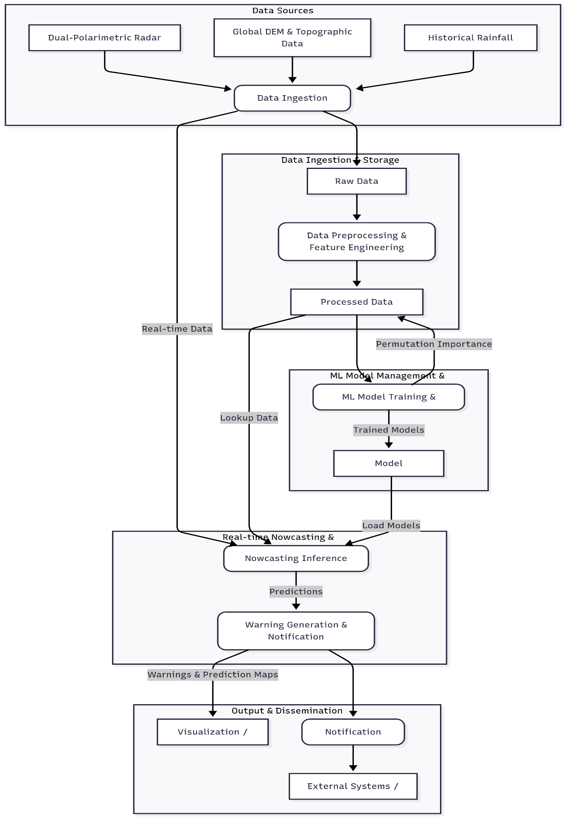
3.3 Workflow
- Model Training:
    - Data Collection & Ingestion: Raw radar data (e.g., from KMA), topographic data (e.g., from USGS), and historical rainfall records are continuously ingested and stored in Raw Data Storage.
    - Preprocessing & Feature Engineering: Raw data is processed by modules such as the FAST Algorithm. Derived radar variables (17 variables) and topographic variables (5 variables) are computed and transformed (e.g., logarithmic transformation, standardization). Image patches for classification are generated.
    - Storm Cell Categorization: Identified storm cells are categorized into types (CC, MCC, SLD, SLP).
    - Variable Importance Assessment: For regression models, a permutation importance algorithm is run on training data to identify pertinent radar variables for predicting mean rain rate and top 10% mean rain rate.
    - Model Training: ML regression models (Lasso, RFR, SVR, ANN) and CNN-based ML classification models are trained on their respective training datasets using the selected variables.
    - Model Validation: Trained models are evaluated against validation datasets using specified metrics (e.g., MAE, MAPE, MSE, R² for regression; FPR, Precision, Recall, F1 score for classification).
    - Model Deployment: Validated models are stored in the Model Store/Registry and deployed to the Nowcasting Inference Engine for real-time prediction.
- Real-time Nowcasting and Early Warning:
    - Real-time Data Ingestion: Current radar data is ingested into the system.
    - Real-time Feature Engineering: For current storm cells, relevant radar variables are derived, and image patches are generated along with associated topographic variables.
    - Storm Cell Location Prediction: The ML classification model predicts the future location of storm cells (whether a central pixel will belong to a storm cell) for 30- and 60-minute forecasts.
    - Rainfall Rate Prediction: For the predicted storm cell areas, the ML regression models estimate the mean rain rate and top 10% mean rain rate at the future timestamp.
    - Warning Generation: If the predicted top 10% mean rain rate for a storm cell area is greater than or equal to 30m˜m/h, an early warning is generated for that area.
    - Distribution: Warnings and nowcast maps are sent to the Notification Service, which dispatches alerts to subscribed users via their preferred channels. Prediction maps and warning areas are also updated on web and mobile applications for visualization.

3.4 Patterns
- Impact of Forecasting Time on Model Performance: Shorter-term forecasts demonstrate higher accuracy. The 30-minute nowcasting models consistently provided better predictions than the 60-minute models.
- Superiority of ML Models over Benchmarks: Machine learning regression models generally showed improved validation performance compared to a simple benchmark model that uses prior values for prediction. This highlights the value of incorporating radar variables into ML models.
- Convergence of Variable Importance Rankings: Regardless of whether linear or nonlinear ML regression models were used, the determined rankings of important input variables tended to converge.
- Influence of Storm Cell Type on Variable Importance: The relative importance rankings of radar variables varied depending on the storm cell type (e.g., CC versus MSL datasets). This indicates that MCS type information should be considered in rainfall nowcasting models.
- Best Performance: Mesoscale Convective Complex (MCC) models demonstrated the highest precisions and high recalls, resulting in the best F1 scores among individual storm types. This is linked to their larger size and more abundant training data.

- Non-functional Requirements
1. Performance:
- Response Time:
    - The system should generate 30-minute nowcasts within 5 minutes of receiving new radar data.
    - The system should generate 60-minute nowcasts within 10 minutes of receiving new radar data.
    - Warning notifications should be dispatched to users within 30 seconds of a warning being generated.
- Prediction Accuracy:
    - The Mean Absolute Error (MAE) for mean rain rate predictions should be consistently lower than the benchmark model.
    - The Coefficient of Determination (R²) for rainfall predictions should be consistently higher than the benchmark model.
    - For classification models, the F1 score for MCC storm cells should be at least 0.73 for 30-min predictions and 0.65 for 60-min predictions.
    - The False Positive Rate (FPR) for classification models should be minimized, especially for critical warnings.

2. Scalability:
- Horizontal Scalability: The system must be able to scale horizontally to accommodate an increasing volume of data, more complex models, and a growing number of users without significant degradation in performance.
- Data Volume: The system should handle several years of historical radar and storm cell data for model training and validation.
- Geographic Expansion: The architecture should allow for expansion to cover larger geographic areas or additional regions beyond the Korean Peninsula.

3. Reliability/Availability:
- Uptime: The system should aim for high availability, e.g., 99.9% uptime, to ensure continuous nowcasting and warning dissemination, especially during critical weather events.
- Fault Tolerance: The system should be resilient to component failures, with mechanisms for automatic recovery and minimal data loss.
- Data Integrity: All ingested and processed data must maintain high integrity, ensuring accuracy and consistency.
4. Security
- Access Control: Strict role-based access control (RBAC) must be implemented to ensure that only authorized users can access specific data, models, or functionalities.
- Data Encryption: All sensitive data, both in transit and at rest (e.g., user credentials, personal notification preferences), must be encrypted.
5. Manageability:
- Modularity: The system should be designed with modular components to facilitate easier updates, bug fixes, and feature enhancements.
- Configuration Management: The system should allow for easy configuration of parameters such as warning thresholds (e.g., 30 mm/h for top 10% mean rain rate ), model hyperparameters, and data sources.
- Monitoring and Alerting: Comprehensive monitoring tools should be in place to track system health, performance metrics, and model accuracy, with automated alerts for anomalies.
6. Usability:
- User Experience (UX): The user interfaces (web and mobile) should be intuitive, easy to navigate, and provide clear visualization of rainfall predictions and warning areas.
- Customization: Users should be able to customize their notification preferences and areas of interest.
- Notification Clarity: Warning messages should be clear, concise, and actionable for different user groups (e.g., public vs. emergency responders).
- Technology Stack

- Frontend
A web application would typically be built using foundational web technologies such as HTML5, CSS3, and JavaScript. To create dynamic and interactive user interfaces for dashboards and maps, popular JavaScript frameworks or libraries like React, Angular would be employed. Mapping functionalities for displaying geographical data, radar images, and warning areas would rely on libraries such as Streamlit, OpenLayers, or Mapbox GL JS.

- Backend
The back-end would primarily leverage Python, as the paper explicitly mentions its use for establishing quantitative models. For building efficient APIs to expose nowcasting predictions and warning information, lightweight Python web frameworks like Flask or FastAPI are commonly used.

- Data Storage
For structured data like derived radar variables, storm cell characteristics, and historical rainfall rates, a Relational Database such as PostgreSQL or MySQL is generally preferred for its data integrity and query capabilities.

- Notification Services
The notification issuer component, responsible for dispatching early warnings, would also primarily use Python. It would integrate with various Notification Services/APIs like email services (e.g., SendGrid), SMS gateways, and potentially push notification services.

- Summary
This study addresses the challenges of nowcasting heavy rainfall, particularly due to rapidly evolving mesoscale convective systems (MCSs), which traditional numerical weather prediction (NWP) models struggle with. To overcome these limitations, the research explores the significant advantages of using machine learning (ML) modelling techniques with remote sensing data, especially weather radar data, for high-resolution rainfall nowcasting.
A key objective of the study is to quantify the importance of radar variables and identify pertinent predictors of rainfall that can also be associated with domain knowledge, which is essential for improving ML model performance. The research adopted a set of MCS types, including convective cell (CC), mesoscale CC, diagonal squall line (SLD), and parallel squall line (SLP), categorized using the fuzzy logic algorithm for storm tracking (FAST) over the Korean Peninsula.
The study investigated and quantified the relationships between rain rates and over 15 variables derived from dual-polarimetric weather radar data products using five ML regression methods and a permutation importance algorithm. As an application, ML classification models were also developed to predict storm cell locations. Recalibrated ML regression models, utilizing the identified pertinent predictors, were coupled with these ML classification models to provide early warnings of heavy rainfall.
Results suggest that future work should consider MCS type information to enhance ML modelling for nowcasting and early warning of heavy rainfall. The study identifies storm area averaged reflectivity, storm area volume, storm area maximum vertically integrated liquid water, echo bottom height, and longest radius as highly important predictors of rainfall. Conversely, radar variables related to the directions and velocities of storm cells were considered the least important predictors for nowcasting rain rate. The study also notes that while linear and nonlinear ML regression models may quantify variable importance slightly differently, their rankings of important input variables generally converge.

