**HealthAI: Intelligent Healthcare Assistant Using IBM Granite & Streamlit**

**Category: Cloud Application Development**

Skills Required: Python, IBM Cloud, Scikit-Learn, Streamlit, Pyngrok, Google Generative AI

**Team Information**

Team ID: NM2025TMID03678

Team Size: 4

Team Leader: HARSHA VARDHINI V

Team Member: GOKILA A

Team Member: GOWTHAMI U

Team Member: JANANI P

**Project Description**

HealthAI harnesses IBM Watson Machine Learning, Generative AI, and a Streamlit-powered web application to provide intelligent healthcare assistance. The platform integrates patient interaction, disease prediction, personalized treatment planning, and health analytics visualization. Public access to the app is enabled via Ngrok tunnels for easy sharing.

**Features include:**

- Patient Chat: AI-powered chatbot to answer health-related questions empathetically.

- Disease Prediction: Evaluate user-reported symptoms and generate potential conditions.

- Treatment Plans: Generate evidence-based recommendations including medications and lifestyle changes.

- Health Analytics: Visualize patient health metrics (heart rate, blood pressure, glucose, etc.) with AI-driven insights.

**Scenarios**

1. **Symptom-Driven Disease Prediction**  - Action: User enters symptoms (e.g., cough, fever, fatigue). - Outcome: HealthAI generates possible conditions and next-step advice.

2. **Personalized Treatment Planning** - Action: User provides a condition (e.g., Mouth Ulcer). - Outcome: AI generates medications, lifestyle guidance, and follow-up instructions.

3. **Health Trends Insight** - Action: User views Health Dashboard. - Outcome: Streamlit visualizations display health data trends (heart rate, BP, glucose, symptoms).

4. **On-Demand Patient Chat** - Action: User asks questions in the chat interface. - Outcome: AI provides empathetic, fact-based responses with disclaimers.

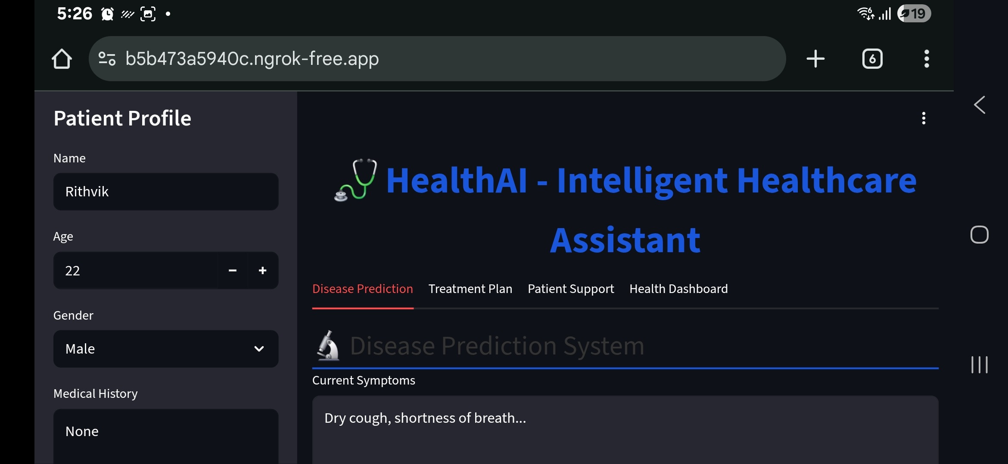

**Technical Architecture**

**Prerequisites**:- Python (3.7+)- Streamlit for web app UI- Pyngrok for tunneling- Google Generative AI SDK (optional)- IBM Watson SDK and Granite13b-instruct-v2 model- Scikit-Learn for analytics- IBM Cloud Account with Watson ML- GPU-enabled hardware recommendedArchitecture Workflow:User Input → AI Inference (Granite/Watson) → Data Processing → Streamlit Visualization → Ngrok Public Access

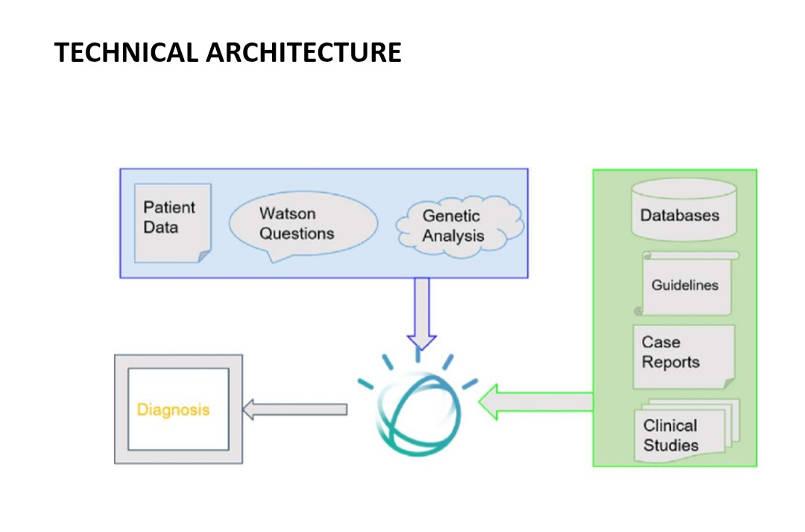

**Project Setup & Implementation**

Step 1: Install dependencies - pip install streamlit pyngrok google-generativeai scikit-learn

Step 2: Configure Ngrok Authentication - Set NGROK_AUTH_TOKEN in code.

Step 3: Develop app.py (Streamlit App) - Sidebar for patient profile. - Tabs for Disease Prediction, Treatment Plan, Patient Support, Health Dashboard.

Step 4: Launch the server - streamlit run app.py - Ngrok provides a public URL for external access.

**Core Functionalities**

**Disease Prediction**: Predict conditions from user symptoms.

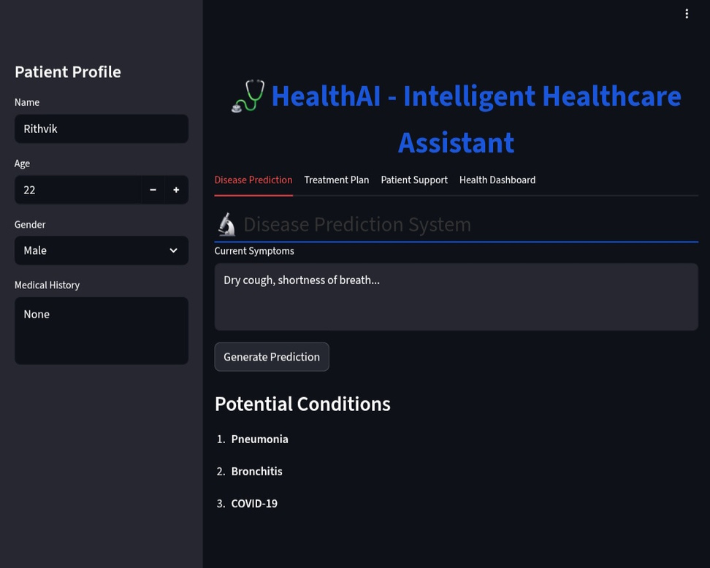

**Treatment Plan Generator**: Suggests medication, diet, lifestyle, and follow-up.

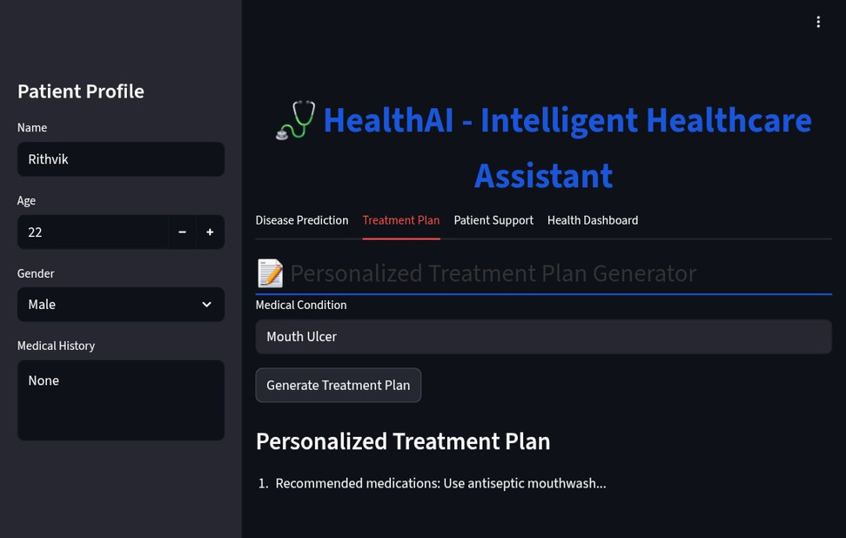

**Patient Support Chat**: Empathetic AI responses with disclaimers.

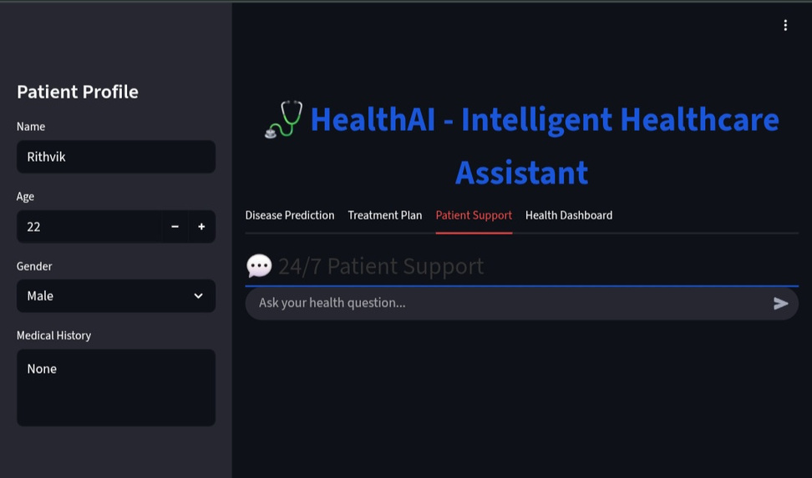

**Health Dashboard**: Line charts (Heart Rate, BP, Glucose) and Symptom Frequency (Bar chart).

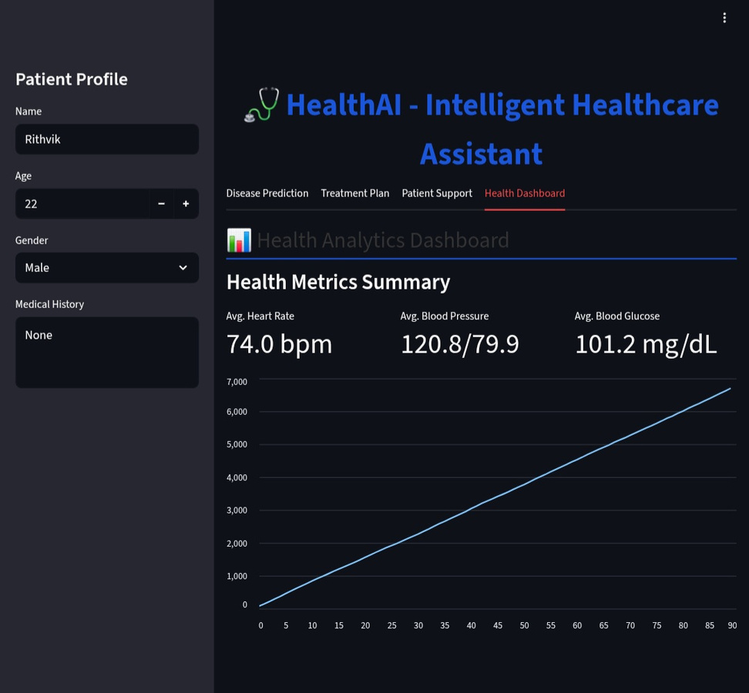

**Metrics Summary**: Display average values with trends.

**Deployment**

**Local Run**:- Run app with Streamlit.- Use Ngrok to expose the app publicly.Cloud Deployment:- Can be containerized with Docker.- Deployable on IBM Cloud Run or similar.- Secure API key handling is implemented.

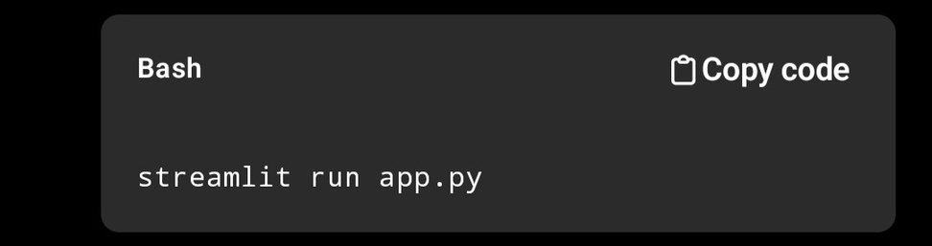

**Documentation & Handover**

- **README**: Installation, usage, API keys.

- **User Guide**: Screenshots of Streamlit interface and workflows.

- **Demo Video**: https://drive.google.com/file/d/1m7OIcepQyubOCzGIcpyWeUUIr-CUwYfW/view?usp=drivesdk

an end-to-end intelligent healthcare assistant—streamlining medical information access, personalized recommendations, and health analytics for better patient engagement and outcomes.