1. **Create a key space by name Employee**

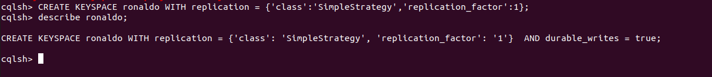

1. **Create a column family by name Employee-Info with attributes Emp_Id Primary Key, Emp_Name, Designation, Date_of_Joining, Salary, Dept_Name**



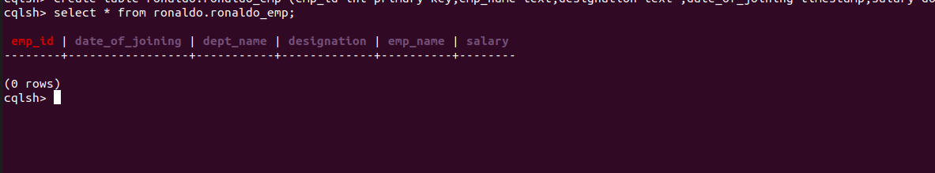

1. **Insert the values into the table in batch**

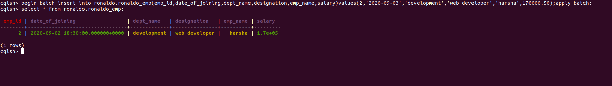

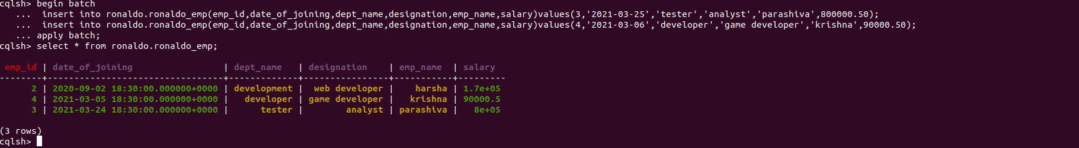

1. **Update Employee name and Department of Emp-Id 4**

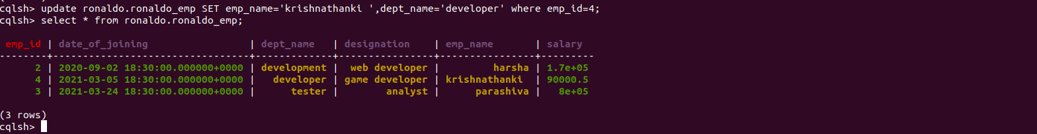

**5. Sort the details of Employee records based on salary**

**C:\Users\Vostro\OneDrive\Desktop\harsha\Screenshot from 2022-04-27 14-43-34.png**

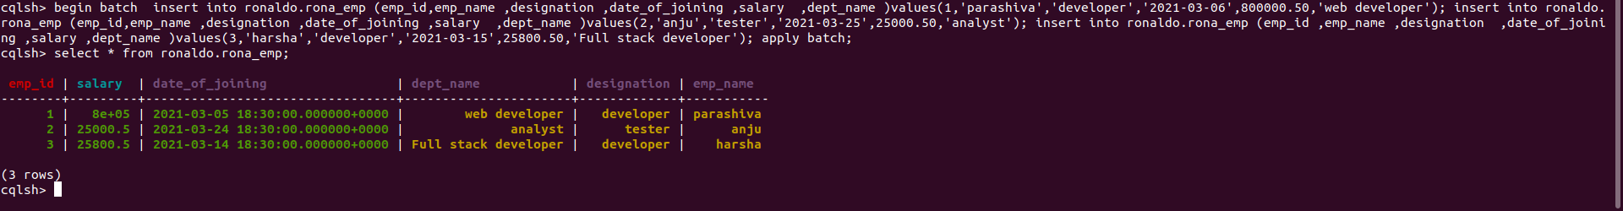

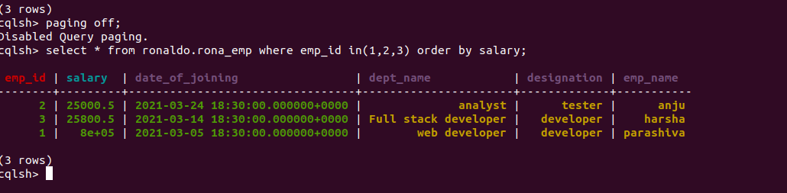

1. **Alter the schema of the table Employee_Info to add a column Projects which stores a set of Projects done by the corresponding Employee.**

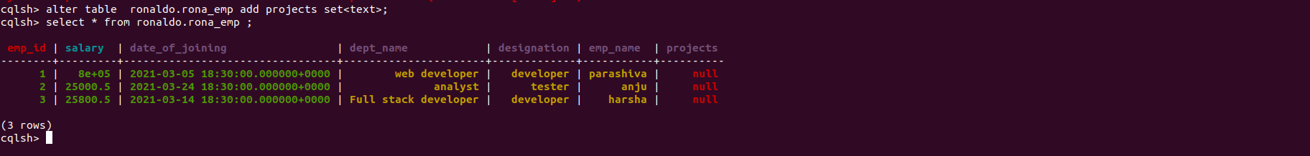

**7. Update the altered table to add project names.**

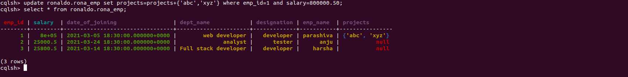

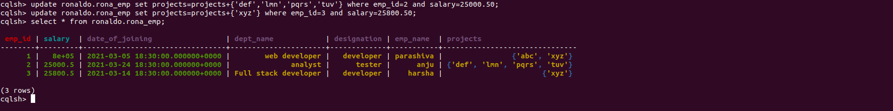

**8. Create a TTL of 15 seconds to display the values of Employees.**

