ST. ANNE’S ARTS AND SCIENCE COLLEGE
Madhavaram, Chennai – 600110

BACHELOR OF COMPUTER APPLICATIONS (BCA)
(2025–2026)

DATA ANALYSIS AND VISUALIZATION
PREDICTING STUDENT ACADEMIC OUTCOMES
IN COMPUTER SCIENCE COURSES
USING PERFORMANCE DATASETS

SUBMITTED BY
HARSHA VARDHINI V
Register Number: 212304909

ABSTRACT
This project focuses on analyzing student performance data to predict academic outcomes in computer science courses using data analytics techniques. The study utilizes tools such as Microsoft Excel, Python, SQL, and Power BI Desktop to process and analyze the dataset effectively.
The dataset includes key attributes such as study hours, attendance, assignment scores, midterm marks, and final exam results. Initially, data cleaning and preprocessing were carried out using Excel to remove inconsistencies, missing values, and duplicates. Further analysis and Exploratory Data Analysis (EDA) were performed using Python libraries such as Pandas and Matplotlib.
The processed data was then stored in a structured database using SQL for efficient querying and management. Finally, an interactive dashboard was created using Power BI to visualize key insights through charts and performance indicators.
This project demonstrates how educational data can be transformed into meaningful insights to identify patterns, predict student outcomes, and support data-driven decision-making in academic institutions.

Introduction
Student performance analysis is important for improving educational outcomes. This project uses data analysis tools to understand patterns in student behavior and academic performance.

PROBLEM STATEMENT
In educational institutions, identifying students who are at risk of failing is a major challenge. Raw student performance data is often unorganized and difficult to analyze directly.
The main problem addressed in this project is the lack of a structured system to analyze student performance data and predict academic outcomes effectively.
This project aims to:
- Clean and preprocess student data
- Analyze performance patterns
- Identify key factors affecting student success
- Predict student results (Pass/Fail)
- Provide visual insights using dashboards
The goal is to help educators take early action to improve student performance.

Dataset Description
The dataset contains 1200 student records including StudyHours, Attendance, Assignments, Midterm, FinalScore, AverageScore, and Result.

Data Cleaning Process
Data cleaning was performed in Excel by removing duplicates, handling missing values, and standardizing data formats.

Exploratory Data Analysis
EDA was conducted using Excel, SQL, and Python to identify relationships between variables such as study hours and performance.

Tools Used
Excel: Data cleaning and preprocessing
SQL: Data storage and querying
Python: Data analysis and prediction model
Power BI: Dashboard visualization
Visualizations & Dashboard
Various charts such as pie charts, bar charts, and scatter plots were created in Power BI to visualize student performance.

EXCEL – DATA CLEANING AND PREPROCESSING

1. Introduction
Microsoft Excel was used for initial data cleaning and preprocessing. The dataset included attributes such as Study Hours, Attendance, Assignments, Midterm Marks, Final Score, and Result.

2. Objectives
- Remove missing values
- Eliminate duplicate records
- Standardize data
- Ensure data accuracy

3. Handling Missing Values
Missing values were identified using filters and removed to maintain data consistency.
Steps:
- Applied Filter (Ctrl + Shift + L)
- Selected blanks
- Deleted rows
4. Removing Duplicates
Duplicate entries were removed using Excel tools.
Steps:
- Selected dataset
- Data → Remove Duplicates
- Confirmed removal

5. Data Type Correction

COLUMN | DATA TYPE
StudyHours | Number
Attendance | Number
Assignments | Number
Midterm | Number
FinalScore | Number
Result | Text

SCREENSHOTS

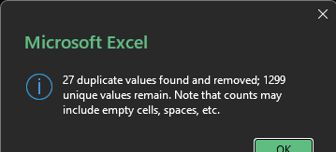

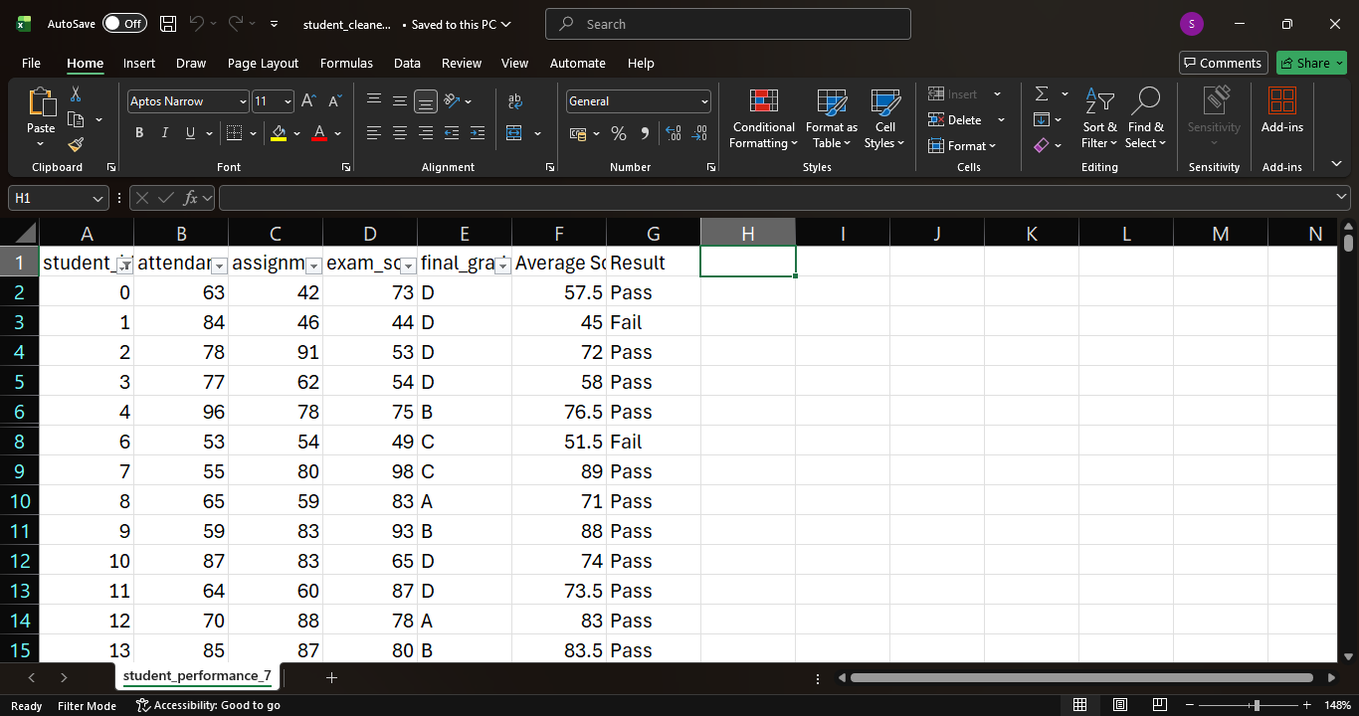

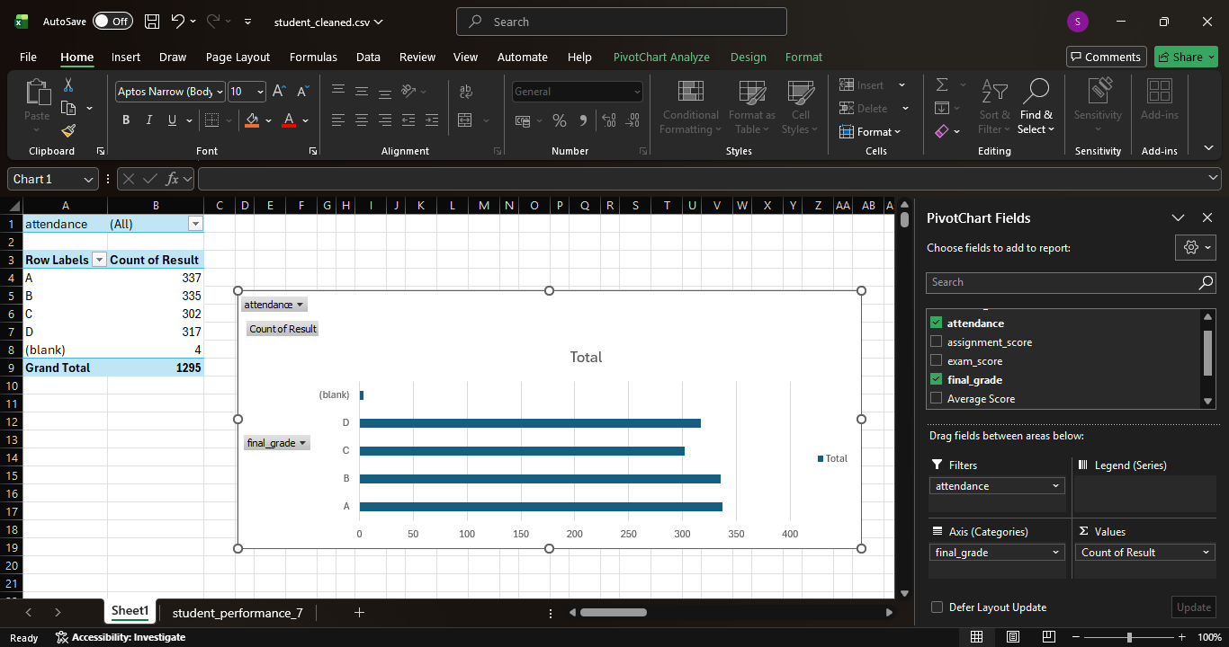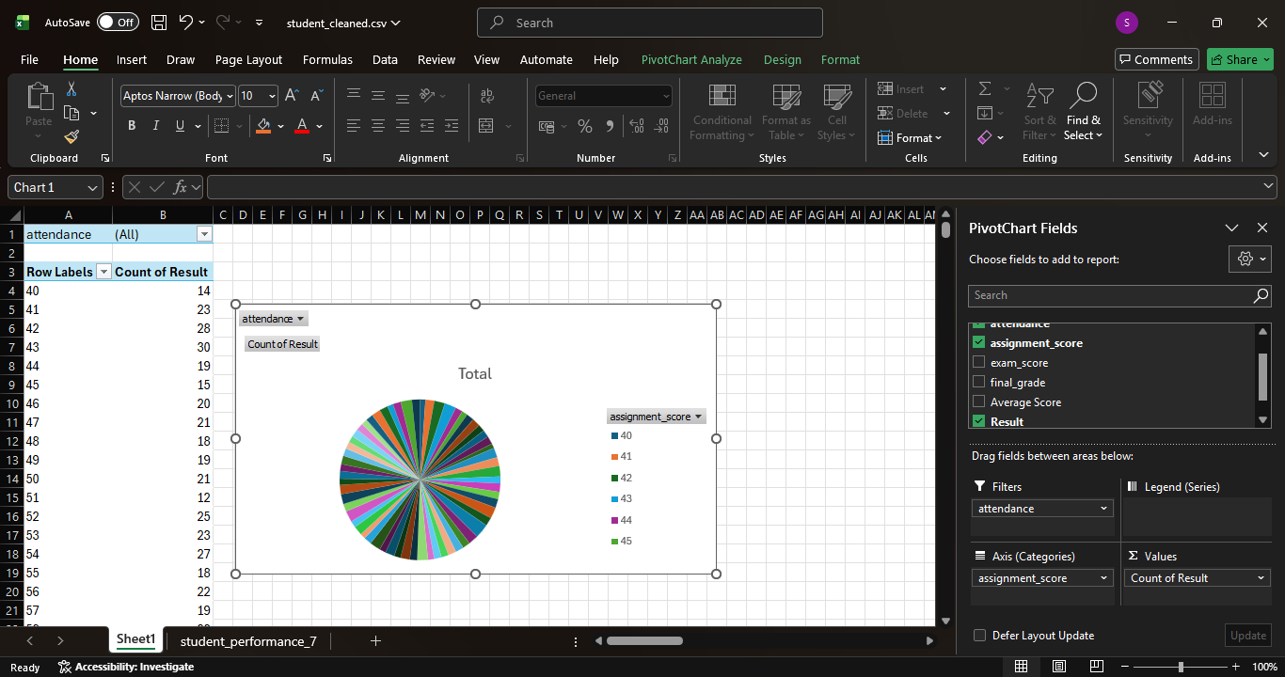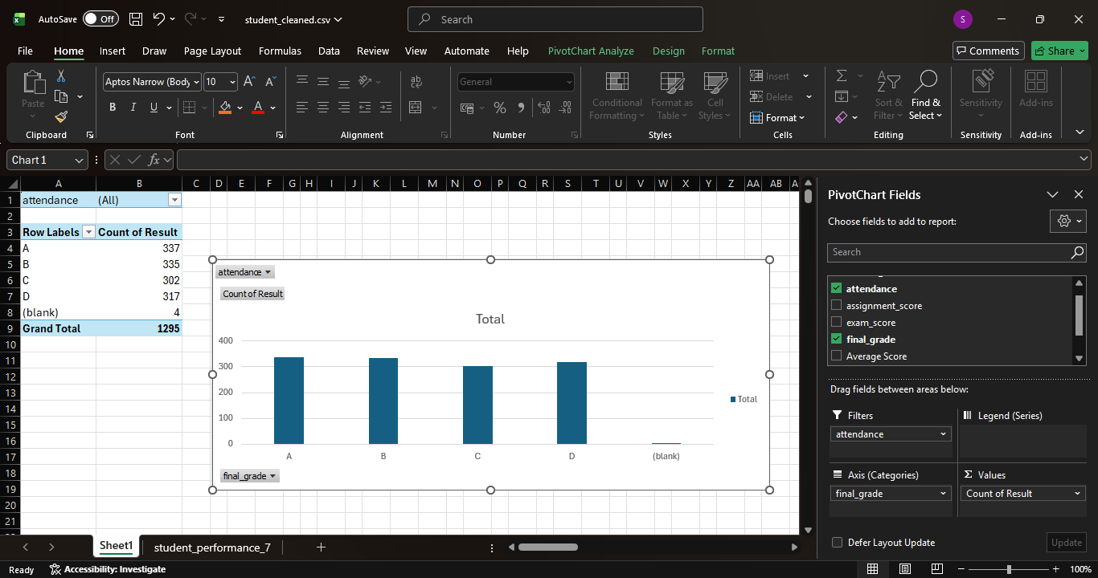
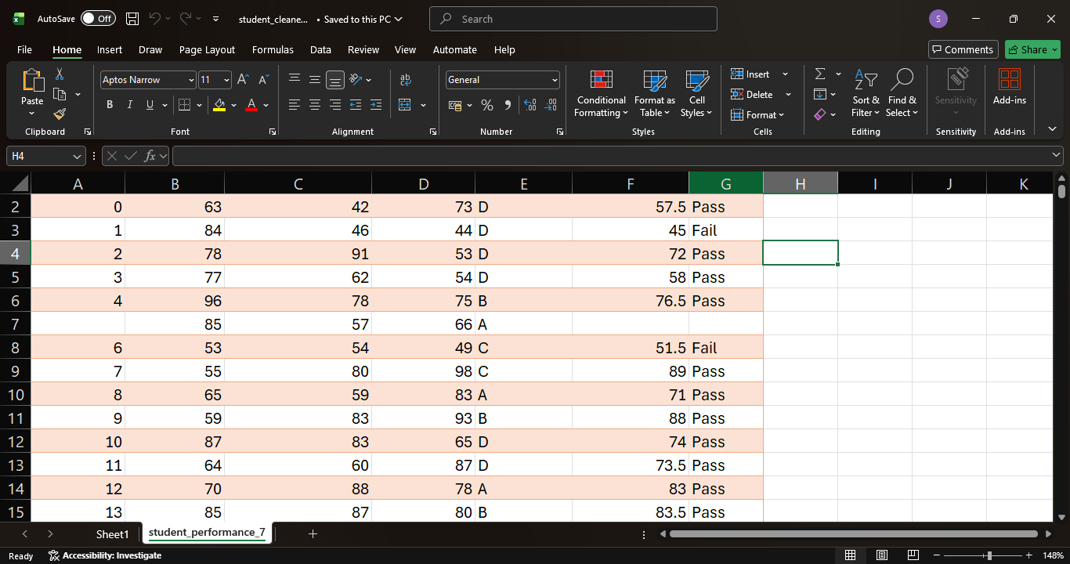

PYTHON – DATA ANALYSIS AND EDA

1. Introduction
Python was used for data analysis and visualization using powerful libraries.

2. Tools Used
- Anaconda Navigator
- Jupyter Notebook
Libraries:
- Pandas
- NumPy
- Matplotlib

3. Data Analysis
- Loaded dataset using Pandas
- Checked structure using .head() and .info()
- Generated summary statistics

4. Data Cleaning
- Removed missing values
- Removed duplicates
- Converted data types

5. Exploratory Data Analysis
1. Distribution Analysis
Understanding score distribution
2. Trend Analysis
Performance patterns based on study hours
3. Relationship Analysis
Correlation between attendance and scores

6. Data Manipulation
- Filtering student records
- Grouping data
- Creating new columns (Average Score)
- Sorting based on performance

SCREENSHOTS
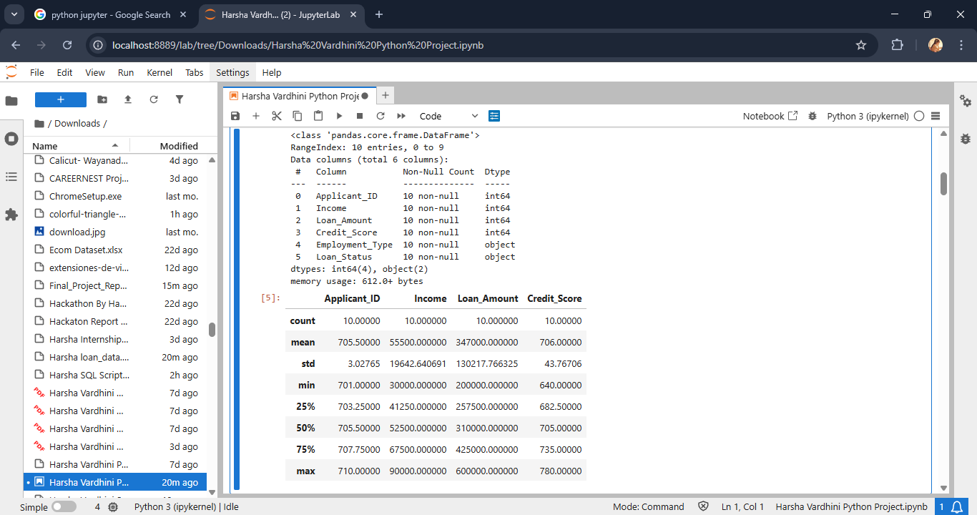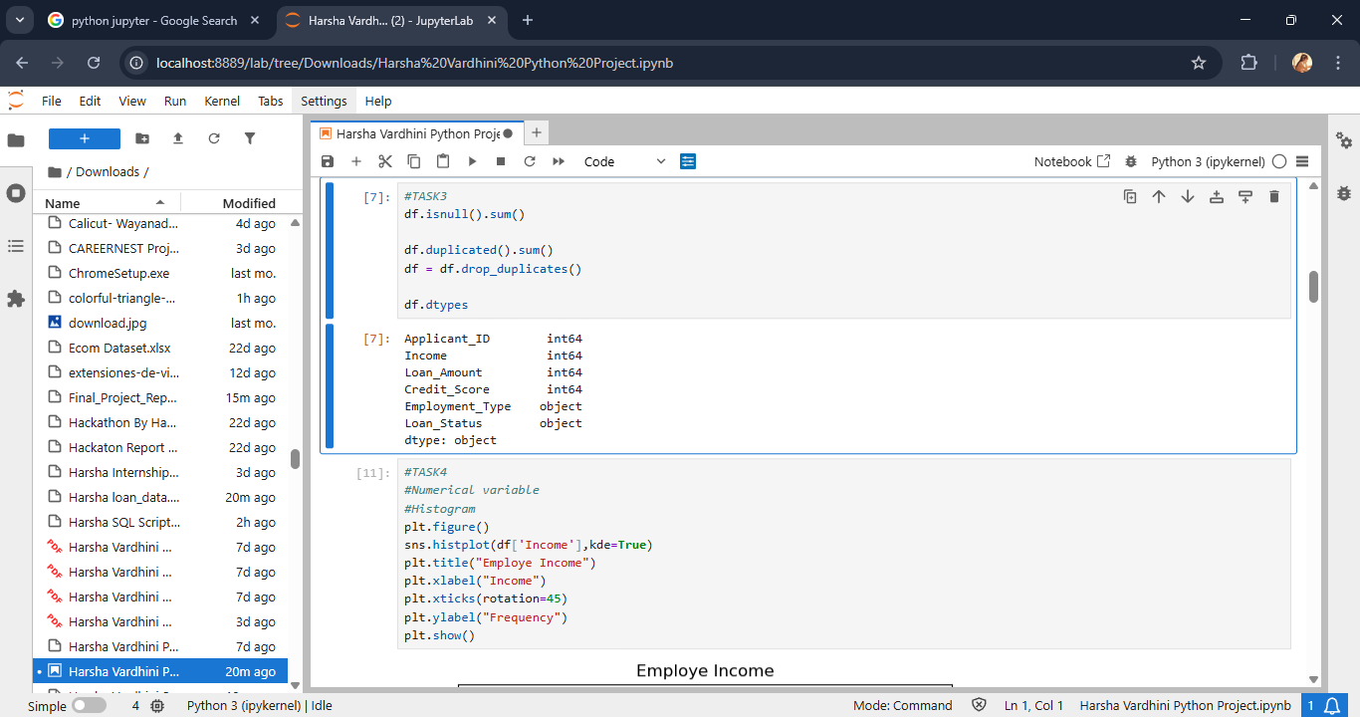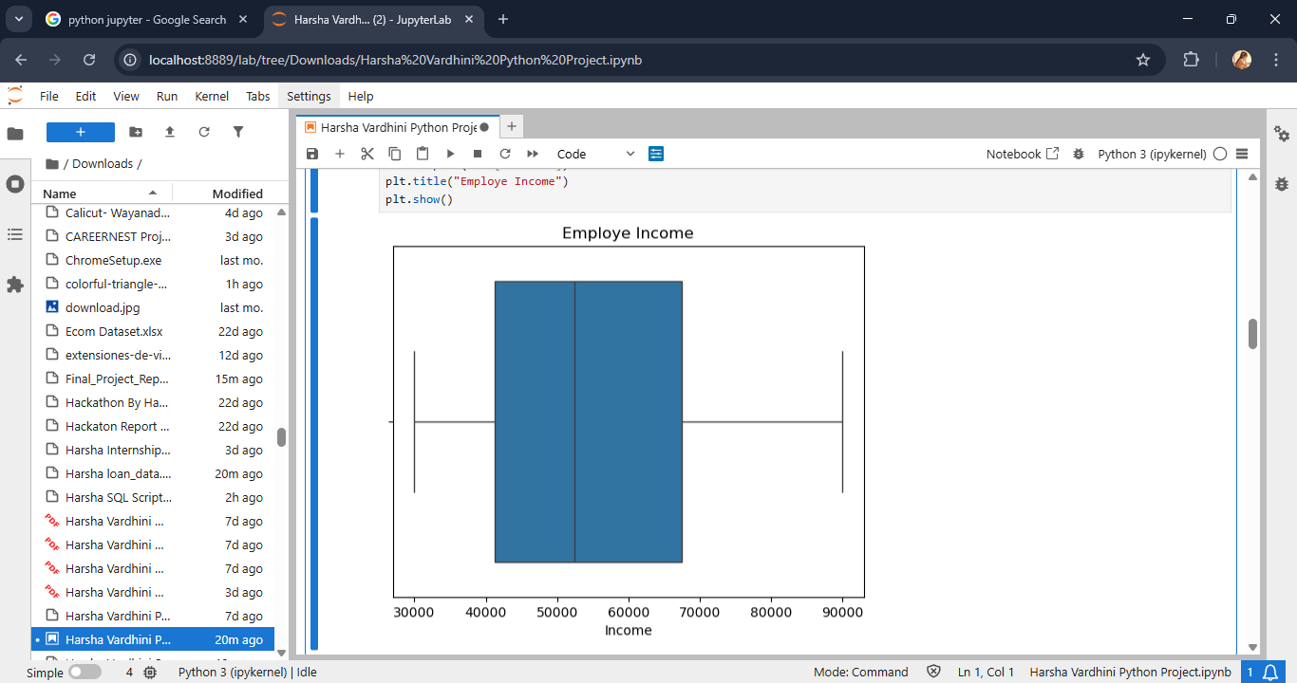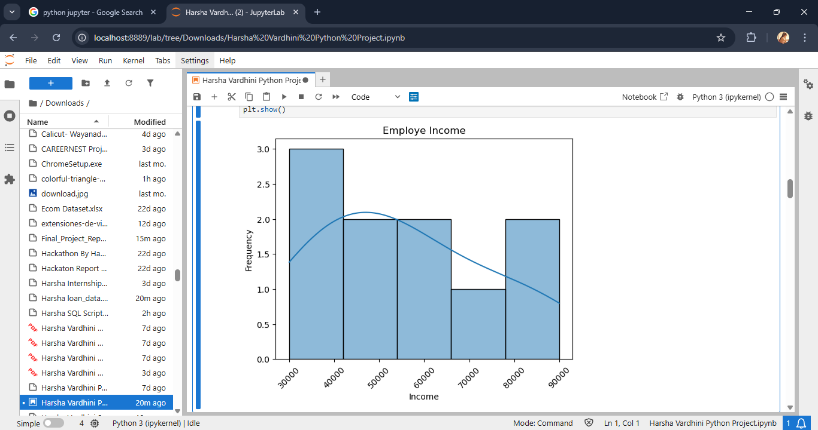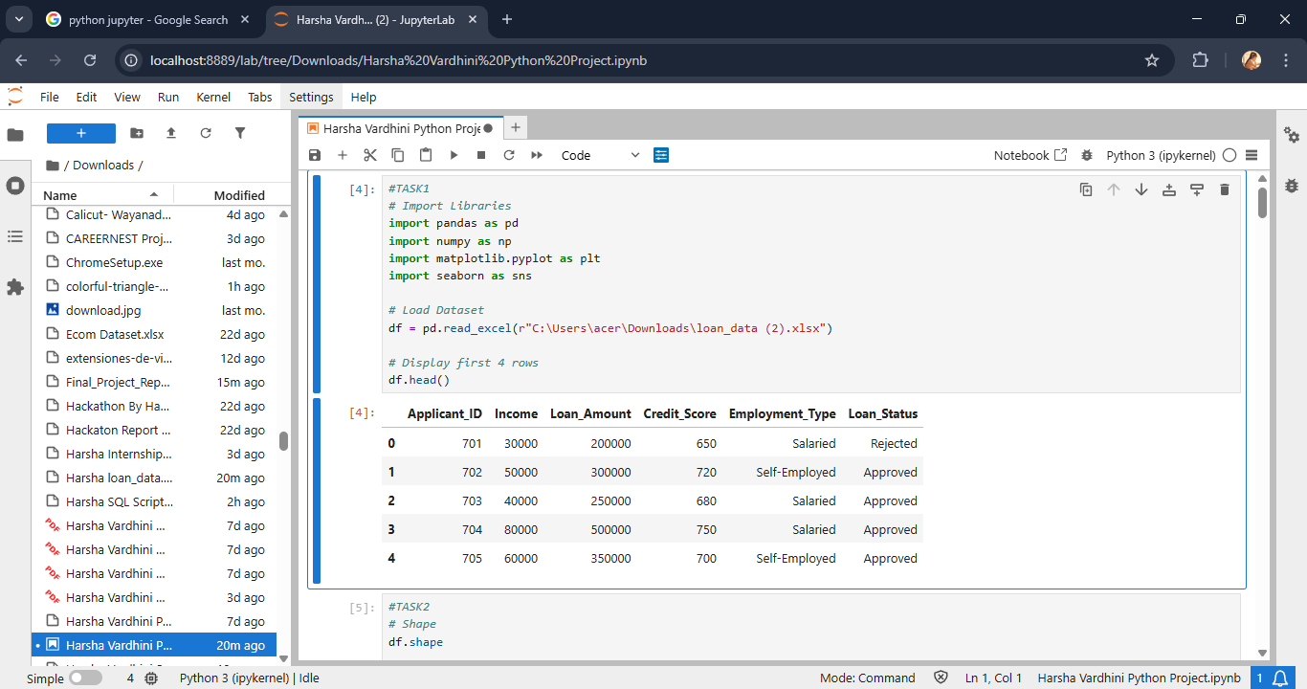
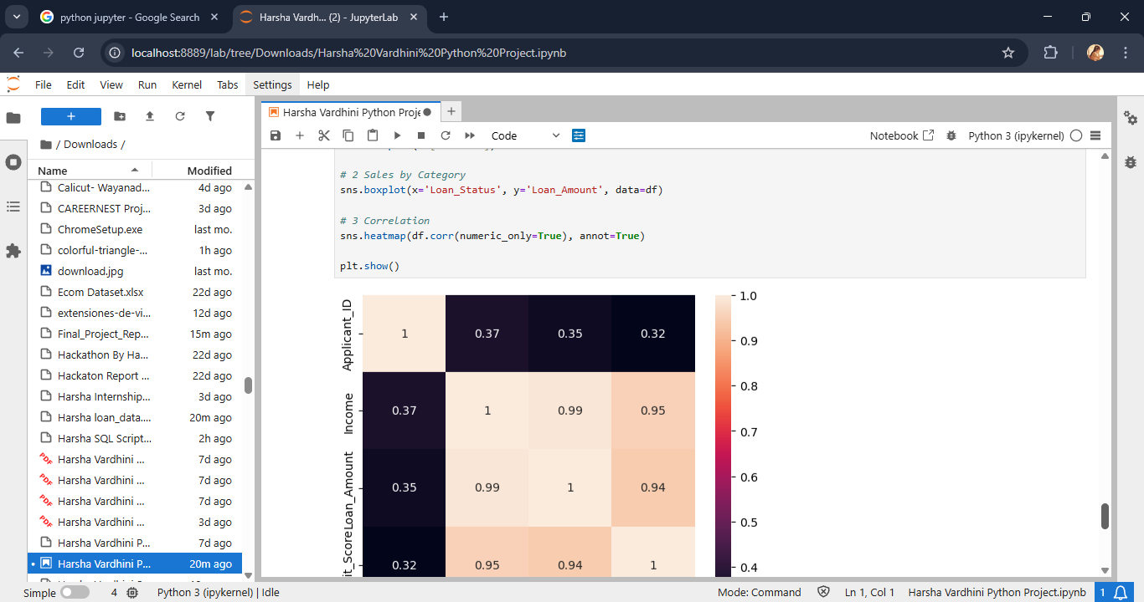
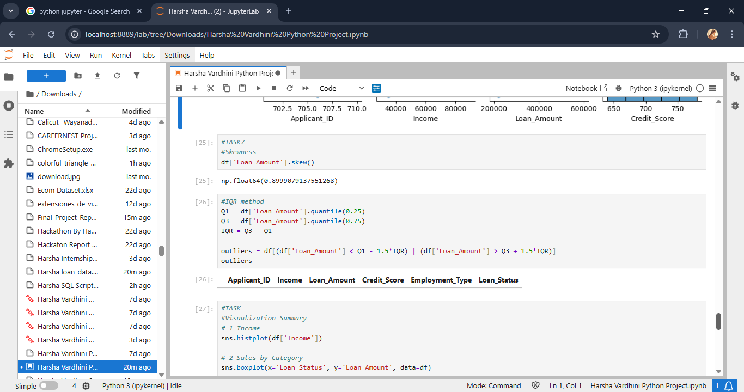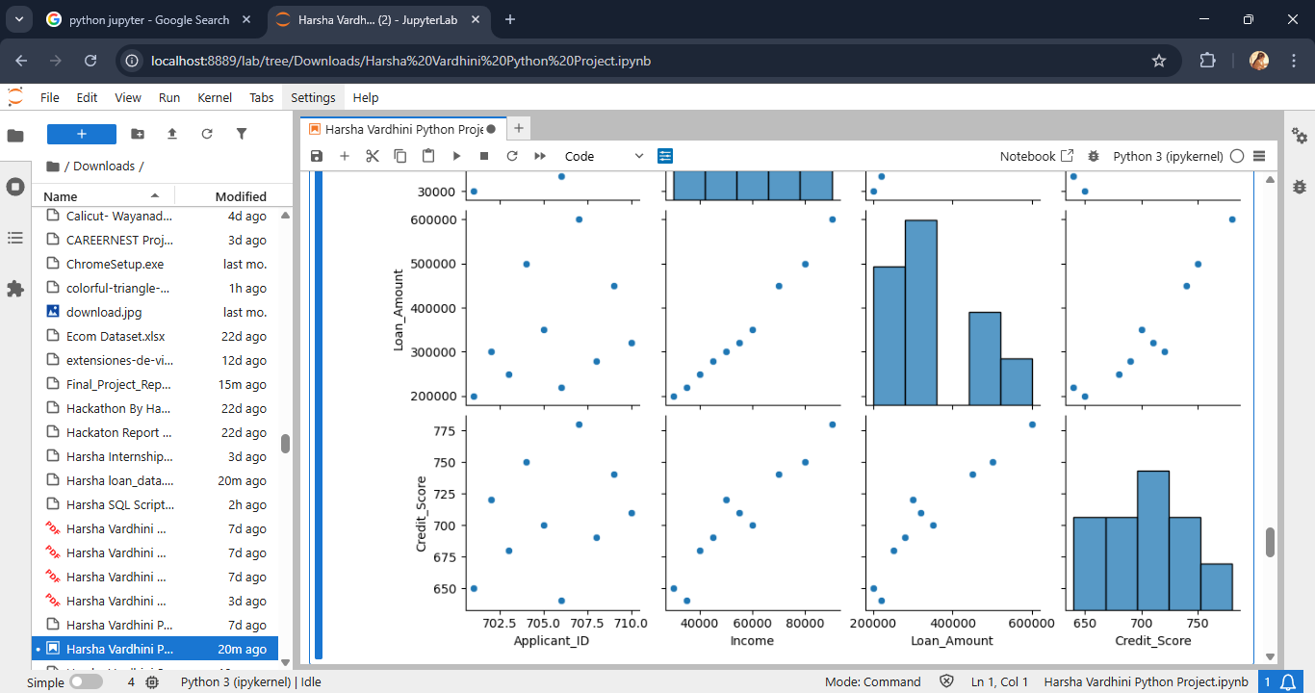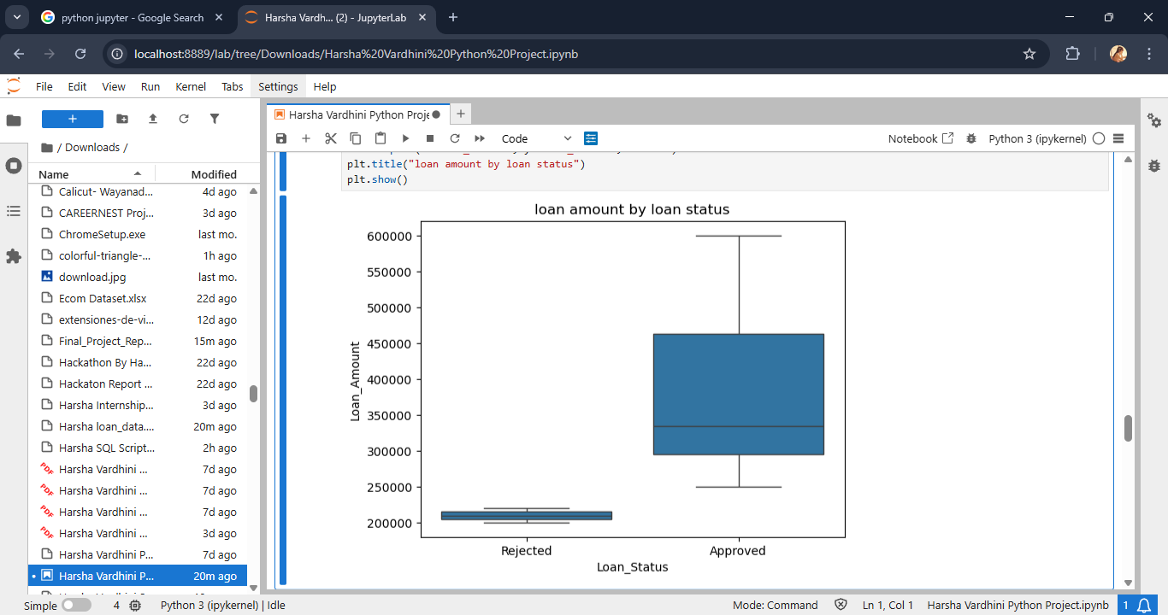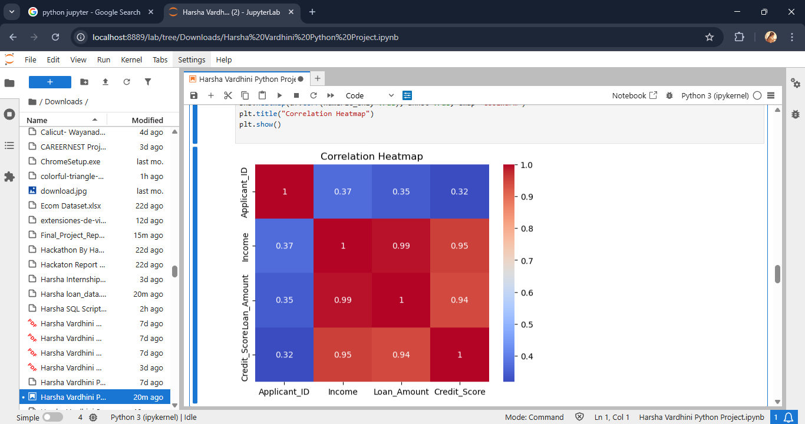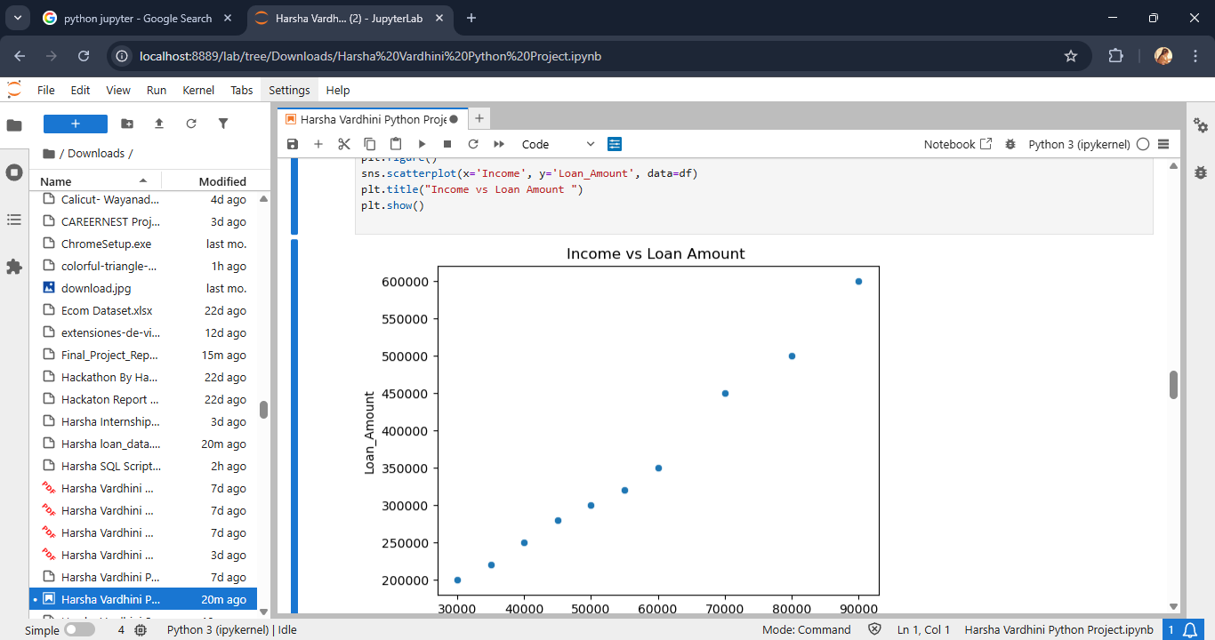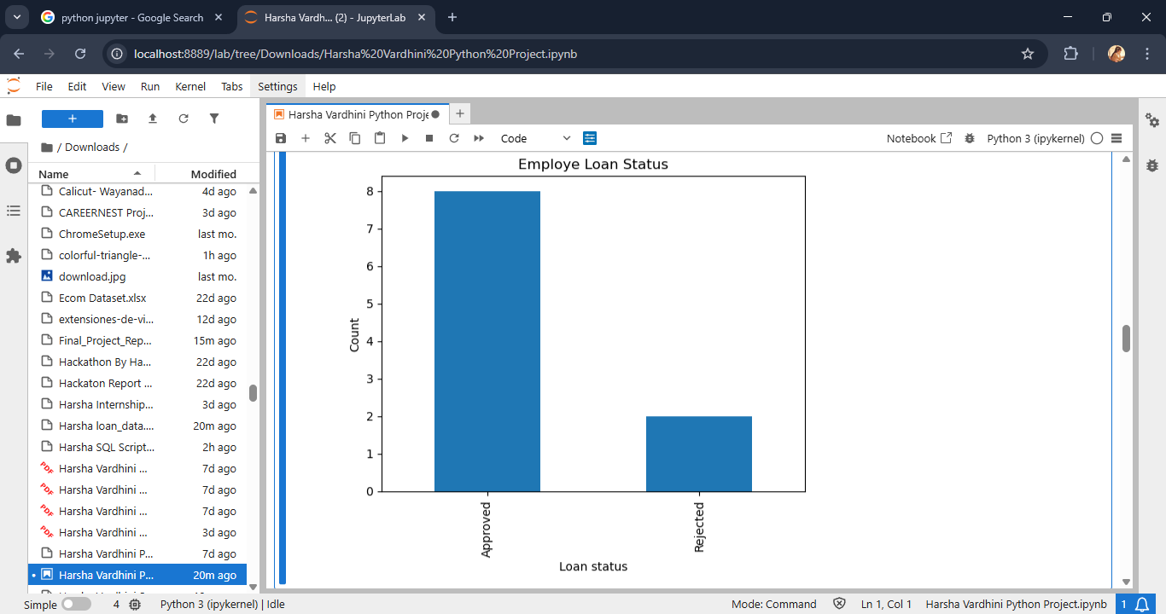

MYSQL – DATA STORAGE

1. Introduction
SQL was used to store and manage student performance data in a structured database.

2. Database Structure
Database: student_performance_db
Table: student_performance
Column | Description
Student_ID | Primary Key
StudyHours | Study hours
Attendance | Attendance %
Assignments | Assignment score
Midterm | Midterm marks
FinalScore | Final marks
Result | Pass/Fail

3. Data Operations
- Data insertion
- Data retrieval using SELECT queries
- Counting total records
- Checking table structure

Screenshots:

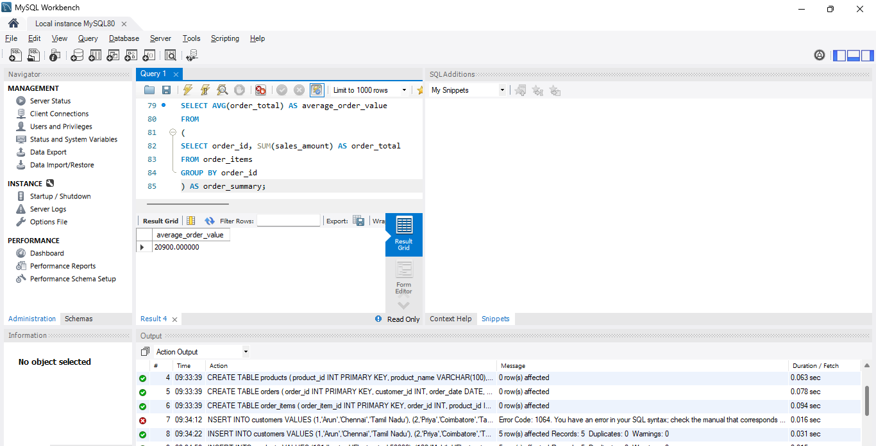
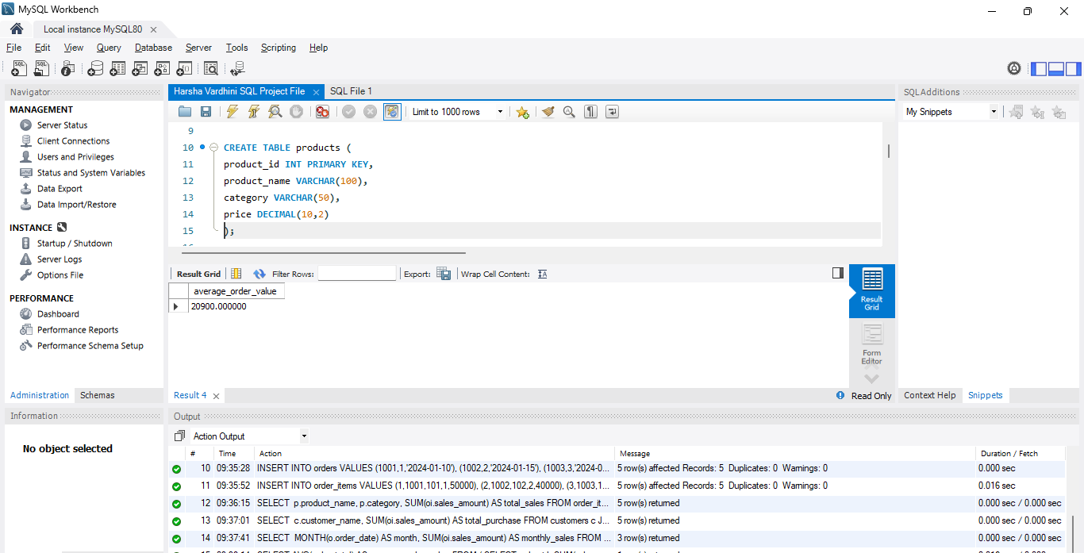

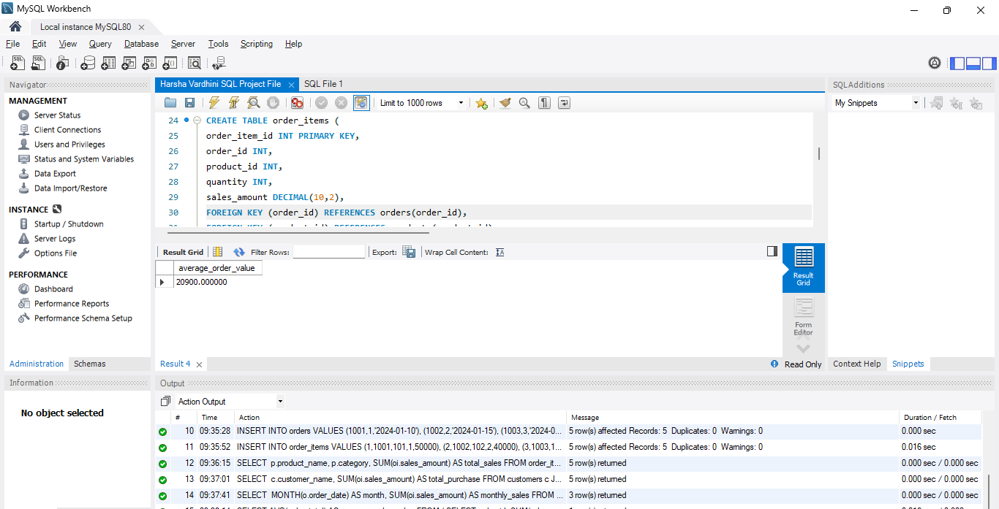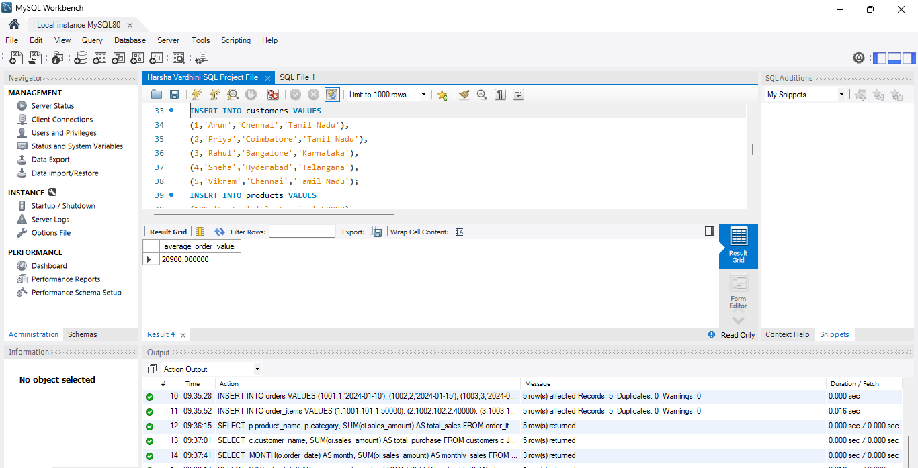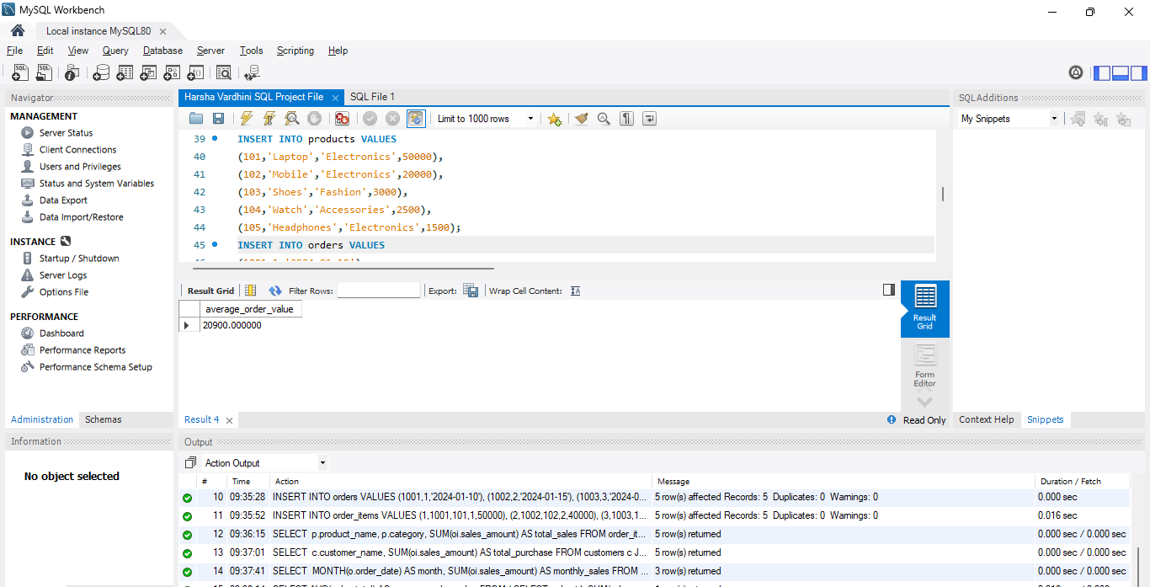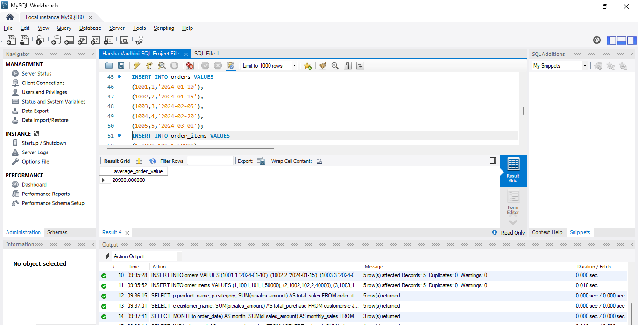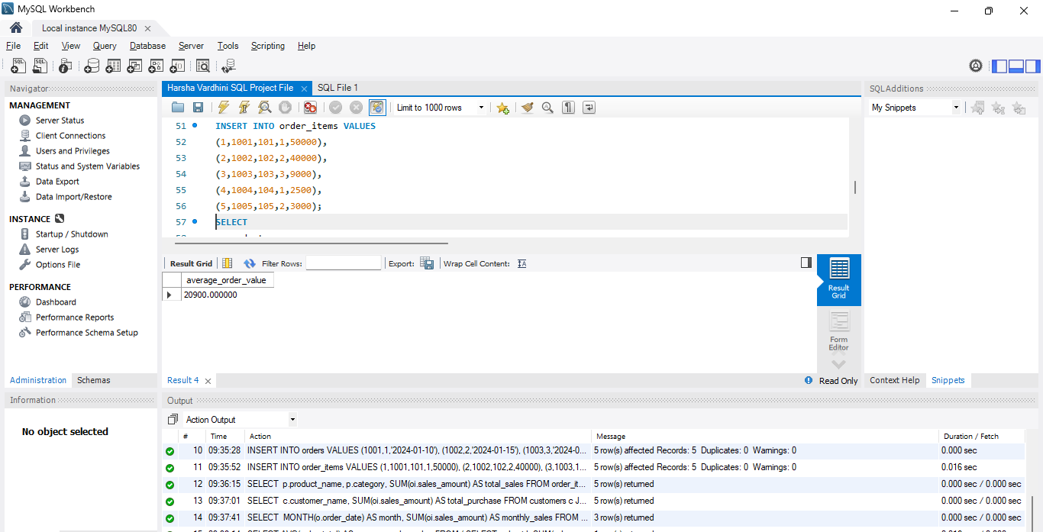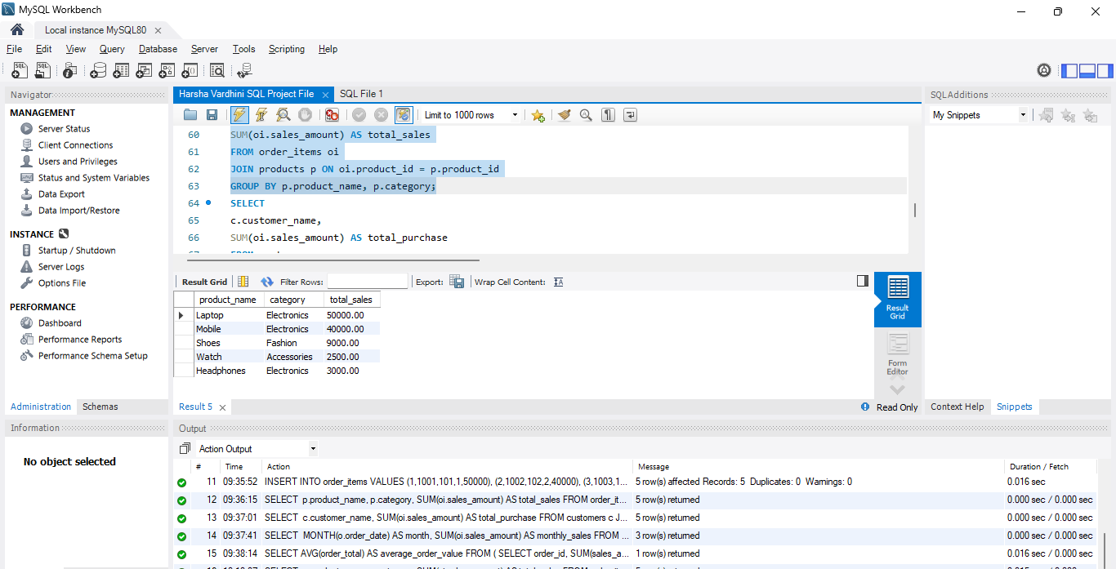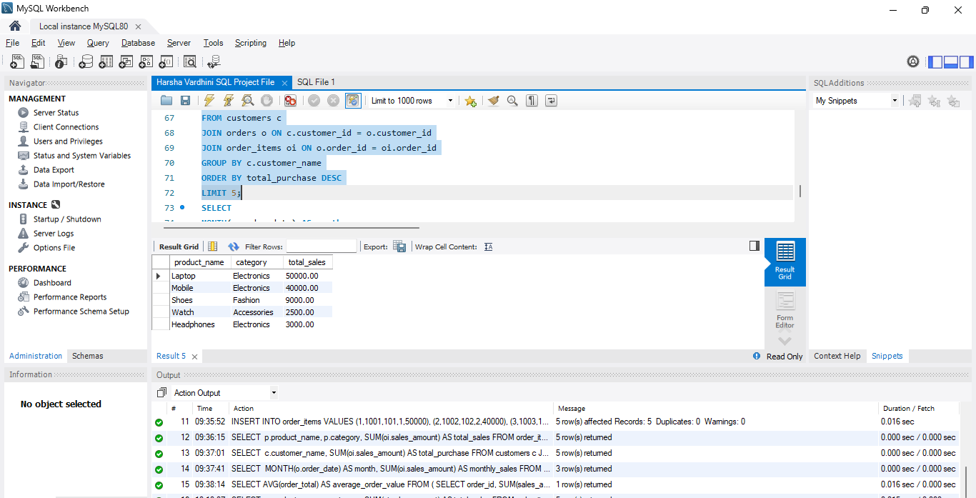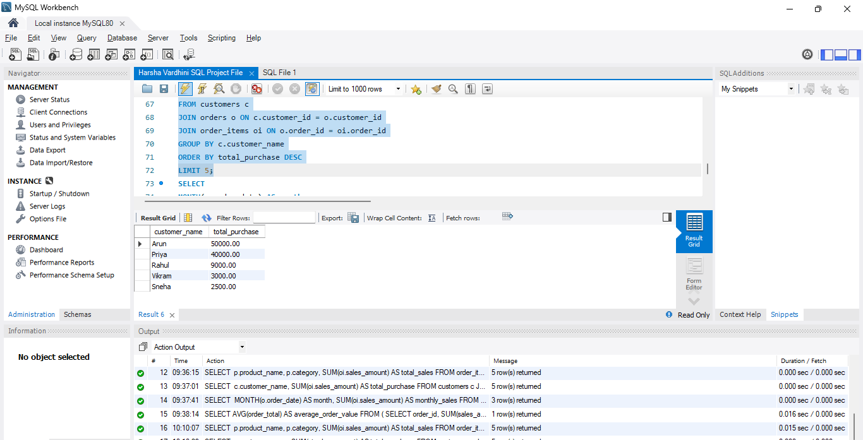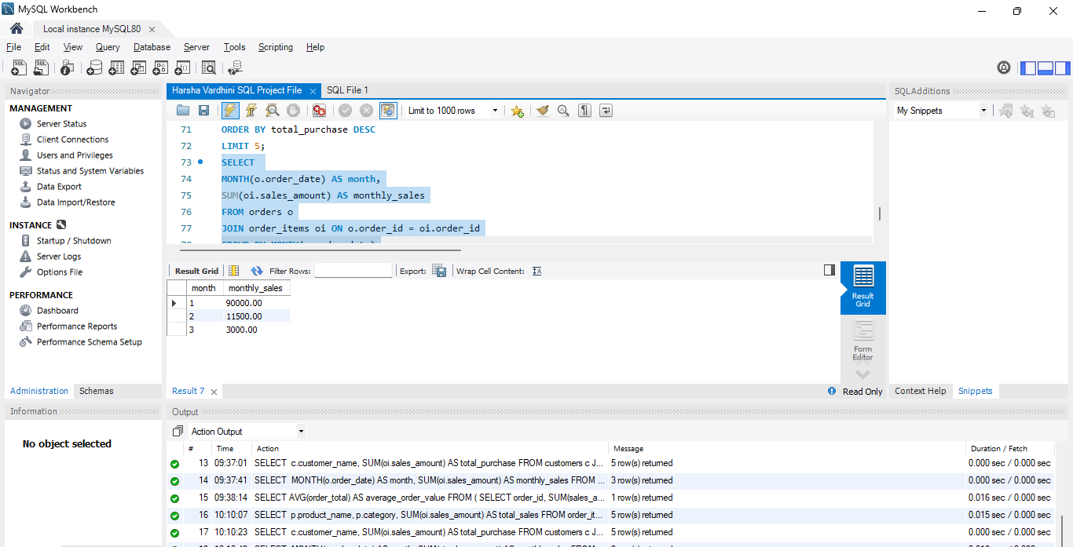

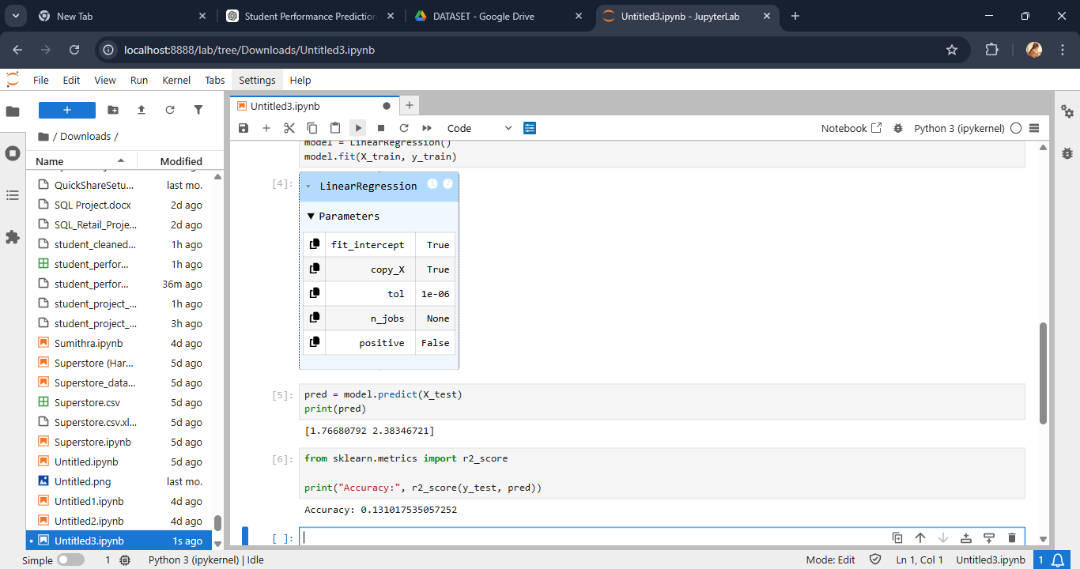

POWER BI – VISUALIZATION AND DASHBOARD

1. Introduction
Power BI was used to create an interactive dashboard for analyzing student performance.

2. Dashboard Components
KPI Cards
- Average Score
- Pass Percentage
Slicer
- Filter by Result (Pass/Fail)
Bar Chart
- Comparison of scores
Line Chart
- Study hours vs performance
Pie Chart
- Pass vs Fail distribution
Scatter Plot
- Attendance vs Final Score
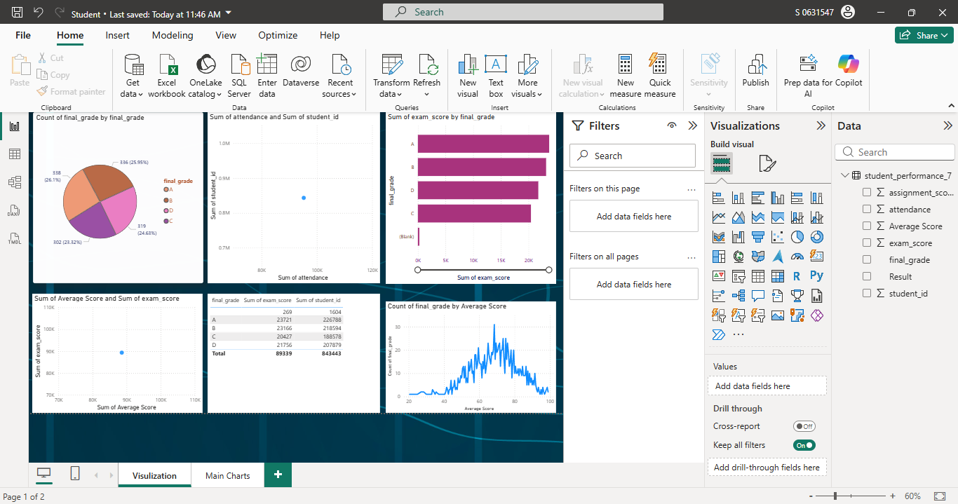
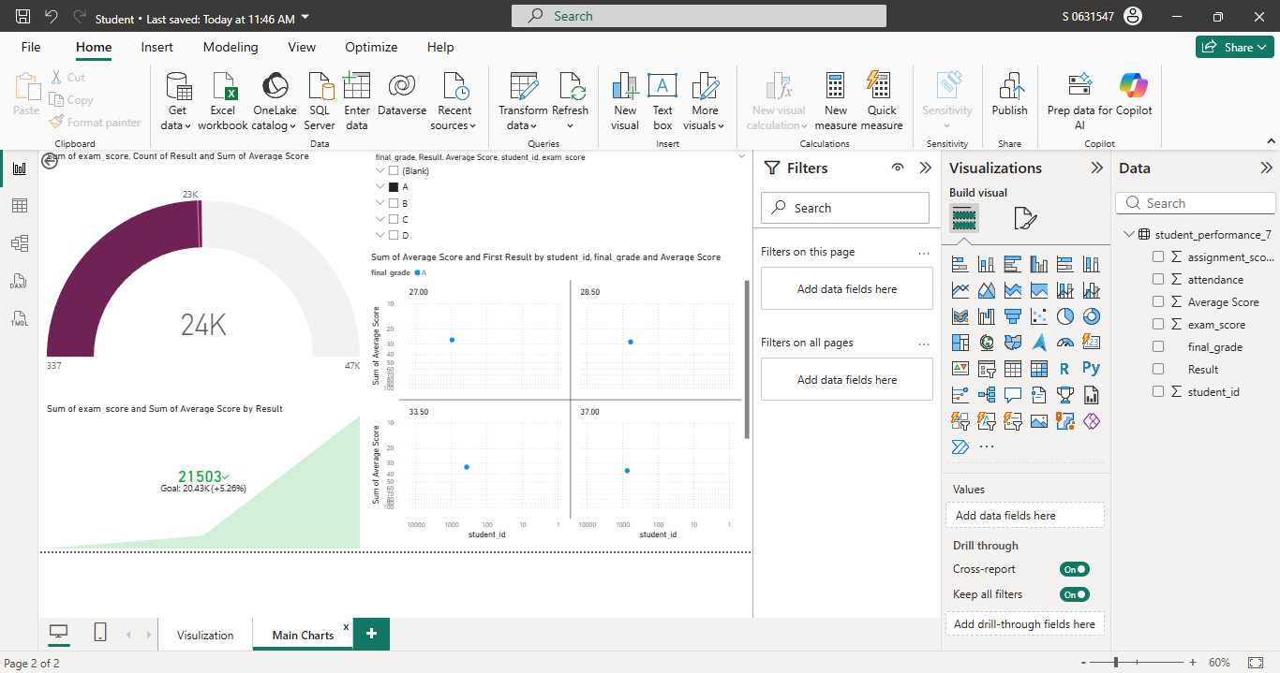

BUSINESS INSIGHTS

- Study Hours Impact Performance
Students who study more tend to score higher
- Attendance is Crucial
Low attendance leads to poor performance
- Assignments Improve Scores
Students completing assignments perform better
- Strong Correlation Between Midterm and Final Scores
Midterm marks indicate final outcomes
- At-Risk Students Identified Early
Helps in taking preventive actions

CONCLUSION

This project successfully demonstrated how student performance data can be analyzed to predict academic outcomes. Data cleaning, analysis, and visualization techniques helped in identifying key factors such as attendance, study hours, and assignments.
The project highlights the importance of data-driven decision-making in education. It enables educators to identify weak students early and take necessary actions to improve performance.

References

1. Kaggle. (n.d.). Student Performance Dataset.

2. Python Software Foundation. Python Documentation.
https://docs.python.org/

3.Microsoft Corporation. Power BI Documentation.
https://learn.microsoft.com/en-us/power-bi/

4.Microsoft Corporation. Excel Support Documentation.
https://support.microsoft.com/excel

5. W3Schools. SQL Tutorial.
https://www.w3schools.com/sql/

