**Pipes**

<td [style.color]="'#306A9D'" [style.font-weight]="700" [style.font-size.px]="20">

{{ product.productName | uppercase }}

</td>

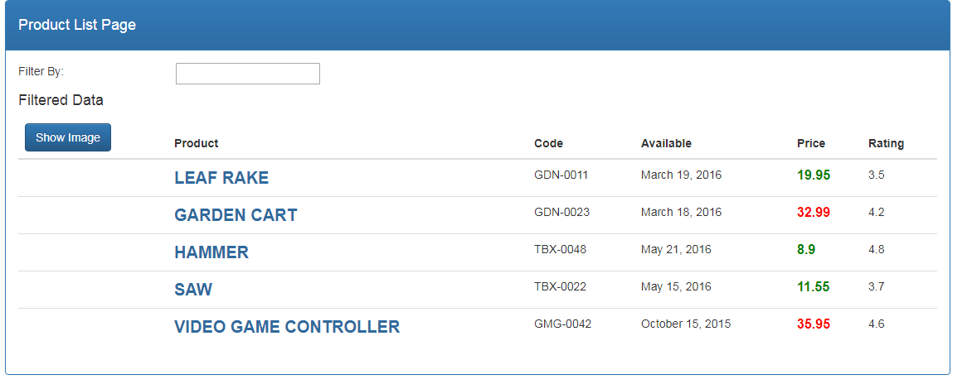

import { Pipe, PipeTransform } from "@angular/core";

@Pipe({

name: 'convertToSpaces'

})

export class ConvertToSpacesPipe implements PipeTransform{

transform(value:string, character:string, ) {

return value.replace(character, '@');

}

}

import { ConvertToSpacesPipe } from 'src/app/products/convert-to-spaces.pipe';

declarations: [

AppComponent,

ProductListComponent,

ConvertToSpacesPipe

]

<td>{{ product.productCode | convertToSpaces:'-'}}</td>

