IBM SkillsBuild National Cybersecurity Bootcamp
BharatCares (CSRBOX Group) in collaboration with IBM
5th October 2026 to 19th October 2026

PROJECT REPORT

Automated Web Security Scanner
Auditing Websites for Missing Security Headers and CORS Misconfigurations

Submitted by
KATTA HARSHAVARDHAN
Participant, IBM SkillsBuild National Cybersecurity Bootcamp

Date of submission: 23rd October 2026

Abstract
Websites are attacked every day through problems such as cross-site scripting (XSS), clickjacking, protocol downgrade attacks and insecure cross-origin resource sharing (CORS) settings. Many of these attacks can be reduced if a web server sends the correct HTTP security headers and is configured carefully, yet checking this manually for every site is slow and easy to forget.
This project presents an Automated Web Security Scanner written in Python. It takes a list of URLs, sends normal HTTP requests, checks six important security headers, tests how the server responds to untrusted CORS origins, and then calculates a security score (0 to 100) and a grade (A to F) for every site. The results are shown as a table and charts, saved to a CSV file, and combined with clear recommendations on how to fix each weakness. The tool is lightweight, needs no dataset, and runs on a normal laptop.

1. Introduction

1.1 Background
Every time a browser loads a website, the server replies with the page and also with a set of HTTP response headers. Some of these headers give instructions to the browser about security, for example which scripts may run, whether the page may be placed inside a frame, and whether the site must always be opened over HTTPS. If these headers are missing, the browser falls back to less secure default behaviour.
CORS is a browser mechanism that decides which other websites are allowed to read responses from a server. A wrong CORS setting, for example trusting every origin together with credentials, can let a malicious website read private data of a logged-in user.

1.2 Problem Statement
Security headers and CORS settings are often forgotten or configured wrongly, and checking many websites by hand is time-consuming. There is a need for a simple, automated tool that audits these settings and clearly reports what is missing.

1.3 Motivation
The OWASP Top 10 lists Security Misconfiguration as a common and serious web risk. A header and CORS scanner addresses this category directly and is a practical first step in any web security assessment or DevSecOps pipeline.

2. Objectives
- To build a Python tool that automatically audits websites for key HTTP security headers.
- To detect unsafe CORS behaviour using fake and null Origin values.
- To calculate a simple, explainable security score and grade for each site.
- To present the results as tables, charts and a downloadable CSV report.
- To give clear recommendations to fix every weakness found.
- To follow ethical practice by scanning only permitted websites and sending only normal requests.

3. Tools and Technologies
Tool / Library | Purpose
Python 3.13 | Main programming language
requests | Sending HTTP GET requests and reading response headers
pandas | Storing results in a table and exporting to CSV
matplotlib | Drawing the bar charts
Jupyter Notebook | Writing, running and presenting the project step by step
urllib.parse | Cleaning and parsing URLs

No external dataset is used. The tool works on live URLs supplied by the user. The minimum hardware needed is a normal laptop (the project ran on a system with 8 GB RAM) and an internet connection.

4. System Design and Methodology

4.1 Workflow
- The user provides a list of target URLs in the TARGETS list.
- Each URL is cleaned (https:// is added if missing).
- A GET request is sent and the response headers are collected.
- The six security headers are checked and points are awarded for each header that is present and valid.
- The CORS test sends two extra requests with Origin: https://evil-attacker.example and Origin: null.
- The Access-Control-Allow-Origin and Access-Control-Allow-Credentials responses are analysed.
- Header points and CORS points are added to give a score out of 100, which is converted to a grade.
- Results are shown in a table, plotted as charts, printed as recommendations and saved as scan_results.csv.

4.2 Security Headers Checked
Header | Points | Why it matters
Content-Security-Policy | 25 | Restricts which scripts and resources can load; main defence against XSS
Strict-Transport-Security | 20 | Forces HTTPS and prevents SSL-strip / downgrade attacks
X-Frame-Options (or CSP frame-ancestors) | 15 | Prevents clickjacking by blocking unwanted framing
X-Content-Type-Options | 10 | Value nosniff stops MIME-type sniffing
Referrer-Policy | 10 | Limits URL information leaked to other websites
Permissions-Policy | 10 | Restricts access to camera, microphone, location, etc.

4.3 CORS Test
The scanner sends a request with a fake Origin and reads the response. The result is classified as follows:
Status | Points | Meaning
SAFE | 10 | No CORS headers, or the fake origin was not trusted
MEDIUM | 5 | Server allows any origin using the wildcard (*)
HIGH | 3 | Server reflects the untrusted origin back (without credentials)
CRITICAL | 0 | Server trusts an untrusted origin or wildcard together with credentials

4.4 Scoring and Grading
Total score = header points (maximum 90) + CORS points (maximum 10). Grades: A (90 and above), B (75 to 89), C (60 to 74), D (40 to 59) and F (below 40).

5. Implementation
The project is implemented in a single Jupyter Notebook with the following main parts:
- Configuration: the TARGETS list, timeout, fake origin and user agent.
- fetch(): sends the request and handles network errors safely, so one broken site does not stop the scan.
- check_headers(): looks for each security header (case-insensitive) and applies extra validation, such as nosniff for X-Content-Type-Options and CSP frame-ancestors as a modern alternative to X-Frame-Options.
- check_cors(): tests the fake origin and the null origin and returns the worst result found.
- scan_site(): combines all checks for one URL and returns a dictionary of results.
- Reporting: pandas DataFrame, two matplotlib charts, text recommendations and CSV export.

A short extract of the core logic is given below:
def check_headers(response):
points, details = 0, {}
resp_headers = {k.lower(): v for k, v in response.headers.items()}
for name, rule in SECURITY_HEADERS.items():
value = resp_headers.get(name.lower())
ok = value is not None
... # extra validation for nosniff, frame-ancestors, HTTPS
details[name] = 'Present' if ok else 'MISSING'
if ok:
points += rule['weight']
return points, details

6. Results and Analysis
The scanner was run on five websites: example.com, httpbin.org, wikipedia.org, github.com and python.org. All 5 of 5 sites were scanned successfully, and each scan took only a few seconds. The scanner produced a score, grade and CORS status for every site, two charts, a list of recommendations and a CSV report (scan_results.csv).

6.1 Scan Results
The table below summarises the score and grade of each scanned site, sorted from highest to lowest score.
Website | Score | Grade | CORS Status | Headers Missing
github.com | 90 | A | SAFE | Permissions-Policy
www.python.org | 45 | D | SAFE | Content-Security-Policy, X-Content-Type-Options, Referrer-Policy, Permissions-Policy
www.wikipedia.org | 30 | F | SAFE | Content-Security-Policy, X-Frame-Options, X-Content-Type-Options, Referrer-Policy, Permissions-Policy
example.com | 10 | F | SAFE | All 6 headers missing
httpbin.org | 0 | F | CRITICAL | All 6 headers missing

6.2 Screenshots of Output
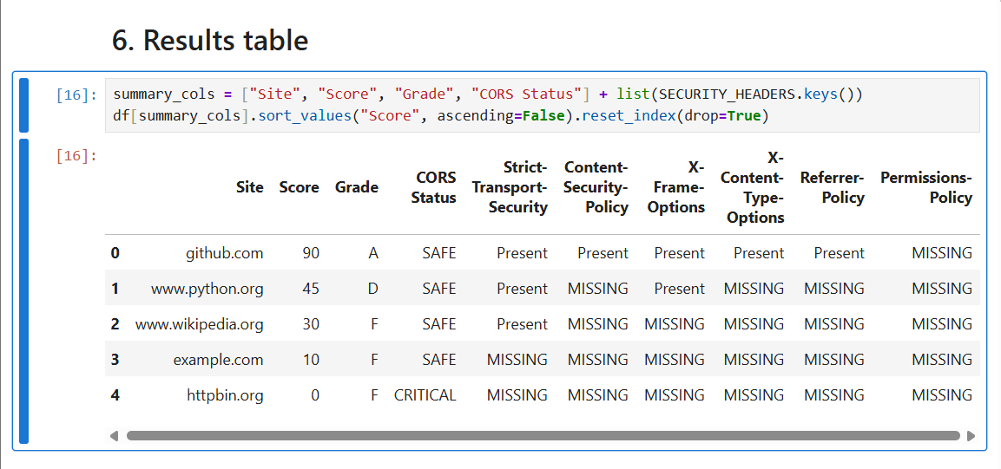
Figure 1: Scan results table from the notebook
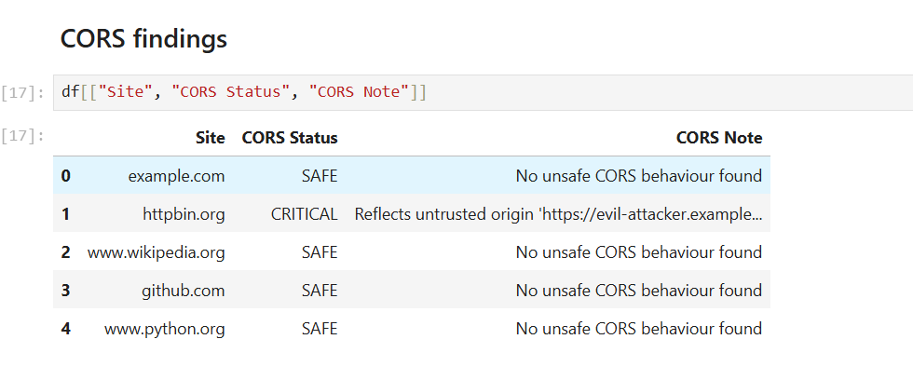
Figure 2: CORS findings for each site
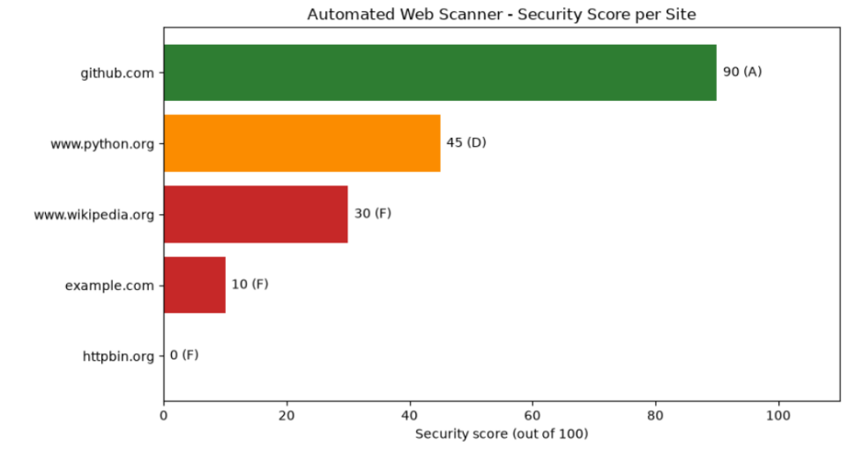
Figure 3: Security score per website
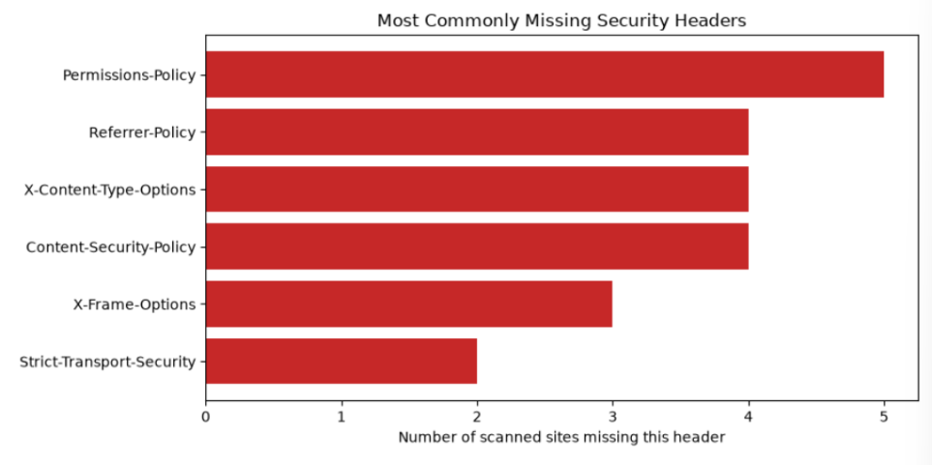
Figure 4: Most commonly missing security headers

6.3 Observations
- github.com scored the highest (90, Grade A). It sent five of the six security headers and was only missing Permissions-Policy, and its CORS behaviour was safe.
- httpbin.org scored the lowest (0, Grade F). It had none of the six headers and also had a CRITICAL CORS result, because it reflected the untrusted test origin back with credentials allowed.
- Permissions-Policy was the most commonly missing header and was absent on all 5 sites. Content-Security-Policy, X-Content-Type-Options and Referrer-Policy were each missing on 4 of 5 sites.
- Strict-Transport-Security was the best-adopted header, missing only on example.com and httpbin.org. This shows that HTTPS enforcement is more widely adopted than the newer browser-hardening headers.
- The average score across the five sites was 35 out of 100, and only one site (github.com) scored above 50. Four of the five sites had a safe CORS result.

6.4 Interpretation
The CRITICAL result for httpbin.org is expected. httpbin is a public HTTP request-and-response testing service that is deliberately permissive so that developers can call it from any website. It therefore trusts any origin, and the scanner correctly detected this behaviour. Similarly, example.com is a minimal placeholder page that is not meant to be a production site, so its low score is also expected. These two results show that the CORS check and the header check work as designed. In a real application that handles user data, the same CORS result would be a serious vulnerability.
A low score does not mean that a site has been hacked. It means the site has not enabled some of the extra protection layers that browsers support, so a future vulnerability would be easier to exploit.

7. Recommendations Produced by the Tool
For every site, the notebook prints which headers to add and why. Typical fixes are:
- Add Strict-Transport-Security: max-age=31536000; includeSubDomains
- Add Content-Security-Policy with a restrictive default-src policy
- Add X-Frame-Options: DENY (or SAMEORIGIN) and X-Content-Type-Options: nosniff
- Add Referrer-Policy: strict-origin-when-cross-origin
- Add Permissions-Policy to disable unused browser features
- Use an allow-list of trusted origins in CORS instead of * or reflecting the Origin header, and never combine untrusted origins with credentials

7.1 Site-specific recommendations from this scan
Website | What should be fixed
github.com | Add Permissions-Policy to reach a full score.
www.python.org | Add Content-Security-Policy, X-Content-Type-Options: nosniff, Referrer-Policy and Permissions-Policy.
www.wikipedia.org | Add Content-Security-Policy, X-Frame-Options, X-Content-Type-Options, Referrer-Policy and Permissions-Policy.
example.com | Add all six headers, starting with Strict-Transport-Security and Content-Security-Policy.
httpbin.org | Add all six headers; restrict CORS to a trusted allow-list (if used in a real application).

8. Ethical Considerations
The scanner only sends ordinary GET requests, the same as a normal browser, and does not attempt any exploitation, brute-forcing, fuzzing or payload injection. It should only be used on websites owned by the user or on sites that are intended for testing and public learning. Scanning systems without permission may be illegal under the IT Act, 2000 and similar laws. The test list in this project therefore uses only public, test or educational sites.

9. Limitations
- Only the main page of each site is checked, not every page.
- Only the presence of a header is checked, not how strong its value is (for example a weak CSP still counts as present).
- Sites protected by firewalls or bot filters may block the scanner or return different headers.
- The scoring weights are a simple educational model, not an official standard.

10. Future Scope
- Check cookie flags (Secure, HttpOnly, SameSite).
- Check TLS/SSL certificate validity, expiry and protocol version.
- Analyse the strength of CSP and HSTS values.
- Crawl multiple pages of a website and scan them all.
- Export the results as a formatted HTML or PDF report.
- Integrate the scanner into a CI/CD pipeline as an automated security gate.

11. Conclusion
The Automated Web Security Scanner successfully audits websites for six important security headers and for basic CORS misconfigurations, and turns the findings into an easy-to-read score, grade, chart and recommendation list. On the five sites tested, scores ranged from 0 to 90, with Permissions-Policy missing everywhere and one site showing a critical CORS issue. The project is lightweight, needs no dataset, and shows how a small amount of Python can automate an important part of web security assessment. It also gave practical experience with HTTP, security headers, CORS and the concept of security misconfiguration learnt during the IBM SkillsBuild Cybersecurity Bootcamp.

12. References
- OWASP Secure Headers Project - owasp.org/www-project-secure-headers
- OWASP Top 10 - A05: Security Misconfiguration - owasp.org/Top10
- MDN Web Docs - HTTP Headers and CORS - developer.mozilla.org
- Python Requests documentation - requests.readthedocs.io
- IBM SkillsBuild Cybersecurity learning plan and Bootcamp Masterclass material - skills.yourlearning.ibm.com

