Cloud-Based Quiz Application - Project Report

1. Executive Summary
The Cloud-Based Quiz Application is a comprehensive, full-stack web application designed to provide an interactive and engaging platform for users to test their knowledge on various cloud computing topics. Built with a modern tech stack featuring React (Vite) for the frontend and Node.js/Express with Supabase for the backend, the application offers a seamless user experience with real-time data, responsive design, and a robust administrative panel.

2. Key Features

2.1 User Features
- • Interactive Home Page: A visually stunning landing page with animated backgrounds and a live global leaderboard.
- • User Authentication: Secure signup and login functionality powered by Supabase Auth.
- • Dashboard: A personalized dashboard showing available quizzes, recent activity, and progress.
- • Quiz Interface: A dynamic quiz taking experience with timer, instant feedback, and progress tracking.
- • Real-time Leaderboard: A global leaderboard showcasing top performers with dark mode aesthetics.
- • Responsive Design: Fully optimized for desktop, tablet, and mobile devices.

2.2 Admin Features
- • Dashboard Overview: Real-time analytics on users, quizzes, and attempts.
- • Quiz Management: Create, update, and delete quizzes and questions.
- • User Management: View and manage registered users (promote to admin, ban/unban).
- • Analytics: Detailed insights into quiz performance and user engagement.
- • Application Settings: Configure global app settings like branding and maintenance mode.

3. Technology Stack

Frontend:
- • Framework: React 18 (Vite)
- • Styling: Tailwind CSS, Framer Motion, Lucide React
- • State Management: React Hooks
- • Routing: React Router DOM

Backend:
- • Runtime: Node.js
- • Framework: Express.js
- • Database: PostgreSQL (via Supabase)
- • Authentication: Supabase Auth
- • API: RESTful API endpoints

4. Application Screenshots

4.1 Home Page
The landing page features a modern, dark-themed design with an animated background and a clear call to action.
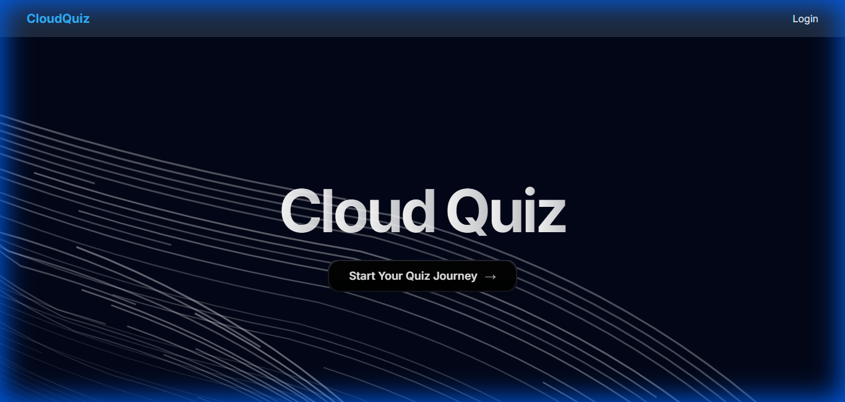

4.2 User Dashboard
Upon logging in, users are greeted with their dashboard, displaying available quizzes and their recent performance.
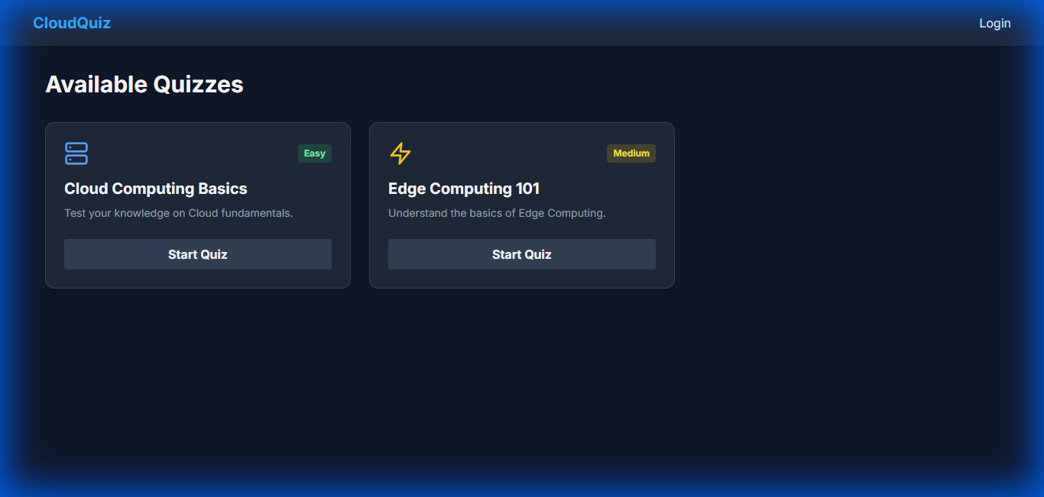

4.3 Quiz Interface
The quiz interface is designed for focus, with a clean layout, timer, and clear option selection.
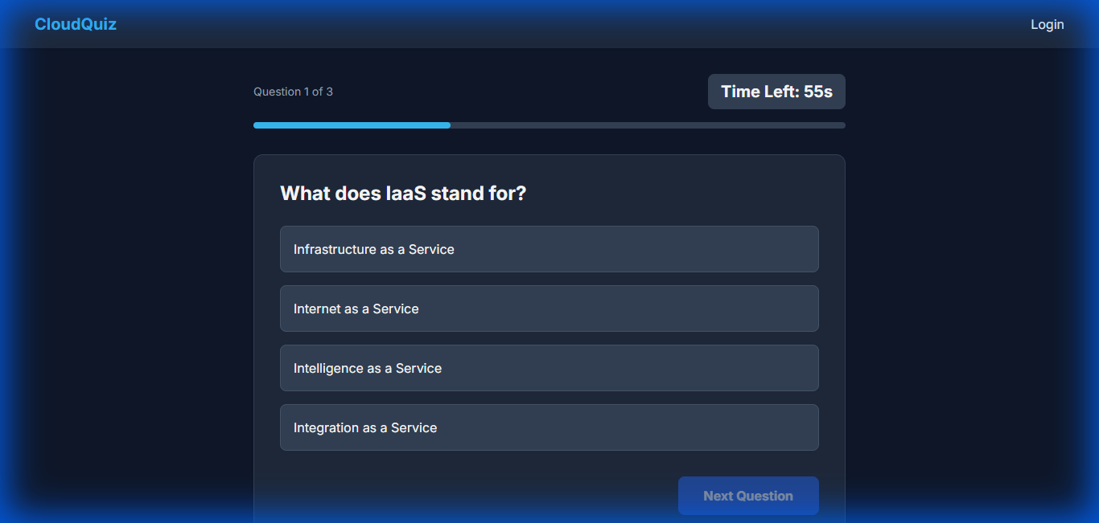

4.4 Admin Dashboard
(Note: Admin features are accessible to users with the 'admin' role, providing comprehensive management tools.)
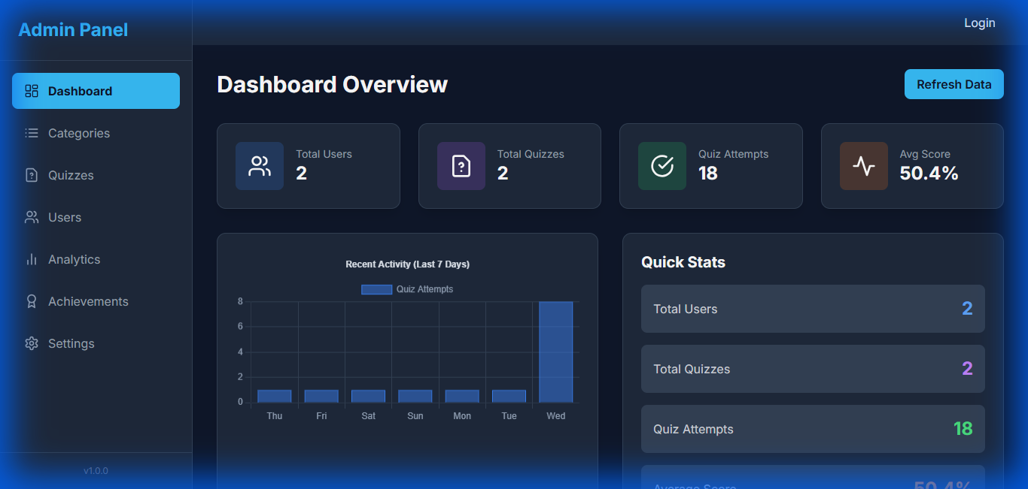

5. Conclusion
The Cloud-Based Quiz Application successfully meets the objectives of providing a robust, scalable, and engaging platform for learning and assessment. The integration of real-time data, modern UI/UX principles, and a secure backend ensures a high-quality experience for both users and administrators.

