|  |
| --- |
|  |
|  |
|  |
| FLOOD MONITORING |
| AND EARLY WARNING |

|  |
| --- |
| SUMMITTED BY ,  V.Praharsha  au723921243058  Praharshasingle@gmail.com |

DEVELOPMENT

*A flood monitoring development project aims to create systems and tools to effectively

monitor and manage floods, reducing the risks and impacts associated with flooding events. Such projects can include a range of components, and they often leverage technology and data to improve flood forecasting, warning, response, and resilience. Here are key aspects of a flood monitoring development project:

**1.Data Collection and Sensors:** Install sensors and monitoring equipment in flood-prone areas to collect data on rainfall, river levels, soil moisture, and other relevant factors. This data is crucial for early warning and preparedness.

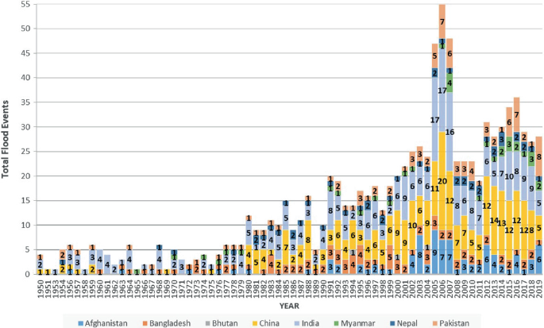

**2.Weather Forecasting:** Integrate weather forecasting data and models to predict heavy rainfall and potential flooding. This allows for early warnings to be issued before a flood event occurs.

**3.Hydrological Modeling:** Develop hydrological models to understand how rainfall and other factors affect river flow, groundwater levels, and flood risk. These models help in predicting flood patterns.

**4.Real-time Monitoring:** Implement real-time monitoring systems that collect and transmit data to central control centers, which can be monitored by relevant authorities and emergency services.

**5.Early Warning Systems:** Develop and implement early warning systems that can alert residents and authorities about impending floods, giving them time to prepare and evacuate if necessary.

**6.Community Engagement:** Educate and engage with the local community to ensure they understand the risks, know how to respond to flood warnings, and are prepared to take action.

**7.Communication Infrastructure:** Ensure there is a robust communication network in place to disseminate flood alerts and warnings to affected areas efficiently.

**8.GIS and Mapping:** Use Geographic Information Systems (GIS) to create flood risk maps, which can help in identifying vulnerable areas and planning evacuation routes and shelters.

**9.Disaster Response Plans:** Develop and update disaster response plans to ensure coordination among emergency services and local authorities during a flood event.

**10.Resilience Measures:** Implement flood resilience measures, such as levees, flood barriers, and improved urban planning, to mitigate the impact of floods.

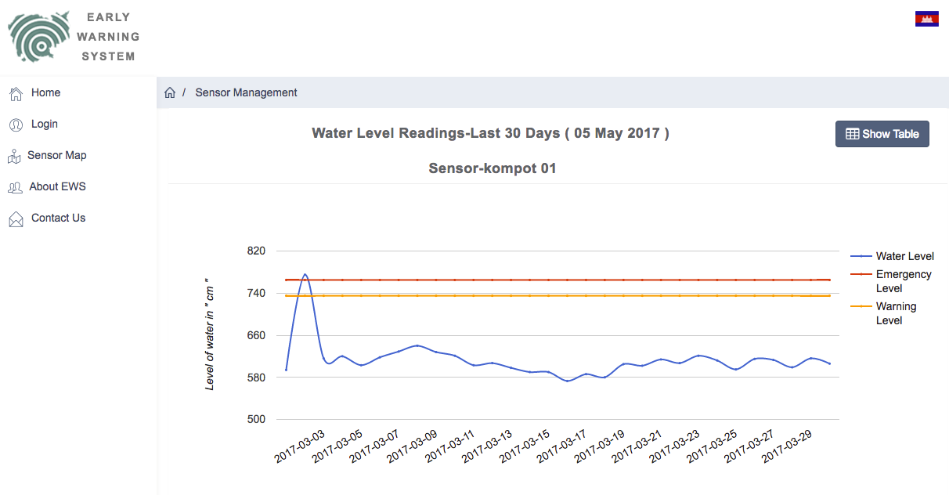

## Development code :

import random

import time

class FloodSensor:

def __init__(self, location):

self.location = location

self.status = "OK"

self.water_level = 0

def update_status(self, water_level):

if water_level >= 10:

self.status = "ALERT"

else:

self.status = "OK"

self.water_level = water_level

def generate_sensor_data():

# Simulate sensor data with random values for water level

sensor_data = {}

for location in ["River A", "River B", "Lake C"]:

water_level = random.randint(0, 15)

sensor_data[location] = water_level

return sensor_data

def monitor_flood():

sensors = [FloodSensor("River A"), FloodSensor("River B"), FloodSensor("Lake C")]

while True:

sensor_data = generate_sensor_data()

for sensor in sensors:

water_level = sensor_data[sensor.location]

sensor.update_status(water_level)

print(f"Location: {sensor.location}, Status: {sensor.status}, Water Level: {water_level}")

time.sleep(5) # Simulate sensor data update every 5 seconds

if __name__ == "__main__":

monitor_flood()

output :

**Location: River A, Status: OK, Water Level: 7**

**Location: River B, Status: OK, Water Level: 5**

**Location: Lake C, Status: OK, Water Level: 9**

**Location: River A, Status: OK, Water Level: 2**

**Location: River B, Status: OK, Water Level: 12**

**Location: Lake C, Status: ALERT, Water Level: 14**

**Location: River A, Status: OK, Water Level: 8**

**Location: River B, Status: ALERT, Water Level: 11**

**Location: Lake C, Status: ALERT, Water Level: 10**

**... (continues with updates every 5 seconds)**

