1.maximum and minimum

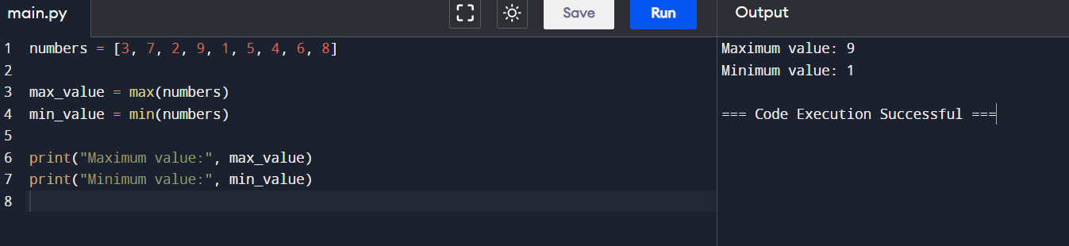

**2.merge sort**

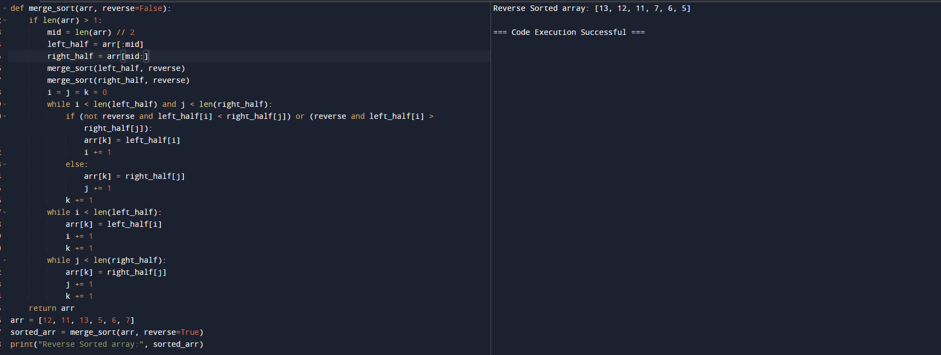

**3.quick sort**

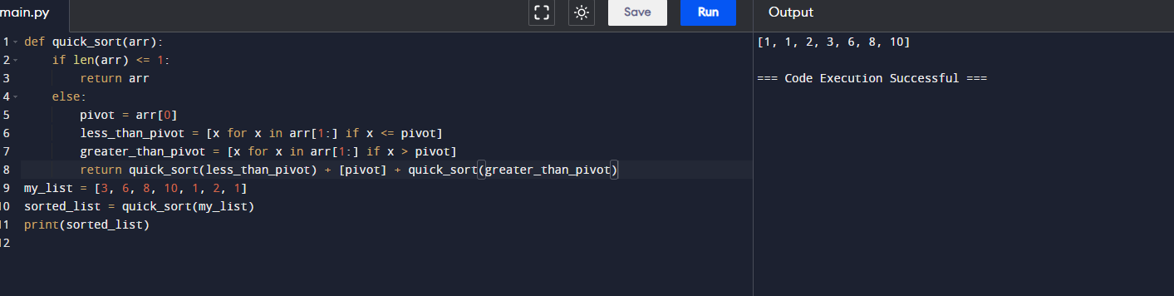

**4.binary search**

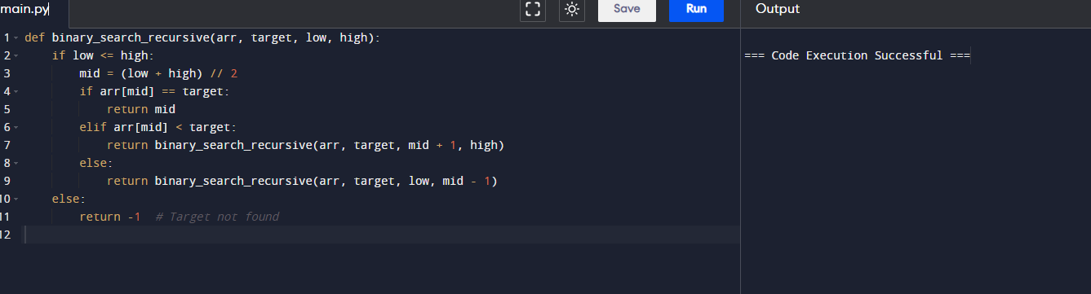

**5.strassen’s matrix multiplication**

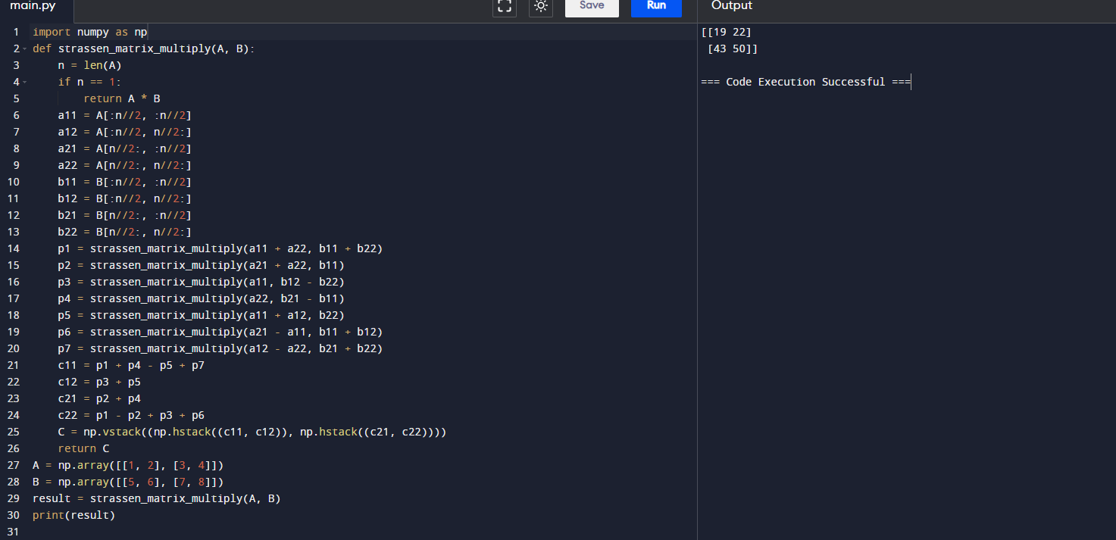

**6.karatsuba algorithm**

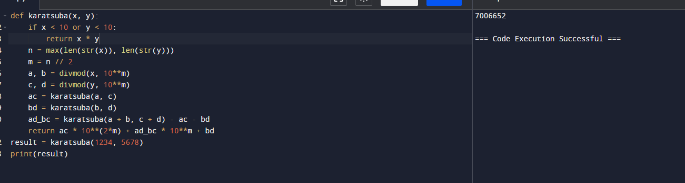

**7.closest pair of points**

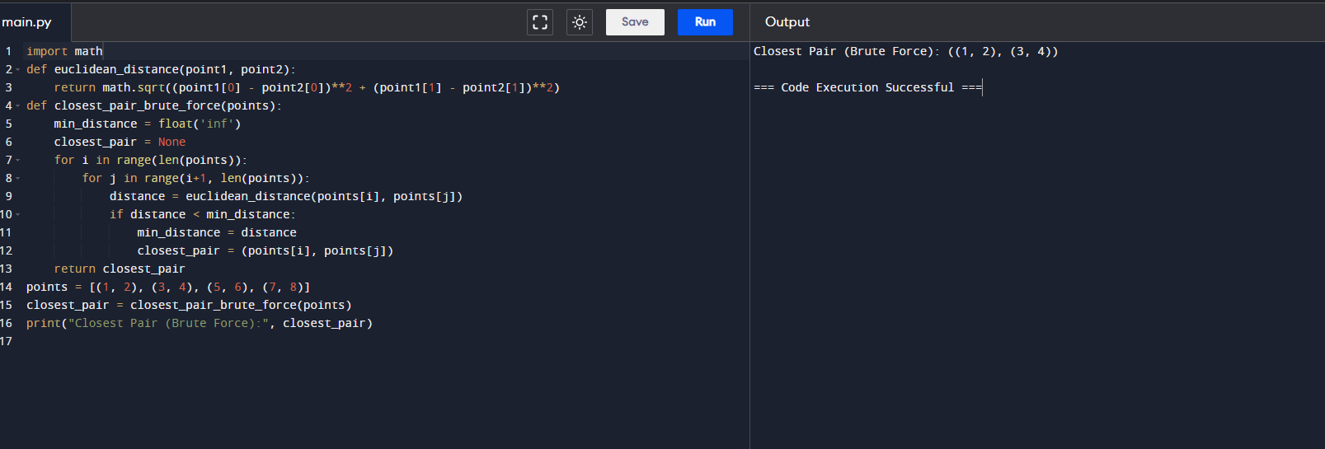

**8.median of medians**

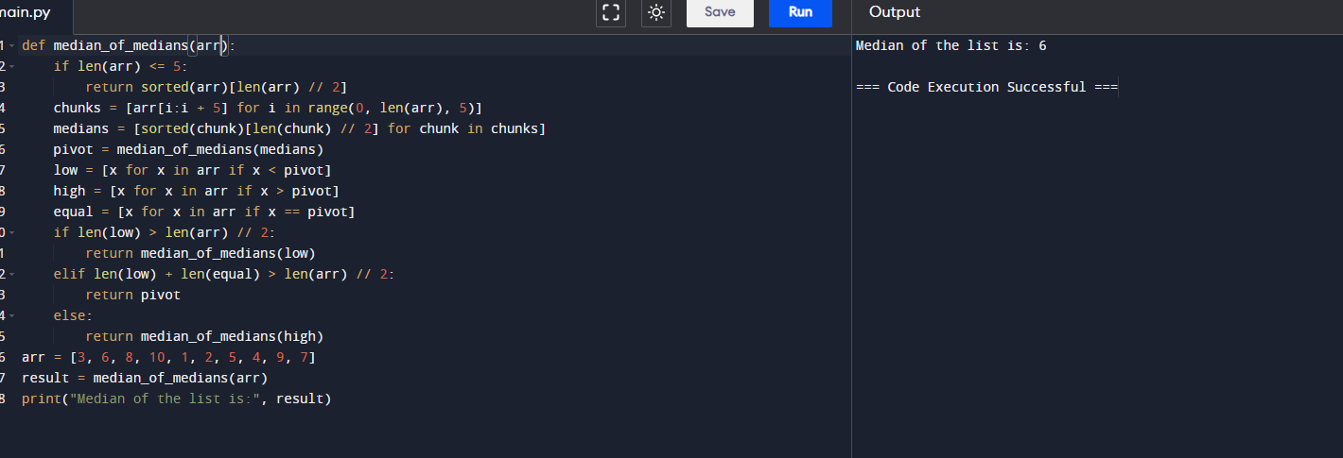

**9.meet in middle**

