**/.m :**

**Project Overview**

A vulnerability scanning tool is a software application designed to identify potential weaknesses or security holes in computer systems, networks, or applications. By automating the process of scanning for vulnerabilities, these tools can significantly enhance security posture.

**Key Features of Your Tool:**

* **Port Scanning:** Identify open ports on target systems.
* **Vulnerability Detection:** Scan for known vulnerabilities using databases like NVD.
* **Web Application Scanning:** Detect vulnerabilities in web applications, such as SQL injection, XSS, and CSRF.
* **Network Scanning:** Identify potential network-level vulnerabilities, like misconfigurations.
* **Reporting:** Generate detailed reports of findings, including severity levels and remediation recommendations.

**Python Libraries for Vulnerability Scanning**

* **Scapy:** For network packet manipulation and crafting.
* **Nmap:** For network discovery and port scanning.
* **Requests:** For making HTTP requests to web applications.
* **Beautiful Soup 4:** For parsing HTML and XML content.
* **Vulnerability Databases:** Use libraries like pyvuln to interact with vulnerability databases like NVD.

**Project Structure**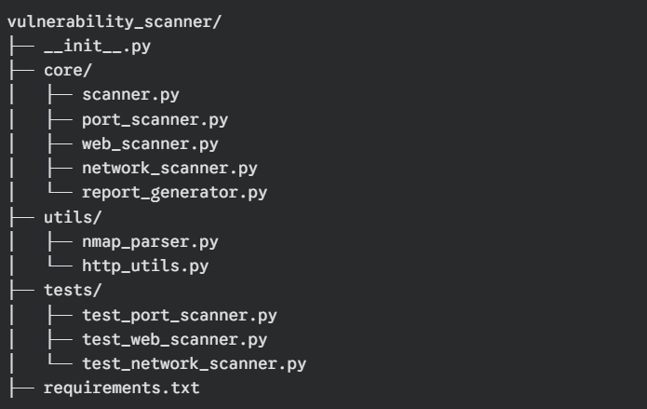:

**Security Considerations**

* **Ethical Hacking:** Ensure you have proper authorization to scan target systems.
* **Input Validation:** Validate user input to prevent malicious attacks.
* **Error Handling:** Implement robust error handling to prevent crashes and security vulnerabilities.
* **Rate Limiting:** Avoid overwhelming target systems with too many requests.
* **Security Best Practices:** Follow secure coding practices to minimize risks.

**Python Libraries for Vulnerability Scanning**

* **Scapy:** For network packet manipulation and analysis.
* **Nmap:** For network discovery and port scanning.
* **Requests:** For making HTTP requests to web applications.
* **Beautiful Soup 4:** For parsing HTML and XML content.
* **Vulnerability Databases:** Use libraries like pyvuln to interact with databases like NVD.
* **OWASP ZAP:** A powerful open-source web application scanner that can be integrated into Python scripts.

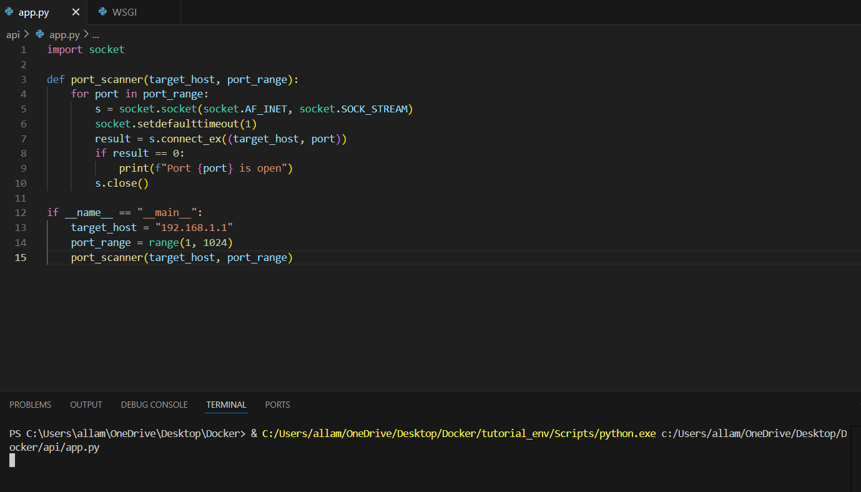

**Ethical Considerations and Legal Implications**

* **Obtain Permission:** Always obtain explicit permission before scanning target systems.
* **Avoid Malicious Activity:** Use your tool responsibly and ethically.
* **Comply with Laws and Regulations:** Adhere to local laws and regulations regarding network security and hacking.

**Conclusion: A Powerful Tool for Security Assessment**

* Developing a vulnerability scanning tool with Python offers a versatile and efficient approach to identifying potential security risks in networks and applications. By leveraging Python's extensive libraries and its ease of use, you can create tools that are both powerful and user-friendly.