**Day 24 – Aug 28th**

**HARSHA BHEEMISETTY** – 202708972

**TASK 1 – ABSTRACT FACTORY DESIGN PATTERN**

**Mobile.java**

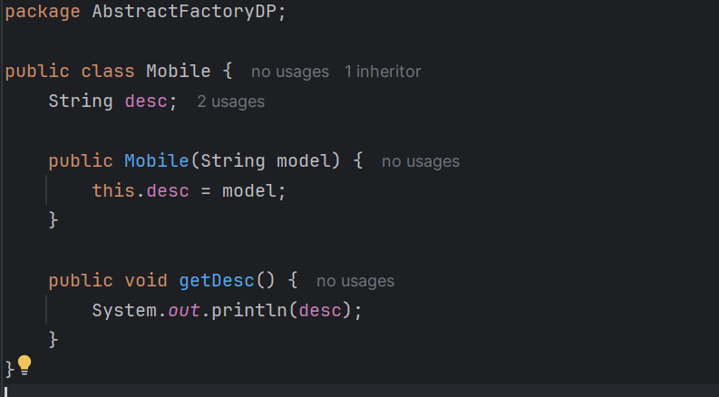

**NoMobile.java**

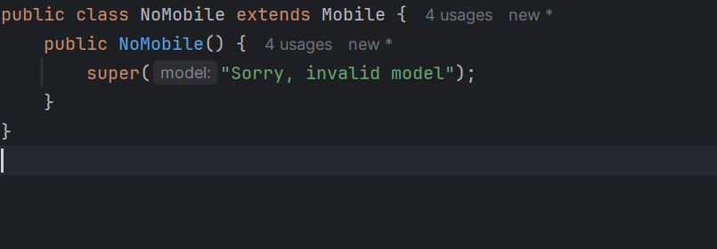

**Apple.java**

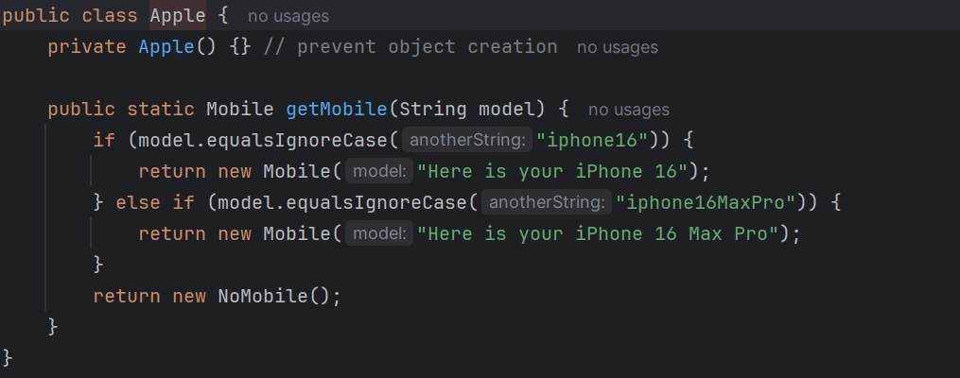

**Samsung.java**

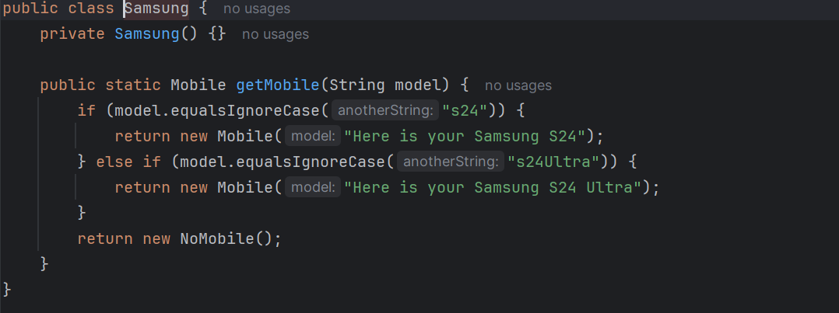

**Oneplus.java**

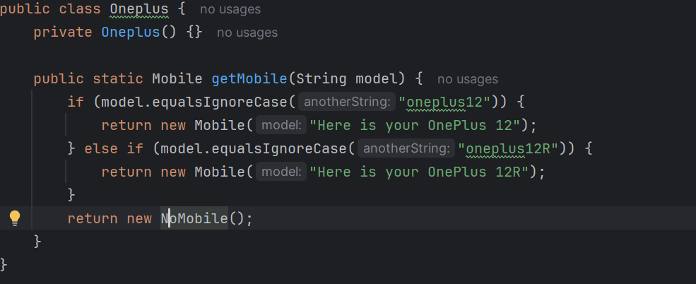

**MobileStore**

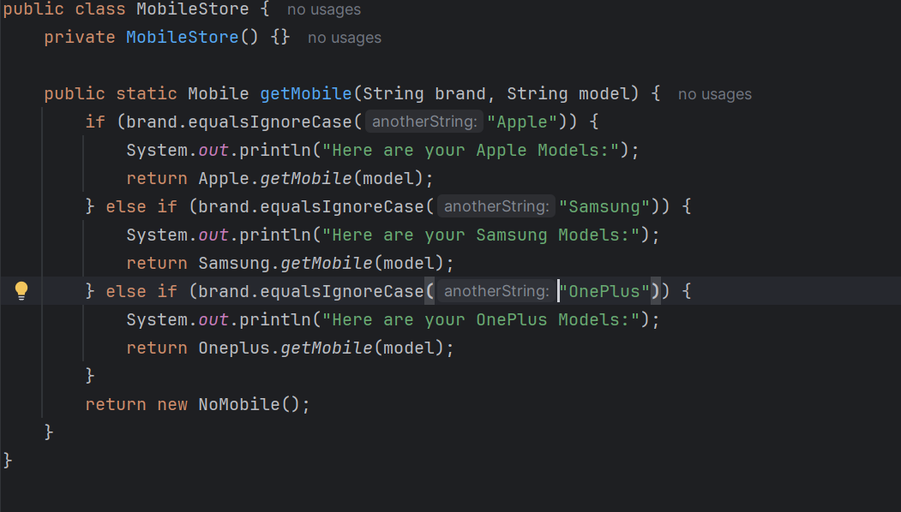

**Client Abstract Factory**

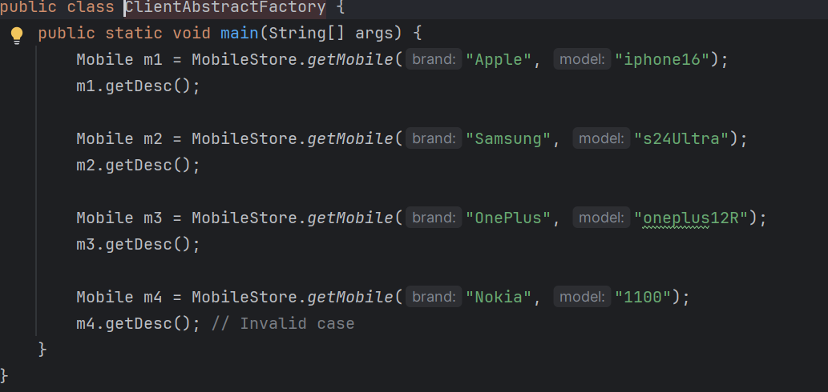

**OUTPUT:**

Here are your Apple Models:

Here is your iPhone 16

Here are your Samsung Models:

Here is your Samsung S24 Ultra

Here are your OnePlus Models:

Here is your OnePlus 12R

Sorry, invalid model

**NOTES:**

* **Abstract Factory Pattern implemented**
* **MobileStore = Super Factory**
* **Apple, Samsung, OnePlus = Concrete Factories**
* **Mobile & NoMobile = Products**

**TASK 2 – BUILDER METHOD DESIGN PATTERN**

**Laptop.java**

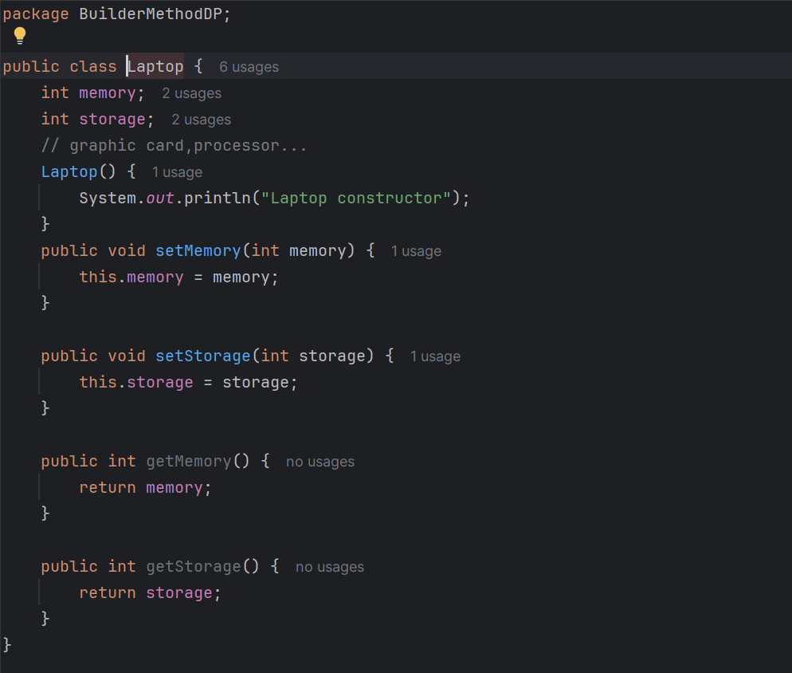

**LaptopBuilder.java**

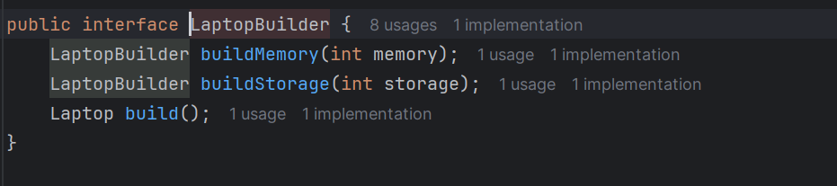

**LaptopDirector.java**

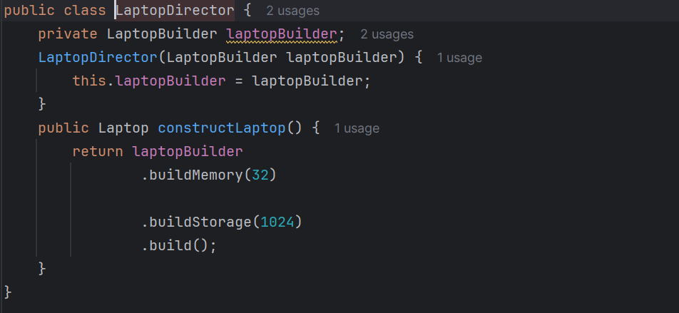

**LaptopConcreteBuilder.java**

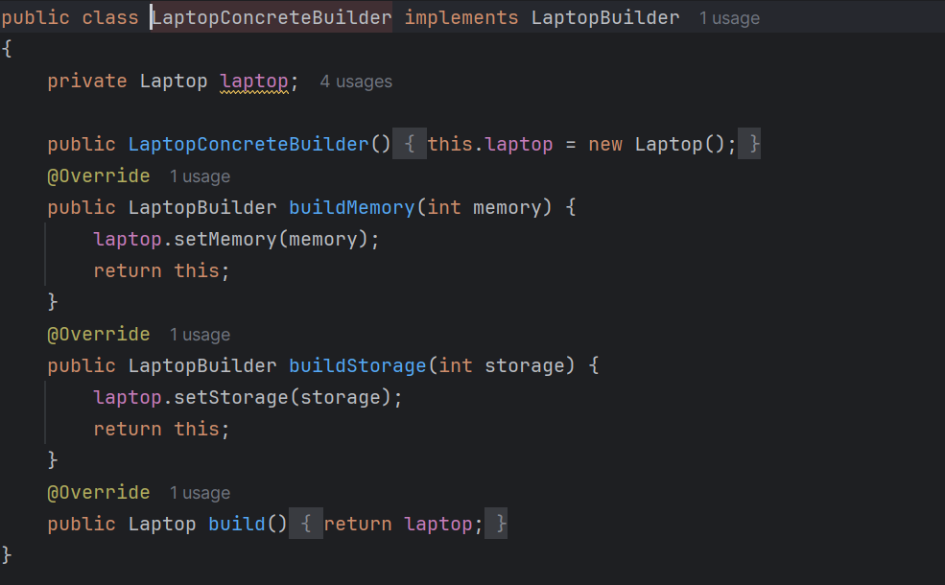

**ClientBuiledMethod.java**

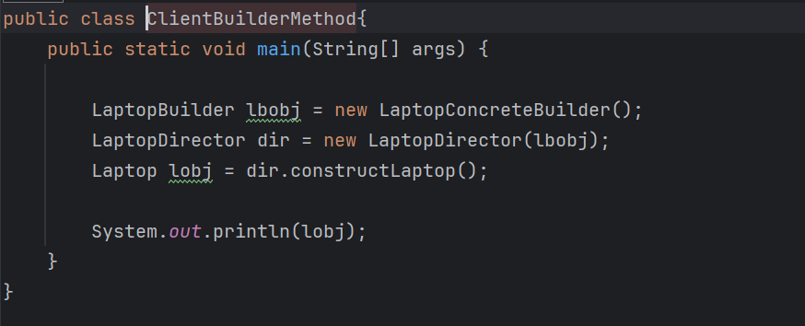

**OUTPUT:**

Laptop constructor

[BuilderMethodDP.Laptop@30f39991](mailto:BuilderMethodDP.Laptop@30f39991)

**NOTES:**

**This is now a proper Builder Pattern:**

* **Laptop = Product**
* **LaptopBuilder = Builder interface**
* **LaptopConcreteBuilder = Concrete Builder**
* **LaptopDirector = Director (optional)**
* **ClientBuildMethodDP = Client**

**TASK 3 – PROTOTYPE DESIGN PATTERN**

**Colors.java**

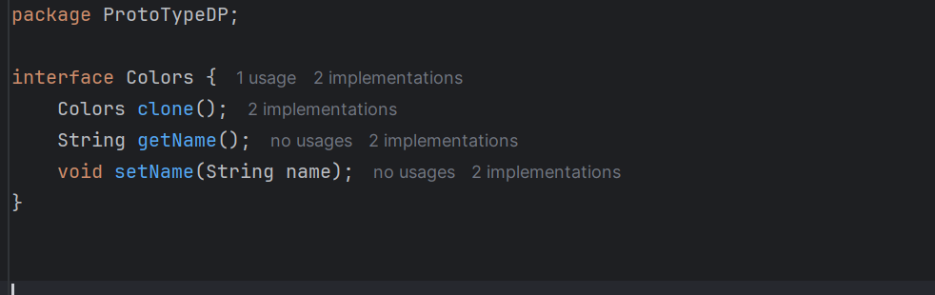

**BlackConcretePrototype.java**

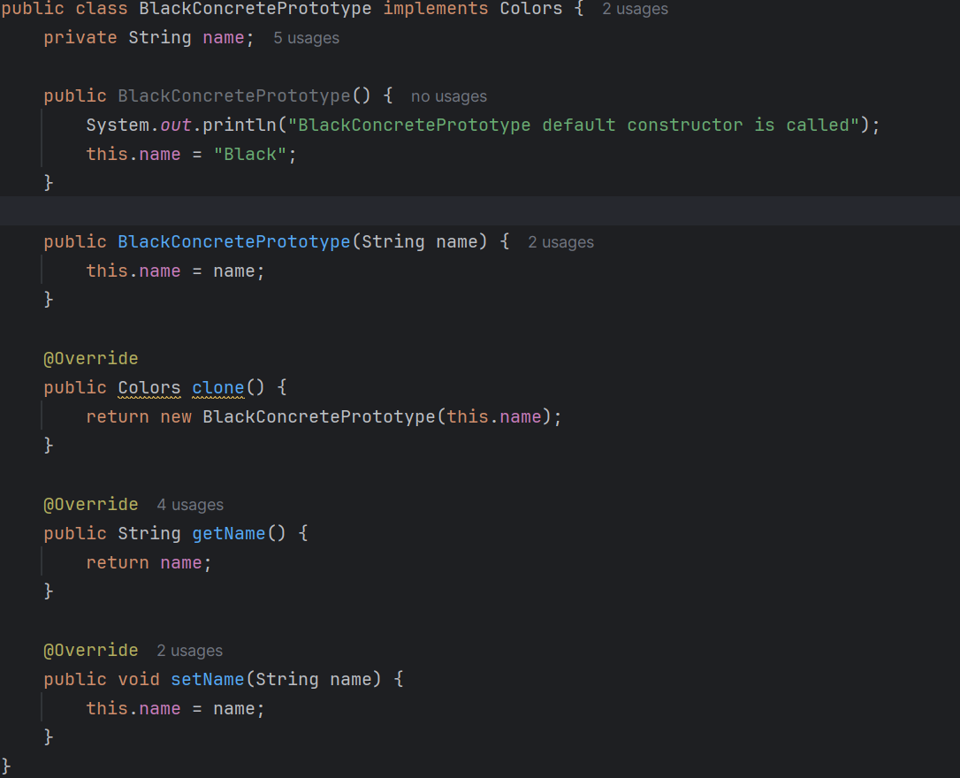

**WhiteConcretePrototype.java**

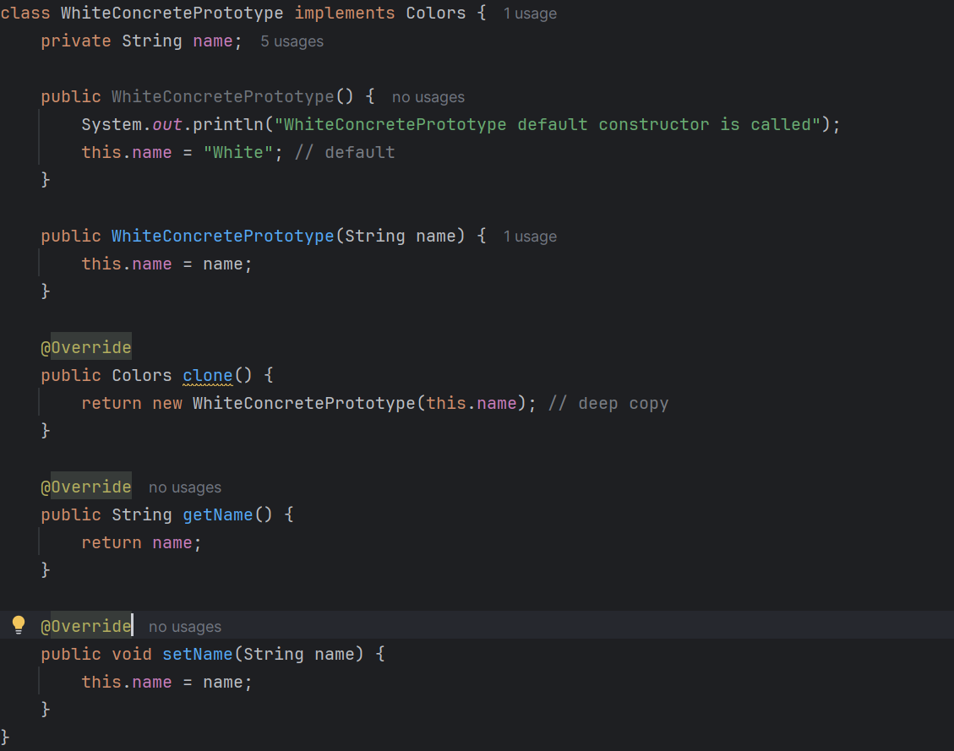

**ClientPrototype.java**

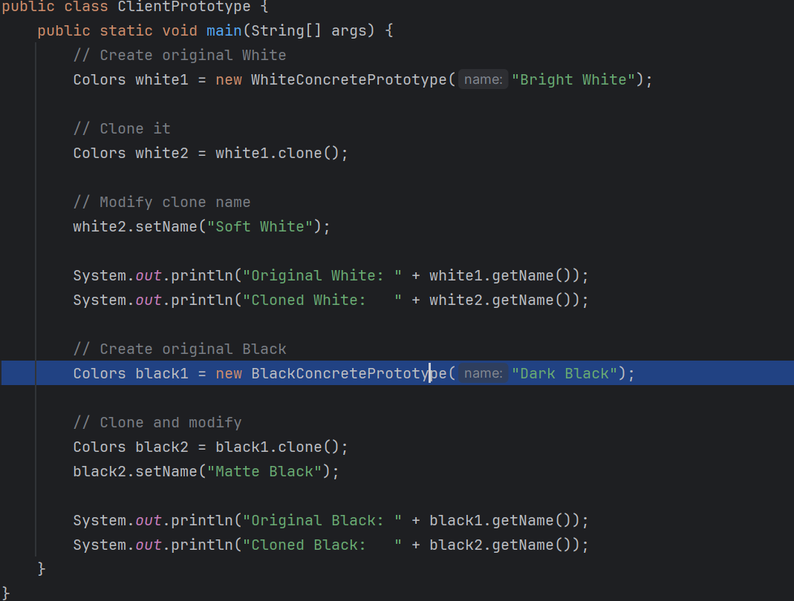

**OUTPUT:**

Original White: Bright White

Cloned White: Soft White

Original Black: Dark Black

Cloned Black: Matte Black

**HOMETASK1**

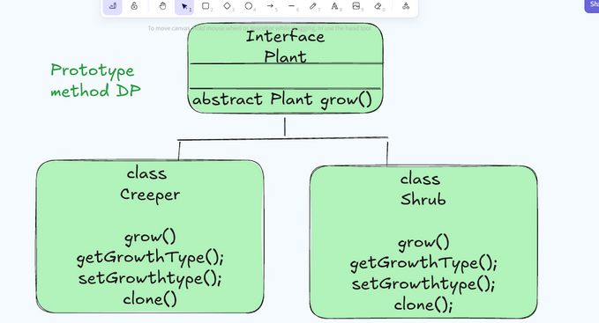

**Plant.java**

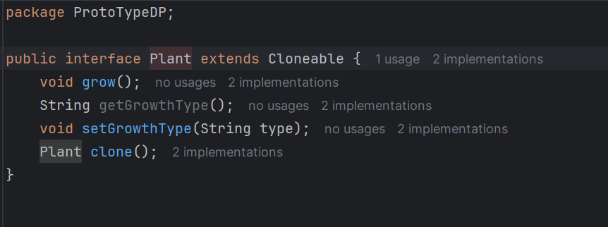

**Creeper.java**

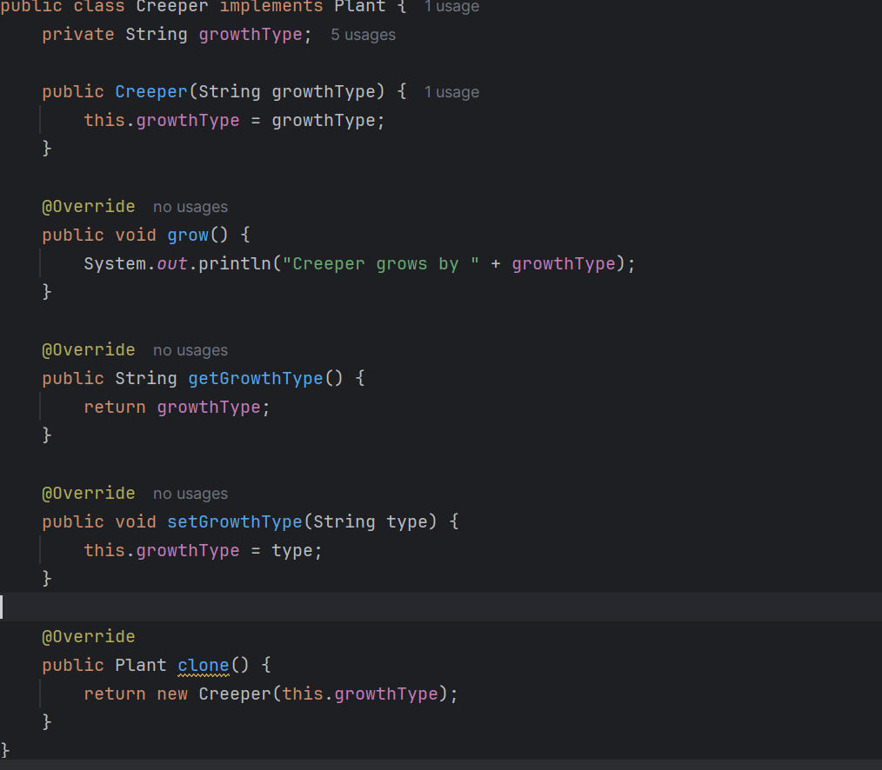

**Shrub.java**

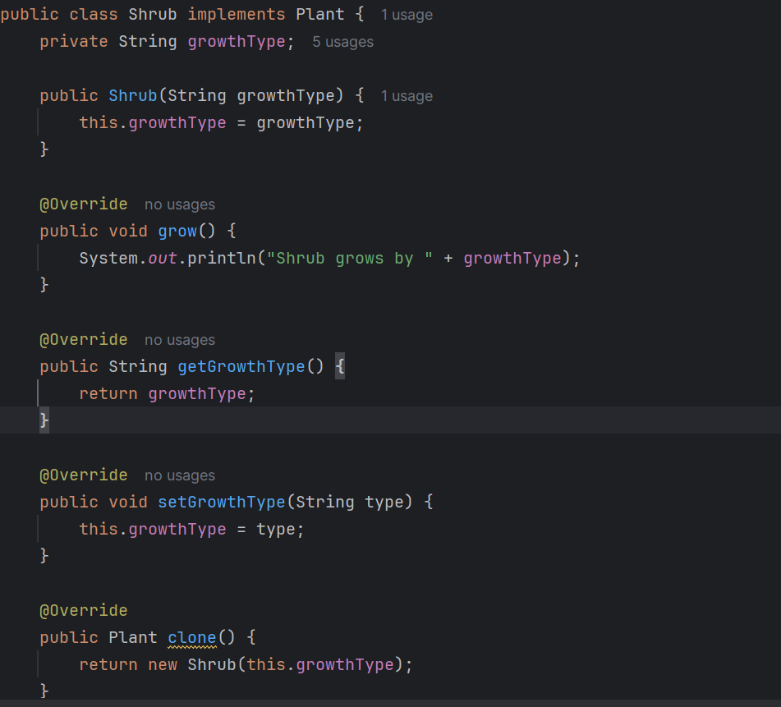

**Main.java**

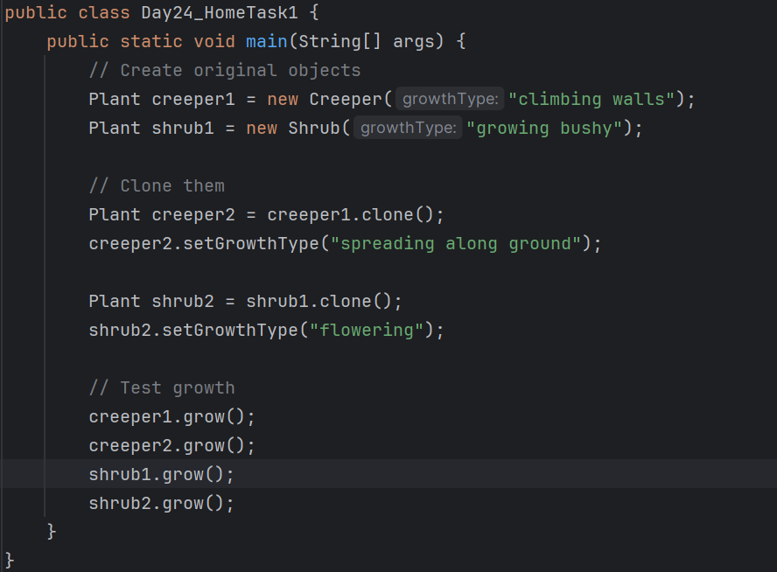

**OUTPUT:**

Creeper grows by climbing walls

Creeper grows by spreading along ground

Shrub grows by growing bushy

Shrub grows by flowering