**Day 29 – August 30th**

**TASK1 –**

* Created AWS account.
* Installed No SQL Workbench
* Installed AWS Cli.

**TASK2 - Create a table in NoSQL workbench – DynamoDB**

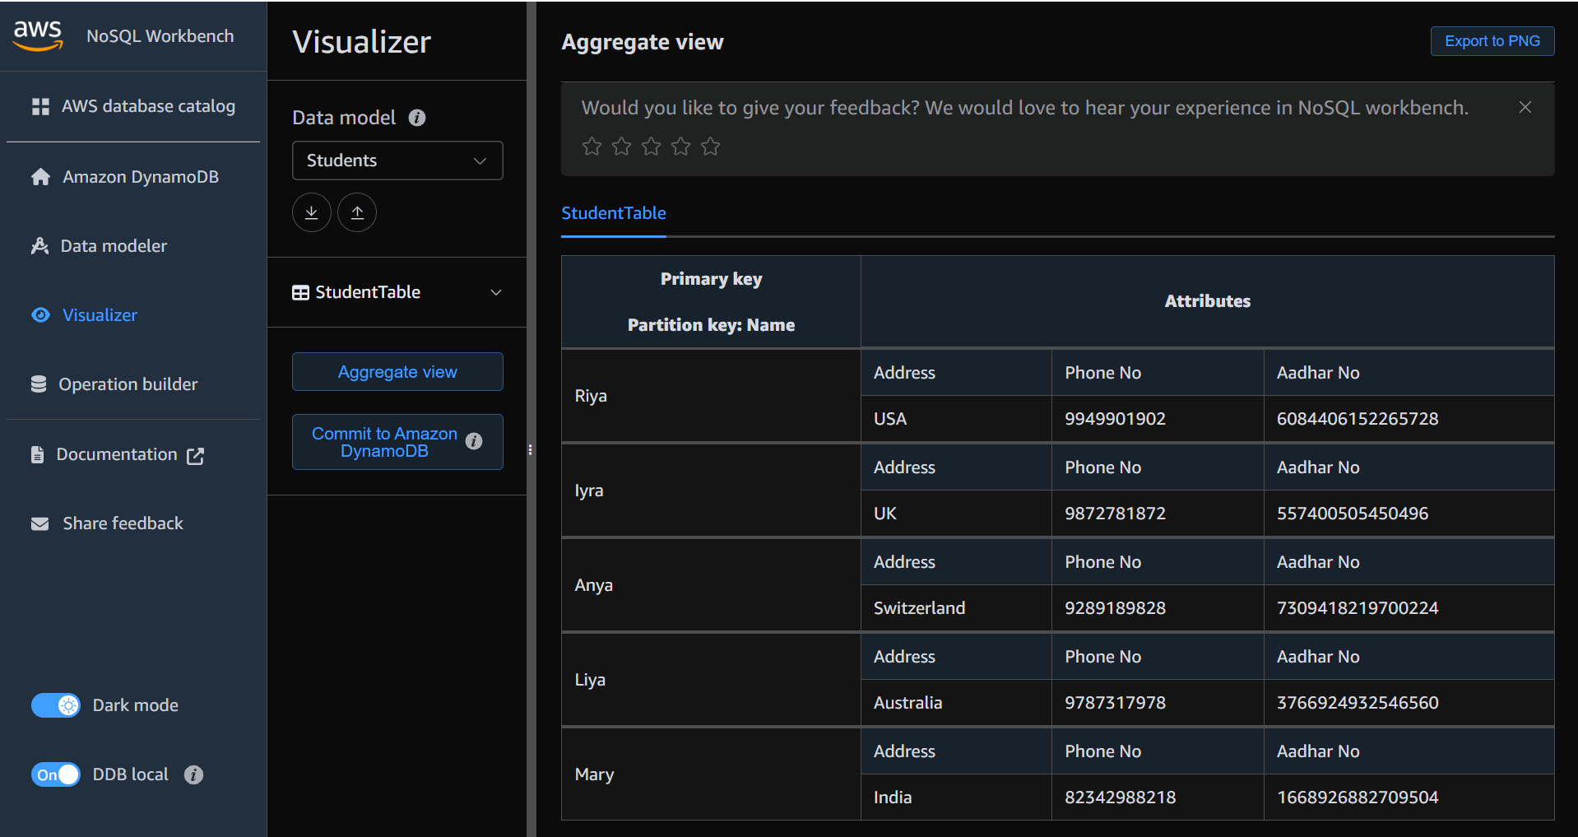

**TASK3 - Create different connections with different no’s and see if it works … (also commit table to the DynamoDB.**

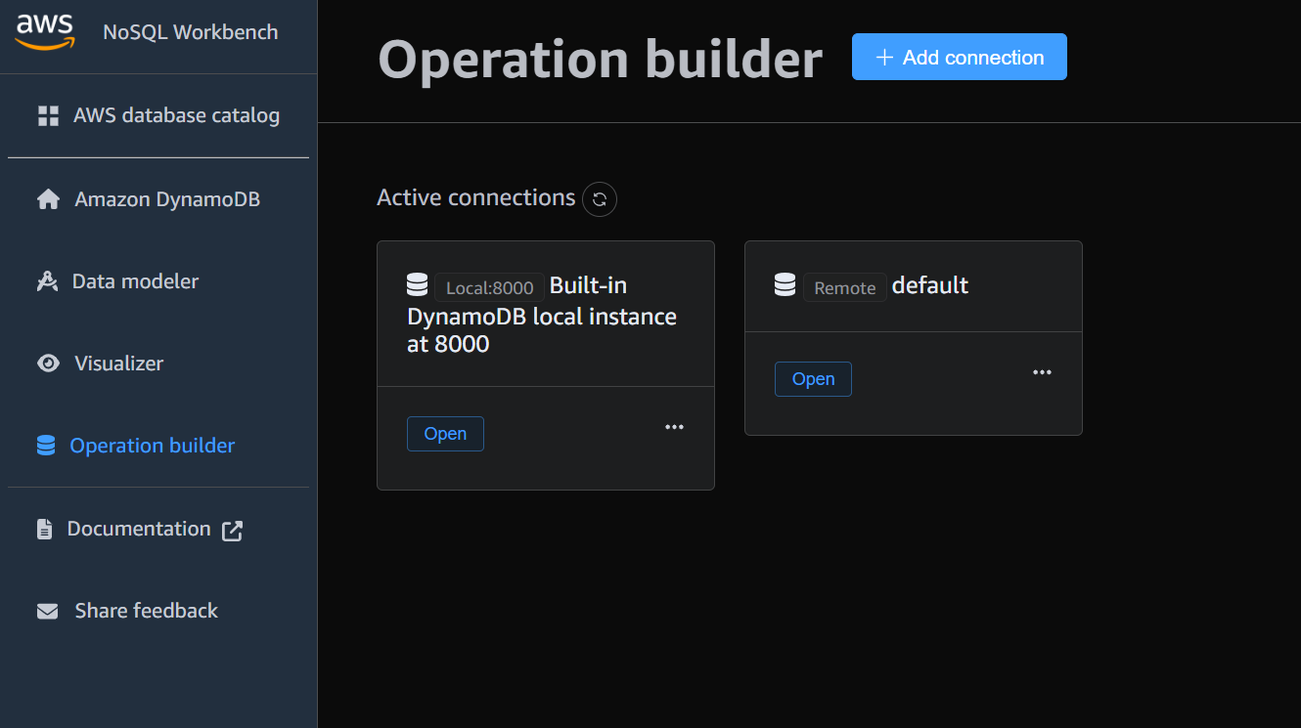

**TASK4 - After downloading MSI… install and then in cmd check for AWS version no**

