**Day 30 – September 5th**

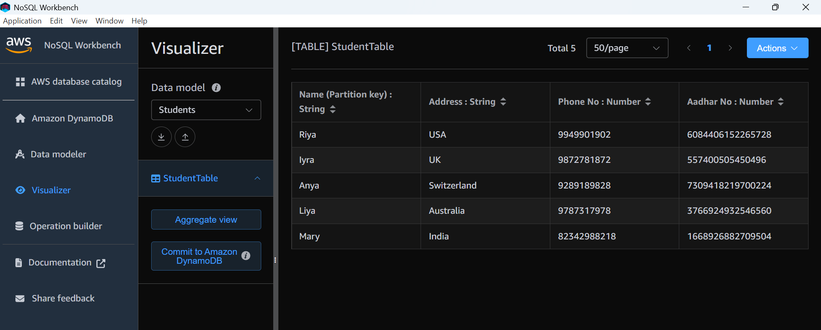

aws dynamodb put-item --table-name EmployeeSpet --item '{"EmpName":{"S": "Prasunamba"}, "EmpAddress":{"S": "India"}, "email": {"S": "Prasunamba.mk@gmail.com"}}' --return-consumed-capacity TOTAL {"ConsumedCapacity": {"CapacityUnits": 1.0, "TableName": "EmployeeSpet"}}

aws dynamodb delete-table --table-name Custtomer

aws dynamodb list-tables

aws dynamodb describe-table --table-name Student