Day 9 – DevOps - CI/CD build pipeline.
Project -> .github -> workflows -> ci-cd-pipeline
name: Java CI/CD Pipeline
on:
push:
branches:
- DayWiseProjectFiles # 👈 Runs when you push to this branch
pull_request:
branches:
- DayWiseProjectFiles # 👈 Runs when PR targets this branch
jobs:
build:
name: 🛠 Build & Test
runs-on: ubuntu-latest
steps:
# Step 1: Checkout repository
- name: 📥 Checkout repository
uses: actions/checkout@v4
# Step 2: Setup JDK 21
- name: ☕ Set up JDK 21
uses: actions/setup-java@v4
with:
distribution: 'temurin' # Eclipse Temurin (recommended)
java-version: '21'
# Step 3: Cache Maven dependencies (optional but speeds up build)
- name: 🧱 Cache Maven packages
uses: actions/cache@v4
with:
path: ~/.m2
key: ${{ runner.os }}-m2-${{ hashFiles('**/pom.xml') }}
restore-keys: |
${{ runner.os }}-m2-
# Step 4: Build project
- name: 🏗️ Build with Maven
run: mvn -B clean compile
# Step 5: Run Tests
- name: ✅ Run Tests
run: mvn test
# Step 6: Package JAR (optional)
- name: 📦 Package Application
run: mvn package -DskipTests
# Step 7: Upload Artifacts (optional)
- name: 📤 Upload build artifact
uses: actions/upload-artifact@v4
with:
name: java-build-artifact
path: target/*.jar

pom.xml
<?xml version="1.0" encoding="UTF-8"?>
<project xmlns="http://maven.apache.org/POM/4.0.0"
xmlns:xsi="http://www.w3.org/2001/XMLSchema-instance"
xsi:schemaLocation="http://maven.apache.org/POM/4.0.0 http://maven.apache.org/xsd/maven-4.0.0.xsd">
<modelVersion>4.0.0</modelVersion>
<groupId>org.example</groupId>
<artifactId>PROJECT_StudentCourseRegistration</artifactId>
<version>1.0-SNAPSHOT</version>
<properties>
<maven.compiler.source>21</maven.compiler.source>
<maven.compiler.target>21</maven.compiler.target>
<project.build.sourceEncoding>UTF-8</project.build.sourceEncoding>
<junit4.version>4.13.2</junit4.version>
<junit5.version>5.10.2</junit5.version>
<junit.platform.version>1.10.2</junit.platform.version>
<slf4j.version>2.0.17</slf4j.version>
<logback.version>1.5.6</logback.version>
</properties>
<dependencies>
<!-- ✅ Jackson -->
<dependency>
<groupId>com.fasterxml.jackson.core</groupId>
<artifactId>jackson-databind</artifactId>
<version>2.17.2</version>
</dependency>
<!-- ✅ AWS SDK DynamoDB -->
<dependency>
<groupId>software.amazon.awssdk</groupId>
<artifactId>dynamodb</artifactId>
<version>2.20.28</version>
</dependency>
<!-- ✅ Logging -->
<dependency>
<groupId>org.slf4j</groupId>
<artifactId>slf4j-api</artifactId>
<version>${slf4j.version}</version>
</dependency>
<dependency>
<groupId>ch.qos.logback</groupId>
<artifactId>logback-classic</artifactId>
<version>${logback.version}</version>
</dependency>
<!-- ✅ JUnit 4 (Optional) -->
<dependency>
<groupId>junit</groupId>
<artifactId>junit</artifactId>
<version>${junit4.version}</version>
<scope>test</scope>
</dependency>
<!-- ✅ JUnit 5 Jupiter -->
<dependency>
<groupId>org.junit.jupiter</groupId>
<artifactId>junit-jupiter-api</artifactId>
<version>${junit5.version}</version>
<scope>test</scope>
</dependency>
<dependency>
<groupId>org.junit.jupiter</groupId>
<artifactId>junit-jupiter-engine</artifactId>
<version>${junit5.version}</version>
<scope>test</scope>
</dependency>
<dependency>
<groupId>org.junit.platform</groupId>
<artifactId>junit-platform-suite-api</artifactId>
<version>1.10.2</version>
<scope>test</scope>
</dependency>
<dependency>
<groupId>org.junit.jupiter</groupId>
<artifactId>junit-jupiter-params</artifactId>
<version>${junit5.version}</version>
<scope>test</scope>
</dependency>
<!-- ✅ Hamcrest for assertThat() -->
<dependency>
<groupId>org.hamcrest</groupId>
<artifactId>hamcrest</artifactId>
<version>2.2</version>
<scope>test</scope>
</dependency>
<!-- ✅ JUnit Platform Launcher (for running tests from main) -->
<dependency>
<groupId>org.junit.platform</groupId>
<artifactId>junit-platform-launcher</artifactId>
<version>${junit.platform.version}</version>
<scope>test</scope>
</dependency>
<!-- ✅ Mockito -->
<dependency>
<groupId>org.mockito</groupId>
<artifactId>mockito-junit-jupiter</artifactId>
<version>5.12.0</version>
<scope>test</scope>
</dependency>
<dependency>
<groupId>org.mockito</groupId>
<artifactId>mockito-core</artifactId>
<version>5.12.0</version>
<scope>test</scope>
</dependency>
</dependencies>
<build>
<plugins>
<!-- ✅ Compiler Plugin -->
<plugin>
<groupId>org.apache.maven.plugins</groupId>
<artifactId>maven-compiler-plugin</artifactId>
<version>3.11.0</version>
<configuration>
<source>${maven.compiler.source}</source>
<target>${maven.compiler.target}</target>
</configuration>
</plugin>
<!-- ✅ Surefire Plugin -->
<plugin>
<groupId>org.apache.maven.plugins</groupId>
<artifactId>maven-surefire-plugin</artifactId>
<version>3.2.5</version>
<configuration>
<useModulePath>false</useModulePath>
</configuration>
</plugin>
<!-- ✅ Exec Plugin to run main -->
<plugin>
<groupId>org.codehaus.mojo</groupId>
<artifactId>exec-maven-plugin</artifactId>
<version>3.2.0</version>
<configuration>
<mainClass>Day36_DemoTestLauncher</mainClass>
</configuration>
</plugin>
</plugins>
</build>
</project>
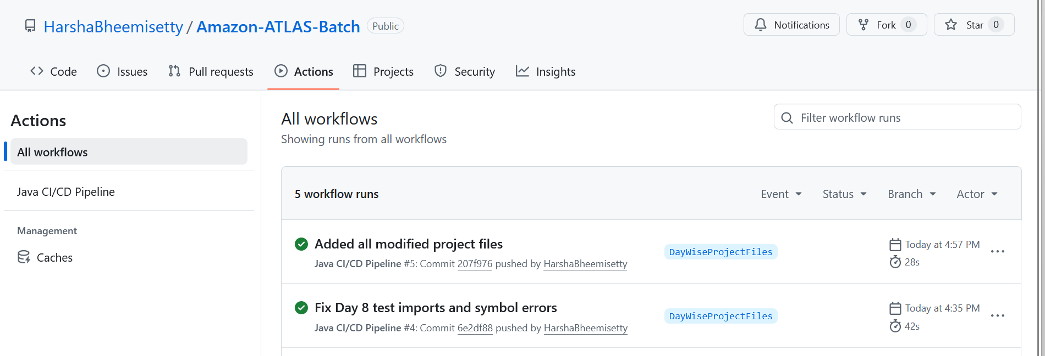
Build Successful!!!!

