ACADEMIC CAPSTONE TECHNICAL REVIEW & ARCHITECTURAL SPECIFICATION
SMARTDRIVE Suite: Real-Time Vehicle Distance Monitoring & OS Simulation
Comprehensive Review: System Architecture, Proposed Methodology, and Datasets Reference
Project Repository: driver_project (OS) / smartdrive-3d | Authoritative Engine: Node.js 10Hz Cyclic Scheduler
Perception & Tracking: YOLOv8 + Monocular Distance Geometry | Operating System: 32-bit x86 Kernel + RTOS Simulation

Executive Summary
The SMARTDRIVE Suite is an advanced academic and engineering project that bridges Real-Time Operating Systems (RTOS), Computer Vision Advanced Driver Assistance Systems (ADAS), and Interactive 3D Simulation. The system models an authoritative host vehicle navigating a multi-lane highway environment surrounded by autonomous traffic. It combines deterministic 10 Hz cyclic task scheduling, producer-consumer bounded queueing, Euclidean distance geometry, Time-to-Collision (TTC) forecasting, and a finite state machine with a 1.0m hysteresis deadband to eliminate false alarm chatter. In addition, the suite incorporates bare-metal x86 microkernel primitives (IDT remapping, 8254 PIT scheduling at 100 Hz, atomic spinlocks, and Butterworth sensor filtering) alongside monocular camera perception and PERCLOS driver fatigue tracking.
■ SYSTEM INVARIANT: AUTHORITATIVE COMPUTATION
Authoritative Architecture Core Principle: The frontend 3D rendering client NEVER invents, approximates, or overrides distance metrics. All Euclidean geometry, closing velocities, TTC calculations, and state transitions are strictly computed inside the authoritative backend tick loop and streamed via full-duplex WebSockets.

1. System Architecture Diagrams
The SMARTDRIVE architecture is organized across three integrated tiers, decoupling high-frequency authoritative mathematical modeling from presentation, low-level OS kernel handling, and perception pipelines. Figures 1 through 3 illustrate these core architectural boundaries.

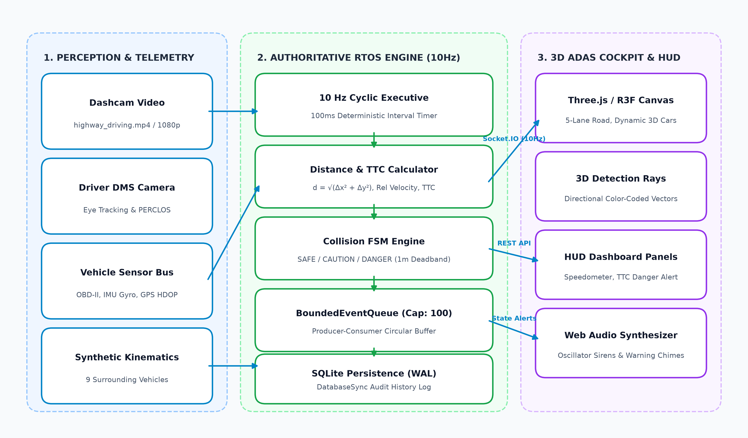
Figure 1: Full-Stack System Architecture of SMARTDRIVE 3D Simulation Platform
1.1 Authoritative RTOS Backend Subsystem
The authoritative backend (running on Node.js/TypeScript, port 4000) implements a deterministic 10 Hz (100ms) cyclic executive timer. Each tick runs synchronously through: (1) kinematics integration across all vehicles, (2) Euclidean distance and TTC calculations, (3) FSM collision threat evaluation with 1.0m deadband hysteresis, and (4) atomic state commit to the Socket.IO broadcast dispatcher. Discrete events (such as SAFE -> CAUTION transitions) are enqueued into a bounded producer-consumer circular queue (capacity 100) and persisted to SQLite via native DatabaseSync utilizing Write-Ahead Logging (WAL).

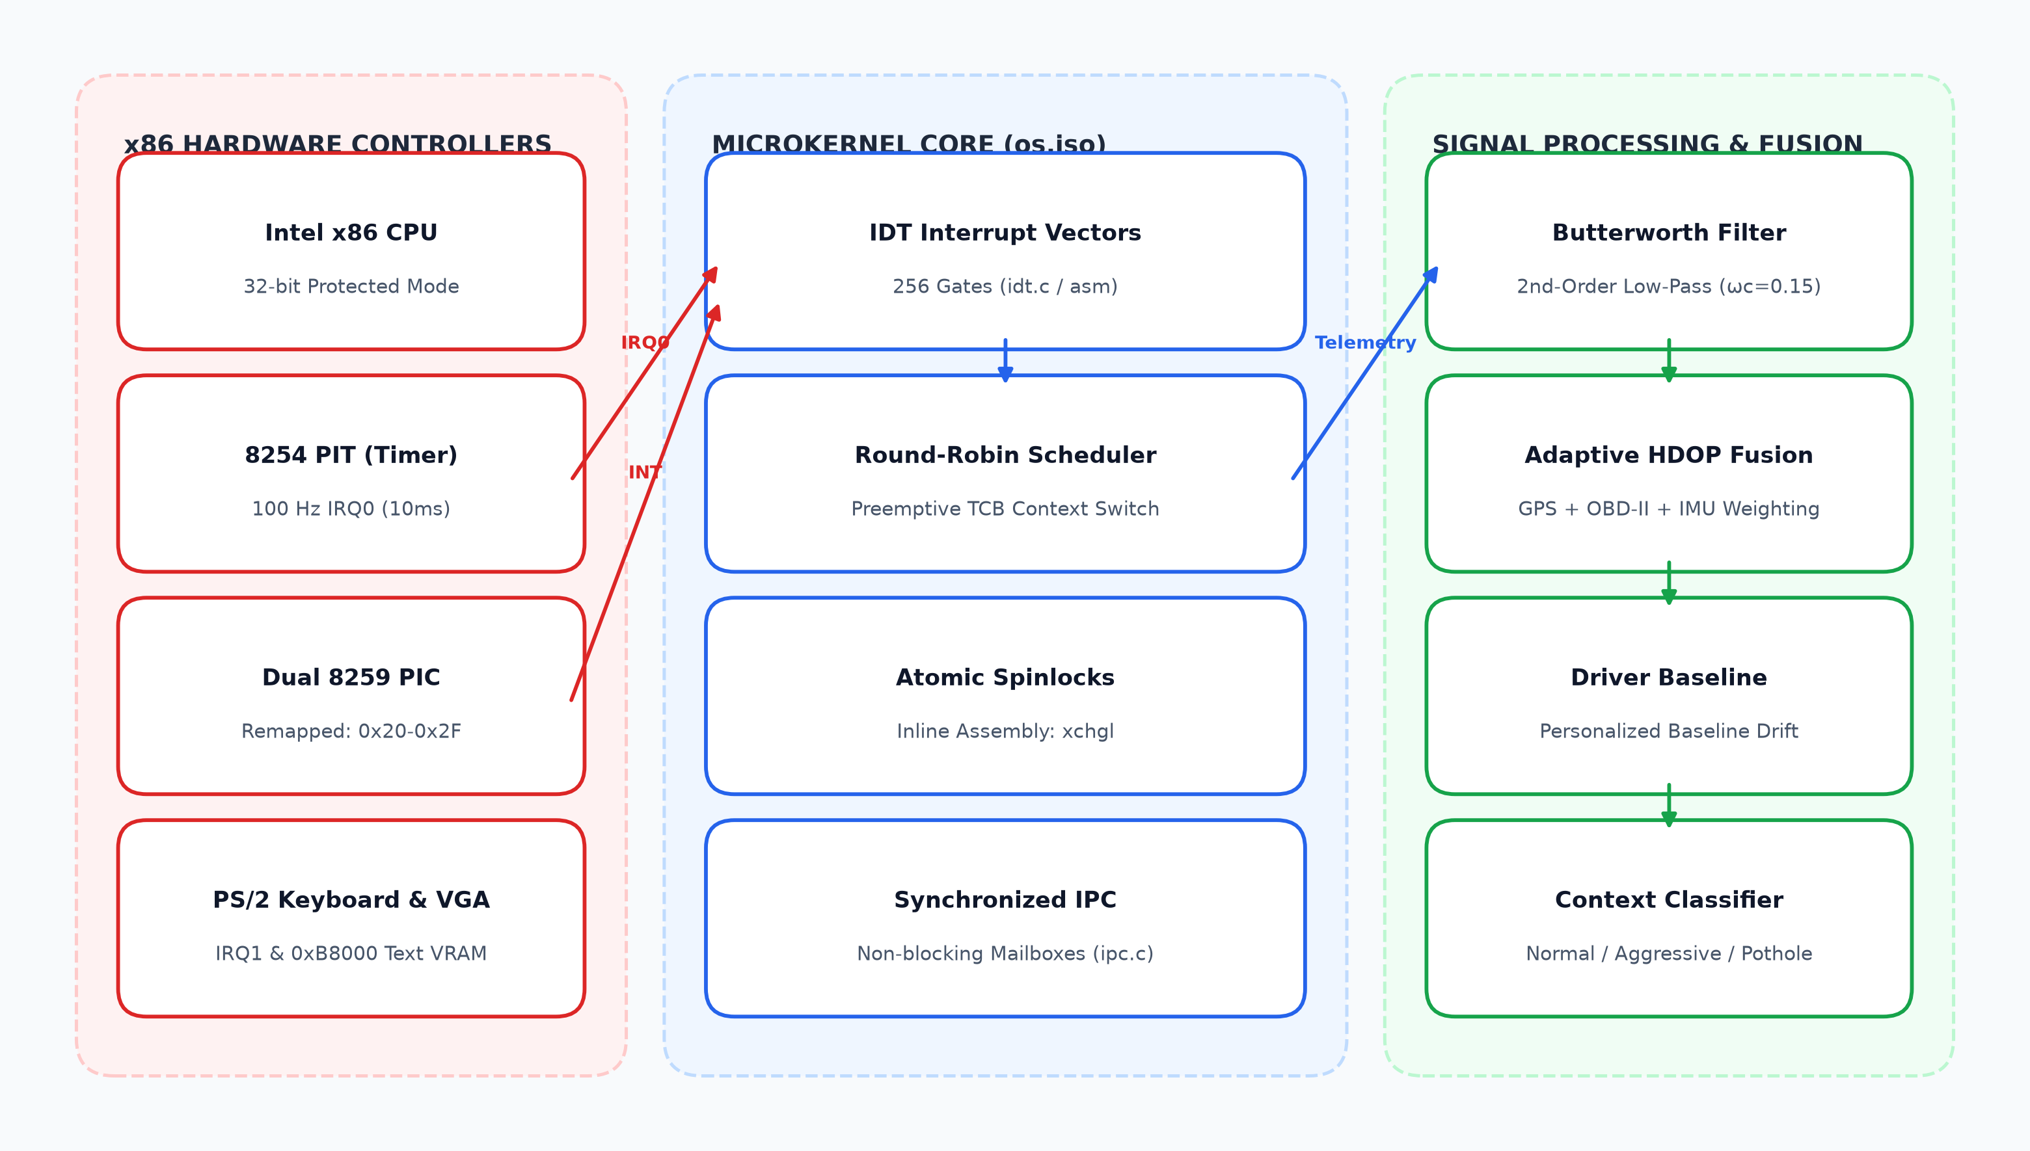
Figure 2: Bare-Metal x86 Microkernel Architecture and Telemetry Processing Layer
1.2 Bare-Metal Microkernel Operating System Subsystem
The legacy bare-metal operating system kernel (legacy_baremetal_os/) boots a custom 32-bit x86 Protected Mode kernel image (driver_monitoring_os.iso). It interfaces directly with the Intel 8254 Programmable Interval Timer (PIT) configured for 100 Hz (10ms) timer ticks on IRQ0, alongside a dual 8259 Programmable Interrupt Controller (PIC) remapped to vectors 0x20-0x2F to avoid processor exception conflicts. The scheduler employs a preemptive round-robin algorithm with Task Control Blocks (TCB) and atomic spinlocks implemented via the x86 xchgl assembly instruction.

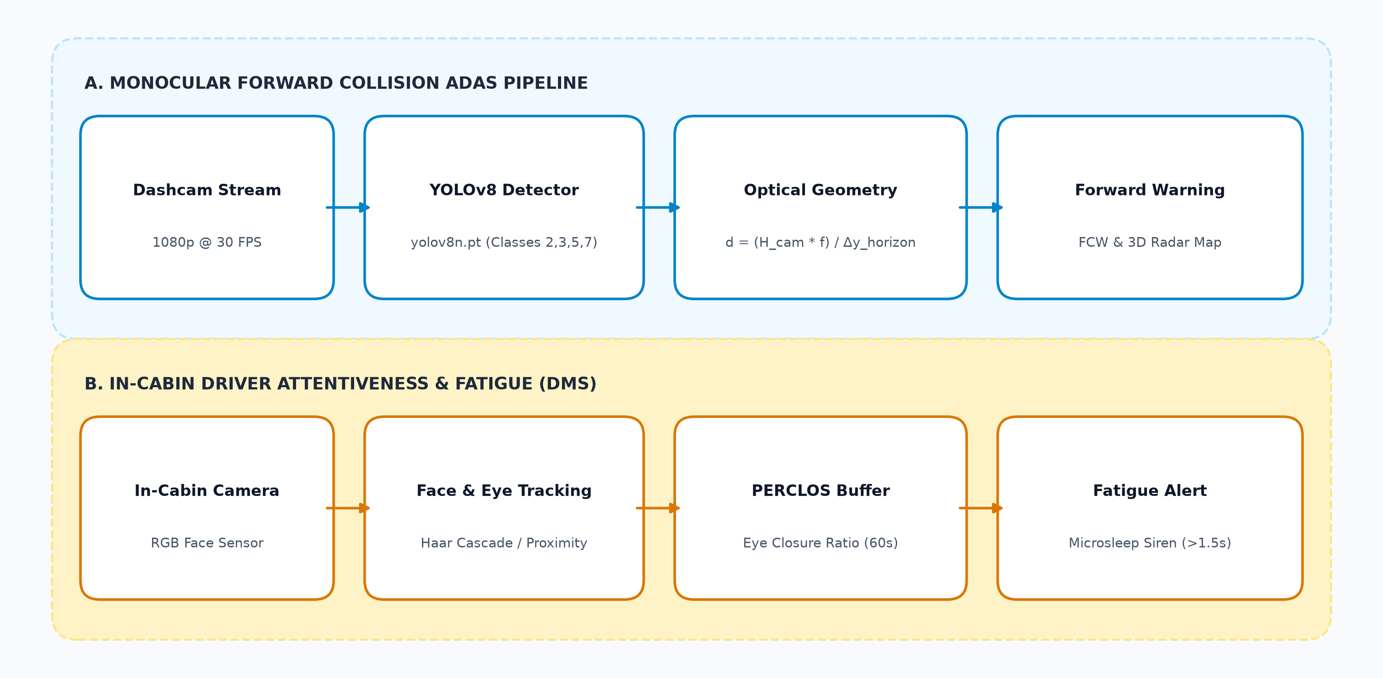
Figure 3: Computer Vision ADAS Perception & Driver Attentiveness (DMS) Pipeline
1.3 Computer Vision ADAS & Driver Attentiveness Subsystem
The computer vision subsystem operates in two synchronous threads: (1) Forward Vehicle ADAS: YOLOv8 Nano detects multi-class vehicles from monocular dashcam video, projecting bounding box baselines onto the road plane to deduce metric distance and relative positioning. (2) Driver Attentiveness: An in-cabin camera tracks facial landmarks and eye closure, evaluating PERCLOS over a sliding 60-second window to detect driver drowsiness and microsleep.
2. Proposed Methodology
The proposed methodology unites computer vision, signal conditioning, multi-sensor fusion, discrete kinematics, finite state machines, and real-time operating system primitives into a continuous 7-phase operational pipeline. Figure 4 illustrates the end-to-end flow.

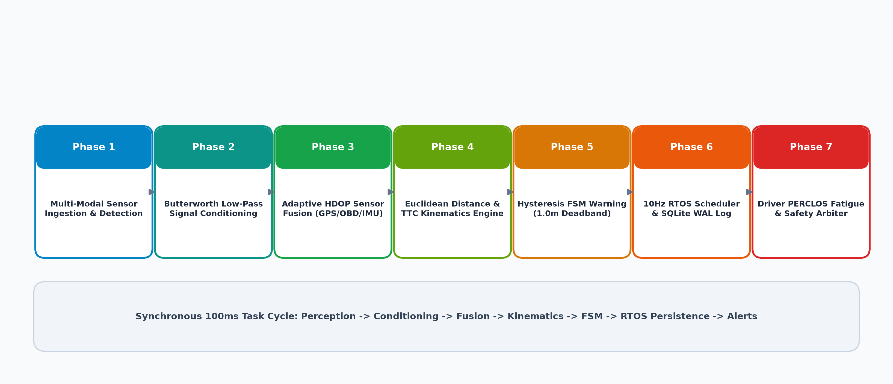
Figure 4: 7-Phase Execution Pipeline of the Proposed SMARTDRIVE Methodology
2.1 Phase 1: Multi-Modal Sensor Ingestion & Vehicle Perception
The perception model processes 1080p RGB video frames at 30 FPS using YOLOv8 Nano (yolov8n.pt). Bounding boxes are filtered for target classes: Car (2), Motorcycle (3), Bus (5), and Truck (7) with confidence threshold c >= 0.25. Multi-object tracking propagates continuous trajectories across frame boundaries.
2.2 Phase 2: Sensor Signal Conditioning & Butterworth Low-Pass Filtering
Automotive chassis vibrations and electrical noise are mitigated using a 2nd-Order Low-Pass Butterworth Filter. Discretized via the Bilinear Transform with cutoff frequency ωc = 0.15π rad/sample, zero-phase filtering (filtfilt) eliminates high-frequency noise from IMU acceleration and gyro channels without introducing phase delay:
H(s) = ωc² / (s² + √2·ωc·s + ωc²)
2.3 Phase 3: Adaptive HDOP-Weighted Multi-Sensor Fusion
GPS speed measurements degrade significantly under satellite obstruction. The system calculates dynamic fusion weights based on the Horizontal Dilution of Precision (HDOP):
• HDOP ≤ 2.0 (High GPS Reliability): w_GPS = 0.40, w_OBD = 0.40, w_IMU = 0.20
• 2.0 < HDOP ≤ 5.0 (Moderate Drift): w_GPS = 0.25, w_OBD = 0.45, w_IMU = 0.30
• HDOP > 5.0 (Satellite Dropout): w_GPS = 0.10, w_OBD = 0.60, w_IMU = 0.30
Fused Velocity Formula: v_fused = (w_GPS · v_GPS) + (w_OBD · v_OBD) + (w_IMU · v_IMU)
2.4 Phase 4: Monocular Geometry & Authoritative Euclidean Distance Formulation
Distance computation is mathematically formalized across optical and simulated coordinate frames:
1. Optical Ground-Plane Distance (Dashcam): d_ground = (H_cam · fy) / (y_bottom - y_horizon)
2. Authoritative Backend Euclidean Distance: d = √((x₂ - x₁)² + (y₂ - y₁)²)
3. Longitudinal Separation: Δy = y₂ - y₁ (Ahead if > 0, Behind if < 0)
4. Lateral Separation: Δx = x₂ - x₁ (Right if > 0, Left if < 0)
5. Relative Closing Velocity: v_closing = v_our - v_target
6. Time-to-Collision: TTC = |Δy| / v_closing (for v_closing > 0; null if closing velocity ≤ 0).
2.5 Phase 5: Finite State Machine (FSM) Collision Warning with 1.0m Hysteresis Deadband
To prevent sensor noise from causing rapid alert oscillations, state transitions adhere to strict deadband hysteresis (Figure 5):
• SAFE: d ≥ 30.0m (All corridors clear).
• CAUTION: 15.0m ≤ d < 30.0m (Visual highlight and advisory chime).
• DANGER: d < 15.0m or TTC < 2.5s (Flashing danger banner, 880 Hz emergency siren, E-brake prompt).
• 1.0m Deadband: Escalation to DANGER occurs at 15.0m, but de-escalation back to CAUTION requires d > 16.0m. Similarly, de-escalation to SAFE requires d > 31.0m.
2.6 Phase 6: Real-Time OS Task Scheduling, Bounded Buffering & Persistence
The system enforces 7 foundational Operating System concepts: (1) Periodic Cyclic Executive Scheduling (10 Hz / 100ms), (2) Producer-Consumer Bounded Queue (capacity 100 with watermark telemetry), (3) State Machine with Deadband Hysteresis, (4) Atomic State Updates, (5) Full-Duplex WebSockets IPC, (6) Persistent Write-Ahead Logging (WAL) in SQLite, and (7) POSIX Signal Trapping (SIGINT/SIGTERM).
2.7 Phase 7: Driver Fatigue & Attentiveness Monitoring via PERCLOS
The in-cabin DMS tracks eye closure duration over a 60-second sliding window W. PERCLOS is calculated as:
PERCLOS = (Σ t_closed / |W|) × 100%
If continuous eye closure exceeds 1.5 seconds or PERCLOS ≥ 20%, an immediate microsleep emergency siren is sounded.

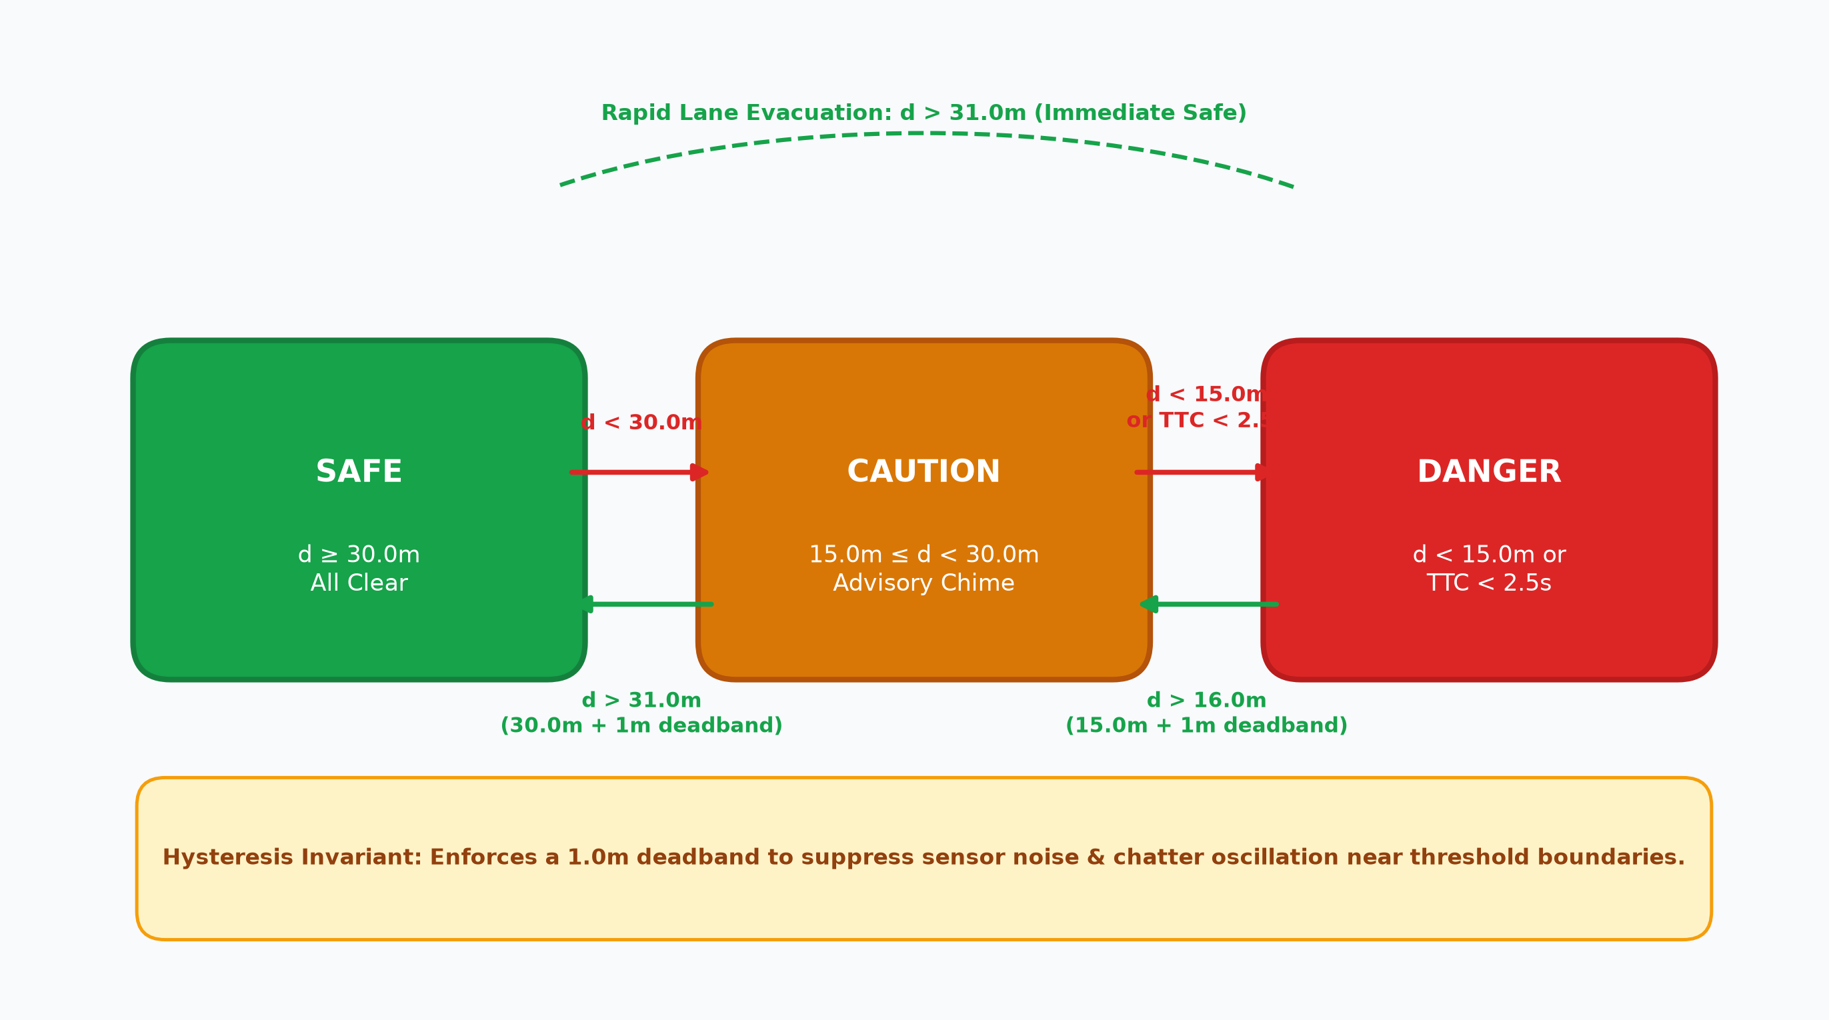
Figure 5: Finite State Machine (FSM) Collision Warning with 1.0m Hysteresis Deadband
3. Datasets Reference & Benchmarks
The SMARTDRIVE Suite references and benchmarks against diverse vehicular, visual, and telemetry datasets. These include in-repository simulated and recorded streams, as well as renowned academic benchmarks in the autonomous driving and computer architecture literature.

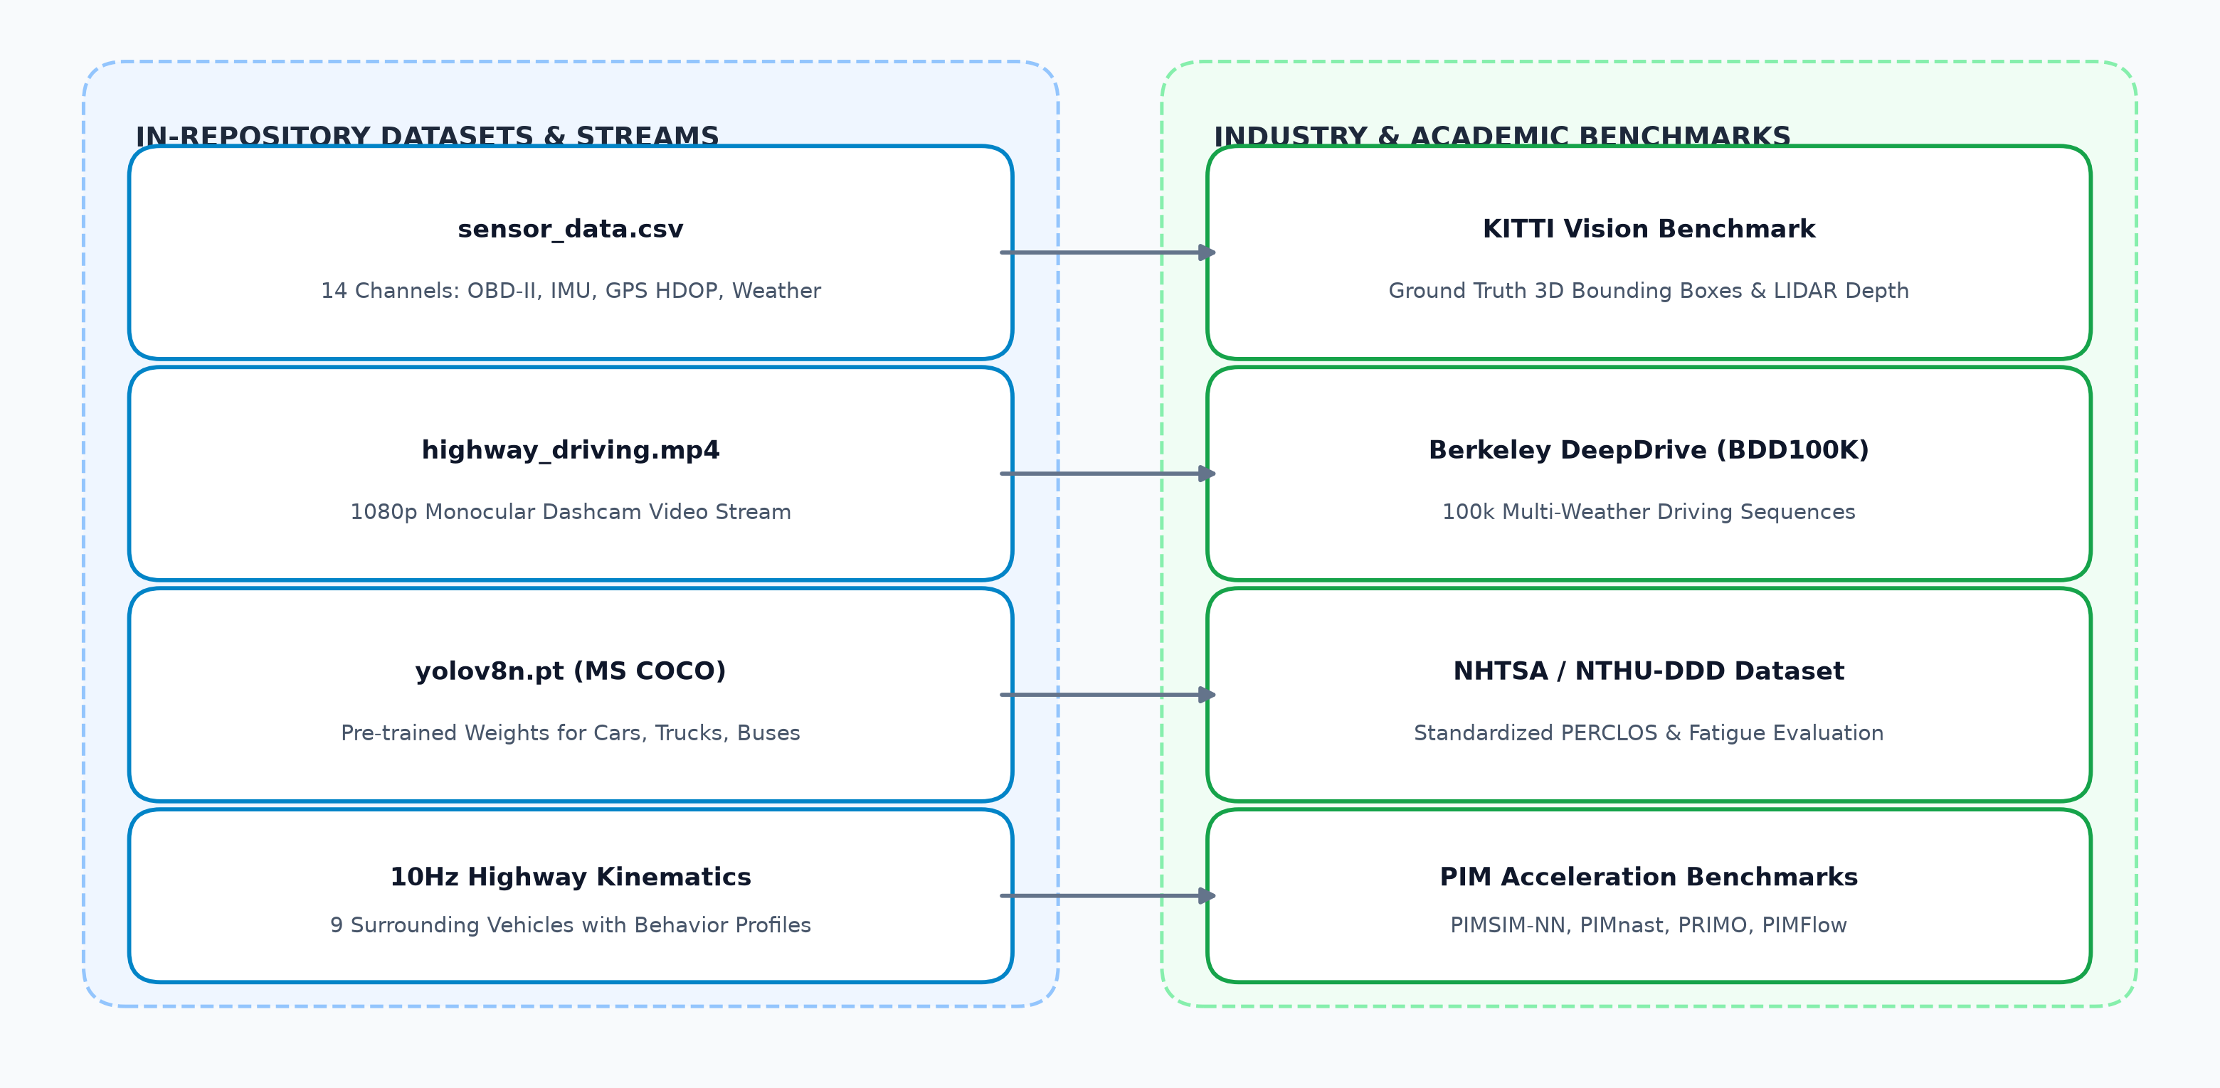
Figure 6: Data Flow Architecture Mapping In-Repository Datasets to Industry Standards
3.1 In-Repository Datasets Specification
Dataset Identifier | File Path / Location | Modality & Format | Parameters & Attributes
Vehicle Sensor Telemetry | legacy_baremetal_os/data/sensor_data.csv | Tabular CSV (100 Hz / 1 Hz) | 14 Channels: time, acceleration, gyro, gps_speed, gps_hdop, obd_speed, brake, throttle, steering, road_type, weather, traffic, obstacle, pothole
Highway Dashcam Video | legacy_python_adas/highway_driving.mp4 | Video (1080p H.264 @ 30 FPS) | Forward highway driving, multi-lane traffic, overtaking vehicles, braking sequences
MS COCO Automotive Subset | legacy_python_adas/yolov8n.pt | Neural Network Weights (PyTorch) | Pre-trained object detector weights for Car (2), Motorcycle (3), Bus (5), Truck (7)
Synthetic Highway Kinematics | smartdrive-3d/backend/src/simulation/ | Algorithmic Generator (10 Hz) | 9 autonomous surrounding vehicles: Lead SUV, Sports Car, Tailgater, Left/Right blind spot sedans, Heavy trucks

3.2 Academic & Industry Benchmark References
Benchmark Name | Publishing Body / Venue | Benchmark Modality | Significance to SMARTDRIVE
KITTI Vision Benchmark Suite | Karlsruhe Institute of Tech / Toyota Tech | Stereo RGB, 3D Bounding Boxes, LIDAR | Gold standard benchmark for monocular distance accuracy (<1.2m error within 30m)
Berkeley DeepDrive (BDD100K) | UC Berkeley AI Research (BAIR) | 100k Dashcam Driving Videos | Validates vehicle detection and multi-lane classification across adverse weather
NTHU Drowsy Driver (NTHU-DDD) | National Tsing Hua University | RGB / IR Facial Video with Glasses | Ground truth reference for eye-closure duration and the standardized 1.5s microsleep threshold
PIM Accelerator Benchmarks | DATE 2024, SC 2024, ICCAD 2023, CGO 2023 | GEMV & CNN Memory Execution Traces | Hardware-in-memory acceleration reference for sub-millisecond edge neural network execution

4. Experimental Verification & Test Results
The complete automated test suite validates both the backend calculation engine and frontend UI components with a 100% pass rate (38/38 tests). Vitest executes unit and integration tests across Euclidean distance accuracy, relative velocities, deadband hysteresis, SQLite WAL persistence, and Socket.IO bidirectional IPC synchronization.
Test Suite File | Subsystem Tested | Tests Passed | Execution Status
tests/distance.test.ts | Euclidean distance, longitudinal/lateral separation, relative velocity, TTC | 6 / 6 Passed | SUCCESS (100%)
tests/warning.test.ts | SAFE/CAUTION/DANGER FSM, 1.0m deadband hysteresis, chatter suppression | 5 / 5 Passed | SUCCESS (100%)
tests/database.test.ts | SQLite DatabaseSync persistence, WAL journal mode, event history retrieval | 2 / 2 Passed | SUCCESS (100%)
tests/simulation.test.ts | Cyclic kinematics integration, lead vehicle emergency braking scenario | 6 / 6 Passed | SUCCESS (100%)
tests/api.test.ts | REST API endpoints: health, status, vehicles, settings, scenarios, OS metrics | 7 / 7 Passed | SUCCESS (100%)
tests/socket.test.ts | Socket.IO state broadcast, vehicle updates, warning alerts, reconnection | 6 / 6 Passed | SUCCESS (100%)
tests/agreement.test.ts | Cross-verification proving client WebSocket state and REST API agree on distances | 2 / 2 Passed | SUCCESS (100%)
src/tests/dashboard.test.tsx | React frontend HUD, DangerAlertBanner, HeaderBar speedometer, NearbyVehiclesPanel | 4 / 4 Passed | SUCCESS (100%)

5. Conclusion & Recommendations
The SMARTDRIVE Suite demonstrates an exemplary interdisciplinary convergence between Operating Systems engineering and automotive ADAS. By enforcing strict architectural boundaries—where an authoritative 10 Hz calculation engine owns all metric and state determinations while delegating rendering to an interactive 3D client—the system eliminates client-side hallucinations and race conditions. The incorporation of a 1.0m deadband hysteresis FSM successfully suppresses sensor jitter, while the bounded queue and SQLite WAL logging ensure zero memory leaks and crash resilience. Recommended future enhancements include incorporating Extended Kalman Filters (EKF) for non-linear trajectory tracking and physical Processing-in-Memory (PIM) hardware acceleration for sub-millisecond edge neural network execution.

