1. When given date is 29 Feb of any leap year eg: 2020-02-29, the endpoint fails to handle request with "internal server error" & 502 response code.

<https://p9fwi1d77e.execute-api.eu-west-1.amazonaws.com/Prod/next-birthday?dateofbirth=2020-02-29&unit=day>

Response code : 502 Bad Gateway

{

"message": "Internal server error"

}

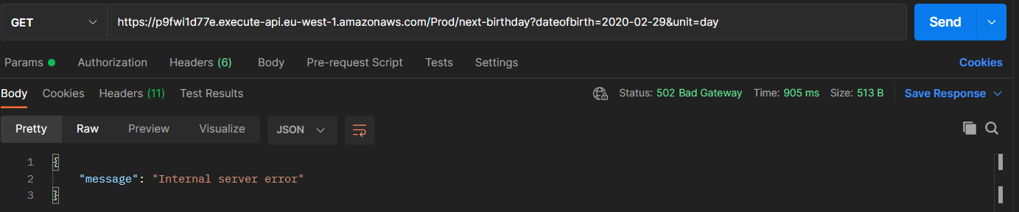

2. Endpoint fails to consider future date of birth eg: current date is 2021-07-22, given date of birth parameter is 2022-07-25

Actual output: 3 days left

Expected : 368 days left

https://p9fwi1d77e.execute-api.eu-west-1.amazonaws.com/Prod/next-birthday?dateofbirth=2022-07-25&unit=day

{

"message": "3 days left"

}

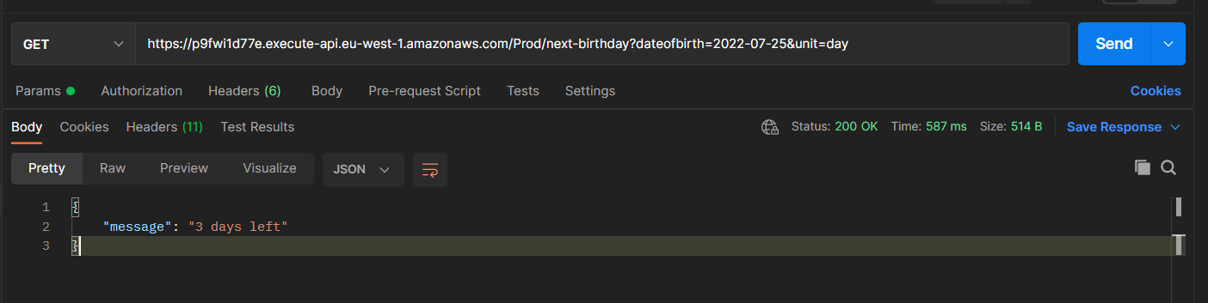

3. When given unit parameter is not valid in request, endpoint fails to with null as response.

<https://p9fwi1d77e.execute-api.eu-west-1.amazonaws.com/Prod/next-birthday?dateofbirth=2019-06-30&unit=days>

Actual Response : {

"message": null

}

Expected Response : {"message" : "Please specify the correct unit"}

