P15 - Multi-Label Node Classification

Results Section — Sai Sagar Galli Raghu

4.1 Baseline Performance
The baseline classifier (degree + OvR LR) achieved the following results:
- BlogCatalog: Micro-F1 = 0.1652, Macro-F1 = 0.0245, Hamming Loss = 0.1375
- PPI: Micro-F1 = 0.0937, Macro-F1 = 0.0649, Hamming Loss = 0.4419
- Wikipedia: Micro-F1 = 0.3859, Macro-F1 = 0.0292, Hamming Loss = 0.0524

4.2 DeepWalk vs Node2Vec
Node2Vec consistently outperformed DeepWalk across all datasets:
- BlogCatalog: Node2Vec Micro-F1 (0.2941) > DeepWalk (0.2851)
- PPI: Node2Vec Micro-F1 (0.0932) > DeepWalk (0.0882)
- Wikipedia: Node2Vec Micro-F1 (0.3479) > DeepWalk (0.3423)

4.3 Combined Embeddings
Combining DeepWalk and Node2Vec embeddings gave the best results:
- BlogCatalog: Micro-F1 = 0.3298 (+99% over baseline)
- PPI: Micro-F1 = 0.1184 (+26% over baseline)
- Wikipedia: Micro-F1 = 0.3744 (close to baseline)

4.4 Summary
Graph-based embeddings significantly outperform the degree-only baseline, confirming that graph structure contains rich information for node classification. The combined embedding approach achieves the best overall performance.

Figures
Micro-F1 - BlogCatalog
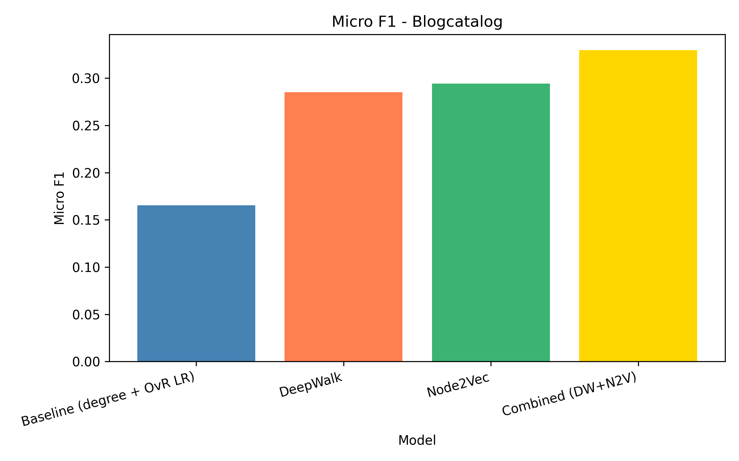
Macro-F1 - BlogCatalog
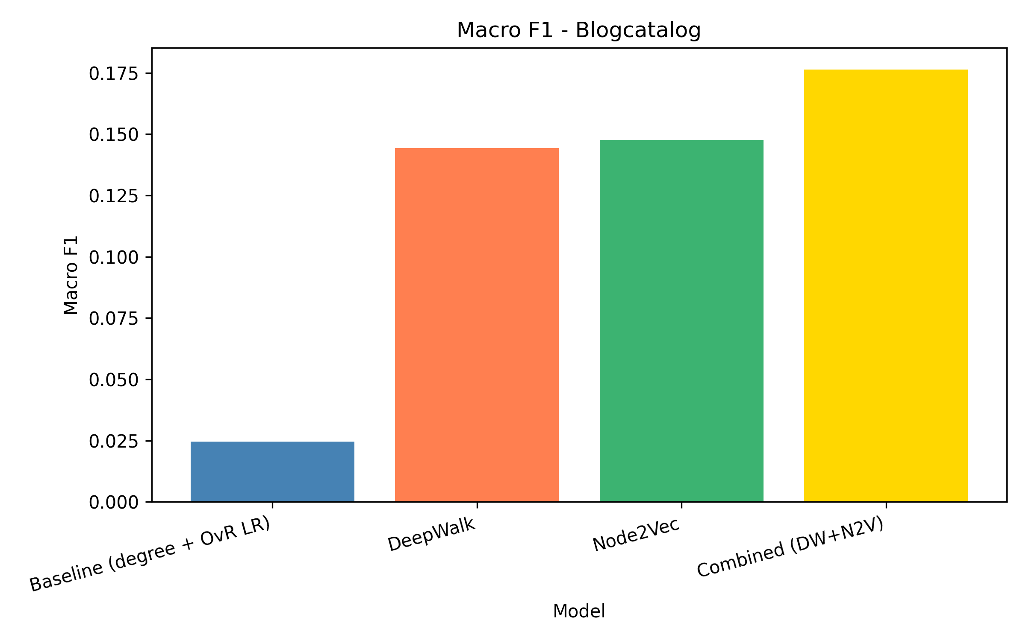
Hamming Loss - BlogCatalog
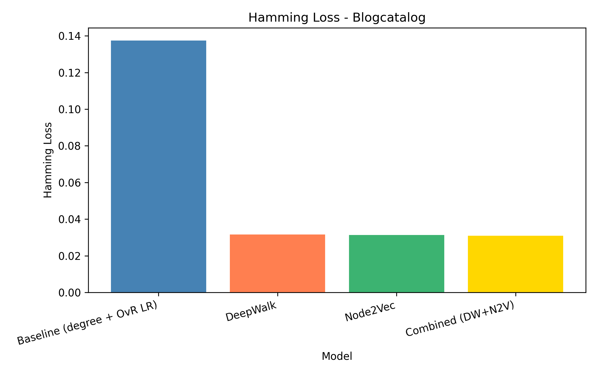
Micro-F1 - PPI
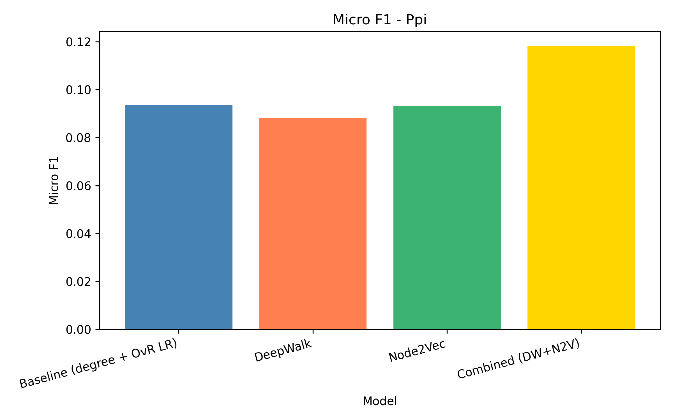
Macro-F1 - PPI
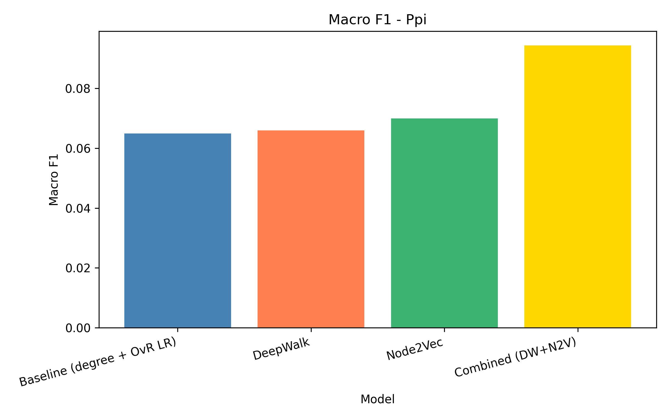
Hamming Loss - PPI
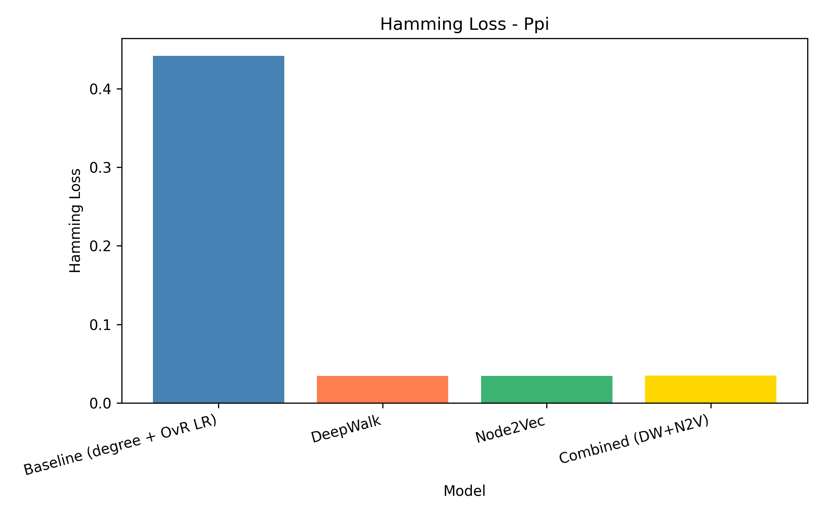
Micro-F1 - Wikipedia
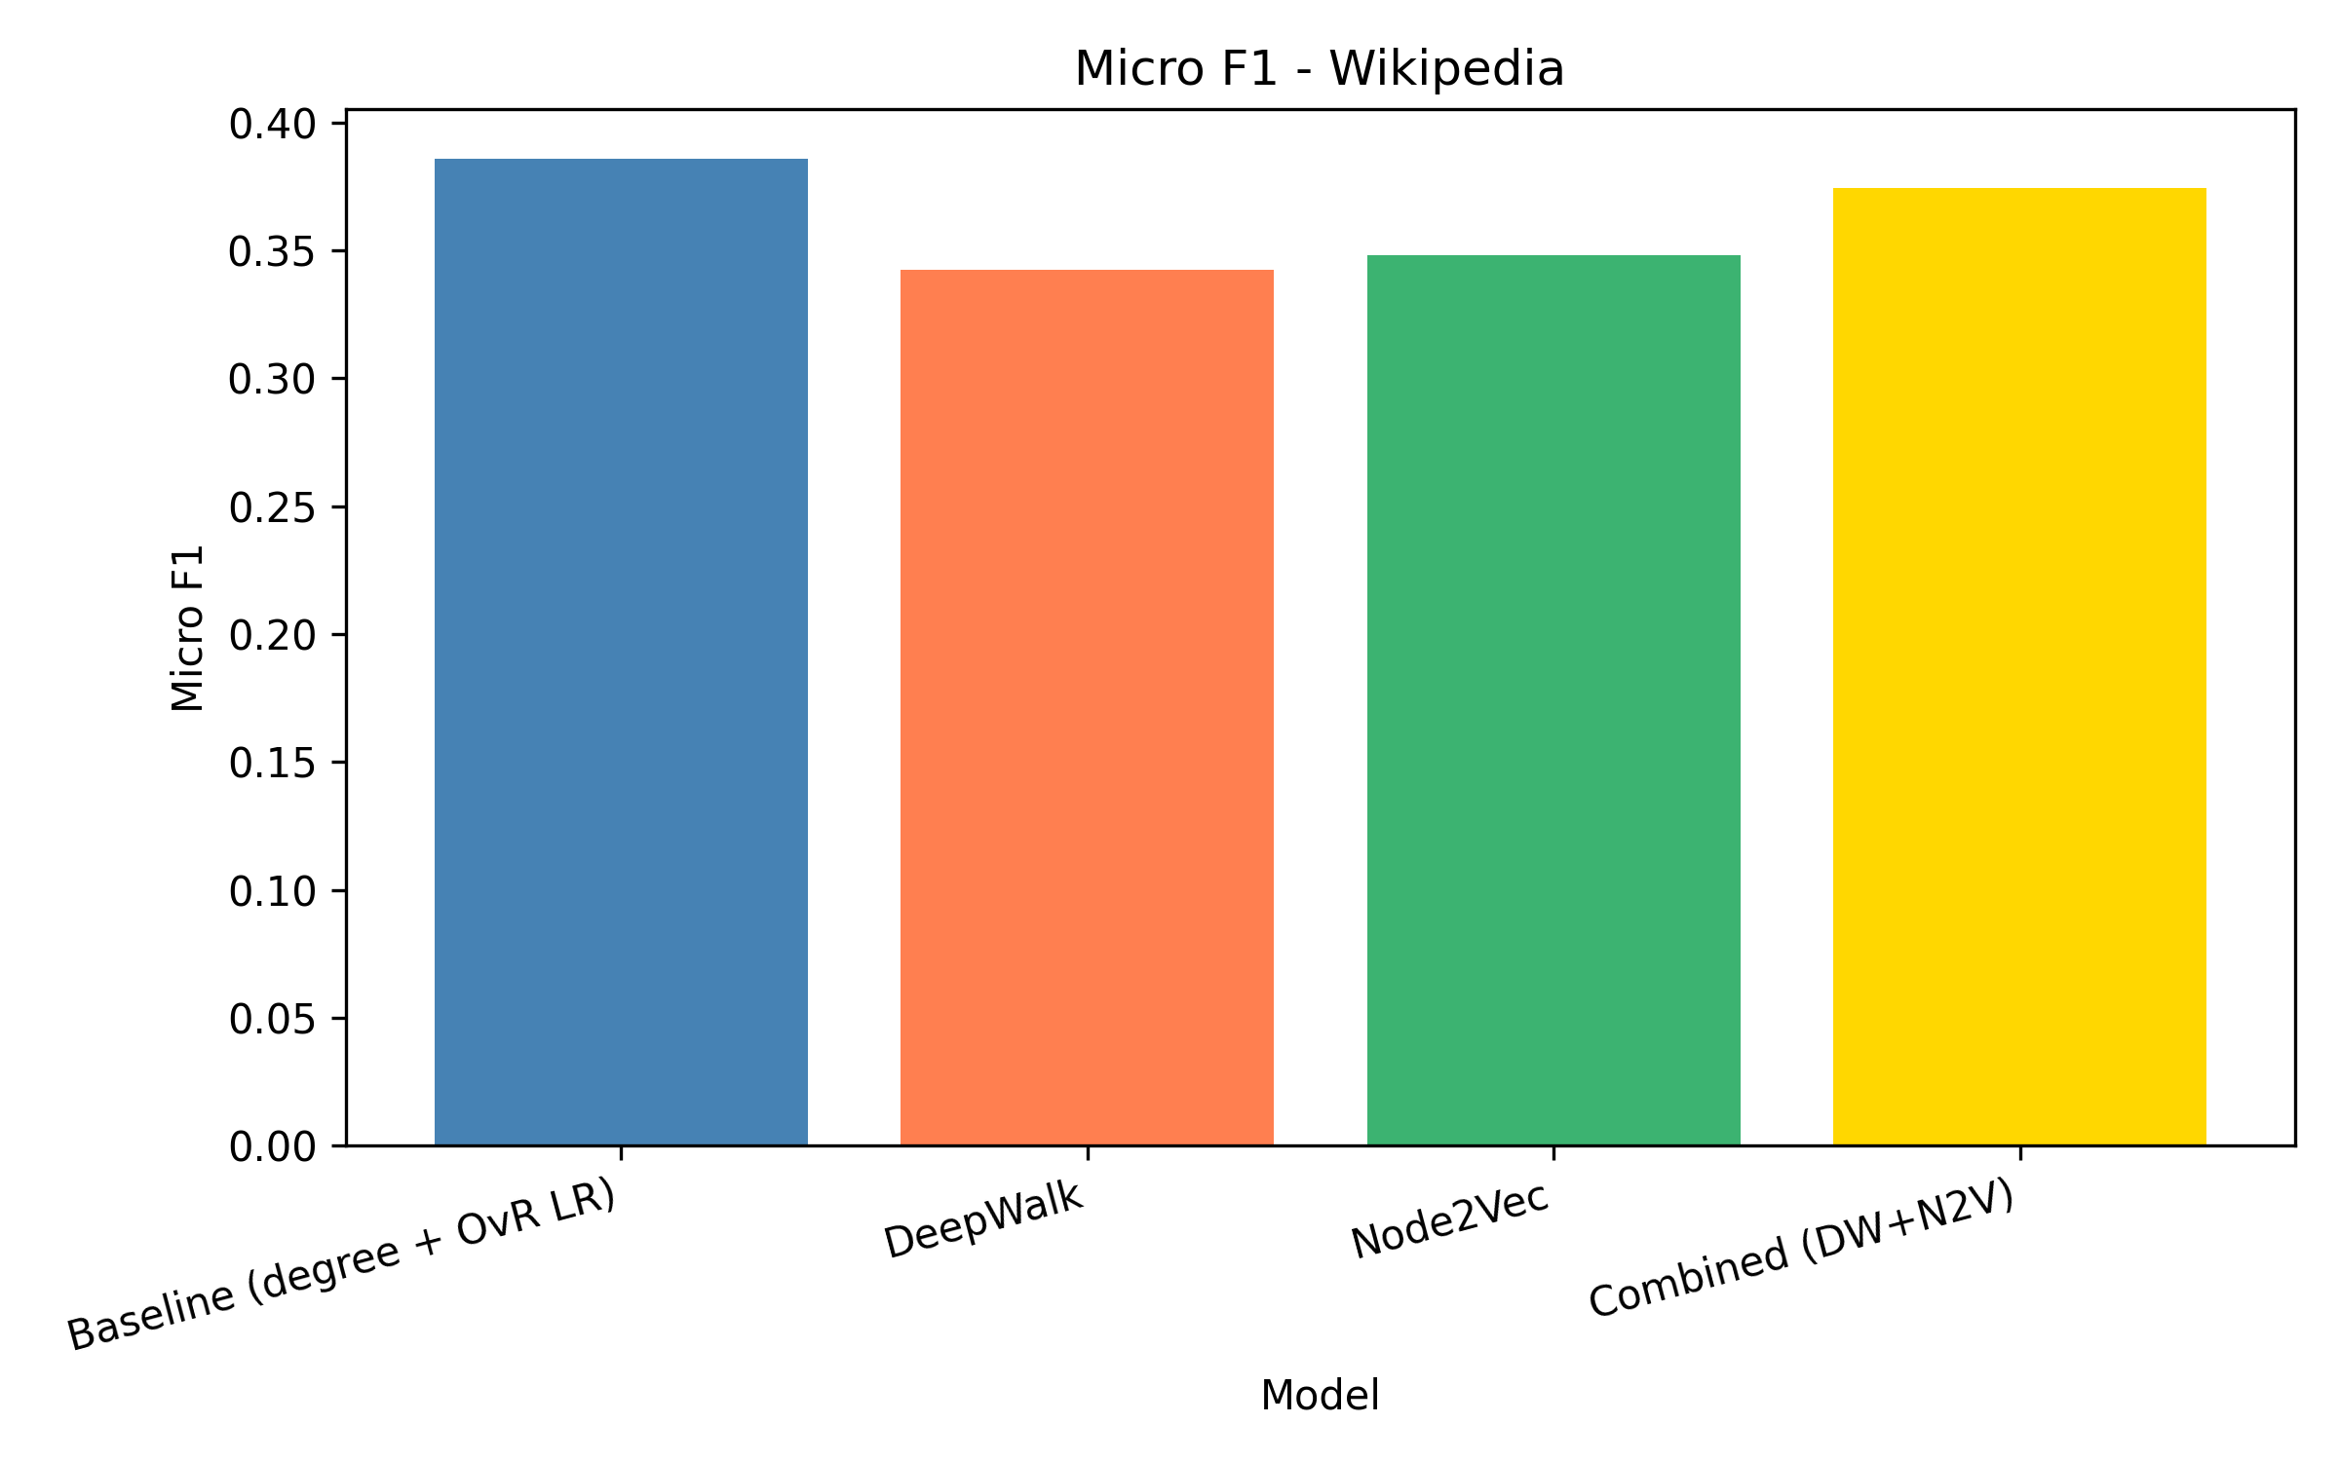
Macro-F1 - Wikipedia
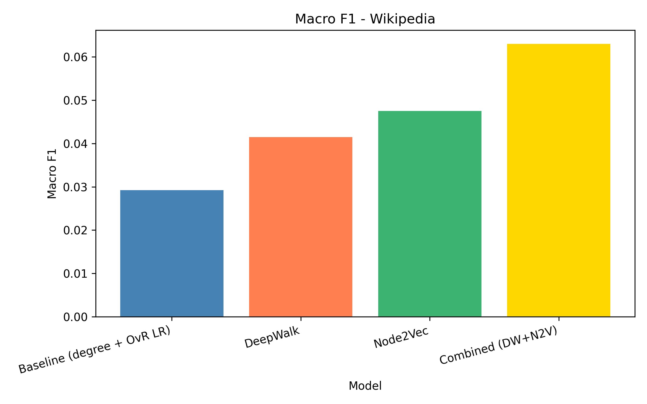
Hamming Loss - Wikipedia
