Assignment 1

Harsha K Y

PES1201801839

1. Copy file abc.txt from local directory to the user’s directory (testroot) in HDFS.

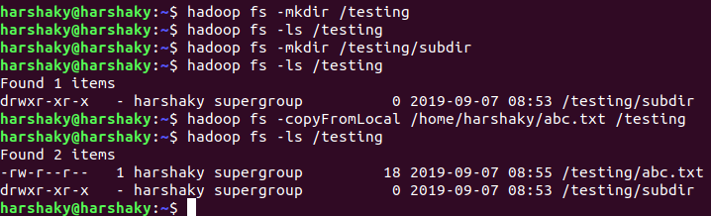

2. Get a directory listing of the user’s directory in human readable format

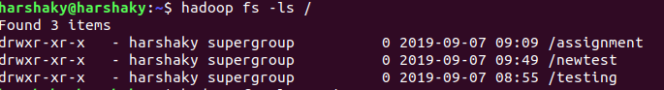

3. Create a three-level hierarchical directory structure of tr1, tr2, tr3 in root directory.

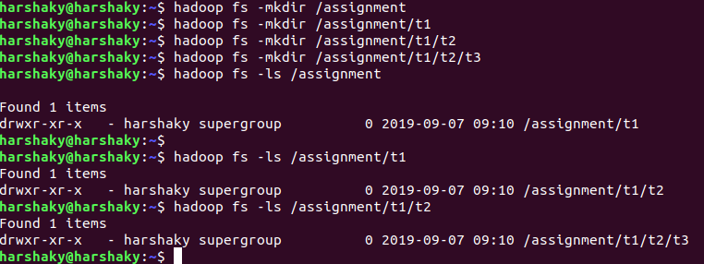

4. Copy a file called sample.txt from local directory into tr3 and tr2.

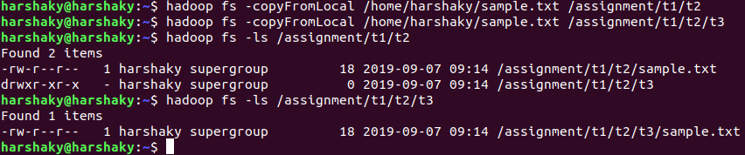

5. Append new content into the sample.txt of tr3 from stdin

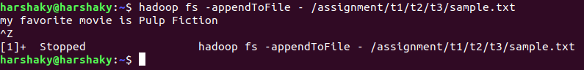

6. Move that file to tr1.

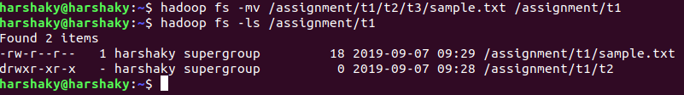

7. Move the file from tr2 to local directory



8. Give the listing of testroot recursively based on size

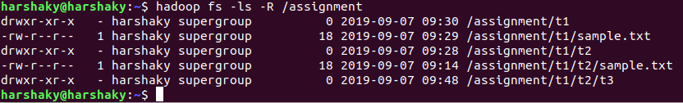

9. Create another root directory called newtest.



10. Create a zero-length file called newsample.txt in tr2.

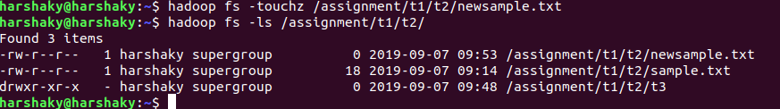

11. . Copy a file bcd.txt from root directory to tr2.

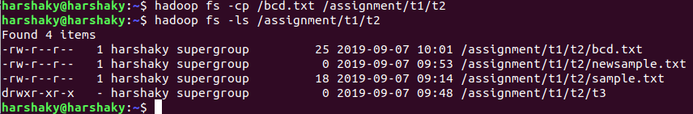

12. Copy the contents of tr2 to the directory ‘newtest’.

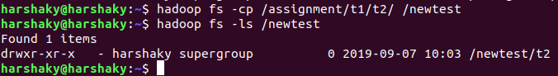

13. Give the listing of newtest based on date.

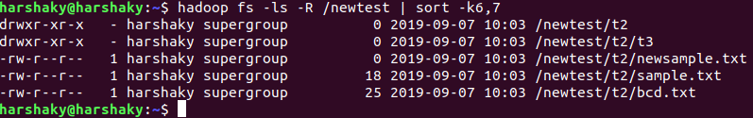

14. Delete the directory tr2.

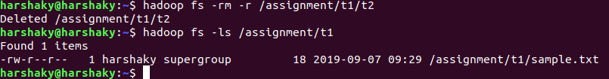

15. Get the syntax of setfacl.

hadoop fs -setfacl [-R] [-b|-k -m|-x <acl_spec> <path>]|[--set <acl_spec> <path>]

16. Reduce the size of sample.txt to 5

17. Show the last content of abc.txt.