Harsha K Y

PES1201801839

Big Data Assignment – 2

1. Create a file called sales.txt and put it in pig installation directory

2.

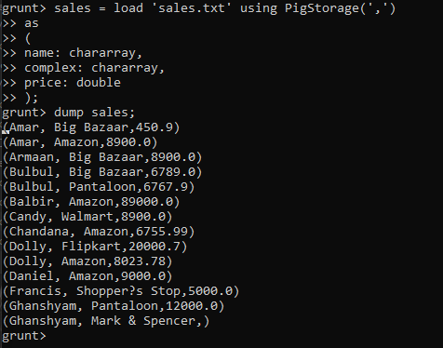

3.



4.

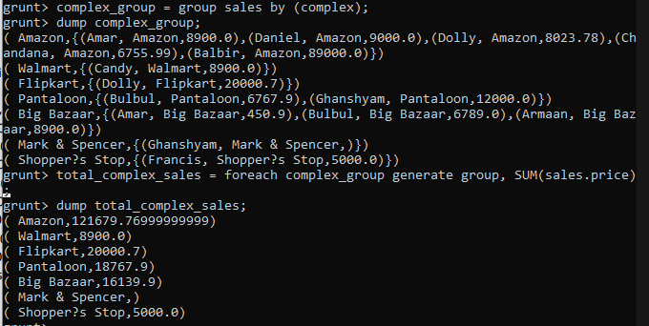

5.

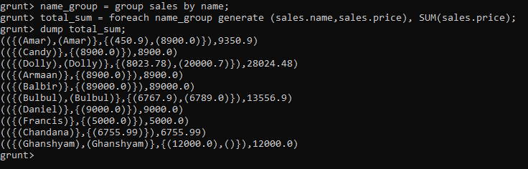

6. Create a new file emp.txt

7. create a new file dept.txt

8.

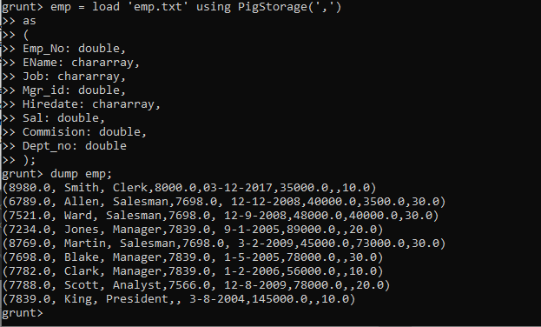

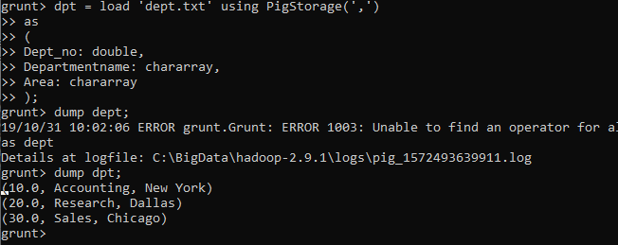

9.

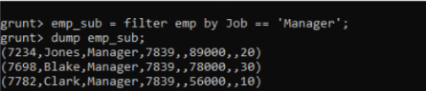

10.

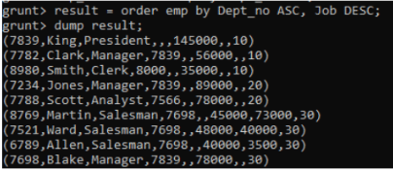

11.

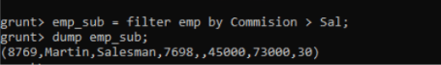

12.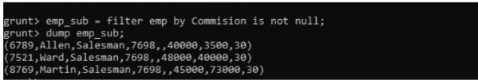

13.

