Harsha K Y

PES1201801839

Big Data Assignment 3

1. Create a database called movie_details and use it

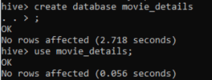

2. Create tables to hold the movie and ratings data in Hive

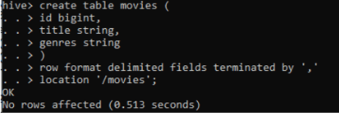

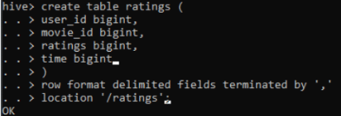

3. Display 20 records of movies

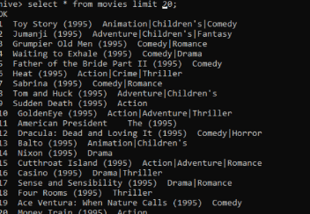

4. Display 20 records of ratings

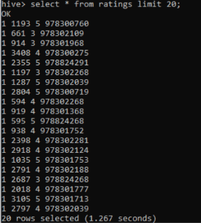

5. Find out numbers of non-adults as per Indian standard, who has rated movies



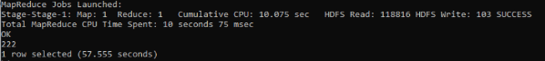

6. Find the age of the most rated user with counts of rating





7. Find the count of the ratings based on age



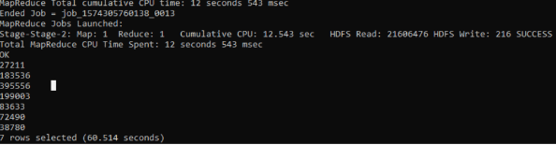

8. Find the movie with the maximum number of ratings.



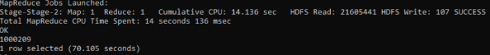

9. Find the movie with the lowest rating.



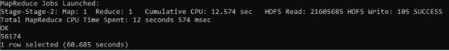

10. Create a database called user_details and use it.

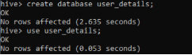

11. Create tables to hold user and occupation data in Hive

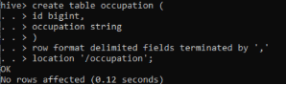

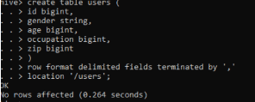

12. Find out occupation of all the users



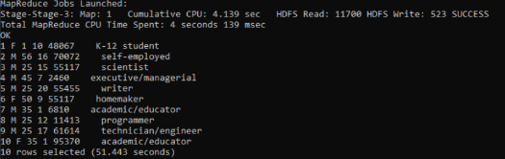

13. Find out the no of users with same occupation and having age more than 25 along with occupation details



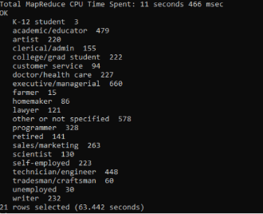

14. Find the occupation of all female users.



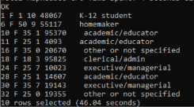

15. Find the number of female and male working as doctor/health care



