ABSTRACT

Text classification is an important task in supervised machine learning. A piece of text is assigned to one or more classes or categories. This can be done manually or with the help of powerful machine learning algorithms. The problem with doing this manually is that it takes up a lot of time and resources.

Let’s say you own a blogging website or a news website. Every article that is being posted has to be classified and put into a category. Making people read these articles manually is both time consuming and expensive. It would be easier if the computer itself classified these articles, as soon as they are posted. This is where natural language processing comes into play. Natural Language Processing or NLP, is a Machine Learning (ML) task that is used to train an ML model to recognize text data and get meaningful insights from it. This means that a trained ML model will be able to go through some text data and give us some context onit.

So, if you pass an article as input, this model will be able to tell you where it belongs. NLP can also be used to do other interesting tasks such as Sentiment Analysis. This means that a model will be able to tell if some text data is positive, negative, or neutral about any topic that is in discussion. Context Analyzer provides solutions for both of these tasks.

### INTRODUCTION

#### ProjectDescription

The goal of this project is to provide Natural Language Processing (NLP) services in the form of APIs. NLP is one of the major tasks in Machine Learning (ML). Whenever someone finds themselves wanting a computer program that can carry out NLP tasks for them, they would have to go through very time consuming and difficult processes of data collection, data cleaning, finding people skilled enough to do something with that data, build an effective model that can ultimately be used to do the NLP tasks. Instead, an individual or an organization can make use of the APIs provided as a result of this project do these tasks. All they have to do is make API calls with their inputs and the API returns a JSON object with predictions. This is going to save the users months of time and effort. Users can make calls using any language that supports fetching JSON data from the browser. This gives them incredible flexibility while building their applications. It also allows them to focus more of their manpower on their main products. There is always a rising need for machines more powerful, intelligent, and faster than us to take over the tedious and repetitive tasks that we just don’t want to do. ML has provided solutions exactly to these tasks over the years. If someone is conducting a survey on a certain topic, they would not want to spend hours looking at tweets and determining the general sentiment about that topic. They would rather feed that information to a program and let it tell them what kind of sentiment the tweets are showing. The tricky part is getting that program to work properly and accurately. The project uses three different models, trained for three different tasks (Sentiment Analysis, Category Prediction, Spam Detection). All of them averaging an accuracy of over 94%. So, accuracy isn’t a problem anymore. The project was built on node.js using a tensorflow.js integration. This means most of the tasks are done on the browser itself, making it faster and requiring very less computationalpower.

##### Problem Definition

Text classification is a very important task in supervised machine learning. A piece of text is assigned to one or more classes or categories. This can be done manually or with the help of powerful machine learning algorithms. The problem with doing this manually is that it takes up a lot of time and resources. Let’s say you own a blogging website or a news website. Every article that is being posted has to be classified and put into a category. Making people read these articles manually is both time consuming and expensive.

It would be easier if the computer itself classified these articles, as soon as they are posted. This is where the need for Natural Language Processing arises. Natural Language Processing or NLP, is a Machine Learning (ML) task that is used to train an ML model to recognize text data and get meaningful insights from it. This means that a trained ML model will be able to go through some text data and give us some context on it. So, if you pass an article as input, this model will be able to tell you where itbelongs.

NLP can also be used to do other interesting tasks such as Sentiment Analysis. This means that a model will be able to tell if some text data is positive, negative, or neutral about any topic that is in discussion. Our phones and email accounts are bombarded with spam every day. The only way to filter out the spam is by either making users flag the messages as spam manually or filter out the messages at the server end itself using an effective program. Context Analyzer provides solutions to all three of thesetasks.

##### Purpose

The problem of classifying text can be done by the organizations or the users themselves. To do that they would have to start collecting data, hire skilled ML engineers, spend a lot of money and time building out an effective and accurate model. Then some more time has to be spent tuning the model to perform better on all kinds of data. All of this can be avoided when companies just

use the APIs provided by this project. The purpose of this project was to automate cartain NLP tasks and also provide them as services through APIs. Integrating APIs is much cheaper and faster than building an entire team to carry out these tasks.

##### Scope

The web application provides a UI which can be used to carry out these tasks for one time users. The sentiment analysis API can be used for predicting sentiment of data from social media platforms, reviews on products, etc.. Category prediction is a multi-class classification task that can be used on news articles or blogs to classify them into different classes like politics, entertainment, sports, health, etc.. The spam detection API allows users to determine whether a message (any form of message; like SMS, email etc.) is spam. Initially these three tasks were identified as the major ones. The application is built in a way that it is always easy to add new features or build new APIs and add them.

##### ProposedSolution

The application consists of three different models all built using a Convolutional Neural Network, or CNN. The three models are trained on; a news dataset, the IMDB reviews dataset, and an SMS Spam dataset. The news dataset is going to be used to train the model for the multi class classification task. The IMDB reviews dataset is going to be used to train the model for sentiment analysis. The SMS spam dataset is used to train the model for spam detection. These models, once put into production will be able to do these classification tasks in mere seconds. This will also be cheaper and more effective.

To provide APIs, Node.js will be used. This has very good integration for tensorflow.js. Which means all ML tasks can be done on the browser itself. Node.js is also an amazing javascript runtime that can be used to build highly efficient endpoints. The web application can also be

used as an external tool for the classification tasks. Once the dataset is loaded, the preprocessing starts.

First the stop words function is used to remove the prepositions like “the, of, he, she etc”. It also simplifies the words, for example if there are multiple words like “doing, did, done” it will be converted to “do”. Then the tokenizer is used to turn the text into sequence of numbers. The neural network takes only numbers as input. Once the preprocessing is done, the model is created with several layers. The output layer returns a value denoting which class the text belongs to. Once the model is trained and saved, tensorflow js is used to load it. After this, everything is done on the browser. The predictions are made at the node endpoints.

## LITERATURE SURVEY

### LITERATURESURVEY

#### BackgroundStudy

A lot of research goes into NLP almost every day. Providing APIs for NLP tasks is a bit of a complex task. One such way to build NLP APIs is using a robust back-end technology like Node.js and making use of its brilliant integration with Tensorflow.js. Tensorflow.js allows us to interact with ML models directly from the browser. This makes it currently one of the best libraries for building NLP APIs. Tensorflow.js, for a while was running only on experimental Node.js. Recently it was ported to latest stable build of Node.js. It shows that this is a good way to move forward.

##### ExistingSystems

Google Cloud Natural Language provides NLP APIs. They also make use of tensorflow.js to provide the service. OpenNLP and Stanford NLP provide NLP libraries that can be integrated with supported languages. TextRazor provides NLP APIs but they do not use tensorflow.js. All these systems have certain drawbacks and gaps that can be filled with Context Analyzer API. The drawbacks and the solutions for them are mentioned in a future section.

##### RelatedWork

The paper titled**Recurrent Neural Network for Text Classification with Multi-Task Learning**was written by**Pengfei Liu, Xipeng Qiu, Xuanjing Huang.**The paper mainly talks about using a multi-task learning framework to jointly learn across multiple related tasks. The goal is to prove that their proposed model can improve the performance of a task with the help of other related tasks. They achieve this by introducing three RNN based architectures. The differences among them are only the mechanisms of sharing information among several tasks.

The paper titled Long Short-Term Memory was written by**Sepp Hochreiter, Jurgen Schmidhuber.**This paper introduces Long Short Term Memory for the first time. It aims to solve the problems with back propagation over time, and it does. The authors have given a detailed architecture and conducted experiments to prove that LSTM is better than traditional RNNs. Their experiments showed that LSTM also leads to more successful runs and learns much faster.

##### Drawbacks of ExistingSystems

Unlike Google Cloud Natural Language, this project allows users to customize the API results however they want. The response from the API is a JSON object, which means users can fetch any data they want from the output easily. Also, making API calls is easier than ever as all it requires is the input to be appended to the URL. (for ex: “localhost:3000/api/sentiment? predict=your+input”). A simple GET request would give you the predictions in a JSON response. While Open NLP and Stanford NLP provide good libraries, it wont be easy for every user to download the library and write code to make use of it. It is much easier to just make API calls and get output almost instantly. The major problem that Context Analyzer is solving is the ease of use and integration. As stated above, making API calls is very easy and simple for everyone to understand. The JSON response is also very easy to decode and every part of the response can be fetched individually based on the user’srequirements.

#### FeasibilityStudy

##### Technical Feasibility

The application runs completely on the browser. This does not require any additional installations or downloads. It is extremely easy to add new APIs or features when built. The back-end uses all the es6 features of Node.js which means it is highly responsive and fast. Obviously, the development part is hidden completely from the user. All the user will see is a responsive UI.

##### EconomicFeasibility

The development of this web application barely costs anything. It can be built with computers that have a decent amount of computational power. I decided to use the CPU version of tensorflow and tensorflow.js. This means it can be built using devices without a GPU. All the tools and technologies used were open-source, so, no licensing was required.

##### Operational Feasibility

Operating the web application is also very easy. The web application is built completely on the browser, so it will be fast and responsive. The application also contains documentation for the APIs. Every new user can go through it and find out how to use the APIs. One time users can also make use of the UI provided for each of the APIs. This takes in the user input and returns predictions. This is effective to show as a demo for the APIs and gives the users an idea of how quickly the results are given.

#### Tools andTechnologies

##### Tensorflow / tfjs-node

**Tensorflow**is an end-to-end open-source platform for ML. It has a wide range of tools and libraries, along with community resources that help us build state-of-the-art ML powered applications. In the context of this project, tensorflow was used to build and train the models.**Tensorflow.js**is an ML library for JavaScript. It allows us to develop ML models in JavaScript and use ML directly in the browser or in**Node.js.**This application made the most use of tensorflow and tfjs-node as it was the core component in building the APIs and models.

##### Node.js

**Node.js**is an asynchronous event-driven JavaScript runtime.**Node.js**allows us to build scalable network applications.**Node.js**served as the main back-end for this project for its**REST API**and**asynchronous**capabilities. A lot of asynchronous code is written to support the loading of models and making predictions.**Node.js**powers all of these tasks effectively.

##### Python 3

**Python**is a powerful and fast programming language. Python is user-friendly and easy to learn. Python basically runs on any platform and is open-source. Python was largely used as the platform for building and training the models. Tensorflow integrated with Python is the most powerful tool for ML. Python’s endless libraries facilitate users to perform almost any task.

##### Postman

**Postman**is an API development tool that helps users test and build powerful APIs. From headers to authentication tokens to simple JSON values, Postman supports all these features. It was largely used in the development part of the web application. All the routes and requests were simulated, monitored, and verified using Postman. Only then would they be integrated with the front-end.

##### Handlebars.js /hbs

**Handlebars.js**is used to build semantic templates. Handlebars is compatible with**Moustache**templates as well. Handlebars templates are compiled into JavaScript functions. These templates allow for reusability and dynamic rendering of content.**Hbs**is an express.js view engine for**Handlebars.js.**Hbs can be used with express.js to seamlessly write handlebars templates and integrate them with the HTML code. Hbs supports Partials and Views. Views are your main HTML pages and Partials support rendering of partial content on the views. This makes for building an effective, dynamic, and lightweight front-end.

## HARDWARE AND SOFTWARE REQUIREMENTS

### HARDWARE AND SOFTWAREREQUIREMENTS

#### HardwareRequirements

##### DevelopmentEnvironment:

* + - * **HDD:4GB**
      * **OS:**Ubuntu 18.04 LTS, Windows 10, MacOSx
      * **Processor:**Intel i5 Gen8
      * **RAM:8GB**

#### SoftwareRequirements

* + - **Server Side:**Node.js 13.x, Express 4.x, tfjs-node1.5.x
    - **Client-Side:**Handlebars 4.x, HTML5,CSS3
    - **Environment:**Ubuntu 18.04, Windows 10, Node, Python runtimeenvironment
    - **Code Editor / Ide:**VS Code, JupyterLab

# SOFTWARE REQUIREMENTS SPECIFICATIONS

### SOFTWARE REQUIREMENTSSPECIFICATIONS

A software requirement specification gives a detailed description of a software system along with its functional and non-functional requirements.

#### Users

Users are the people who interact with the application. They might be making use of the API or using the web UI to get predictions.

**API User**is the user who uses the API to get predictions. They make API calls from their own application and make use of the response.

**One-time User**is the user who uses the web UI of the application to get predictions for their owninput.

#### FunctionalRequirements

##### DataCollection

Deciding what kind of data is required for building the models. Downloading pre- collected data from Kaggle, and other sources.

##### Data Preparation andPre-processing

Building a dictionary of words from the dataset. This step is important in the pre- processing section of the project as the dictionary is used to get more refined and accurate predictions. This dictionary has the mapping between normalized words and their integer

IDs. The gensim.corpora.Dictionary class is used. Removing unnecessary fields from the dataset. There might be some unnecessary fields like ‘id’, ‘date’, etc., these should be removed if not necessary for building the model. The text data is converted into a list of tokens. The neural network takes only text data as input. The tokenizer() function is used for this. This leaves us with a tokenized list as our ‘X’ and the classes as our ‘Y’. This can now be used as inputs for the neuralnetwork.

##### Train theModel

This is where the pre-processed data is used to effectively train the model. Used keras sequential model with 6 different layers. The LSTM layer is what helps the model remember context. This allows for accurate predictions.

##### Evaluate themodel

Evaluating the models using some metrics. This can be a classification report or f1-score or any metric of the appropriate choice. This gives us a good idea of how the model is performing and lets us know what improvements are required.

##### MakePredictions

This is when the trained model is used to make predictions. The ‘test set’ as its often called, is passed as input to the model and it returns a list of predictions for each row of the test set. This gives us a good estimate of how the model will perform.

##### Server sideprocessing

The user input from the web UI or the API has to be pre-processed before predicting the class. This is done at the server using tfjs-node. The predicted output from the model is turned into JSON and sent as response.

#### Non – FunctionalRequirements

##### Scaling

Using technologies like Node.js with Tensorflow.js which allows for the web application to be scaled easily.

##### Performance

Increase accuracy of predictions by tuning hyper-parameters. Use the ability to run things faster with asyncrhronous programming.

##### Availability

Ensure that the web-app is always functional and available to use for the users. The server handling the API requests must always be up. Any sort of downtime will cause inconvenience to users.

##### Maintenance

Checking the functionality of the application from time to time to ensure it is working properly. Updating deprecated functions in various libraries.

**SYSTEM DESIGN**

### SYSTEMDESIGN

#### FlowDiagram

##### MLview

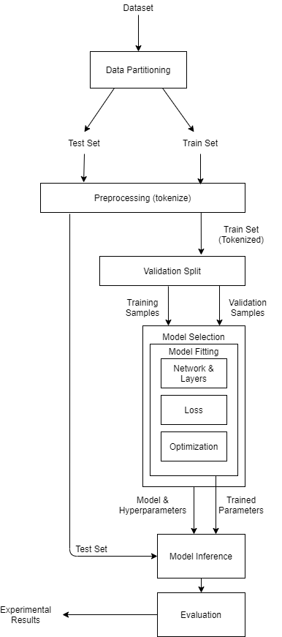

**Figure 5.1 – Flow diagram, ML view**

The flow diagram for the ML view deals only with the ML processes of the project. It shows how data flows between the different modules of the ML model buildingprocess.

##### Web-applicationview

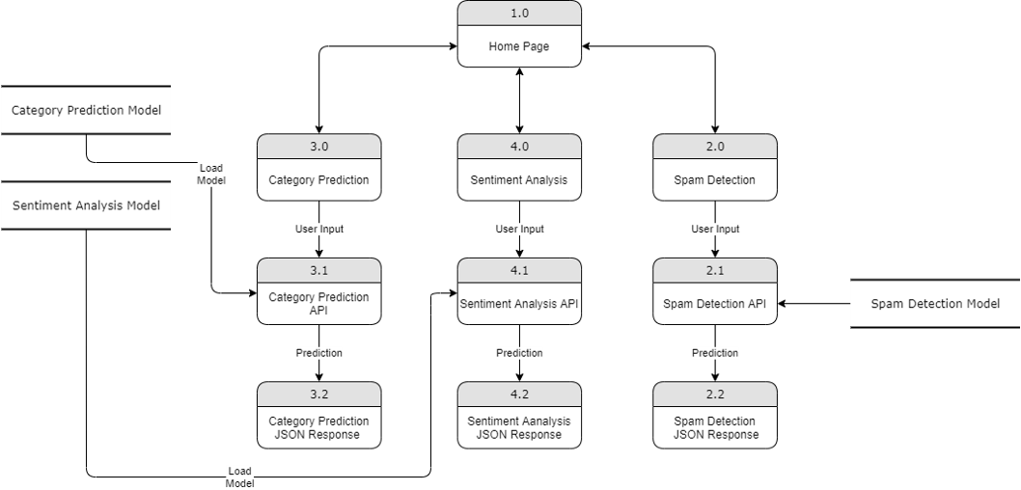

**Figure 5.2 – Flow diagram, Web-application view**

The flow diagram for the web-application view deals with how the different processes communicate in the web-application from server side to client side, and also how the server communicates with the models saved in memory.

#### DetailedMethodology

##### TextPre-processing

The datasets contain text data that need to be converted into tensors in order to provide them as input for the CNN. The neural network does not take in raw text data as input, so we need to convert this text data into a sequence of numbers (or a tensor) which is the appropriate input type. But first, a dictionary of words from the dataset is create. Its significance is explained later. This dictionary is built using the**gensim.corpora.Dictionary**class. This contains a dictionary of words with their integer values as keys. This dictionary is of paramount importance as it plays a very important role in increasing the accuracy of the model. The dictionary is then used to convert the dataset into numerical inputs by using the**token2id**method available from**gensim.corpora**. This method converts the dataset into key-value pairs by giving each word in the dataset the integer value from the same word in the dictionary. This process is called**tokenization**and the numbers are called**tokens**. These tokens are then converted into a 1D list which consists only of tokens. The code and outputs from these processes are available in the Implementationsection.

The user input for predictions are also pre-processed in the same way. The same dictionary is used. If the dictionary isn’t used the user inputs would be saved as [0,1,2,3,4] and this wouldlead to very inaccurate predictions. When the dictionary is used, the code checks if the words from the user input exists in the dictionary, and then the appropriate token is assigned. This makes the model give us better predictions.

##### Building themodel

* + - * **Convolutional NeuralNetworks**

Convolutional Neural Networks, or CNNs, are specialized neural networks that take in input as a 2D matrix. In the case of this project, the input, that is a list of tokens is

converted into a series of convoluted matrices. Each row of the matrix corresponds to a token which may be a word or a character. Each row is a vector that represents a word. In NLP the filters in CNNs slide over sentence matrices, a few words at a time.

##### The layers of themodel

All three models used in this project are similar but with slight differences. What all 3 models have in common is that they all have the same layers but the parameters differ to make sure the datasets were used to train the model with maximum efficiency.

##### Embedding

The embedding layer can only be used as the first layer of the model. The embedding layer takes 2 main parameters. The input dimension and the output dimension. The input dimension is an integer that specifies the size of the vocabulary. The output dimension is an integer that specifies what shape the output of the embedding layer must be. This means that we can use the embedding layer to convert higher dimensional data into lower dimensional vector space.

In this project it is implemented like this:

*model.add(Embedding(len(dictionary), embed_size)*

##### LSTM

To make predictions, the model needs to look at recent information. If the information is close by, the predictions are made properly. In the sentence “The sky is*blue”,*the word*blue*can be predicted easily because the context of the sky is close by. Consider a big paragraph of text. If, in the first sentence it has, “Lewis Hamilton has won the F1 World Championship six times”, and in the last sentence it has, “he is a great*racer”,*the model would have a hard time predicting the word*racer.*This problem is solved by LSTMs. LSTMs make it possible for models to remember contextfromafewsentences,orevenparagraphsbefore.TraditionalRNNsareonly

good at remembering recent information. LSTMs are designed to remember context. This makes it a great tool for Natural Language Processing.

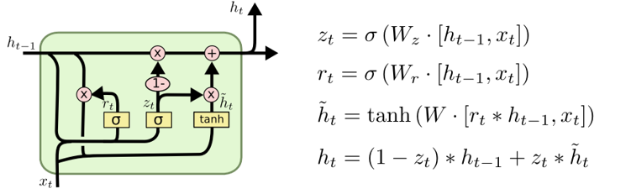

**Figure 5.3 - LSTM**

##### Modelarchitecture

The following diagrams show the architecture of the models. They consist of all the layers in the model, showing input and output shapes for each layer. The architecture diagrams for all 3 models; sentiment analysis, multi-class classification, spam detection are shownbelow.

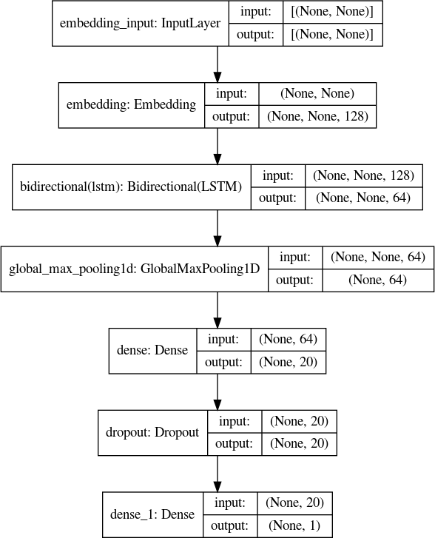

**Figure 5.4 – Architecture of Sentiment Analysis model**

The above diagram shows the layers and input and output shapes of each layer for the sentiment analysis model.



**Figure 5.5 – Architecture of Category Prediction model**

The above diagram shows the layers and input and output shapes of each layer for the multi-class classification model.

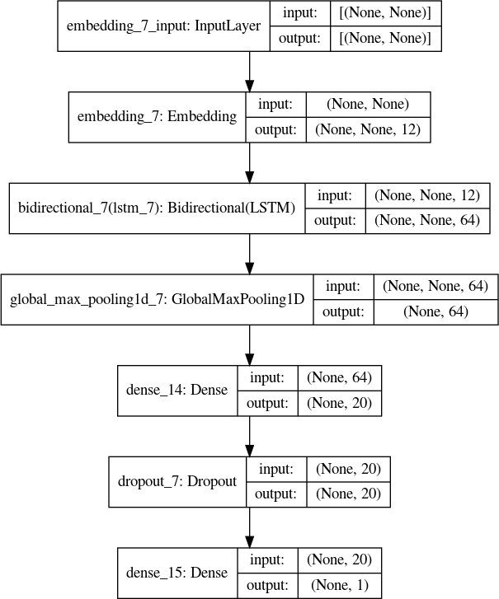

**Figure 5.6 – Architecture of Spam Detection model**

The above diagram shows the layers and input and output shapes of each layer for the spam detection model.

## IMPLEMENTATION

### IMPLEMENTATION

#### Sample Source Code andDescription

##### Setting up routes for the webapplication

First, the prerequisites for the server to run are setup. That includes, installing express.js and importing it. Also importing hbs, body-parser, path. Here set up the view engine as hbs, this tells the server to use handlebars as the view engine and it serves up hbs files at the client side from the folder specified.

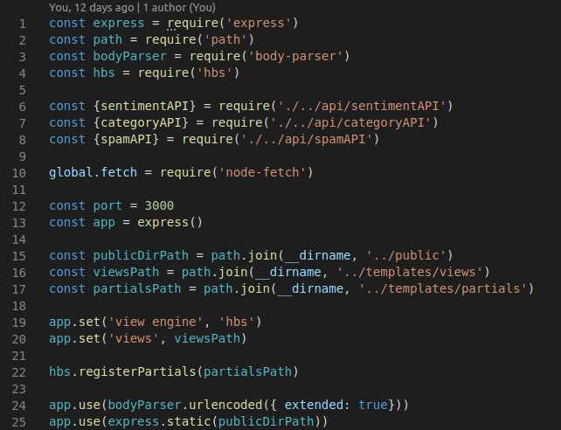

**Figure 6.1 – server.js set-up**

After this, the routes can be written. Most of the GET requests render a hbs file. For example, a GET request made to ‘/sentiment-analysis’ would render a hbs file for the sentiment analysis task. The routes look like this.

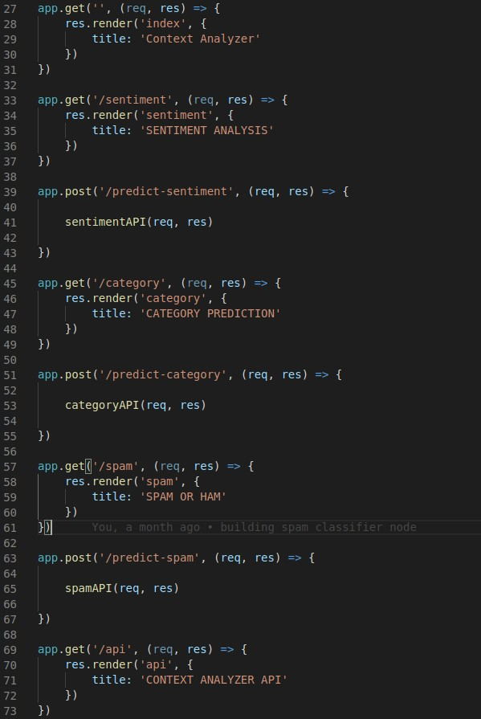

**Figure 6.2 – server.js routes**

##### The APIlogic

When the API calls happen, a function runs to load the model and make predictions and send those predictions as response.

The code for sentiment analysis API.

**Figure 6.3 – Sentiment analysis API**

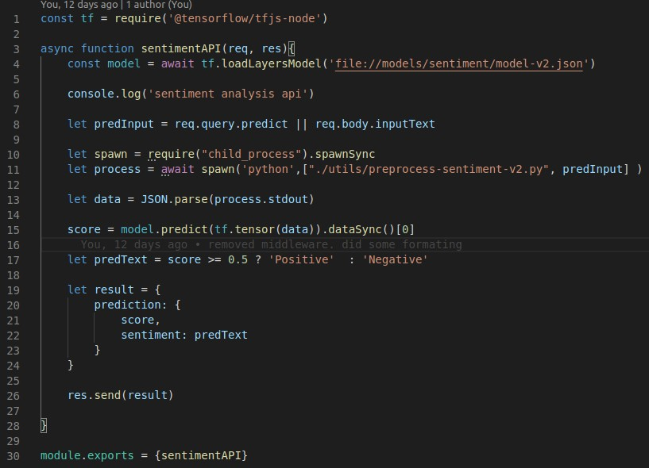

**Figure 6.3 – sentimentAPI.js**

The other APIs are also setup in a similar way. The asynchronous function setup makes sure that the model is loaded properly. The input is preprocessed and the model is used to predict the processed input. The predictions are sent as a JSON response.

##### Pre-processing and ModelGeneration

* + - * **Pre-processing**

All of the above handles the server side of the application. But the most important part of the application is the models. Without them none of this can be used in any meaningful way. So, here is how the models are generated.

The pre-processing is pretty similar for all of the models. Only the size of the input differs as each dataset is different. The code for pre-processing looks something like this.

##### Code fromsentiment.ipynb

MAX_SEQUENCE_LEN= 130

The above code is used to create the dictionary that was mentioned in the methodology section. This is also used to convert the raw text input into a list of tokens that will be used as input to the neural network.

x_train=texts_to_input(df.review, dictionary)

Converts df.reviews into list of tokens and stores it inx_train.

##### Model Generation

After the dataset is processed. x_train, y_train, x_test, y_test are created for training and testing purposes. y_train and y_test are created by converting the labels ‘positive’, ‘negative’ into 1 and 0.

df['sentiment']=df['sentiment'].map({'pos':1,'neg':0})

Next, we move on to building the model. The model is built carefully by choosing the right parameters and layers. This is done to ensure maximum efficiency and minimum loss. The model is trained over 3 epochs.

The output looks like this.

Train on 60000 samples, validate on 15000 samples Epoch 1/3

60000/60000 [==============================] - 271s 5ms/sample - loss: 0.3670 - acc: 0.8293 -

val_loss: 0.2173 - val_acc: 0.9251 Epoch 2/3

60000/60000 [==============================] - 271s 5ms/sample - loss: 0.1643 - acc: 0.9402 -

val_loss: 0.1007 - val_acc: 0.9669 Epoch 3/3

60000/60000 [==============================] - 268s 4ms/sample - loss: 0.0728 - acc: 0.9759 -

val_loss: 0.0648 - val_acc: 0.9782

##### ModelEvaluation

* **Sentiment AnalysisModel**

Once the model is trained, it is saved using

model.save('sentiment_model-v2.h5')

The test set is used to make predictions and evaluate the model.

prediction=model.predict(x_test) y_pred=(prediction> 0.5)

**fromsklearn.metricsimport**f1_score

print('F1-score:**{0}**'.format(f1_score(y_pred, y_test)))

F1-score: 0.9861099959855479

##### Category PredictionModel

Since the category prediction model is dealing with 15 different classes, it is better to evaluate it using a different metric like classification report. This is done like this:

**importnumpyasnp**

**fromsklearn.metricsimportclassification_report**

y_test_pred=[lb.classes_[i]**foriinnp**.argmax(model.predict(x_test), axis=1)]

print(classification_report(df_test.category,y_test_pred))

The classification report output -

precision recall f1-score support

|  |  |  |  |  |  |
| --- | --- | --- | --- | --- | --- |
| BLACK VOICES | | 0.23 | 0.02 | 0.03 | 447 |
| BUSINESS | | 0.61 | 0.25 | 0.35 | 631 |
| COMEDY | | 0.67 | 0.05 | 0.10 | 492 |
| ENTERTAINMENT | | 0.56 | 0.80 | 0.66 | 1543 |
| FOOD & DRINK | | 0.70 | 0.73 | 0.72 | 595 |
| HEALTHY LIVING | | 0.54 | 0.35 | 0.42 | 706 |
| HOME & LIVING | | 0.60 | 0.38 | 0.47 | 412 |
| PARENTING | | 0.58 | 0.75 | 0.65 | 872 |
| PARENTS | | 0.45 | 0.26 | 0.33 | 368 |
| POLITICS | | 0.82 | 0.91 | 0.86 | 3254 |
| QUEER VOICES | | 0.69 | 0.69 | 0.69 | 661 |
| SPORTS | | 0.49 | 0.47 | 0.48 | 489 |
| STYLE & BEAUTY | | 0.75 | 0.82 | 0.79 | 984 |
| TRAVEL | | 0.71 | 0.77 | 0.74 | 1034 |
| WELLNESS | | 0.68 | 0.82 | 0.74 | 1787 |
| micro | avg | 0.68 | 0.68 | 0.68 | 14275 |
| macro | avg | 0.61 | 0.54 | 0.54 | 14275 |
| weighted | avg | 0.66 | 0.68 | 0.65 | 14275 |

##### Spam detectionModel

Evaluation for this model is done in a similar way to the sentiment analysis model, using the F1 score.

prediction=model.predict(x_test) y_pred=(prediction> 0.5)

print('F1-score:**{0}**'.format(f1_score(y_pred, y_test)))F1-score: 0.9281045751633986

This covers the entire project in brief. However there is still one tiny, yet important part to be done. The tensorflow.js code can not import .h5 files. It can only import .json models. So the model.h5 files have to be converted into model.json files. This is done easily in just one line.

$ tensorflowjs_converter --input_format=keras /tmp/model.h5 /tmp/tfjs_model

#### Screenshots

1. Home



**Figure 6.4 – Home Page**

1. Sentiment Analysis

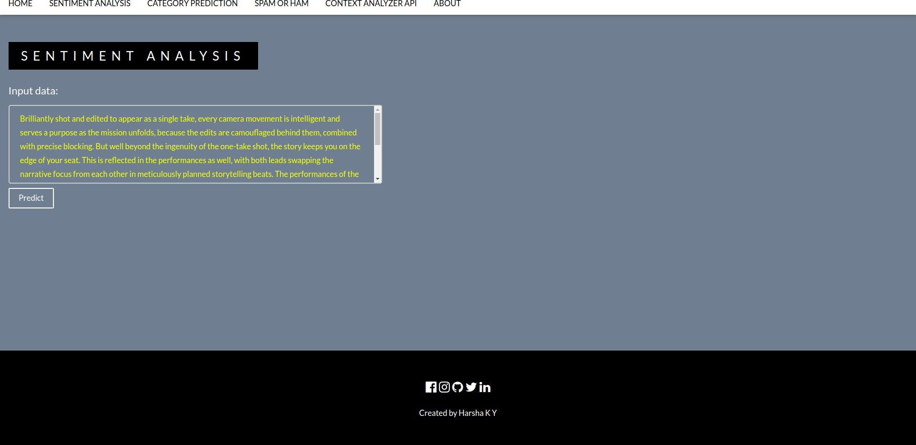

**Figure 6.5 – Sentiment Analysis**

1. Category Prediction

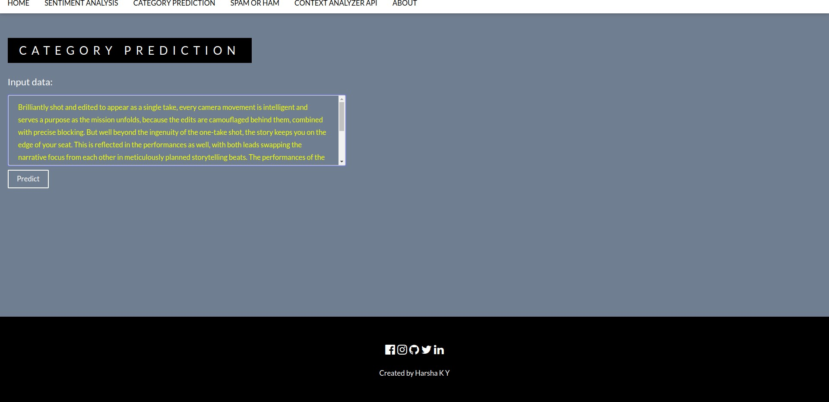

**Figure 6.6 – Category Prediction**

1. SpamDetection

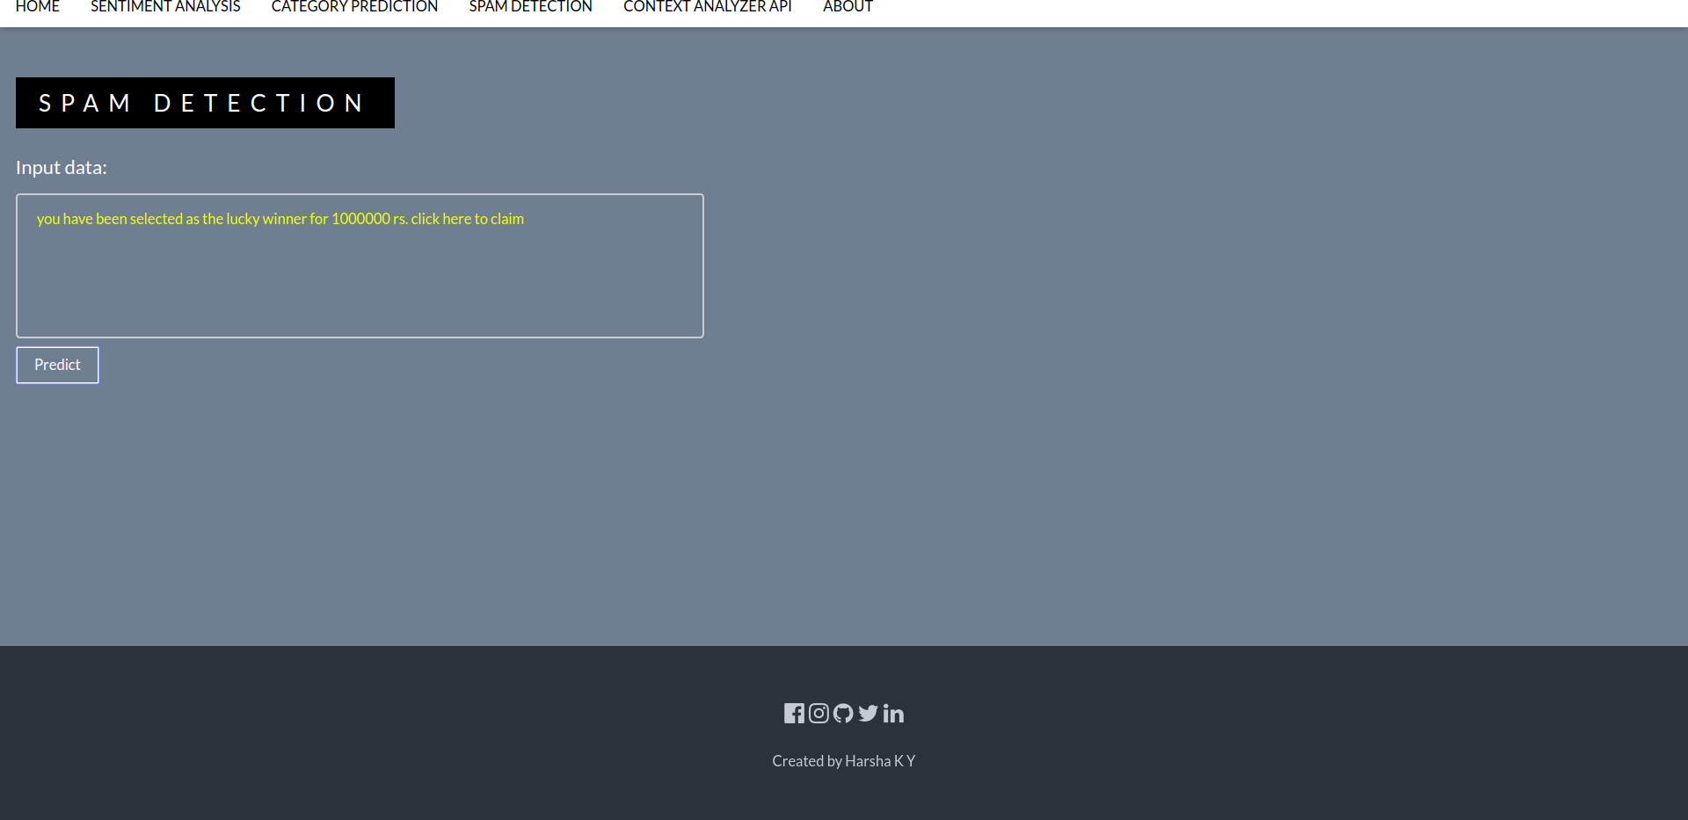

**Figure 6.7 – Spam Detection**

1. Context Analyzer API(Documentation)

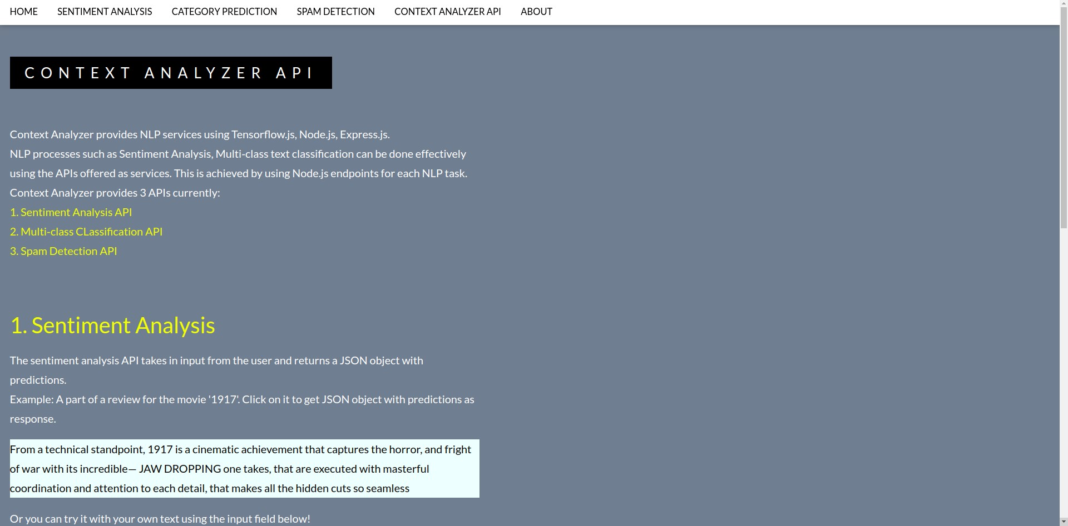

**Figure 6.8 – API Documentation**

1. JSONresponses

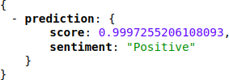

**Figure 6.9 – Sentiment Response**

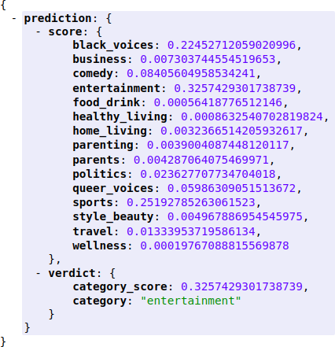

**Figure 6.10 – Category Response**

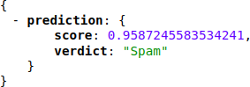

**Figure 6.11 – Spam Response**

# RESULTS AND DISCUSSION

### RESULTS ANDDISCUSSION

The project was successfully implemented as APIs for Natural Language Processing tasks. The APIs can be used to get results in real-time by just making a HTTP GET request with any text data as input.

#### CorrectClassification

The three models’ training phases resulted in an average accuracy score of 96.5%, with the spam detection model being the most accurate at 97%. This can be attributed to the fact that the spam detection model was trained on data that had a clear distinction between text that was spam and text that was legitimate. For example, texts usually flagged as spam are “money winning schemes” or information about how one has won a certain sum of money. The least accurate one was multi-class classification model. This yielded an accuracy of 96%. The model was trained to recognize 15 different categories. This would take a toll on the accuracy.

An example training output:

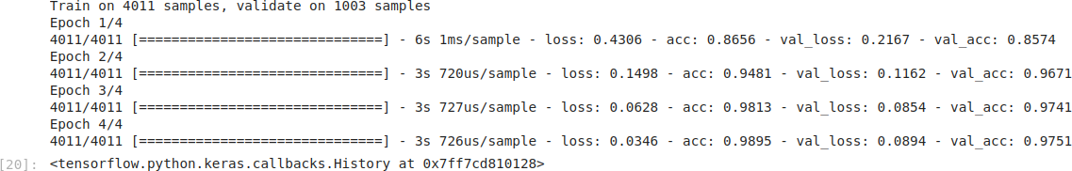

**Fig 7.1 – Training Epochs**

The above figure shows how the accuracy improves and loss decreases with each epoch. The number of epochs and batch sizes and other parameters were carefully chosen after several iterations. These are the best results achieved over the course of the project.

This model is saved and can be used to make API calls. A GET request made to

/api/spam?predict=YOUR_INPUTwill get a JSON response with the prediction. The JSON response looks like this

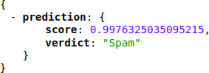

**Fig 7.2 – Spam detection response**

The input data for this was the following text: “IMPORTANT - You could be entitled up to

£3,160 in compensation from mis-sold PPI on a credit card or loan. Please reply PPI for info or STOP to opt out.”. The response said that the above text had a 99% chance of being spam, and it is. Here we see the model work correctly.

#### WrongPredictions

Most of the time, well trained models do end up giving out proper classification results. But, there are instances when even the model with 96% accuracy can get it wrong. Here’s one of the instances when the model got itwrong.

When the input for the multi-class classification model is a text than can potentially belong to two different categories, it can get it wrong. A news article about a politician taking a trip could be classified as politics instead of travel. A sportsperson committing a crime could be classified as sports instead of crime. During the ongoing pandemic, a lot of news articles are about the Coronavirus. Even, sports articles have information about the pandemic which could lead to wrongpredictions.

A GET request made to/api/category?predict=YOUR_INPUT will respond with a JSON containing probability scores for each of the 15 categories.

When the input is“Stanford University, which has built the most successful broad-based athletic department in the country, said on Wednesday that its model was financially unsustainable in part because of the coronavirus pandemic and that it would permanently drop 11 sports to help offset what it projected would be at least a $70 million deficit over the next three years”. This article is clearly about sports, but the model classified it astravel.

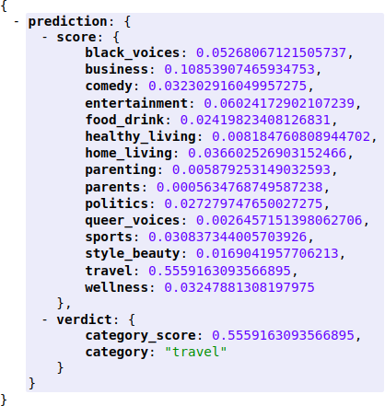

**Fig 7.3 – Category wrong prediction**

The wrong classification could be because the text has the words Stanford University and thinks its an article about travel or some sort of destination.

#### Discussion

The results of the project are very promising. With most of modern software development moving towards APIs, having robust ML models which can give predictions in real-time is very useful.

These days, almost all languages are capable of making HTTP GET and POST requests. The REST architecture which was used to build the project proved very advantageous. The three models work with the endpoints /api/spam, /api/category, and /api/sentiment. They take a parameter “predict” as input. This holds the value for the text to be predicted.

All the users have to do is just use a function like axios.get(‘/api/spam? predict=CUSOM_INPUT’) using a library like axios, and they would get a JSON response with the predictions. The asynchronous feature of Node.js allows for multiple requests to be processed at once with no problem atall.

**SOFTWARE TESTING**

### SOFTWARETESTING

Software testing is the process of checking whether the actual results of using the product meet the expected results. It can also be used to evaluate the functionality of the the application. This lets us find faults and identify potential fixes if any mistakes are found.

##### TestCases

**Table 8.1 – Test Case T001**

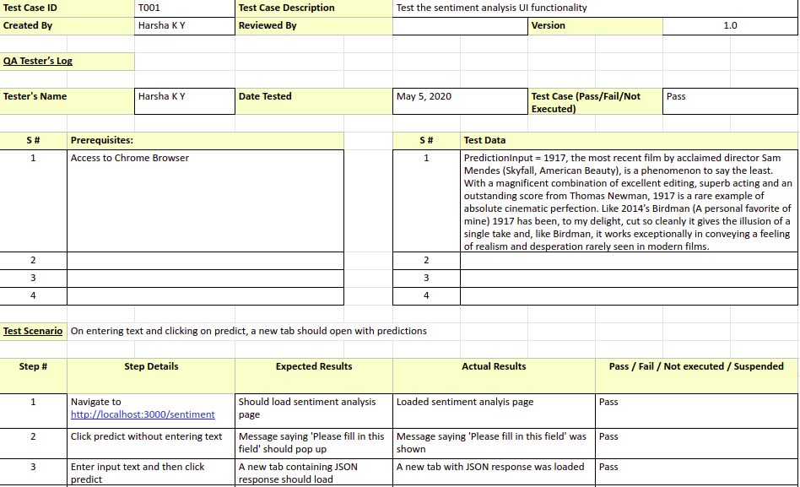

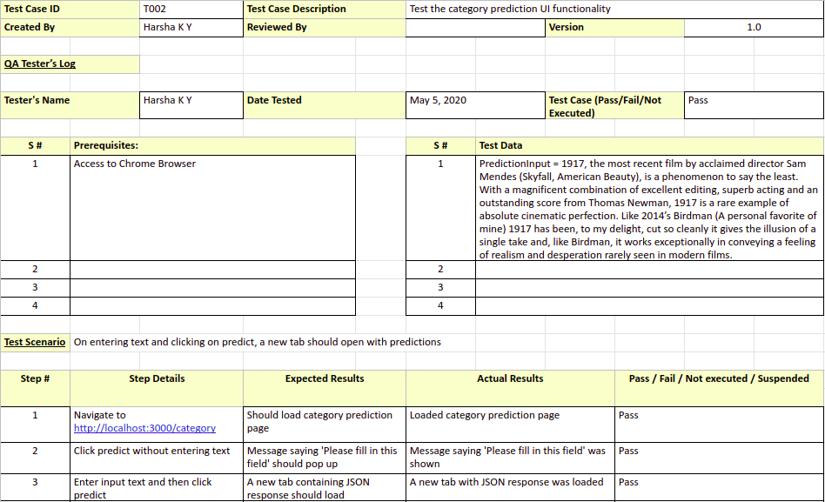**Table 8.2 – Test Case T002**

**Table 8.3 – Test Case T003**

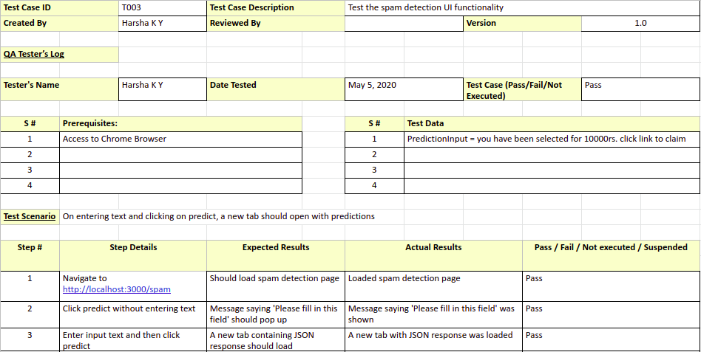

**Table 8.4 – Test Case T004**

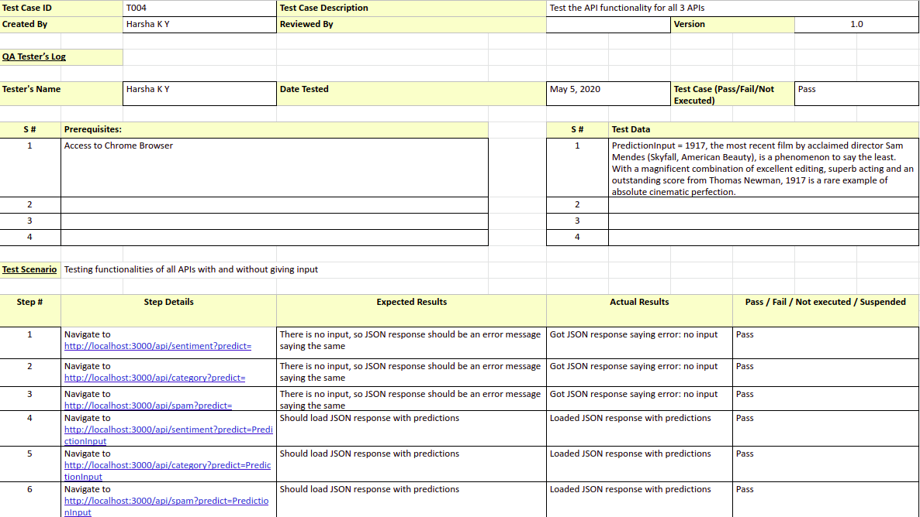

* 1. **ModelTesting**

All three models were tested for accuracy. The first accuracy and loss values are generated during the trainingphase.

model.compile(loss='binary_crossentropy',optimizer='adam',metrics=['accur acy'])

The ‘metrics’ attribute lets us specify if we want to output the accuracy or not. The validation_split is set to 0.2 for all 3 models. This means that 20% of the training data will be used to validate metrics like loss and accuracy.

##### Accuracy and Loss for Sentiment Analysismodel

Train on 60000 samples, validate on 15000 samples Epoch 1/3

60000/60000 [==============================] - 271s 5ms/sample - loss:

0.3670 - acc: 0.8293 - val_loss: 0.2173 - val_acc: 0.9251 Epoch 2/3

60000/60000 [==============================] - 271s 5ms/sample - loss:

0.1643 - acc: 0.9402 - val_loss: 0.1007 - val_acc: 0.9669 Epoch 3/3

60000/60000 [==============================] - 268s 4ms/sample - loss:

0.0728 - acc: 0.9759 - val_loss: 0.0648 - val_acc: 0.9782

After 3 epochs, the loss was**0.064**and accuracy was**0.97**.

##### Accuracy and Loss for Category Predictionmodel

Train on 102776 samples, validate on 25694 samples Epoch 1/3

102776/102776 [==============================] - 225s 2ms/sample - loss:

0.2230 - acc: 0.9351 - val_loss: 0.1655 - val_acc: 0.9441 Epoch 2/3

102776/102776 [==============================] - 231s 2ms/sample - loss:

0.1430 - acc: 0.9510 - val_loss: 0.1237 - val_acc: 0.9576 Epoch 3/3

102776/102776 [==============================] - 221s 2ms/sample - loss:

0.1083 - acc: 0.9624 - val_loss: 0.1126 - val_acc: 0.9615

After 3 epochs, the loss was**0.11**and accuracy was**0.96**. The loss is higher here as the model was trained to classify into 15 differentclasses.

##### Accuracy and Loss for Spam Detectionmodel

Train on 4011 samples, validate on 1003 samples Epoch 1/4

4011/4011 [==============================] - 6s 1ms/sample - loss: 0.4306

- acc: 0.8656 - val_loss: 0.2167 - val_acc: 0.8574 Epoch 2/4

4011/4011 [==============================] - 3s 720us/sample - loss:

0.1498 - acc: 0.9481 - val_loss: 0.1162 - val_acc: 0.9671 Epoch 3/4

4011/4011 [==============================] - 3s 727us/sample - loss:

0.0628 - acc: 0.9813 - val_loss: 0.0854 - val_acc: 0.9741 Epoch 4/4

4011/4011 [==============================] - 3s 726us/sample - loss:

0.0346 - acc: 0.9895 - val_loss: 0.0894 - val_acc: 0.9751

After 4 epochs, the loss was**0.08**and the accuracy was**0.97**.

On an average, the three models have given an accuracy of 0.965.

# CONCLUSIONS

### CONCLUSION

The goal of this project from the start was to build reliable, accurate APIs for NLP tasks. Having achieved that for 3 different tasks; Sentiment Analysis, Category Prediction, Spam Detection, it is safe to say that ML APIs are going to dominate in the nearfuture.

It is very easy for users to just integrate APIs for NLP tasks than build them from scratch. The tools and technologies used to build this application allow for easy integration of new features and new APIs. Having provided a page with documentation for the API, users are going to find it easy to make use of my APIs.

Since most of the tasks are done on the browser itself, it requires very less computation power. This means that the APIs can be easily used for predictions on mobile devices as well.

**FUTURE ENHANCEMENTS**

### FUTUREENHANCEMENTS

* + - Increase theaccuracy.
    - The API itself should provide more features. Features like text labeling, summary generation, etc. should be implemented.
    - Users and API keys specific to the user must be set up. As of now, the APIs are free for all and not specific to the users.
    - Develop APIs for more NLPtasks.

## APPENDIX B: USER MANUAL

### APPENDIX B: USER MANUAL

* + - The header contains links for Sentiment Analysis, Category Prediction, Spam Detection. Users can click on any one of these and the app will redirect the user to the appropriate page.
    - Every page has a text area where the user can input their text data. For example in the category prediction page, the UI contains a text area where the users can type in some text for which they wantpredictions.
    - After typing, the user can click on predict, and a new tab opens with JSON data which has predictions and probabilityscores.
    - The ‘Context Analyzer API’ section has documentation for the API. The users can use this documentation to find out how to integrate the APIs for their ownuse.
    - The code for the project can be found at<https://github.com/HarshaKy/text-classifier>
    - The project can be downloaded and run in development mode.
    - After downloading, navigate to the root of the project and run the following commands in the same order to run the project in developmentmode.

1. npminstall
2. npmstart
   * + Once the app is running, open a browser and navigate tohttps://localhost:3000/