1. After logging into the HRMS App using our Web-App or Mobile App, find and navigate to the **Option Button**(1) and click on it to open the form.

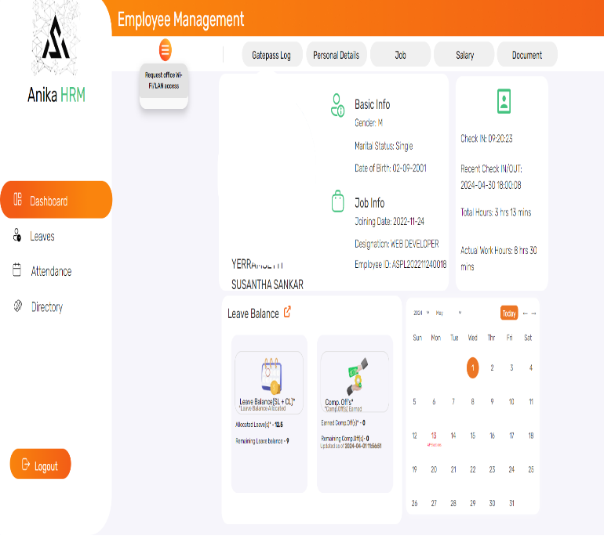 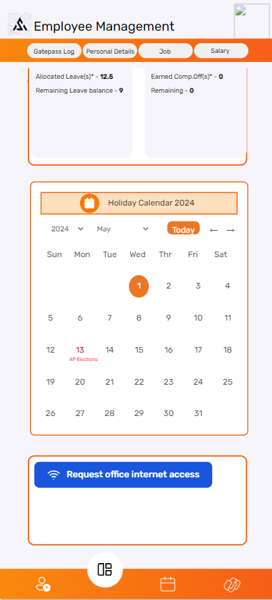

**1**

**1**

          [ Web-App Page ]                                                                       [ Mobile App Page ]

2. After logging into the HRMS App using our Web-App or Mobile App, find and navigate to the **Option Button**(1) and click on it to open the form.

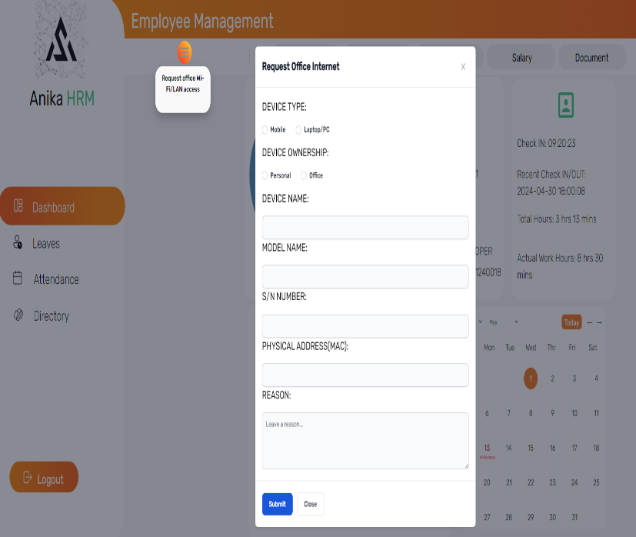 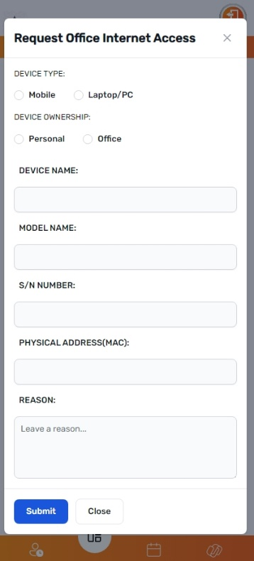

**2**

**2**

          [ Web-App Page ]                                                                        [ Mobile App Page ]

3. After logging into the HRMS App using our Web-App or Mobile App, find and navigate to the **Option Button**(1) and click on it to open the form.

