**Harsha R - 1BM18CS034**

# Program no – 15 Program Title – Controlling a Servo with an IR remote and reciever

**Aim**

Switch colors using the rgb led, display the current color in the lcd display.

## Hardware Required

* Arduino Board
* IR reciver, IR remote
* Servo

## Circuit Diagram

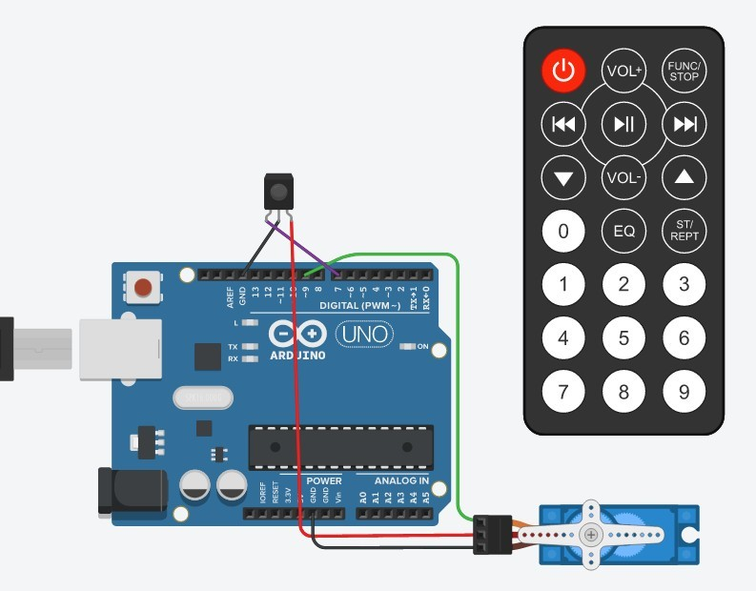

**Code:**

#include <Servo.h>

#include <IRremote.h>

// setup servo pin, initializae pos

int pos = 0; Servo servo_9;

// setup ir reciever int ir_in = 7; IRrecv irrecv(ir_in); decode_results results;

void setup()

{

Serial.begin(9600);

servo_9.attach(9); Serial.println("Enabled Servo"); irrecv.enableIRIn(); Serial.println("Enabled IRin");

}

void loop()

{

if (irrecv.decode(&results)) { switch (results.value){ case 0xFD609F:

servo_9.write(360);

Serial.println("Clockwise");

break; case 0xFD20DF:

servo_9.write(-360);

Serial.println("Counter Clockwise");

break; default:

Serial.print("Use only << or >>");

break;

}

irrecv.resume();

}

}

## Observation /Output

Servo moves left and reight when respective buttons are pressed on the IR Remote