**Harsha R - 1BM18CS034**

Program no – 14

Program Title – RGB led interfacing with LCD panel

**Aim**

Switch colors using the rgb led, display the current color in the lcd display.

# Hardware Required

* Arduino Board
* Tilt Sensor
* RGB LED
* LCD Panel
* Mini Breadboard
* 4 x 240 Ohm Resistor

LED color switches from Red -> Green -> Blue and name of the current color is displayed on the LCD panel

# Circuit Diagram

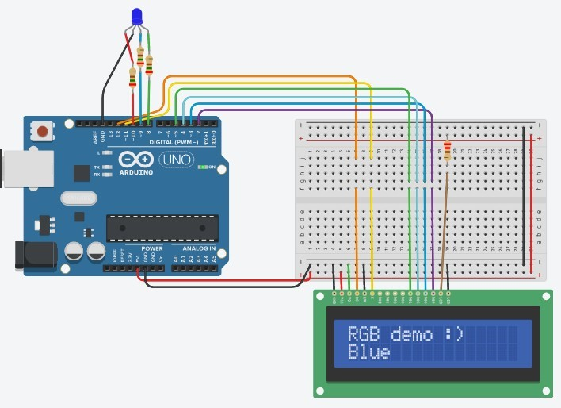

**Code:**

#include <LiquidCrystal.h>

LiquidCrystal lcd(12, 11, 5, 4, 3, 2);

void setup() { pinMode(8, OUTPUT);

pinMode(9, OUTPUT);LED color switches from Red -> Green -> Blue and name of the current color is displayed on the LCD panel

pinMode(10, OUTPUT);LED color switches from Red -> Green -> Blue and name of the current color is displayed on the LCD panel

lcd.begin(16, 2); lcd.print("RGB demo :)");

}

void loop() { lcd.setCursor(0, 1);

lcd.print("Red "); digitalWrite(10, HIGH); digitalWrite(9, LOW); digitalWrite(8, LOW);

delay(500); lcd.setCursor(0, 1);

lcd.print("Blue "); digitalWrite(10, LOW); digitalWrite(9, HIGH);

digitalWrite(8, LOW);

delay(500); lcd.setCursor(0, 1);

lcd.print("Green"); digitalWrite(10, LOW); digitalWrite(9, LOW);

digitalWrite(8, HIGH);

delay(500);

}

# Observation /Output

LED color switches from Red -> Green -> Blue and name of the current color is displayed on the LCD panel