Ocean Cleanup Big Data Solution Analysis
A real-time resource prioritization and cleanup intelligence solution for The Ocean Cleanup

Prepared as a business pitch analysis using the provided cleanup dataset
Topics: Data Analysis and Big Data

1. Executive Summary
The problem is not simply that plastic exists in the ocean. The operational problem is that cleanup resources are limited, while trash volume, plastic composition, volunteer availability, and cleanup intensity vary heavily by geography. A flat cleanup schedule wastes effort because it treats every location as equal.
This document proposes a real-time Cleanup Priority Intelligence System for The Ocean Cleanup. The system uses historical cleanup records to rank states and cleanup zones by urgency, predict expected cleanup volume, and guide where teams, equipment, trucks, collection bags, and recycling partnerships should be deployed first.
The business recommendation is to move from reactive cleanup reporting to predictive cleanup planning. Instead of asking, 'Where did we collect plastic?' the organization should ask, 'Where should the next cleanup investment go to prevent the most plastic leakage into rivers and oceans?'

Key Findings from the Dataset
- The dataset contains 37,904 cleanup records and 61 columns, including cleanup location, cleanup date, people, pounds, bags, item categories, and total items collected.
- After cleaning, 37,576 usable records remained for analysis.
- California and Florida dominate total item volume, meaning they require recurring operational attention rather than one-time campaigns.
- Texas, Pennsylvania, Georgia, and Arizona show very high trash weight, which points to heavier material handling, trucking, and disposal requirements.
- Massachusetts, Connecticut, Ohio, and Maryland show high plastic share among states with enough cleanup records, making them strong candidates for plastic-specific intervention and recycling partnerships.
- A Random Forest predictive model performed strongly for cleanup item volume prediction, with about 41.7 MAE and 0.928 R² on the actual item-count scale.

2. Business Problem
The Ocean Cleanup's mission involves removing legacy plastic and stopping inflow from rivers and waterways. The provided presentation also frames the need to prioritize cleanup locations and allocate resources by state-level plastic patterns. The missing business capability is a data-driven prioritization engine that converts cleanup records into operational decisions.
Current challenge: cleanup activity can become reactive. Teams may know how much trash was collected after an event, but they may not know which region deserves the next crew, which plastic category should drive recycling partnerships, or how much material handling capacity is needed before a cleanup starts.
Proposed solution: build a real-time analytics layer that ingests cleanup data, calculates a priority score, predicts expected cleanup load, and recommends resource allocation.

3. Proposed Real-Time Solution
Solution Name: Ocean Cleanup Priority Intelligence System (OCPIS)
- Live data ingestion: mobile cleanup forms, smart bins, river sensors, volunteer apps, and partner uploads.
- Big data storage: cloud object storage for raw files and a warehouse/lakehouse layer for cleaned analytics tables.
- Streaming layer: Kafka or cloud event streaming to process new cleanup submissions in near real time.
- Analytics layer: state/zone-level aggregation, plastic composition profiling, anomaly detection, and priority scoring.
- Prediction layer: machine learning model to estimate expected cleanup item volume and weight before deploying resources.
- Decision layer: dashboard that recommends which locations need crews, trucks, bags, recycling support, or prevention campaigns.

4. Dataset Understanding

Dataset Overview
Metric | Value
Raw rows | 37,904
Raw columns | 61
Clean usable rows | 37,576
States/regions | 53
Countries | 1
Date range | 1992-09-12 to 2091-01-10

The dataset is suitable for data analysis and big data design because it contains multiple high-cardinality dimensions: state, zone, date, cleanup type, people, distance, weight, bags, and many item-level trash categories. These attributes support descriptive analytics, diagnostic analytics, predictive modeling, and operational optimization.

5. Data Cleaning and Feature Engineering
- Converted Cleanup Date into a date/time field and extracted year and month.
- Converted people, pounds, miles, bags, and item counts into numeric fields.
- Removed records missing core fields such as state, country, date, total items, or pounds.
- Grouped plastic-related categories into a derived Plastic_Item_Total metric.
- Created Plastic_Share to measure how much of a cleanup consisted of plastic-related items.
- Created productivity metrics such as items per cleanup, pounds per cleanup, and items per person.

6. Exploratory Data Analysis
The following visuals convert raw cleanup history into business decisions.
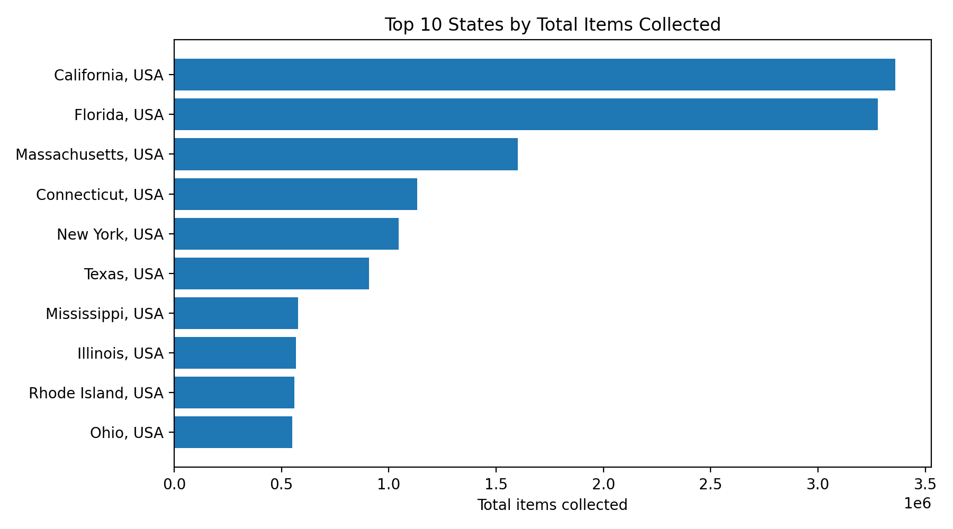
Figure 1. Top states by total items collected.
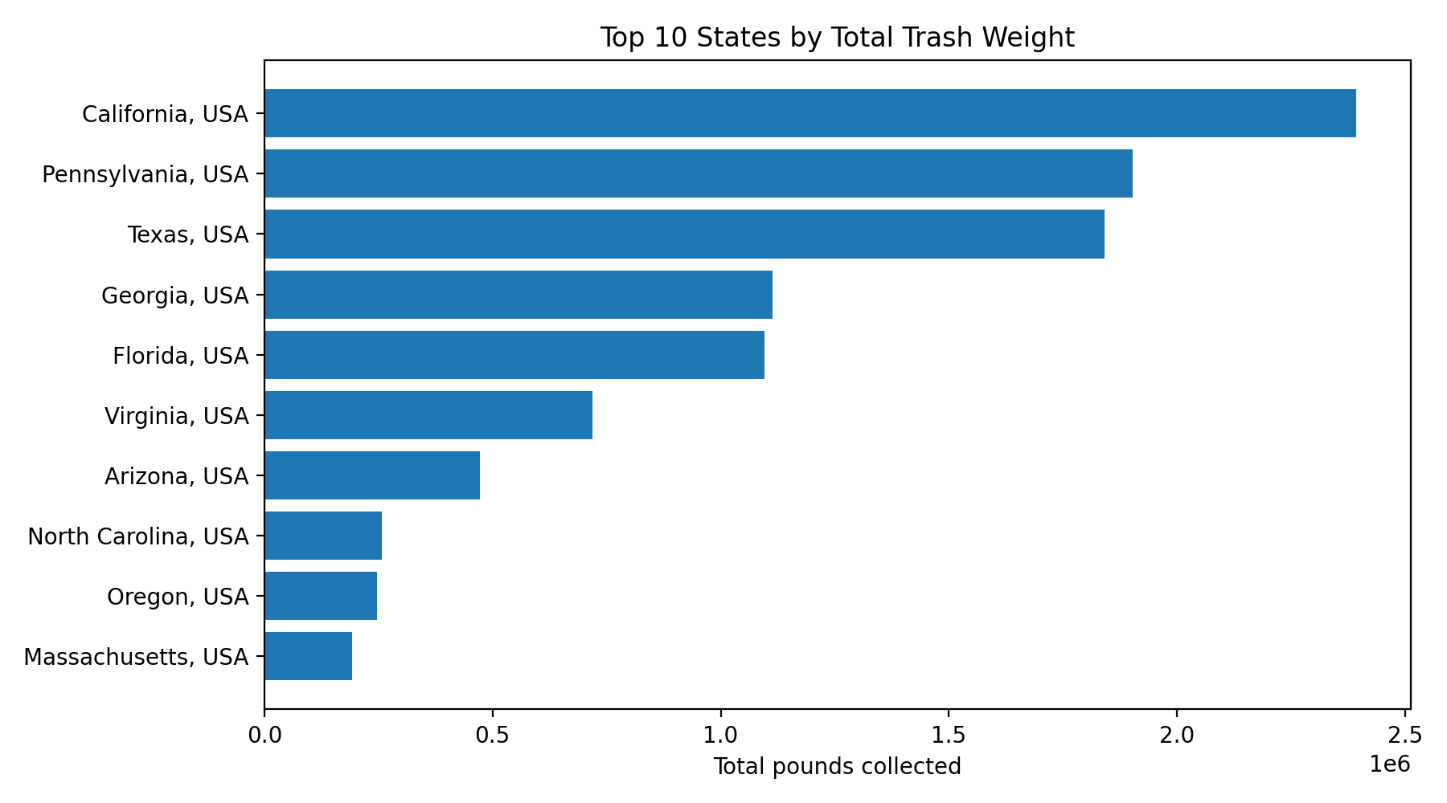
Figure 2. Top states by total pounds collected.
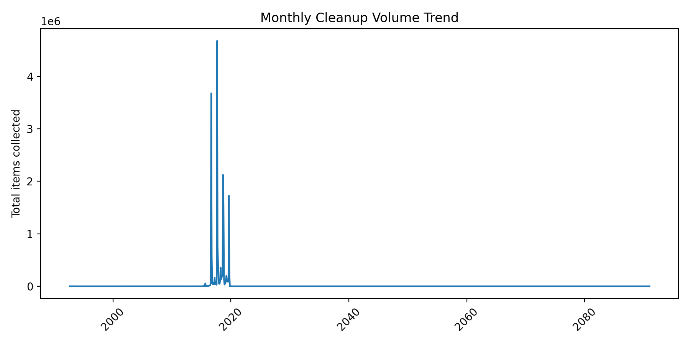
Figure 3. Monthly cleanup volume trend.
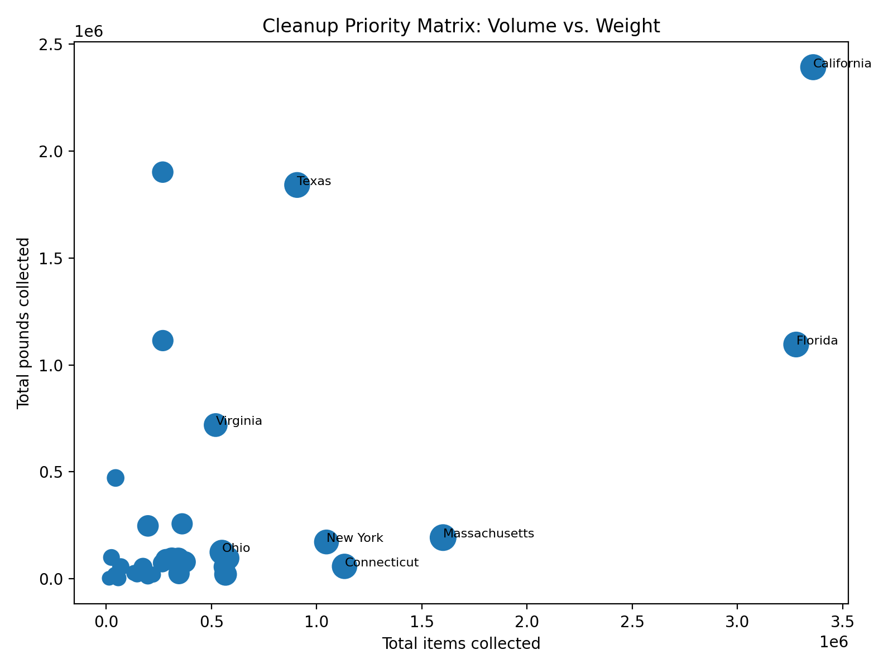
Figure 4. Priority matrix using volume and weight.

Top Priority States
State | Cleanups | Total Items | Total Pounds | Plastic Share | Items/Cleanup | Priority Score
Massachusetts, USA | 616 | 1,600,910 | 192,629 | 0.87 | 2,599 | 88.29
California, USA | 9,271 | 3,360,061 | 2,392,757 | 0.61 | 362.43 | 83.43
Texas, USA | 1,070 | 907,182 | 1,841,845 | 0.63 | 847.83 | 82.00
Florida, USA | 11,319 | 3,279,030 | 1,095,684 | 0.64 | 289.69 | 81.43
Connecticut, USA | 407 | 1,132,531 | 58,071 | 0.89 | 2,783 | 79.14
Ohio, USA | 499 | 550,020 | 124,325 | 0.73 | 1,102 | 75.71
New York, USA | 1,179 | 1,046,652 | 172,155 | 0.62 | 887.75 | 75.43
Virginia, USA | 1,068 | 520,057 | 718,983 | 0.59 | 486.94 | 68.86
Mississippi, USA | 51 | 576,448 | 96,357 | 0.54 | 11,303 | 68.29
Maryland, USA | 467 | 311,789 | 92,708 | 0.78 | 667.64 | 63.71

7. Machine Learning Model
The model predicts expected total items collected for a cleanup. This matters because the organization can estimate the operational load before assigning crews and equipment.

Model Performance Comparison
Model | MAE | RMSE | R2 Actual Scale | R2 Log Scale
Linear Regression | 6,470 | 439,968 | -13,323 | 0.26
Random Forest | 41.69 | 1,024 | 0.93 | 0.98

The Random Forest model is the practical choice for the pitch because cleanup outcomes are nonlinear. A cleanup in a high-volume state with many volunteers, many bags, and high plastic composition does not behave like a simple straight-line equation. Random Forest captures these interactions better than a basic linear model.

8. Business Recommendations

Recommendation 1: Use a Priority Score for Deployment
Rank regions weekly using total items, total pounds, plastic share, and items per cleanup. This prevents decision-making based only on intuition or last event visibility.

Recommendation 2: Separate Lightweight Plastic Hotspots from Heavy Waste Hotspots
California and Florida need frequent high-volume item collection, while Texas, Pennsylvania, Georgia, and Arizona require heavier logistics planning because weight is high.

Recommendation 3: Build Plastic-Specific Recycling Partnerships
States with high plastic share should have pre-arranged recycling and sorting partners so collected plastic does not become a post-cleanup bottleneck.

Recommendation 4: Use Predictive Planning Before Events
Before an event, predict expected item count and pounds using state, cleanup type, volunteers, miles, bags, and plastic profile. This improves staffing, bag supply, truck capacity, and sorting station planning.

Recommendation 5: Move Toward Real-Time Big Data Architecture
Use streaming ingestion and dashboards so cleanup leaders can monitor incoming records, update priority scores, and respond quickly to spikes in plastic loads.

9. Big Data Architecture
- Data Sources: cleanup mobile app, volunteer forms, smart bins, sensor feeds, partner CSV uploads, GPS data.
- Ingestion: Kafka, AWS Kinesis, or Azure Event Hubs for real-time events; batch ingestion for historical files.
- Storage: data lake for raw files and data warehouse for cleaned analytics tables.
- Processing: Spark or Databricks for large-scale cleaning, feature engineering, and aggregation.
- ML Layer: scheduled model training and real-time scoring API.
- Dashboard: Power BI, Tableau, or Streamlit dashboard with priority map, trend charts, and forecasted resource needs.
- Action Layer: automatic recommendations for crew allocation, truck capacity, sorting stations, and recycling partner coordination.

10. Pitch Narrative for the Company
The pitch to The Ocean Cleanup should be direct: this analysis does not replace cleanup technology; it makes cleanup technology smarter. The organization already has a mission and collection capability. What it needs is an intelligence layer that tells leaders where to act first, what resources to send, and how to prevent collected plastic from becoming a logistics problem.
By using cleanup history, plastic composition, and predictive modeling, The Ocean Cleanup can reduce wasted deployments, improve local partner coordination, and create a repeatable decision system for scaling cleanup operations across cities, rivers, and coastal zones.

11. Conclusion
The strongest solution is not only collecting more plastic. The stronger solution is collecting the right plastic, in the right location, with the right resource plan, before it reaches the ocean. The Ocean Cleanup Priority Intelligence System turns historical cleanup data into a real-time big data decision engine.

References
- The Ocean Cleanup. Official website and mission: https://theoceancleanup.com/
- The Ocean Cleanup. Rivers and Interceptor program: https://theoceancleanup.com/rivers/
- The Ocean Cleanup. River plastic pollution sources: https://theoceancleanup.com/sources/
- Provided class presentation: Ocean Plastics Pollution[1].pptx.
- Provided dataset: Data_Level5_BAH_OceanCleanup.csv.

Appendix A: Complete Python Code

# Ocean Cleanup Big Data Analysis - Python Code
# Author: Prepared for pitch-style business analysis

import pandas as pd
import numpy as np
import matplotlib.pyplot as plt

from sklearn.model_selection import train_test_split
from sklearn.compose import ColumnTransformer
from sklearn.preprocessing import OneHotEncoder, StandardScaler
from sklearn.pipeline import Pipeline
from sklearn.ensemble import RandomForestRegressor
from sklearn.metrics import mean_absolute_error, mean_squared_error, r2_score

# 1. Load data
df = pd.read_csv("Data_Level5_BAH_OceanCleanup.csv", low_memory=False)

# 2. Clean data
df["Cleanup Date"] = pd.to_datetime(df["Cleanup Date"], errors="coerce")

numeric_cols = ["Adults", "Children", "People", "Pounds", "Miles", "# of bags", "Total Items Collected"]
for col in numeric_cols:
df[col] = pd.to_numeric(df[col], errors="coerce")

df = df.dropna(subset=["State", "Country", "Cleanup Date", "Total Items Collected", "Pounds"])
df = df[(df["Total Items Collected"] >= 0) & (df["Pounds"] >= 0)]

# 3. Feature engineering
plastic_cols = [
"Food Wrappers (candy, chips, etc.)",
"Take Out/Away Containers (Plastic)",
"Bottle Caps (Plastic)",
"Lids (Plastic)",
"Straws, Stirrers",
"Forks, Knives, Spoons",
"Beverage Bottles (Plastic)",
"Grocery Bags (Plastic)",
"Other Plastic Bags",
"Cups, Plates (Plastic)",
"6-Pack Holders",
"Other Plastic/Foam Packaging",
"Other Plastic Bottles (oil, bleach, etc.)",
"Strapping Bands",
"Tobacco Packaging/Wrap",
"Balloons",
"Cigar Tips",
"Cigarette Lighters",
"Foam Pieces",
"Plastic Pieces"
]

for col in plastic_cols:
df[col] = pd.to_numeric(df[col], errors="coerce").fillna(0)

df["Year"] = df["Cleanup Date"].dt.year
df["Month"] = df["Cleanup Date"].dt.month
df["Plastic_Item_Total"] = df[plastic_cols].sum(axis=1)
df["Plastic_Share"] = df["Plastic_Item_Total"] / df["Total Items Collected"].replace({0: np.nan})
df["Items_per_cleanup"] = df["Total Items Collected"]
df["Items_per_person"] = df["Total Items Collected"] / df["People"].replace({0: np.nan})

# 4. State-level business summary
state_summary = df.groupby("State", as_index=False).agg(
cleanups=("Cleanup ID", "count"),
total_items=("Total Items Collected", "sum"),
total_pounds=("Pounds", "sum"),
total_plastic_items=("Plastic_Item_Total", "sum"),
total_people=("People", "sum"),
total_miles=("Miles", "sum")
)

state_summary["items_per_cleanup"] = state_summary["total_items"] / state_summary["cleanups"]
state_summary["pounds_per_cleanup"] = state_summary["total_pounds"] / state_summary["cleanups"]
state_summary["plastic_share_total"] = (
state_summary["total_plastic_items"] / state_summary["total_items"].replace({0: np.nan})
)

# 5. Priority scoring model
priority = state_summary[state_summary["cleanups"] >= 50].copy()

for col in ["total_items", "total_pounds", "plastic_share_total", "items_per_cleanup"]:
priority[col + "_rank"] = priority[col].rank(pct=True)

priority["Priority_Score"] = 100 * (
0.40 * priority["total_items_rank"] +
0.30 * priority["total_pounds_rank"] +
0.20 * priority["plastic_share_total_rank"] +
0.10 * priority["items_per_cleanup_rank"]
)

priority = priority.sort_values("Priority_Score", ascending=False)
print(priority[["State", "cleanups", "total_items", "total_pounds", "plastic_share_total", "Priority_Score"]].head(10))

# 6. Predictive model for cleanup volume
features = [
"State", "Cleanup Type", "Year", "Month", "People", "Miles", "# of bags",
"Plastic_Item_Total", "Plastic_Share"
] + plastic_cols[:10]

model_df = df[features + ["Total Items Collected"]].dropna()
X = model_df[features]
y = np.log1p(model_df["Total Items Collected"])

categorical_features = ["State", "Cleanup Type"]
numeric_features = [c for c in features if c not in categorical_features]

preprocess = ColumnTransformer(
transformers=[
("cat", OneHotEncoder(handle_unknown="ignore", min_frequency=20), categorical_features),
("num", StandardScaler(), numeric_features)
]
)

model = RandomForestRegressor(
n_estimators=80,
max_depth=16,
min_samples_leaf=5,
random_state=42,
n_jobs=-1
)

pipeline = Pipeline(steps=[
("preprocess", preprocess),
("model", model)
])

X_train, X_test, y_train, y_test = train_test_split(X, y, test_size=0.20, random_state=42)
pipeline.fit(X_train, y_train)

pred_log = pipeline.predict(X_test)
pred = np.expm1(pred_log)
actual = np.expm1(y_test)

mae = mean_absolute_error(actual, pred)
rmse = np.sqrt(mean_squared_error(actual, pred))
r2_actual = r2_score(actual, pred)
r2_log = r2_score(y_test, pred_log)

print("Model Performance")
print("MAE:", mae)
print("RMSE:", rmse)
print("R2 on actual scale:", r2_actual)
print("R2 on log scale:", r2_log)

# 7. Export results
priority.to_csv("ocean_cleanup_priority_scores.csv", index=False)
state_summary.to_csv("ocean_cleanup_state_summary.csv", index=False)

