**MIPS Processor Simulator**

**Overview**

This MIPS Processor is an application written in C++ that simulates the execution of MIPS assembly instructions using MARS compiler. This project provides features like fetching, decoding, execution, and memory access. It is designed to help users understand how MIPS architecture works.

**Features Included**

|  |  |
| --- | --- |
| **Features** | **Description** |
| Fetching | Reads instructions from memory and updates the PC. |
| Decoding | Decodes the fetched info. |
| Execution | Performs arithmetic and logical operations. |
| Memory | Supports load and store instructions. |
| Control Flow | Supports jump and branch |
| Register Operations | Implements register operations. |

**File Structure**

|  |  |
| --- | --- |
| **File** | **Purpose** |
| MIPS_Processor.cpp | Main source file |
| Factorial.asm | Contains assembly code of Factorial. |
| Fibonacci.asm | Contains assembly code of Fibonacci. |
| Power.asm | Contains assembly code of Power. |
| Factorial.txt | It has machine code of Factorial. |
| Fibonacci.txt | It has machine code of Fibonacci. |
| Power.txt | It has machine code of Power |
| Mars4_5 | Assembler |

**Instructions**

1. Extract the files out of the .zip file.
2. Make sure you have the necessary programs downloaded (Java, C++ compiler, etc.).
3. Open your required .asm file into the Mars4_5 assembler, execute using F3 and Save the machine code in binary text format to its corresponding .txt file.
4. Now you can copy and paste the corresponding binary code into the MIPS_Processor.cpp file into the "binarycode" string variable and make sure the binary code is in a single line.
5. Now you can input your necessary digits into the given variables:

* For Factorial: a = Any value, b = 1
* For Power: a= base, b = exponent, c=1
* For Fibonacci: a= Any value, b=1, c=0;

1. Now you can run the MIPS_Processor.cpp to get your expected result.

**Members**

|  |  |  |
| --- | --- | --- |
| **S No.** | **Name** | **Roll No.** |
| 1 | Polareddy Harshavardhan Reddy | BT2024064 |
| 2 | Nethi Vishwa Pradyumna | BT2024157 |
| 3 | Naga Rutwik Malapaka | BT2024091 |

**Github Link**

<https://github.com/HarshaVPolar/MIPS-project.git>

**Outputs / Results**

**1.Factorial**

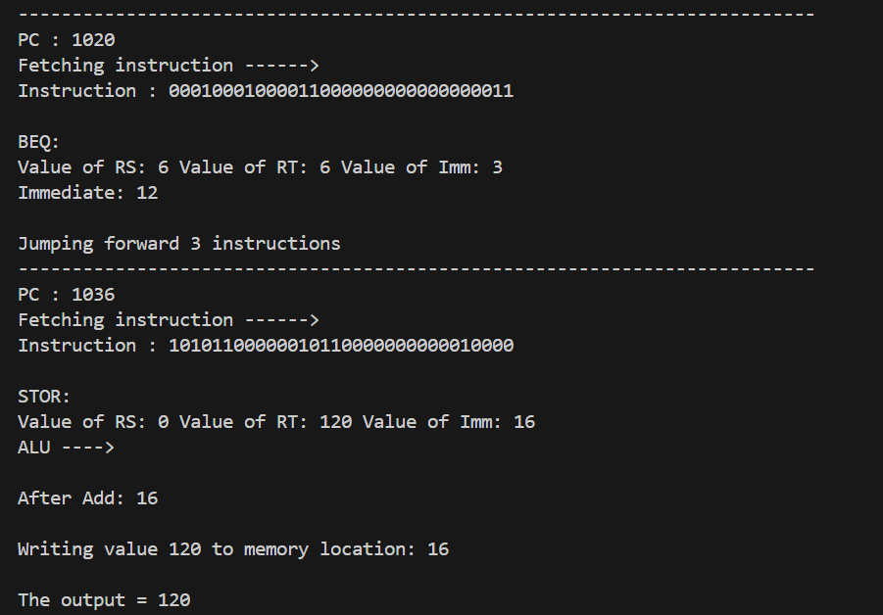

**2.Fibonacci**

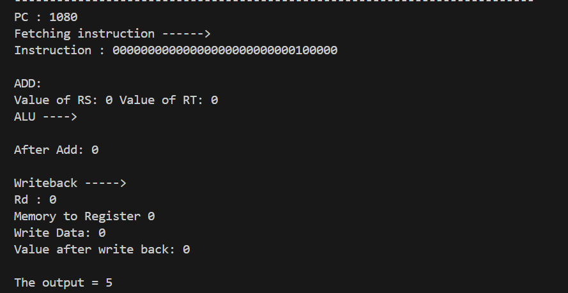

**3. Power**

