EE 657: PRML Course

IIT Guwahati

**Assignment 3**

(i) Otsu’s Image Segmentation

(ii) Multiple Discriminant Analysis for classifying

the face images

Name: P. Harsha Vardhan

Roll No.: 11010281

Branch: Electronics and Communication Engineering

Department: EEE

Email Id: [p.harshavardhan@iitg.ernet.in](mailto:p.harshavardhan@iitg.ernet.in)

*Note: This document contains results of Matlab Code of Assignment 2*

# *Otsu’s Image Segmentation*

**Otsu's method** is used to automatically perform clustering-based image thresholding, or, the reduction of a gray level image to a binary image. The algorithm assumes that the image to be thresholded contains two classes of pixels or bi-modal histogram (e.g.foreground and background) then calculates the optimum threshold separating those two classes so that their combined spread is minimal.

Result of Task1:

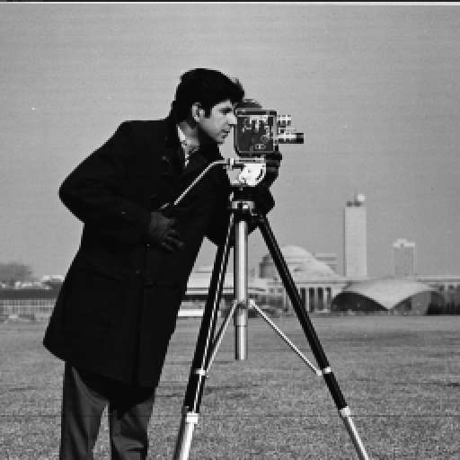

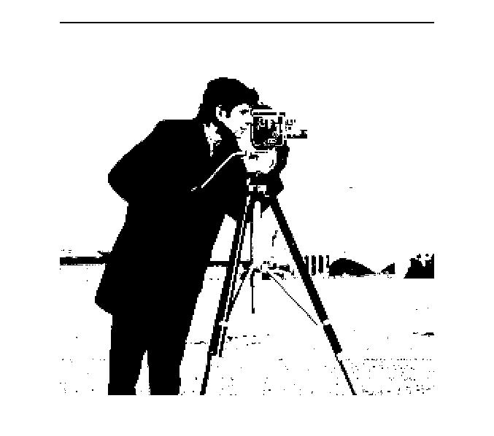

# *Fisher Linear Discriminant Analysis*

Results of Task 2:

3 nearest neighbour classfier accuracy for 10 dimensional space is 84.5%

3 nearest neighbour classfier accuracy for 25 dimensional space is 89.5%

3 nearest neighbour classfier accuracy for 39 dimensional space is 91%