Project- Build an app using R shiny to search for tweets on certain subject and then apply sentiment analysis on the tweets found

Link to the github repository-

Application description-

The app takes in the following inputs from the user-

1)Number of tweets to be displayed via a slider

2) The subject of the tweets via a textbox

The app gives the following outputs-

1)Table of tweets-Until the textbox is filled the app shows an error as no input has been given. Once a text is given it presents all the most recent number of tweets containing that text. The number of tweets is by default 100 but the user can change that.

2)Table of sentiments- The app also gives a table with each row representing the number of tweets which have a particular sentiment. These sentiments are –positive, negative, fear, anger, disgust, joy, anticipation, trust, sadness and surprise.

3) Sentiment chart- The table mentioned above is then made in the form of a graph, with each emotion being represented by a bar.

Run through of the app-

1. The initial screen when the app is run.

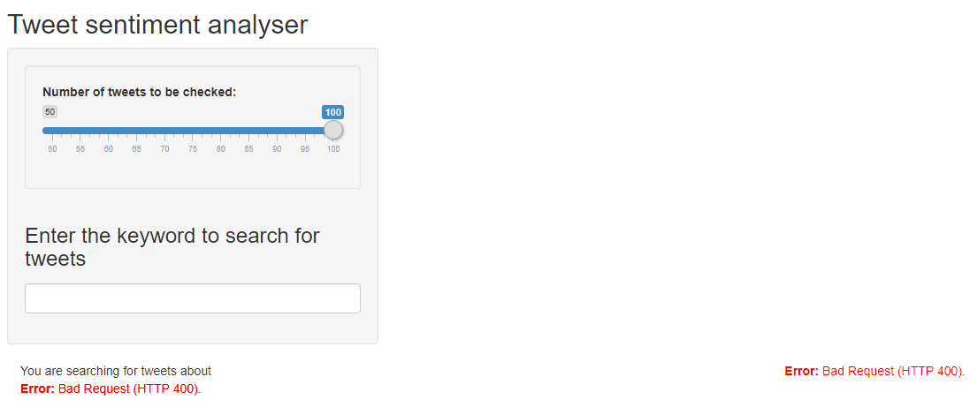

1. On entering some text into the search box, for example we can try – “real madrid”

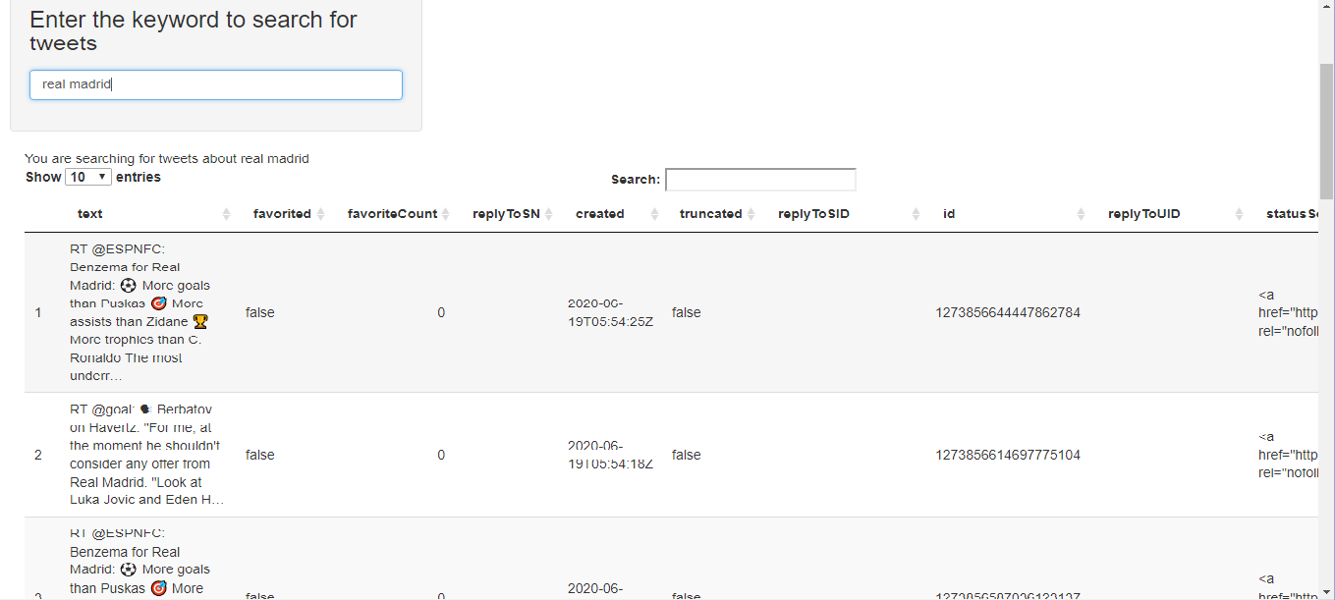

The number of entries can be varied based on the drop down box.

3)Beneath this we have the table of sentiments-

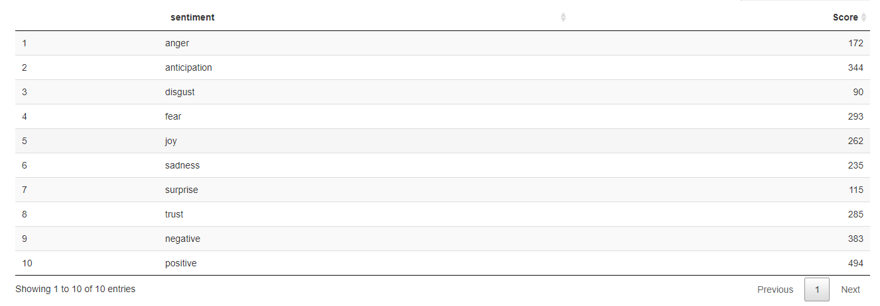

4)Beneath this we have the graph representing the above table.

Code structure-

First all the required libraries are called.

Then we have a function to create the table of sentiments,

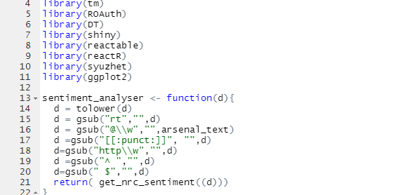

The function uses the function get_nrc_sentiment( ) which is part of the package syuzhet. The rest of the function is to clean each tweet by converting all the text to lower case, removing the “@” symbols and punctuations.

The next part of the code is the steps to get data from the twitter API.

In the UI part of the app, we have the code to present the inputslider, the text box and specifying where the outputs have to be.

In the server part, we have the code that gets tweets from twitter based on user inputs. The

Data received is converted from a list to a data frame.

We the have the code that calls the function to perform sentiment analysis and present the output in tabular and graphical form.

