CO3 Programs

1.Built in packages.

Datetime

import datetime

t=datetime.time(22,56,44)

print(t)

print("hour",t.hour)

print("minute",t.minute)

print("second",t.second)

print("microsecond",t.microsecond)

d=datetime.date.today()

print(d)

print("year",d.year)

print("month",d.month)

print("day",d.day)

d1=datetime.date.today()

print(d1)

td=datetime.timedelta(days=2)

print(td)

d2=d1+td

print(d2)

dt=datetime.datetime.combine(d,t)

print(dt)

Output

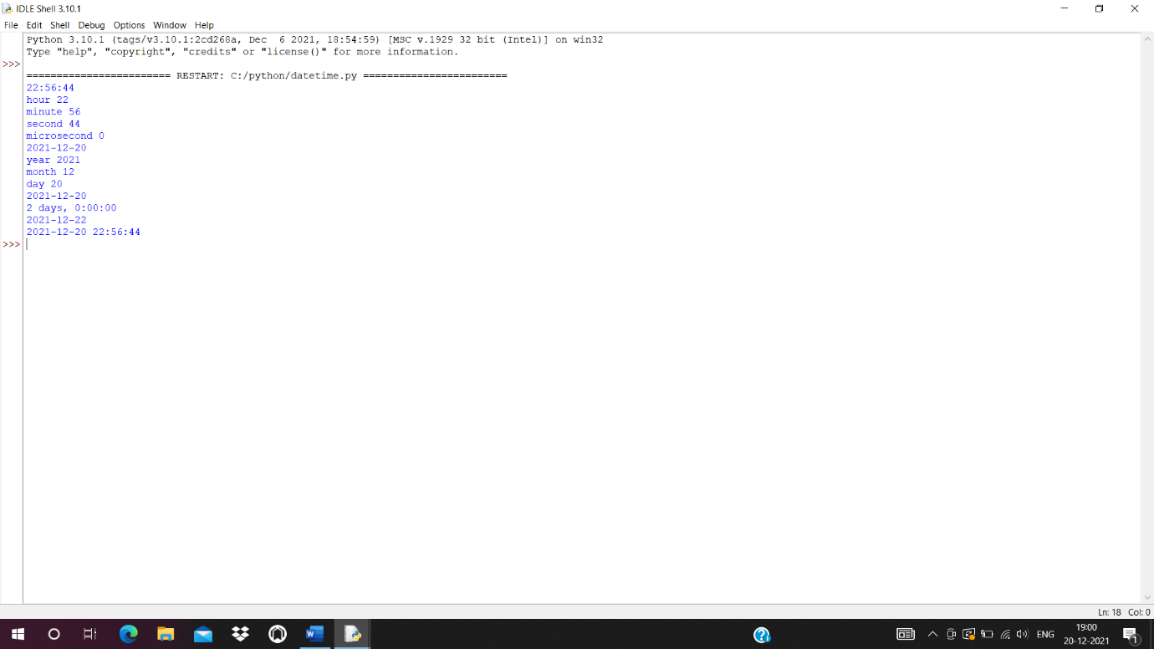

Calender

import calendar

mm=int(input("Enter month:"))

yy=int(input("Enter year:"))

print(calendar.month(yy,mm))

print(calendar.calendar(2015))

Output

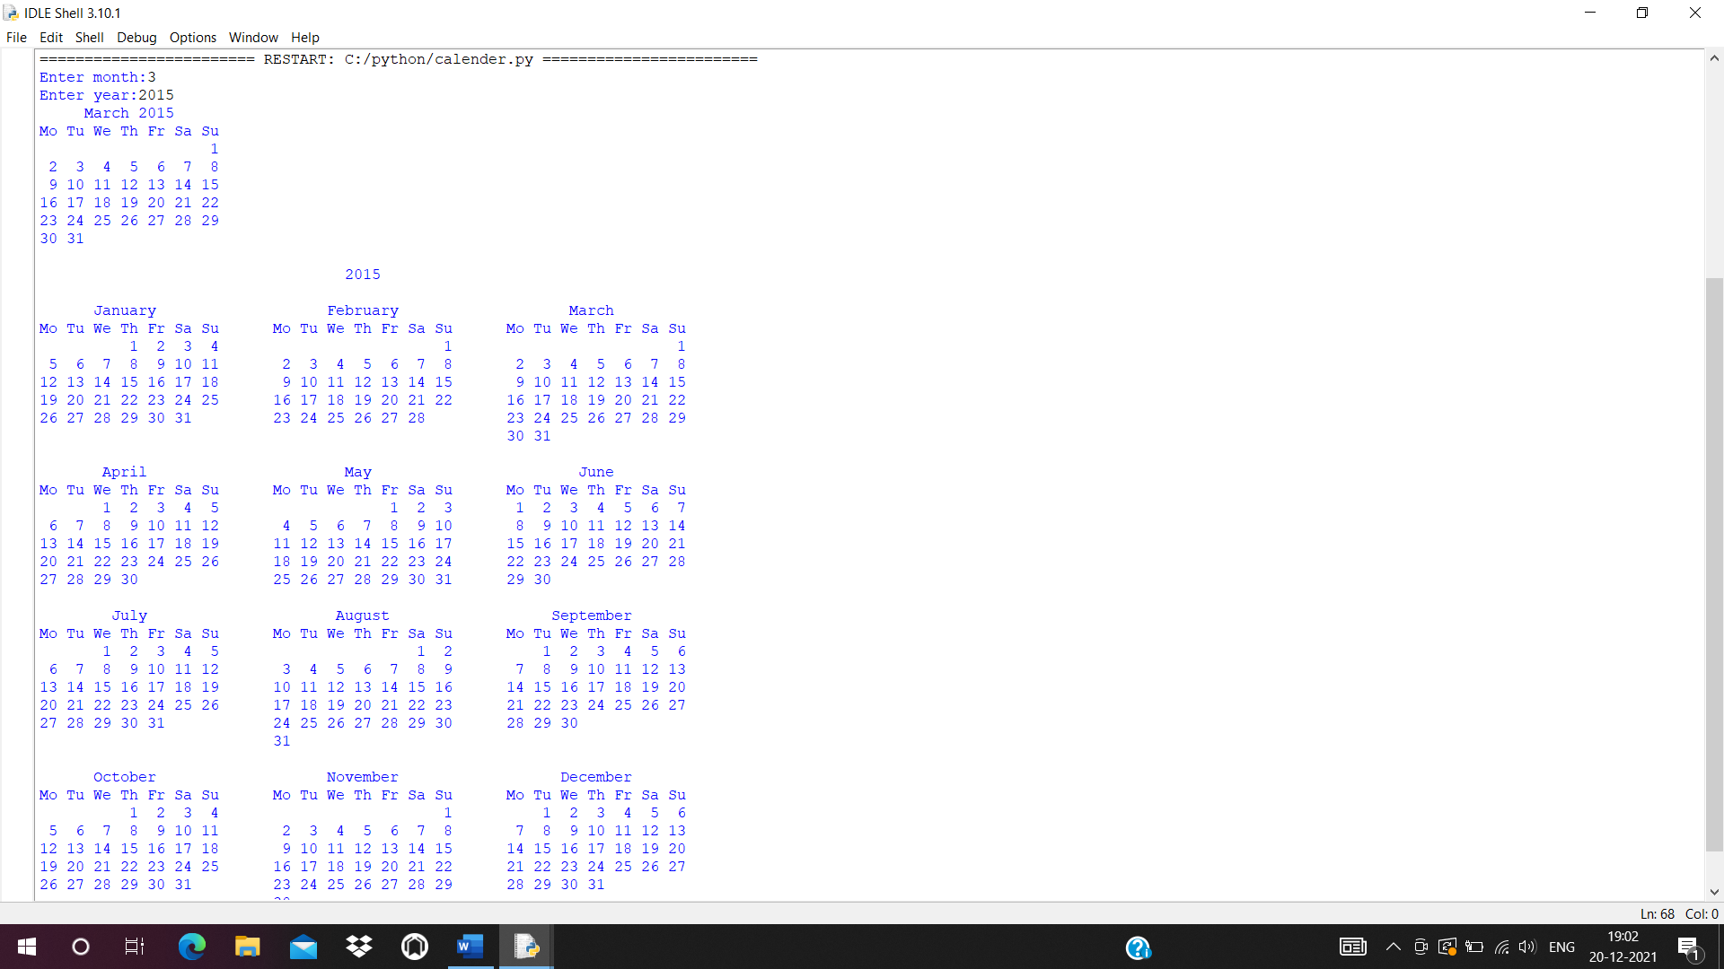

Math

import math

print(math.pi)

import math as m

print(m.pi)

from math import pi,sqrt

print(math.pi)

print(math.sqrt(4))

print(math.cos(90))

print(math.sin(1/2))

print(math.tan(0))

Output

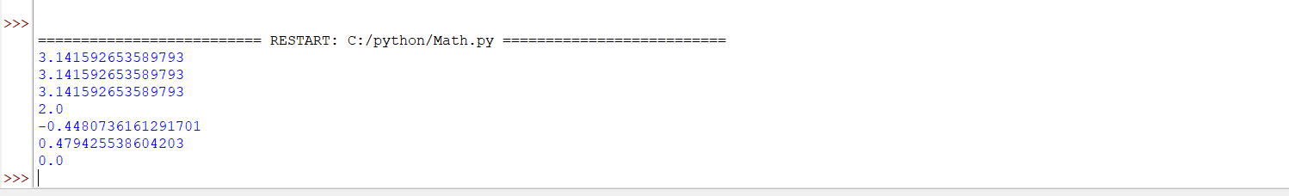

Time

import time

print("current time in sec:",time.time())

print("current time",time.ctime())

print("current time after 30 sec",time.ctime(time.time()+30))

t=time.localtime()

print("time",t)

print("current year",t.tm_year)

print("current month",t.tm_mon)

print("current day",t.tm_wday)

print("current hour",t.tm_hour)

print("current minitue",t.tm_min)

print("current second",t.tm_sec)

Output

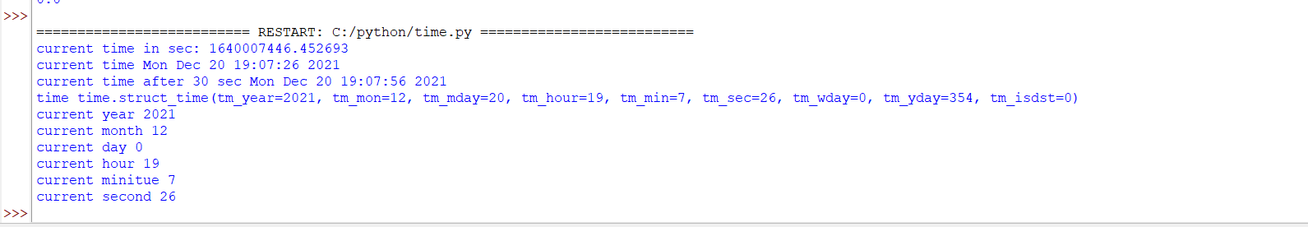

Statistics

import statistics

l=[4,6,8,9,3,4,5,7,8,7,0,7,3]

a=statistics.mean(l)

print(a)

b=statistics.median(l)

print(b)

c=statistics.mode(l)

print(c)

d=statistics.stdev(l)

print(d)

e=statistics.variance(l)

print(e)

Output

5.461538461538462

6

7

2.569545505058064

6.602564102564102

Random

import random

l1 = [5, 2, 7, 8, 14, 12]

print(random.choice(l1))

random.seed(4)

print(random.random())

print(random.random())

r1=random.randint(2,5)

print(r1)

Output

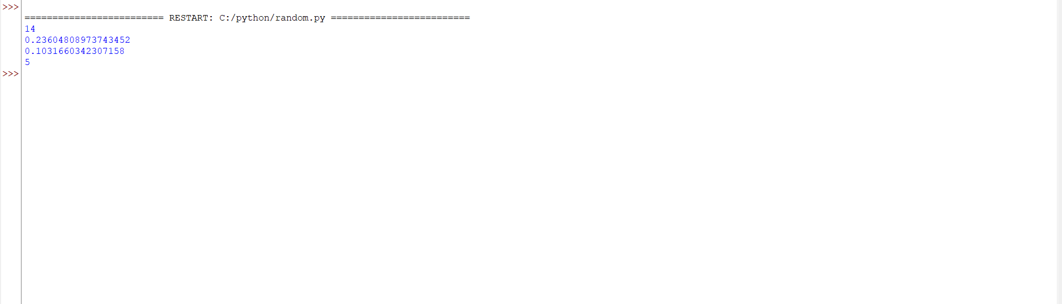

2.Create a package graphics with modules rectangle,circle.Include methods to finf area and perimeter of respective figures in each module.Write programs that find area and perimeter of figures by import statements.

Circle

def area(r):

print(3.14*r*r)

def perimeter(r):

print(2*3.14*r)

Rectangle

def area(x,y):

print(x*y )

def perimeter(x,y):

print(2*(x+y))

__init__

Graphics

from graphics import rectangle

from graphics import circle

print (rectangle)

rectangle.area(5,6)

rectangle.perimeter(8,2)

print(circle)

circle.area(4)

circle.perimeter(6)

Output

