**Topics: Descriptive Statistics and Probability**

1. **Look at the data given below. Plot the data, find the outliers and find out $μ, σ, σ^{2}$**

|  |  |
| --- | --- |
| **Name of company** | **Measure X** |
| Allied Signal | 24.23% |
| Bankers Trust | 25.53% |
| General Mills | 25.41% |
| ITT Industries | 24.14% |
| J.P.Morgan & Co. | 29.62% |
| Lehman Brothers | 28.25% |
| Marriott | 25.81% |
| MCI | 24.39% |
| Merrill Lynch | 40.26% |
| Microsoft | 32.95% |
| Morgan Stanley | 91.36% |
| Sun Microsystems | 25.99% |
| Travelers | 39.42% |
| US Airways | 26.71% |
| Warner-Lambert | 35.00% |

**Answer-**

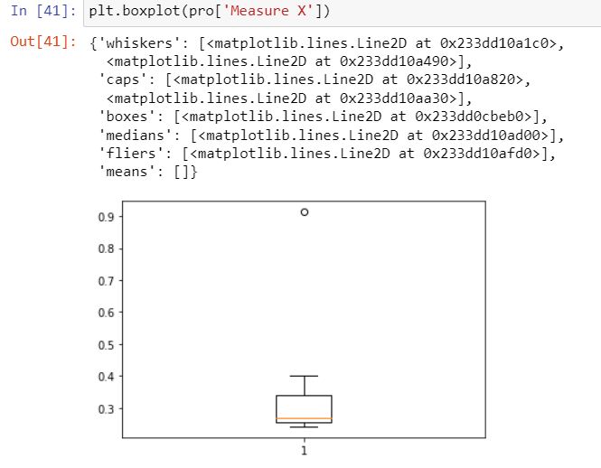

Mean- 0.332713

Standard deviation- 0.169454

Variances - 0.028715

1. **Answer the following three questions based on the box-plot above.**



1. **What is inter-quartile range of this dataset? (please approximate the numbers) In one line, explain what this value implies.**

**Answer-**

The range from 1 quartile to 3rd quartile in called inter-quartile range and 50% of data is lies on IQR

IQR= Q3-Q1=12-5=7

1. **What can we say about the skewness of this dataset?**

**Answer-**

Boxplot shows median is closer to the bottom of the box and whisker is shorter on the left end of the box, so the data is positively skewed or right skewed.

1. **If it was found that the data point with the value 25 is actually 2.5, how would the new box-plot be affected?**

**Answer-**

There will be no outlier found, if the data point with the value 25 is actually 2.5. Subsequently, quartile value of data set may be affect and mean, median needs to be calculated to see if there is any shift in data.

1. **Answer the following three questions based on the histogram above.**



1. **Where would the mode of this dataset lie?**

**Answer-**

The mode can lie between 3 and 10 because majority data points/entries we can see in this range. To pinpoint the actual Mode we have to analyze the data

1. **Comment on the skewness of the dataset.**

**Answer-**

Data distribution is on right side and we can see tail on right side so data is **positively skewed**.

1. **Suppose that the above histogram and the box-plot in question 2 are plotted for the same dataset. Explain how these graphs complement each other in providing information about any dataset.**

**Answer-**

If the above histogram and the box-plot is for the same dataset, there we can see both the plot having positive skewness and there is an outlier for the value 25.

1. **AT&T was running commercials in 1990 aimed at luring back customers who had switched to one of the other long-distance phone service providers. One such commercial shows a businessman trying to reach Phoenix and mistakenly getting Fiji, where a half-naked native on a beach responds incomprehensibly in Polynesian. When asked about this advertisement, AT&T admitted that the portrayed incident did not actually take place but added that this was an enactment of something that “could happen.” Suppose that one in 200 long-distance telephone calls is misdirected. What is the probability that at least one in five attempted telephone calls reaches the wrong number? (Assume independence of attempts.)**

**Answer-**

X = probability of 1 call misdirected out of 200

Probability of occurring of X = 1/200

P(X)= 1/200

Probability of having at least one successful call will be

1-P(X)= 1-1/200= 199/200= 0.967

As every event is independent of other event the probability will be

1- (0.967)^5

0.02475 = 2% chance.

probability that at least one in five attempted telephone calls reaches the wrong number is 2 %

1. **Returns on a certain business venture, to the nearest $1,000, are known to follow the following probability distribution**

|  |  |
| --- | --- |
| X | P(x) |
| -2,000 | 0.1 |
| -1,000 | 0.1 |
| 0 | 0.2 |
| 1000 | 0.2 |
| 2000 | 0.3 |
| 3000 | 0.1 |

1. **What is the most likely monetary outcome of the business venture**?

**Answer-**

For $2000 it has the highest probability of occurrence

1. **Is the venture likely to be successful? Explain**

**Answer-**

if Success == positive returns as a measure

Then there is a 60% probability that the venture would be successful (0.3+0.2+0.1=0.6=>0.6*100=>60%).

1. **What is the long-term average earning of business ventures of this kind? Explain**

**Answer-**

(-2000*0.1)+(-1000*0.1)+(0*0.2)+(1000*0.2)+(2000 *0.3)+(3000*0.1)=800

The long-term average earning for these type of ventures would be around $800

1. **What is the good measure of the risk involved in a venture of this kind? Compute this measure.**

**Answer-**

A good measure to evaluate the risk would be variance and standard deviation of the variable x.

variance = 3500000

S standard deviation = 1870.83

The large value of standard deviation of $1870 is considered along with the average returns of $800 indicates that this venture is highly risky.