**Topics: Normal distribution, Functions of Random Variables**

1. **The time required for servicing transmissions is normally distributed with *μ* = 45 minutes and *σ* = 8 minutes. The service manager plans to have work begin on the transmission of a customer’s car 10 minutes after the car is dropped off and the customer is told that the car will be ready within 1 hour from drop-off. What is the probability that the service manager cannot meet his commitment?**
2. 0.3875
3. **0.2676**
4. 0.5
5. 0.6987

**Answer- B. 0.2676**

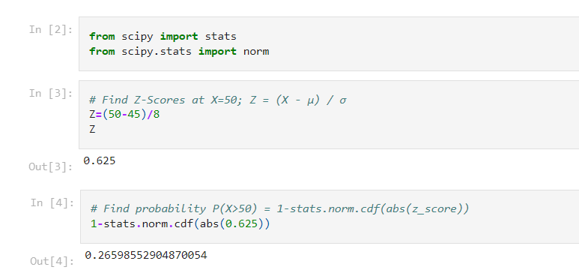

1. **The current age (in years) of 400 clerical employees at an insurance claims processing center is normally distributed with mean *μ* = 38 and Standard deviation *σ* =6. For each statement below, please specify True/False. If false, briefly explain why.**
2. **More employees at the processing center are older than 44 than between 38 and 44.**

**Answer- False.**

Mean = 38

SD = 6

Z score = (Value - Mean)/SD

Z score for 44 = (44 - 38)/6 = 1 => 84.13 %

=> People above 44 age = 100 - 84.13 = 15.87% ≈ 63    out of 400

Z score for 38 = (38 - 38)/6 = 0 => 50%

Hence People between 38 & 44 age = 84.13 - 50 = 34.13 % ≈ 137 out of 400

1. **A training program for employees under the age of 30 at the center would be expected to attract about 36 employees.**

**Answer- True.**

Z score for 30 = (30 - 38)/6 = -1.33 = 9.15% ≈ 36 out of 400

1. **If *X1* ~ *N*(μ, σ2) and *X*2 ~ *N*(μ, σ2) are *id* normal random variables, then what is the difference between 2 *X*1 and *X*1 + *X*2? Discuss both their distributions and parameters.**

**Answer-**

As we know that if X ∼ N(µ1, σ1^2 ), and Y ∼ N(µ2, σ2^2 ) are two independent random variables

then X + Y ∼ N(µ1 + µ2, σ1^2 + σ2^2 ) , and X − Y ∼ N(µ1 − µ2, σ1^2 + σ2^2 ) .

Similarly if Z = aX + bY , where X and Y are as defined above,

*i*.e Z is linear combination of X and Y, then Z ∼ N(aµ1 + bµ2, a^2σ1^2 + b^2σ2^2 ).

Therefore, 2X1~ N(2 u,4 σ^2) and

X1+X2 ~ N(µ + µ, σ^2 + σ^2 ) ~ N(2 u, 2σ^2 )

2X1-(X1+X2) = N( 4µ,6 σ^2)

This means that the sum of two or more independent normally distributed random variables is normal, i.e., Normally Distributed

1. **Let X ~ N(100, 202). Find two values, *a* and *b*, symmetric about the mean, such that the probability of the random variable taking a value between them is 0.99.**
2. 90.5, 105.9
3. 80.2, 119.8
4. 22, 78
5. **48.5, 151.5**
6. 90.1, 109.9

**Answer- D. 48.5, 151.5**

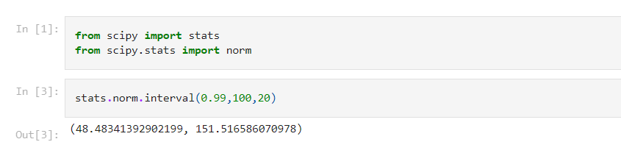

1. **Consider a company that has two different divisions. The annual profits from the two divisions are independent and have distributions Profit1 ~ N(5, 32) and Profit2 ~ N(7, 42) respectively. Both the profits are in $ Million. Answer the following questions about the total profit of the company in Rupees. Assume that $1 = Rs. 45**
2. **Specify a Rupee range (centered on the mean) such that it contains 95% probability for the annual profit of the company.**

**Answer-** Range is Rs (99.00810347848784, 980.9918965215122) in Millions

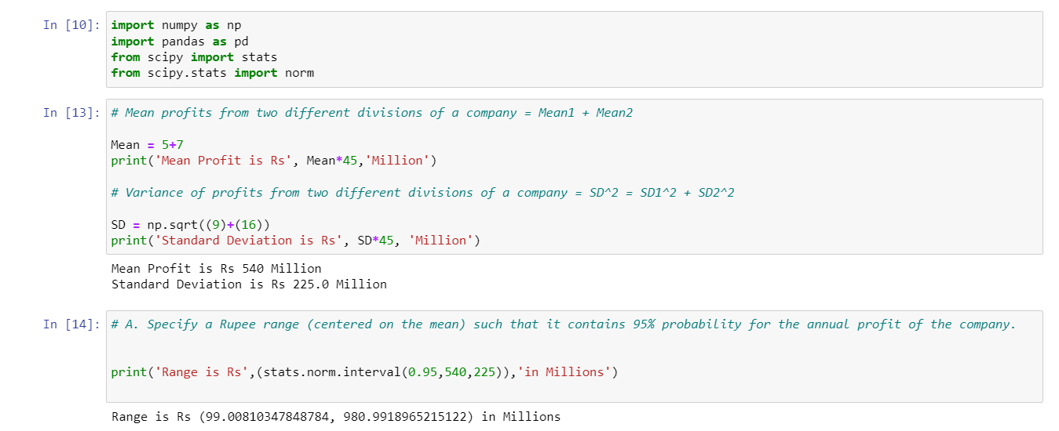

1. **Specify the 5th percentile of profit (in Rupees) for the company.**

**Answer-** 5th percentile of profit (in Million Rupees) is 170.0

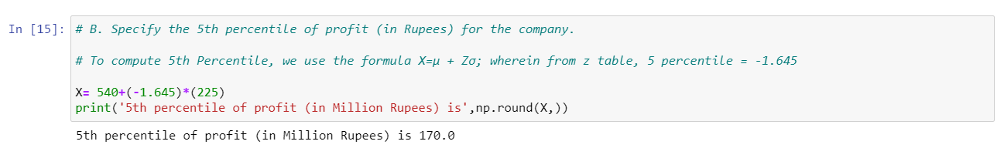

1. **Which of the two divisions has a larger probability of making a loss in a given year?**

**Answer-** larger probability of making a loss in a given year is division 2.

