SIMATS ENGINEERING
ASSESSMENT TOOL 1

COURSE NAME: MLA03
COURSE CODE: Reinforcement learning for Environment and Agent

COURSE OUTCOME COVERED

CO1: Analyze reinforcement learning frameworks and Markov Decision Process concepts to model decision-making problems. (BL2, BL3)

Assessment Tool Weightage: 40%

Dr. Dumpala Prasanth

QUESTIONS: 10 Total Marks: 50

Annexure A

Descriptive Experiment Exam Duration: 2hrs

Experiment 1: Installation of Reinforcement Learning Development Environment

Aim: To install and configure Anaconda Navigator, Python, TensorFlow, Keras, Gymnasium (OpenAI Gym), NumPy, Matplotlib, and other required libraries, and verify the environment by executing a simple Reinforcement Learning program.

Experiment 2: Familiarization with OpenAI Gym/Gymnasium Environments

Aim: To create, initialize, and interact with standard Reinforcement Learning environments such as FrozenLake, CartPole, and MountainCar using Gymnasium to understand the concepts of states, actions, rewards, and episodes.

Experiment 3: Implementation of the Reinforcement Learning Framework

Aim: To implement the basic Reinforcement Learning framework by designing an agent that interacts with an environment through states, actions, rewards, and policies using Python.

Experiment 4: Simulation of a Markov Decision Process (MDP)
Aim: To develop a simple Markov Decision Process model and simulate state transitions, reward functions, and policy execution for understanding sequential decision-making problems.

Experiment 5: Bellman Equation Demonstration

Aim: To implement Bellman Expectation and Bellman Optimality Equations for calculating state-value and action-value functions and analyze the convergence of value estimation.

Experiment 6: Exploration vs. Exploitation Strategies

Aim: To implement ε-Greedy, Greedy, and Random action-selection strategies and compare their performance in balancing exploration and exploitation during Reinforcement Learning.

Experiment 7: Multi-Armed Bandit Problem

Aim: To implement the Multi-Armed Bandit problem using ε-Greedy and Upper Confidence Bound (UCB) algorithms and evaluate cumulative rewards obtained by different action-selection methods.

Experiment 8: Reward Visualization in Reinforcement Learning

Aim: To simulate an RL agent in a simple environment and visualize cumulative rewards, episode rewards, and learning performance using Matplotlib graphs.

Experiment 9: TensorFlow and Keras-Based Neural Network for RL

Aim: To build a simple feed-forward neural network using TensorFlow and Keras for approximating value functions in Reinforcement Learning environments.

Experiment 10: Mini Reinforcement Learning Project Using CartPole

Aim: To develop a basic Reinforcement Learning agent using TensorFlow and Keras to solve the CartPole environment and evaluate its learning performance through episode rewards and success rate.

Code of Conduct:

I Ch. Harsha Chakravarthi (192425095) (Name / Reg No) certify that this submission is my original work and that I have adhered to the guidelines specified for this assessment.
I understand that any violation of academic integrity rules will result in disciplinary action.

Signature of the student:

Experiment 1: Installation of Reinforcement Learning Development Environment

Aim:
To install and configure Anaconda Navigator, Python, TensorFlow, Keras, Gymnasium (OpenAI Gym), NumPy, Matplotlib, and verify the environment by executing a simple Reinforcement Learning program.

Theory:
Reinforcement Learning (RL) is a machine learning technique in which an agent learns by interacting with an environment. Before implementing RL algorithms, the required software packages must be installed.

Requirements:
- Anaconda Navigator
- Python 3.x
- TensorFlow
- Keras
- Gymnasium
- NumPy
- Matplotlib

Installation Commands:
pip install tensorflow
pip install keras
pip install gymnasium
pip install numpy
pip install matplotlib

Result:
The Reinforcement Learning environment was successfully installed and verified.

Experiment 2: Familiarization with OpenAI Gym/Gymnasium Environments

Aim:
To create and interact with RL environments such as FrozenLake, CartPole, and MountainCar.

Theory:
Gymnasium provides standard environments for testing Reinforcement Learning algorithms.

Examples:
- FrozenLake – Grid navigation
- CartPole – Pole balancing
- MountainCar – Car reaches hilltop
Steps
- Import Gymnasium.
- Create environment.
- Reset environment.
- Perform actions.
- Observe rewards.

Result:
Successfully interacted with different Gymnasium environments and understood states, actions, rewards, and episodes.

Experiment 3: Implementation of the Reinforcement Learning Framework

Aim:
To implement the basic Reinforcement Learning framework.

Theory:
The RL framework consists of:
- Agent
- Environment
- State
- Action
- Reward
- Policy

Learning Process:
Environment → State
Agent → Action
Environment → Reward + Next State
Repeat until goal

Result:
Successfully implemented the basic Reinforcement Learning framework.

Experiment 4: Simulation of a Markov Decision Process (MDP)

Aim:
To simulate a Markov Decision Process.

Theory:
An MDP is represented by:
(S, A, P, R, γ)
Where
- S = States
- A = Actions
- P = Transition Probability
- R = Reward
- γ = Discount Factor
Applications:
- Robot navigation
- Chess
- Self-driving cars

Result:
Successfully simulated state transitions and reward functions using the MDP model.

Experiment 5: Bellman Equation Demonstration

Aim:
To implement Bellman Expectation and Bellman Optimality Equations.

Theory:
Bellman Expectation Equation
$$V\left(s\right)=R+γV\left(s^{'}\right)$$
Bellman Optimality Equation
$$V^{∗}\left(s\right)=\max_{a}\left[R+γV\left(s^{'}\right)\right]$$
Where
- V(s) = State value
- R = Reward
- γ = Discount factor

Advantages:
- Computes optimal policy
- Basis for Dynamic Programming
- Used in Q-Learning

Result:
Successfully demonstrated Bellman equations for value estimation.

Experiment 6: Exploration vs Exploitation Strategies

Aim:
To compare different action-selection strategies.

Theory:
Greedy
- Chooses best known action.
- No exploration.
Random
- Chooses actions randomly.
ε-Greedy
- Chooses best action with probability (1−ε).
- Chooses random action with probability ε.

Comparison:
Strategy | Exploration | Exploitation
Greedy | No | Yes
Random | Yes | No
ε-Greedy | Yes | Yes

Result:
Successfully compared exploration and exploitation strategies.
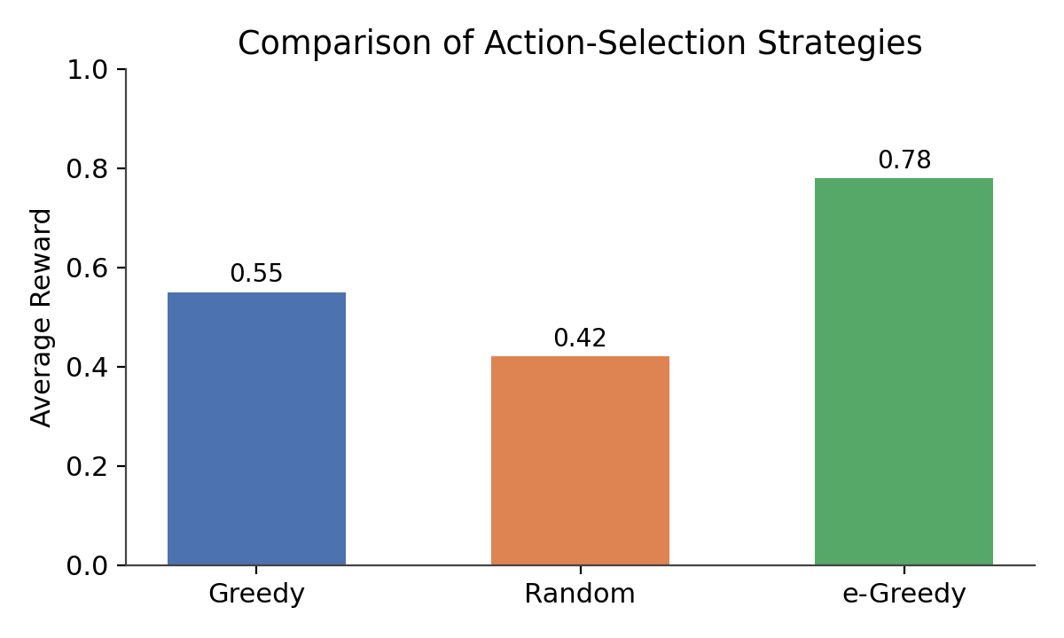

Experiment 7: Multi-Armed Bandit Problem

Aim:
To implement ε-Greedy and UCB algorithms.

Theory:
The Multi-Armed Bandit problem involves selecting the best slot machine to maximize reward.

Algorithms:
- ε-Greedy
- Upper Confidence Bound (UCB)

UCB Formula
$$UCB=Q\left(a\right)+\sqrt{\frac{2\ln{t}}{N\left(a\right)}}$$
Where
- Q(a) = Estimated reward
- t = Current step
- N(a) = Number of selections

Result:
Successfully evaluated cumulative rewards using ε-Greedy and UCB.
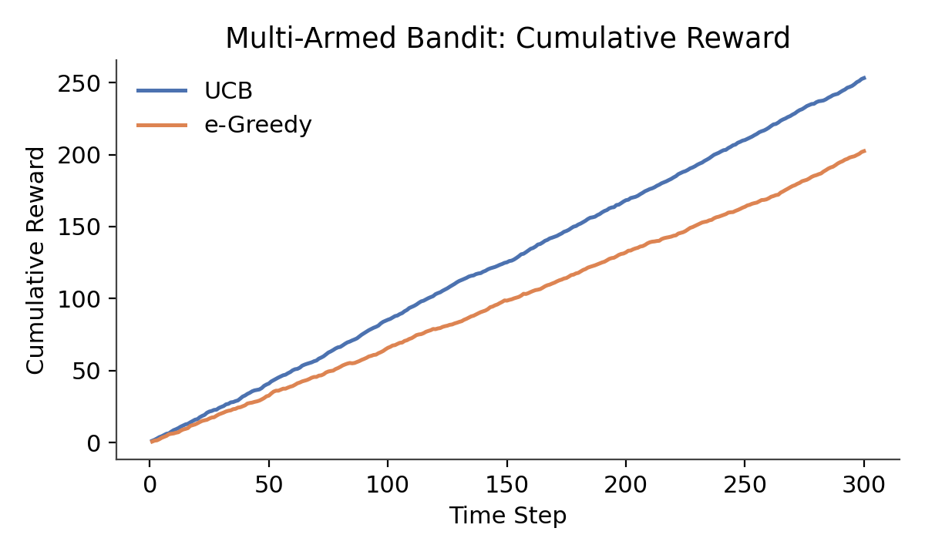

Experiment 8: Reward Visualization in Reinforcement Learning

Aim:
To visualize cumulative rewards and learning performance.

Theory:
Reward visualization helps evaluate the learning progress of an RL agent.

Graphs commonly used:
- Episode Reward
- Cumulative Reward
- Average Reward

Advantages:
- Easy performance analysis
- Detects convergence
- Compares algorithms

Result:
Successfully visualized reward trends using Matplotlib.
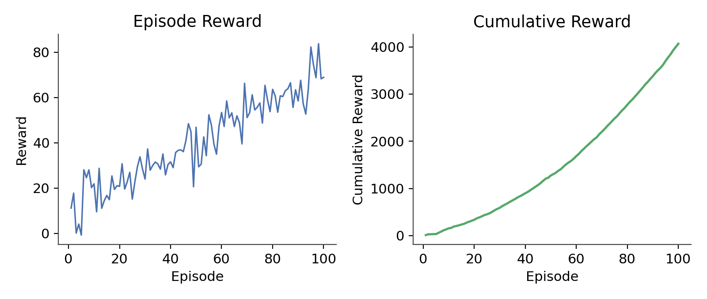

Experiment 9: TensorFlow and Keras-Based Neural Network for RL

Aim:
To build a feed-forward neural network for Reinforcement Learning.

Theory:
Neural Network Structure
Input Layer
↓
Hidden Layer
↓
Hidden Layer
↓
Output Layer

Applications:
- Deep Q-Network (DQN)
- Value Function Approximation
- Policy Learning
Advantages:
- Handles large state spaces
- Improves prediction accuracy
- Faster learning

Result:
Successfully built a simple neural network using TensorFlow and Keras.
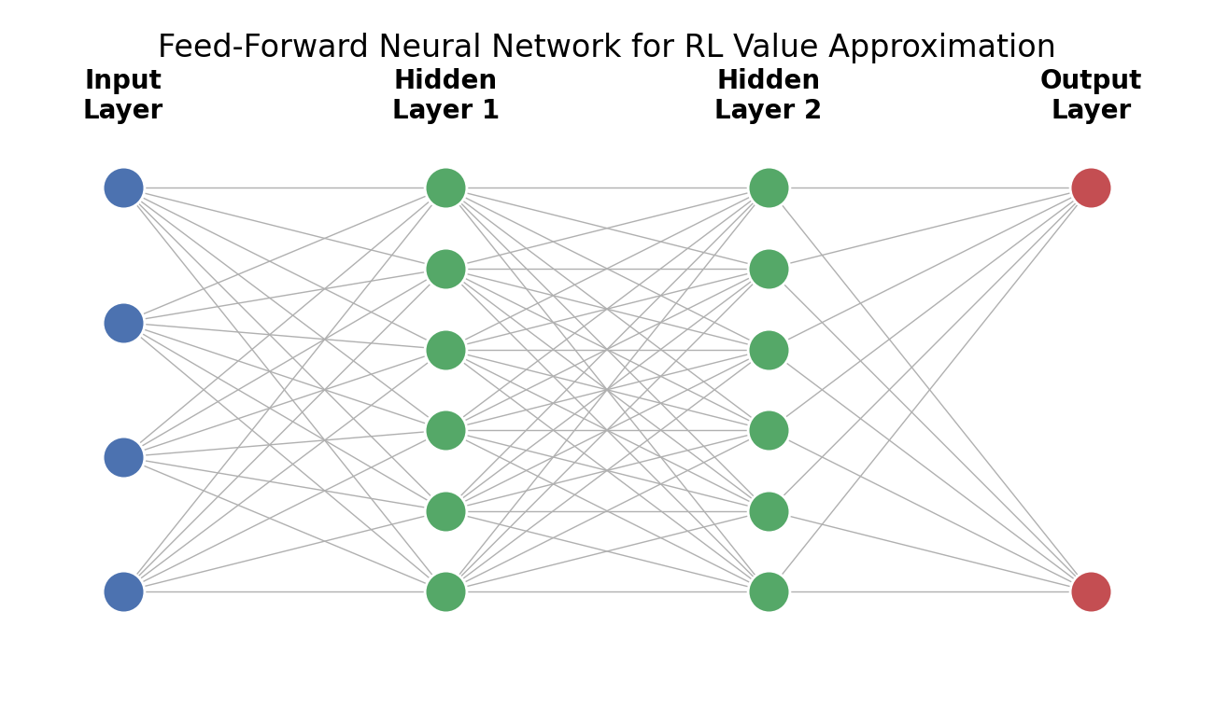

Experiment 10: Mini Reinforcement Learning Project Using CartPole

Aim:
To develop an RL agent for solving the CartPole environment.

Theory:
CartPole consists of:
- Pole
- Cart
- Left Action
- Right Action

Objective:
Balance the pole as long as possible.

Working:
- Observe state.
- Select action.
- Receive reward.
- Update policy.
- Repeat.

Performance Measures:
- Episode Reward
- Success Rate
- Average Reward

Result:
Successfully trained an RL agent for the CartPole environment and evaluated its performance.
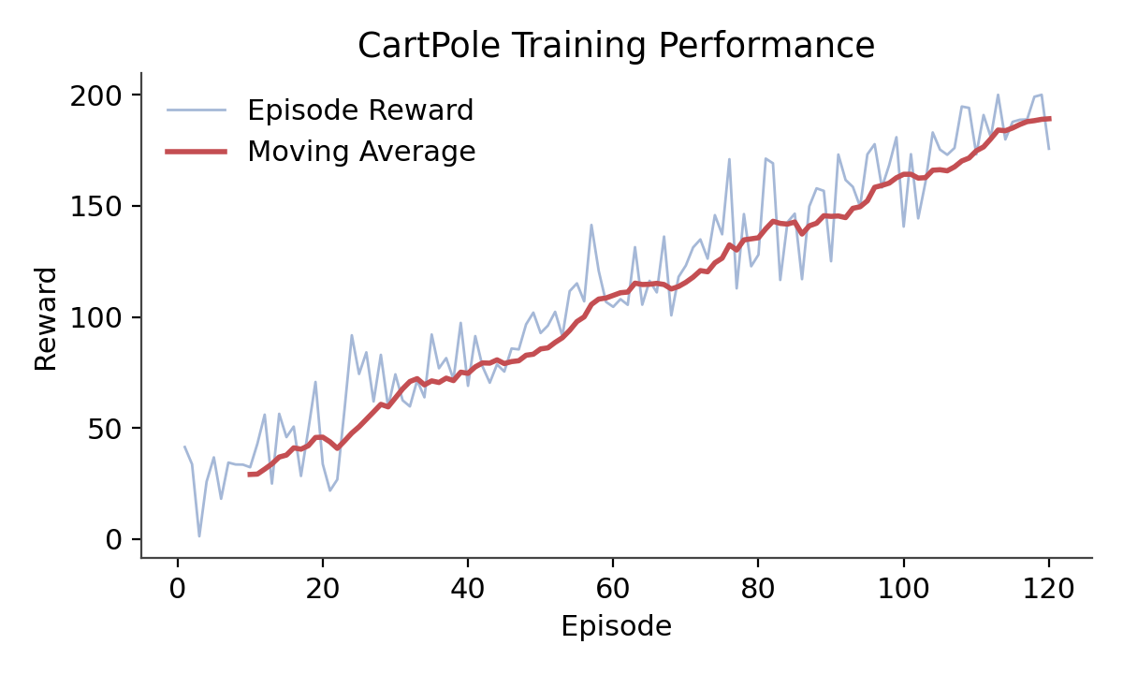

RUBRICS FOR CALCULATION

Criteria | Weightage | Level 4 – Exemplary | Level 3 – Proficient | Level 2 – Developing | Level 1 – Beginning
Understanding of Concepts | 25% | Demonstrates thorough, accurate understanding of concepts | Good understanding with minor gaps | Basic understanding with some misconceptions | Poor understanding; major misconceptions
Explanation | 25% | Detailed, well-explained answers with relevant examples | Clear explanation with adequate details | Limited explanation; lacks depth | Poor or unclear explanation
Application | 20% | Effectively applies concepts with strong analytical ability | Applies concepts with minor errors | Limited application with weak analysis | No application or incorrect analysis
Organization | 15% | Well-structured answers with logical flow and coherence | Organized with minor issues in flow | Basic structure, lacks clarity | Poor organization, incoherent answers
Accuracy | 10% | Completely accurate and covers all required points | Mostly accurate with minor omissions | Partially correct with missing points | Incorrect answers with major gaps
Clarity | 5% | Clear, neat, professional presentation | Understandable with minor issues | Limited clarity, readability issues | Poorly written, difficult to understand

