# INTRODUCTION:

Uber is a prominent Taxi Aggregator that caters to commuters needs. Commuters can use Uber app to request a taxi for their commute needs. With ever increasing smart phones, Uber has become a go to option for most of the travellers

# A BRIEF DESCRIPTION OF THE DATA USED:

We are having two data sets 1. dim city and 2. fact trip, in the fact table we can see 3 columns City_id, city name, country. And in the fact trip we have trip_uuid, datastr, product _type _name, city_id, driver_uuid, is_completed, ETA, ATA, UFF_fare, fare final this columns will provide all the data by using the this 2 data sets we can solve the customer requiements,and Uber provides services across lot of cities and there are various products catered to the traveller’s needs. Uber seeks our help to understand which of the products are profitable and how many times were they able to meet the ETA so they can fine tune the service offerings.

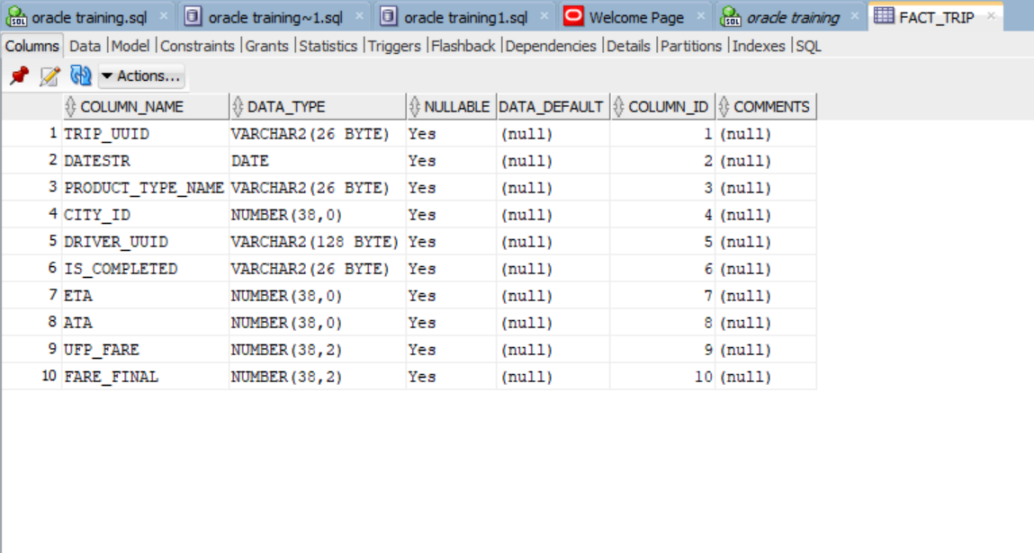

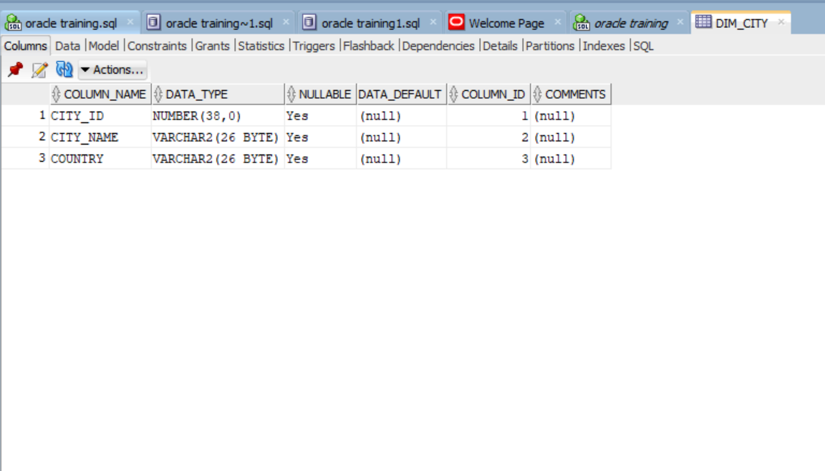

**Anomalies**:

In the given data set I didn’t get any anomalies.

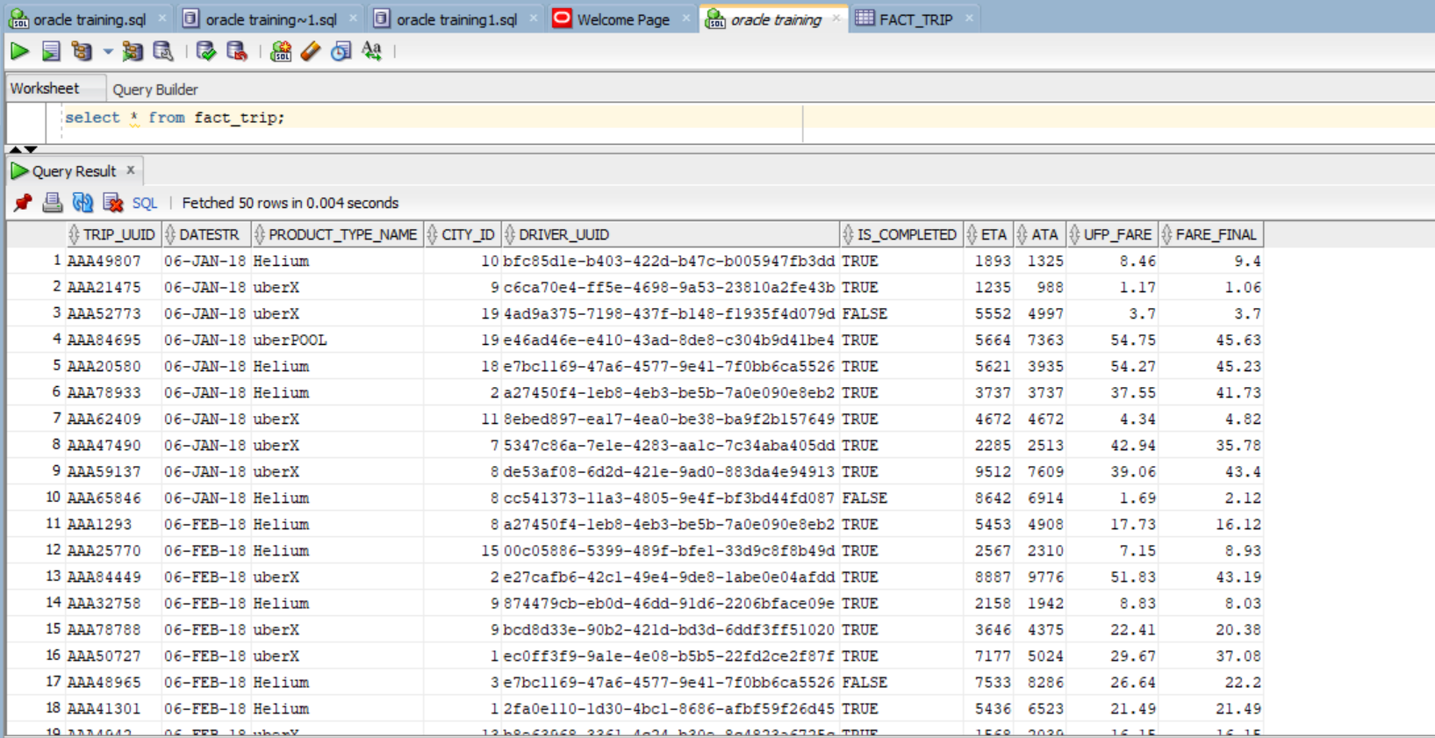

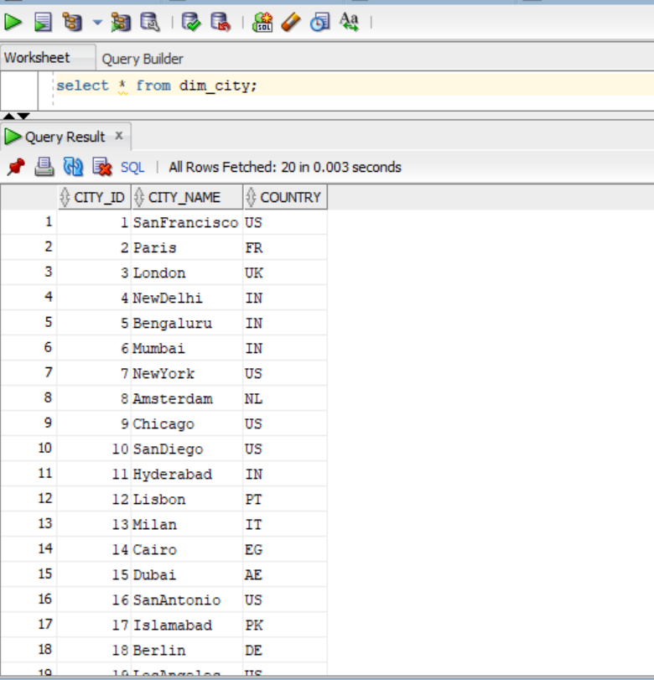

Query’s &outputs:

a. How many city_ids does uberPOOL operate in? select count(distinct(city_id))

from fact_trip

where product_type_name='uberPOOL';

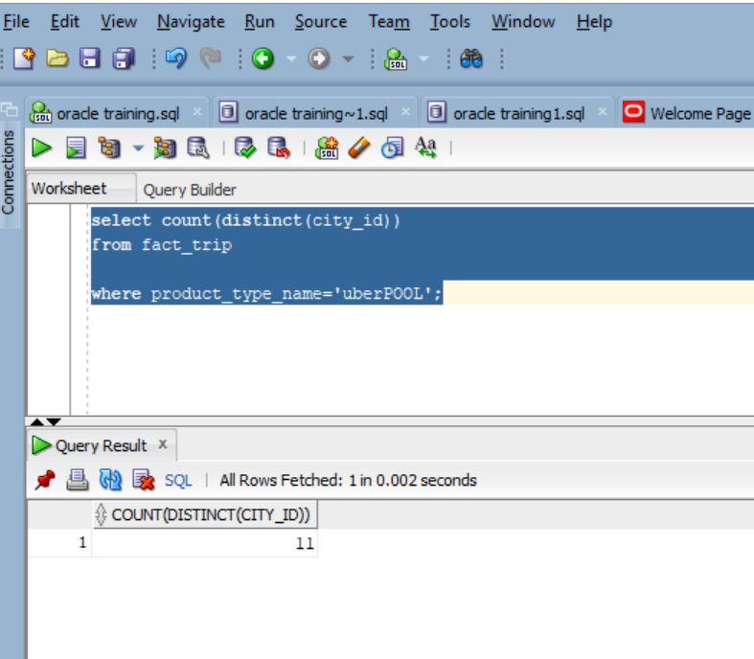

b.Which city_id has the highest error in ETA (where error in ETA = {(eta - ata)/ata}) for the given time period?

select * from(select city_id,(eta-ata)/ata as ETA from fact_trip

order by ETA desc)where rownum=1;

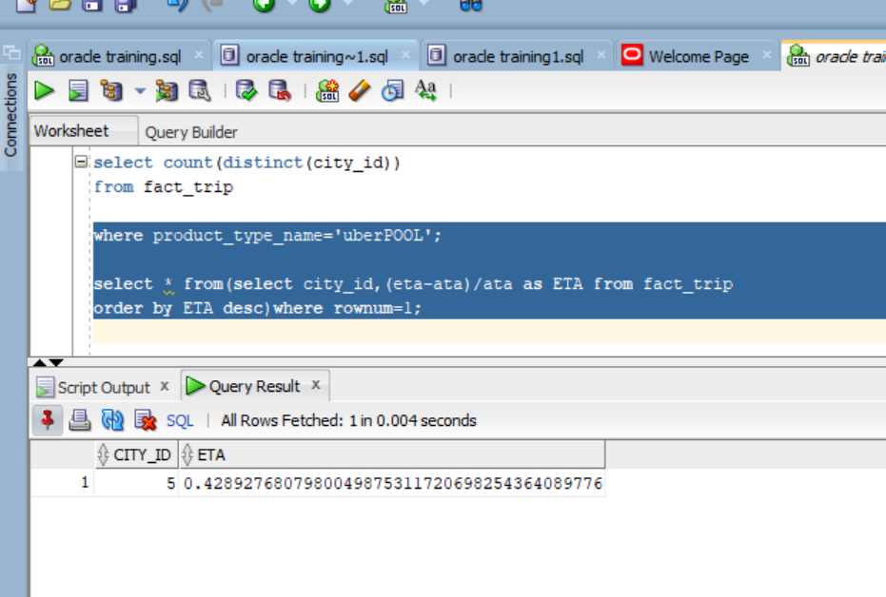

c.Which is the product type with highest total revenue in SanFrancisco?

select * from (SELECT * FROM

(select city_name, product_type_name, sum(fare_final) as Highest_total_revenue

from Fact_trip ftb inner join Dim_city dct on ftb.city_id = dct.city_id

WHERE city_name = 'SanFrancisco'

group by product_type_name,city_name)

order by Highest_total_revenue desc ) where rownum<=1;

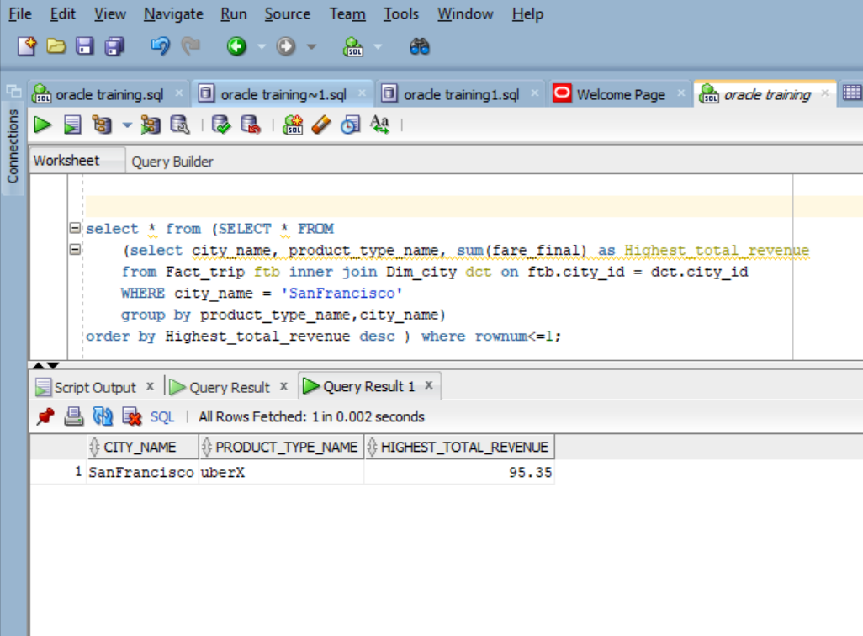

d.Which are the products in each city where total revenue(fare_final) > $1000?

select * from (select product_type_name,sum(fare_final) as total_rev from fact_trip

group by product_type_name) where total_rev>100;

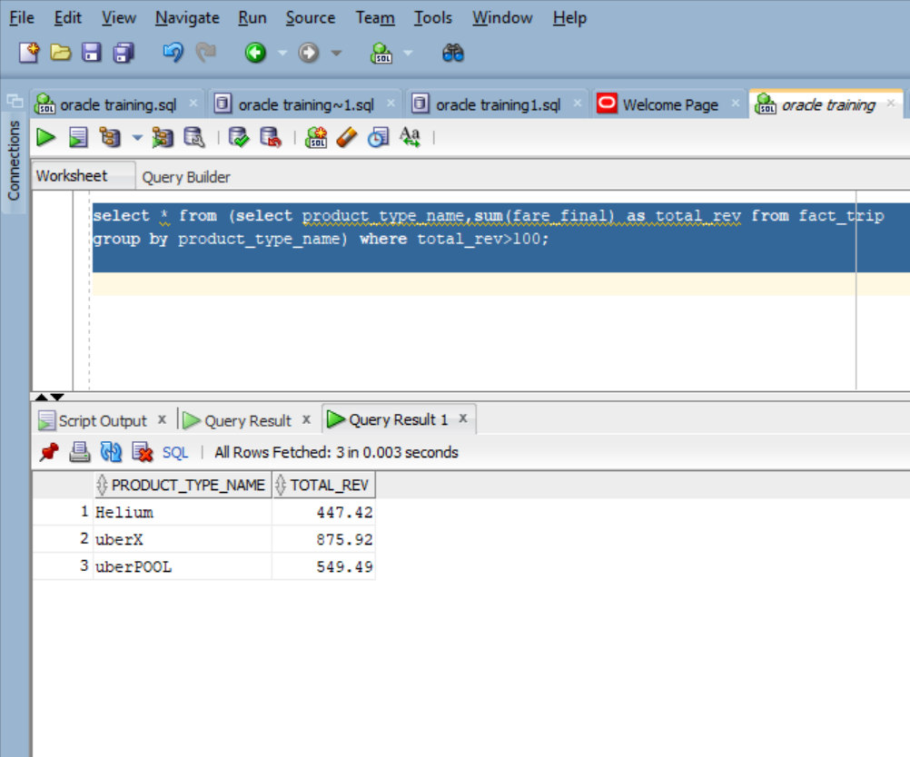

e.Get to 2nd highest country by Uber Revenue (fare_final) for 2nd week of June 2018 across product select country from dim_city where city_id in

(select city_id from

(select city_id,ROW_NUMBER() OVER(ORDER BY tot ) as ran from

(select city_id,sum(fare_final) as tot ,to_number(extract(day from(to_date(datestr, 'mm-dd-yyyy')))) as d from fact_trip

group by fare_final,city_id,datestr ) where d between 8 and 14 ) where ran=2) ;

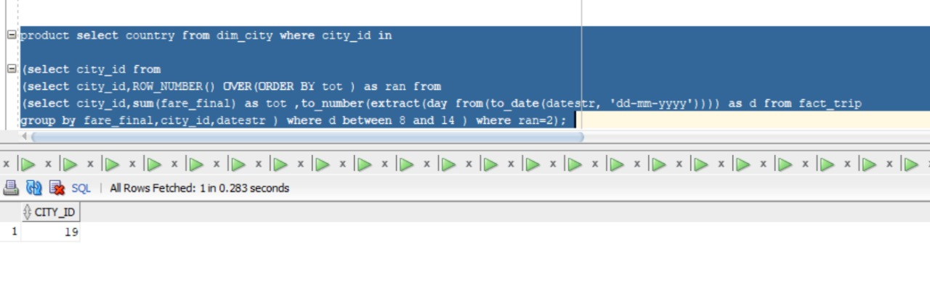

f.Get WOW growth % for US region for June Month. WOW- Week over week .

select

(((select sum(fare_final) from fact_trip where to_char(datestr, 'W')=1)

* (select sum(fare_final) from fact_trip where to_char(datestr, 'W')=2))

/ (select sum(fare_final) from fact_trip where to_char(datestr, 'W')=1)) * 100 as "Growth%" from fact_trip where to_char(datestr,'W')=2 group by to_char(datestr,'W');

