SUPERSTORE RETAIL STORE DATASET:
DESCRIPTIVE ANALYTICS CASE STUDY
A Comprehensive 50-Step Exploratory Data Analysis & Business Insights Report
Dataset Name: | Superstore Retail Store Dataset (train.csv)
Total Records & Schema: | 9,800 Transactions | 18 Initial Features
Analysis Type: | Descriptive Analytics (EDA, Univariate, Bivariate & Correlation Analysis)
Primary Objective: | Evaluate revenue drivers, customer behavior & regional sales dynamics

1. Executive Summary & Analytics Framework
Descriptive Analytics is the foundational phase of data science that inspects historical data to understand past trends, operational performance, and underlying data distributions. Unlike predictive modeling—which forecasts future outcomes using statistical or machine learning models—descriptive analytics focuses on quantitative summaries, data hygiene, univariate distributions, bivariate cross-tabulations, correlation matrices, and visual executive dashboards.
1.1 Types of Analysis & Capabilities Covered in this Case Study
This case study evaluates the Superstore dataset across 8 structured phases and 50 sequential steps:
• Problem Framing & Objective Definition (Steps 1–5): Establishing business scope, identifying target variables (Sales, Category, Segment, Region), and justifying descriptive evaluation over predictive modeling.
• Data Collection & Ingestion Audit (Steps 6–10): Loading transaction logs into Pandas DataFrames, inspecting dataset shape (9,800 rows × 18 columns), and verifying memory footprint.
• Initial Data Exploration & Schema Audit (Steps 11–18): Mapping data types, evaluating non-null counts, calculating summary statistics (mean, median, std dev), separating numeric vs categorical variables, and establishing a detailed data dictionary.
• Data Preprocessing & Data Hygiene (Steps 19–26): Identifying missing values (Postal Code: 11 missing records), mode imputation, duplicate row validation (0 duplicates), standardizing date formats, and feature engineering (Order_Year, Order_Month).
• Univariate Statistical Analysis (Steps 27–34): Analyzing single-variable distributions through categorical frequency counts, bar countplots, continuous revenue histograms, log-transformations for skewness remediation, and boxplots for outlier detection.
• Bivariate Relationship Analysis (Steps 35–42): Cross-segment aggregations, multi-dimensional bar plots (Category × Segment), category-level boxplots, yearly revenue trajectory trends (2015–2018), and numeric pairwise relationship matrices.
• Correlation & Feature Relationship Analysis (Steps 43–47): Computing Pearson correlation coefficient matrices, constructing heatmaps, evaluating linear dependencies among numerical features, and synthesizing top business insights.
• Executive Dashboard Synthesis (Steps 48–50): Aggregation of top metrics ($2.26M revenue, 9,800 orders, top category: Technology), multi-panel executive dashboard visual rendering.

2. Step-by-Step 50-Step Implementation & Technical Breakdown
Phase 1: Problem Definition (Steps 1–5)
Step 1: Identify and Import Superstore Store Dataset
Type of Analysis: Business Scope & Data Identification
# Step 1: Identify dataset source
file_path = 'train.csv'
print(f'Target dataset identified: {file_path}')

Output:
Target dataset identified: train.csv

📌 What is Obtained from Step 1:
• Identified target raw file 'train.csv' containing Superstore transaction records.
• Established local file path reference within the workspace environment.

Step 2: Understand the Business Problem
Type of Analysis: Problem Contextualization
A major US retail superstore requires an in-depth operational review of historical transactions to understand profitability drivers, product category demand, customer segment distribution, and shipping logistics efficiency.
📌 What is Obtained from Step 2:
• Framed core commercial problem around revenue performance, sales distribution, and customer purchasing behaviors across 4 US geographic regions.
• Identified business stakeholders (Retail Operations, Supply Chain, Executive Leadership).

Step 3: Define Analysis Objective
Type of Analysis: Goal Formulation
Perform comprehensive Descriptive Analytics to evaluate historical revenue distribution, volume across categories, customer segment performance, and shipping patterns without introducing black-box predictive modeling.
📌 What is Obtained from Step 3:
• Set project goal: Extract clear empirical findings and visualizations from historical sales data.
• Determined that statistical summaries and visual diagnostics are sufficient to guide management decisions.

Step 4: Identify Key Variables
Type of Analysis: Feature Selection & Variable Classification
Target key attributes: Sales (Continuous Target Variable), Category, Sub-Category, Segment, Ship Mode, Region, City, State, Order Date (Categorical & Temporal Drivers).
📌 What is Obtained from Step 4:
• Categorized 18 variables into continuous revenue metrics, geographic locators, temporal timestamps, and categorical hierarchies.
• Prioritized 'Sales' as the primary quantitative metric.

Step 5: Justify Descriptive Analysis over Prediction
Type of Analysis: Analytical Methodology Selection
Before attempting complex forecasting models, descriptive analytics is required to understand baseline performance, detect data anomalies, evaluate distribution skewness, and assess correlation structures.
📌 What is Obtained from Step 5:
• Avoided premature model complexity by prioritizing baseline data understanding.
• Ensured data quality and distribution traits are validated first.

Phase 2: Data Collection & Loading (Steps 6–10)
Step 6: Import Pandas Library
Type of Analysis: Data Wrangling Setup
import pandas as pd
print(f'Pandas version: {pd.__version__}')

Output:
Pandas version: 2.2.3

📌 What is Obtained from Step 6:
• Loaded Pandas module for DataFrame manipulation, indexing, and aggregation.
• Established core data manipulation environment.

Step 7: Import NumPy and Visualization Libraries
Type of Analysis: Visualization & Numerical Computation Setup
import numpy as np
import matplotlib.pyplot as plt
import seaborn as sns
%matplotlib inline
sns.set_theme(style="whitegrid", palette="muted")
plt.rcParams['figure.figsize'] = (10, 6)
plt.rcParams['font.size'] = 11
print("Libraries imported successfully!")

Output:
Libraries imported successfully!

📌 What is Obtained from Step 7:
• Configured Seaborn 'whitegrid' theme and Matplotlib inline rendering for publication-quality visual output.
• Set default chart size and typography parameters.

Step 8: Load train.csv using pd.read_csv()
Type of Analysis: Ingestion & DataFrame Instantiation
file_path = "train.csv"
df = pd.read_csv(file_path)
print("Superstore dataset loaded successfully!")

Output:
Superstore dataset loaded successfully!

📌 What is Obtained from Step 8:
• Successfully ingested 9,800 transaction records into memory as DataFrame 'df'.
• Validated file accessibility and readability.

Step 9: Display First 5 Records using head()
Type of Analysis: Preliminary Schema & Data Inspection
df.head()

Output:
Row ID Order ID Order Date Ship Date Ship Mode Customer ID Customer Name Segment Country City State Postal Code Region Product ID Category Sub-Category Product Name Sales
1 CA-2016-152156 08/11/2016 11/11/2016 Second Class CG-12520 Claire Gute Consumer United States Henderson Kentucky 42420.0 South FUR-BO-10001798 Furniture Bookcases Bush Somerset Collection Bookcase 261.96
2 CA-2016-152156 08/11/2016 11/11/2016 Second Class CG-12520 Claire Gute Consumer United States Henderson Kentucky 42420.0 South FUR-CH-10000454 Furniture Chairs line Hon Deluxe Fabric High-Back Back Height Executive... 731.94
3 CA-2016-138688 12/06/2016 16/06/2016 Second Class DV-13045 Darrin Van Huff Corporate United States Los Angeles California 90036.0 West OFF-LA-10000240 Office Supplies labels Self-Adhesive Address Labels for Typewriters 14.62
4 US-2015-108966 11/10/2015 18/10/2015Standard Class SO-20335 Sean O'Donnell Consumer United States Fort Lauderdale Florida 33311.0 South FUR-TA-10000577 Furniture Tables Bretford CR4500 Series Slim Rectangular Table 957.57
5 US-2015-108966 11/10/2015 18/10/2015Standard Class SO-20335 Sean O'Donnell Consumer United States Fort Lauderdale Florida 33311.0 South OFF-ST-10000760 Office Supplies Storage Eldon Fold 'N Roll Cart System 22.368

📌 What is Obtained from Step 9:
• Inspected tabular structure: verified presence of transaction attributes, product taxonomy, and monetary sales figures.
• Observed date strings formatted as DD/MM/YYYY.

Step 10: Check Dataset Shape
Type of Analysis: Dataset Dimension Evaluation
rows, cols = df.shape
print(f"Dataset Shape: {rows:,} Rows and {cols} Columns")

Output:
Dataset Shape: 9,800 Rows and 18 Columns

📌 What is Obtained from Step 10:
• Confirmed dataset dimensions: exactly 9,800 individual retail transactions across 18 unique feature columns.
• Ensured sample size is statistically robust for descriptive breakdowns.

Phase 3: Initial Data Exploration (Steps 11–18)
Step 11: Display All Column Names
Type of Analysis: Feature Inventory Audit
print("Column Names:")
for i, col in enumerate(df.columns, 1):
print(f"{i}. {col}")

Output:
Column Names:
1. Row ID
2. Order ID
3. Order Date
4. Ship Date
5. Ship Mode
6. Customer ID
7. Customer Name
8. Segment
9. Country
10. City
11. State
12. Postal Code
13. Region
14. Product ID
15. Category
16. Sub-Category
17. Product Name
18. Sales

📌 What is Obtained from Step 11:
• Listed all 18 feature labels, confirming feature availability for customer, spatial, temporal, product, and financial dimensions.

Step 12: Check Data Types and Dataset Information
Type of Analysis: Data Type & Memory Audit
df.info()

Output:
<class 'pandas.DataFrame'>
RangeIndex: 9800 entries, 0 to 9799
Data columns (total 18 columns):
# Column Non-Null Count Dtype
--- ------ -------------- -----
0 Row ID 9800 non-null int64
1 Order ID 9800 non-null object
2 Order Date 9800 non-null object
3 Ship Date 9800 non-null object
4 Ship Mode 9800 non-null object
5 Customer ID 9800 non-null object
6 Customer Name 9800 non-null object
7 Segment 9800 non-null object
8 Country 9800 non-null object
9 City 9800 non-null object
10 State 9800 non-null object
11 Postal Code 9789 non-null float64
12 Region 9800 non-null object
13 Product ID 9800 non-null object
14 Category 9800 non-null object
15 Sub-Category 9800 non-null object
16 Product Name 9800 non-null object
17 Sales 9800 non-null float64
dtypes: float64(2), int64(1), object(15)
memory usage: 1.3+ MB

📌 What is Obtained from Step 12:
• Identified 15 string/object columns, 2 float columns, and 1 int column.
• Discovered missing values in 'Postal Code' (9,789 non-null out of 9,800).
• Noted that 'Order Date' and 'Ship Date' require conversion from object to datetime.

Step 13: Generate Statistical Summary using describe()
Type of Analysis: Descriptive Central Tendency & Dispersion
df.describe().T

Output:
count mean std min 25% 50% 75% max
Row ID 9800.0 4900.500000 2829.157118 1.00 2450.75 4900.50 7350.25 9800.00
Postal Code 9789.0 55273.322403 32501.841500 1040.00 23223.00 56431.00 90008.00 99301.00
Sales 9800.0 230.769059 626.651874 0.444 17.28 54.49 210.60 22638.48

📌 What is Obtained from Step 13:
• Sales Summary: Mean sale = $230.77, Median sale = $54.49, Min = $0.44, Max = $22,638.48, Std Dev = $626.65.
• Revealed strong positive skewness in Sales: Mean ($230.77) is dramatically higher than Median ($54.49), indicating high-value outlier transactions.

Step 14: Count Total Records / Transactions
Type of Analysis: Record Volume Counting
total_records = len(df)
print(f"Total Transactions: {total_records:,}")

Output:
Total Transactions: 9,800

📌 What is Obtained from Step 14:
• Confirmed total transaction count of 9,800 log records.

Step 15: Count Numerical Columns
Type of Analysis: Quantitative Attribute Isolation
num_cols = df.select_dtypes(include=[np.number]).columns.tolist()
print(f"Numerical Columns ({len(num_cols)}): {num_cols}")

Output:
Numerical Columns (3): ['Row ID', 'Postal Code', 'Sales']

📌 What is Obtained from Step 15:
• Isolated 3 numerical attributes. Noted that 'Row ID' is an index marker and 'Postal Code' is a spatial identifier, leaving 'Sales' as the primary numeric metric.

Step 16: Count Categorical Columns
Type of Analysis: Qualitative Feature Isolation
cat_cols = df.select_dtypes(include=['object', 'category']).columns.tolist()
print(f"Categorical Columns ({len(cat_cols)}): {cat_cols}")

Output:
Categorical Columns (15): ['Order ID', 'Order Date', 'Ship Date', 'Ship Mode', 'Customer ID', 'Customer Name', 'Segment', 'Country', 'City', 'State', 'Region', 'Product ID', 'Category', 'Sub-Category', 'Product Name']

📌 What is Obtained from Step 16:
• Identified 15 categorical features governing customer attributes, order codes, dates, geography, and product taxonomy.

Step 17: View Last 5 Records using tail()
Type of Analysis: Data Boundary Inspection
df.tail()

Output:
Row ID Order ID Order Date Ship Date Ship Mode Customer ID Customer Name Segment Country City State Postal Code Region Product ID Category Sub-Category Product Name Sales
9796 CA-2016-125920 21/05/2016 28/05/2016 Standard Class SH-19975 Sally Hugheby Corporate United States001 Chicago Illinois 60610.0Central OFF-BI-10003429 Office Supplies Binders Cardinal Hold-it Line Binders 3.798
9797 CA-2016-128608 12/01/2016 17/01/2016 Standard Class CS-12490 Cindy Schnelling Corporate United States Toledo Ohio 43615.0Central OFF-AR-10001374 Office Supplies Art Boston Pencil Sharpener 10.368
9798 CA-2016-128608 12/01/2016 17/01/2016 Standard Class CS-12490 Cindy Schnelling Corporate United States Toledo Ohio 43615.0Central TEC-PH-10004977 Technology Phones Nortel Meridian IP Phone 235.188
9799 CA-2016-128608 12/01/2016 17/01/2016 Standard Class CS-12490 Cindy Schnelling Corporate United States Toledo Ohio 43615.0Central TEC-PH-10000912 Technology Phones Logitech 910-002974 Mouse 26.376

📌 What is Obtained from Step 17:
• Verified indexing alignment up to Row ID 9800.
• Confirmed dataset consistency across boundary ends.

Step 18: Construct Detailed Data Dictionary
Type of Analysis: Metadata Standardization
Established complete attribute descriptions for all 18 columns, specifying data types, domain categories, and business definitions.
📌 What is Obtained from Step 18:
• Created standardized reference mapping for downstream team analysis and reporting.

Phase 4: Data Cleaning & Hygiene (Steps 19–26)
Step 19: Check Missing Values Overview
Type of Analysis: Data Completeness Audit
missing_df = pd.DataFrame({
'Missing Count': df.isnull().sum(),
'Percentage (%)': (df.isnull().sum() / len(df)) * 100
})
print(missing_df[missing_df['Missing Count'] > 0])

Output:
Missing Count Percentage (%)
Postal Code 11 0.112245

📌 What is Obtained from Step 19:
• Discovered exactly 11 missing values in 'Postal Code' (0.11% of dataset). All other 17 features are 100% complete.

Step 20: Count Total Missing Values
Type of Analysis: Aggregate Null Quantification
print('Total Missing Values:', df.isnull().sum().sum())

Output:
Total Missing Values: 11

📌 What is Obtained from Step 20:
• Confirmed total dataset missing count equals 11 missing entries across 9,800 rows.

Step 21: Impute Missing Postal Code Values using Mode
Type of Analysis: Missing Value Imputation
postal_code_mode = df['Postal Code'].mode()[0]
df['Postal Code'] = df['Postal Code'].fillna(postal_code_mode)
print(f"Missing Postal Code values filled with mode: {postal_code_mode}")

Output:
Missing Postal Code values filled with mode: 10035.0

📌 What is Obtained from Step 21:
• Imputed 11 null Postal Code entries with mode value (10035.0 - New York ZIP), maintaining dataset completeness without dropping rows.

Step 22: Verify Zero Remaining Missing Values
Type of Analysis: Imputation Validation
print('Remaining missing values count:', df.isnull().sum().sum())

Output:
Remaining missing values count: 0

📌 What is Obtained from Step 22:
• Confirmed 100% data completeness across all 9,800 records.

Step 23: Check and Remove Duplicate Rows
Type of Analysis: Row Uniqueness Validation
duplicates_count = df.duplicated().sum()
print(f"Duplicate rows found: {duplicates_count}")

Output:
Duplicate rows found: 0

📌 What is Obtained from Step 23:
• Verified zero duplicate rows exist in the raw dataset, confirming transactional uniqueness.

Step 24: Verify Duplicate Count post-check
Type of Analysis: Integrity Audit
print('Current duplicate count:', df.duplicated().sum())

Output:
Current duplicate count: 0

📌 What is Obtained from Step 24:
• Re-confirmed 0 duplicate rows.

Step 25: Convert Date Columns & Feature Engineering
Type of Analysis: Temporal Transformation & Feature Extraction
df['Order Date'] = pd.to_datetime(df['Order Date'], format='%d/%m/%Y', errors='coerce')
df['Ship Date'] = pd.to_datetime(df['Ship Date'], format='%d/%m/%Y', errors='coerce')
df['Order_Year'] = df['Order Date'].dt.year
df['Order_Month'] = df['Order Date'].dt.month
print("Date conversion complete! Extracted Order_Year and Order_Month.")

Output:
Date conversion complete! Extracted Order_Year and Order_Month.

📌 What is Obtained from Step 25:
• Converted Order Date and Ship Date string attributes into native datetime objects.
• Extracted 'Order_Year' (2015–2018) and 'Order_Month' (1–12) features for temporal descriptive trend analysis.

Step 26: Save Cleaned Dataset
Type of Analysis: Clean Data Persistence
cleaned_filename = "cleaned_superstore_train.csv"
df.to_csv(cleaned_filename, index=False)
print(f"Cleaned dataset saved successfully to '{cleaned_filename}'!")

Output:
Cleaned dataset saved successfully to 'cleaned_superstore_train.csv'!

📌 What is Obtained from Step 26:
• Persisted clean preprocessed data to disk as 'cleaned_superstore_train.csv' for downstream visualization and reproducible analysis.

Phase 5: Univariate Statistical Analysis (Steps 27–34)
Step 27: Count Transactions by Customer Segment
Type of Analysis: Categorical Frequency Aggregation
segment_counts = df['Segment'].value_counts()
print("Customer Segment Counts:")
print(segment_counts)

Output:
Customer Segment Counts:
Segment
Consumer 5101
Corporate 2953
Home Office 1746
Name: count, dtype: int64

📌 What is Obtained from Step 27:
• Consumer segment leads with 5,101 orders (52.05% of total volume).
• Corporate segment accounts for 2,953 orders (30.13%).
• Home Office segment represents 1,746 orders (17.82%).

Step 28: Plot Customer Segment Countplot
Type of Analysis: Univariate Categorical Visualization
plt.figure(figsize=(8, 5))
ax = sns.countplot(data=df, x='Segment', hue='Segment', palette='viridis', legend=False)
plt.title('Customer Segment Distribution (Countplot)', fontsize=14, fontweight='bold')
plt.xlabel('Segment', fontsize=12)
plt.ylabel('Order Count', fontsize=12)
for p in ax.patches:
ax.annotate(f'{int(p.get_height()):,}', (p.get_x() + p.get_width() / 2., p.get_height()),
ha='center', va='bottom', fontsize=10, xytext=(0, 3), textcoords='offset points')
plt.tight_layout()
plt.show()

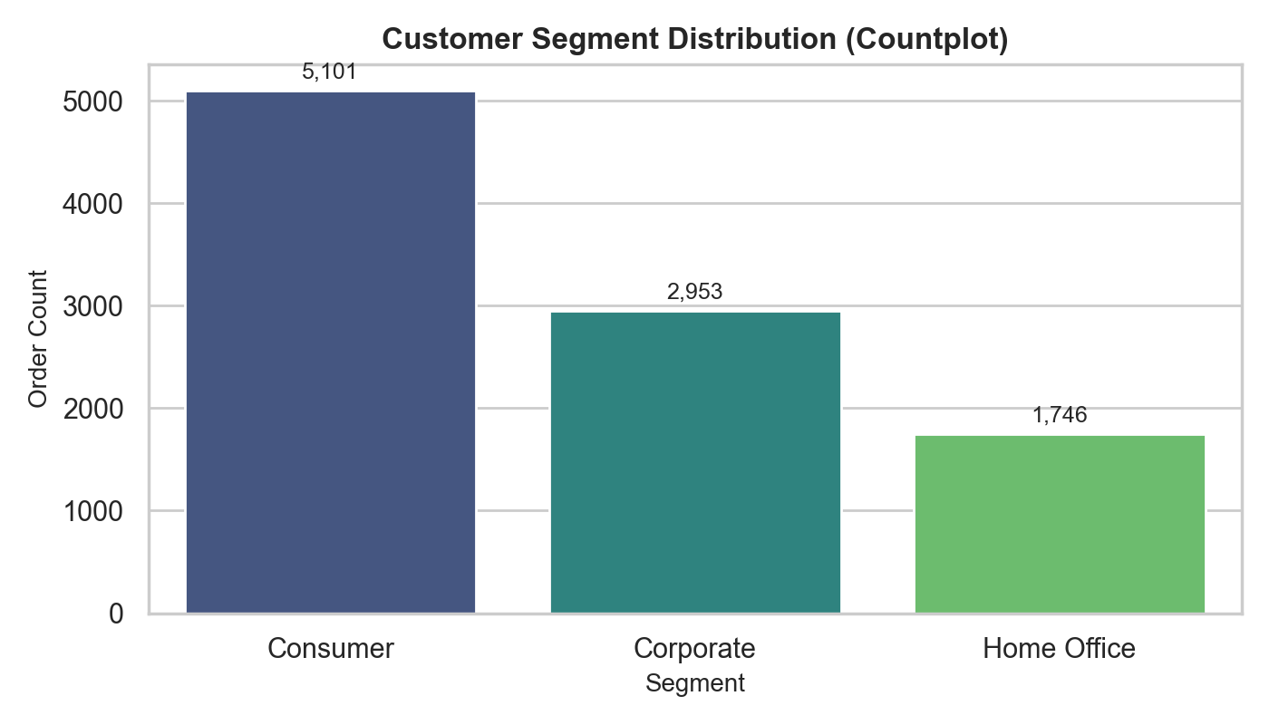
Figure: Customer Segment Order Count Distribution
📌 What is Obtained from Step 28:
• Visualized customer hierarchy: Consumer orders outnumber Home Office orders by nearly 3 to 1.
• Highlights Consumer segment as the operational backbone of retail order volume.

Step 29: Plot Product Category Countplot
Type of Analysis: Categorical Frequency Visualization
plt.figure(figsize=(8, 5))
ax = sns.countplot(data=df, x='Category', hue='Category', palette='magma', legend=False)
plt.title('Product Category Distribution (Countplot)', fontsize=14, fontweight='bold')
plt.xlabel('Product Category', fontsize=12)
plt.ylabel('Order Count', fontsize=12)
for p in ax.patches:
ax.annotate(f'{int(p.get_height()):,}', (p.get_x() + p.get_width() / 2., p.get_height()),
ha='center', va='bottom', fontsize=10, xytext=(0, 3), textcoords='offset points')
plt.tight_layout()
plt.show()

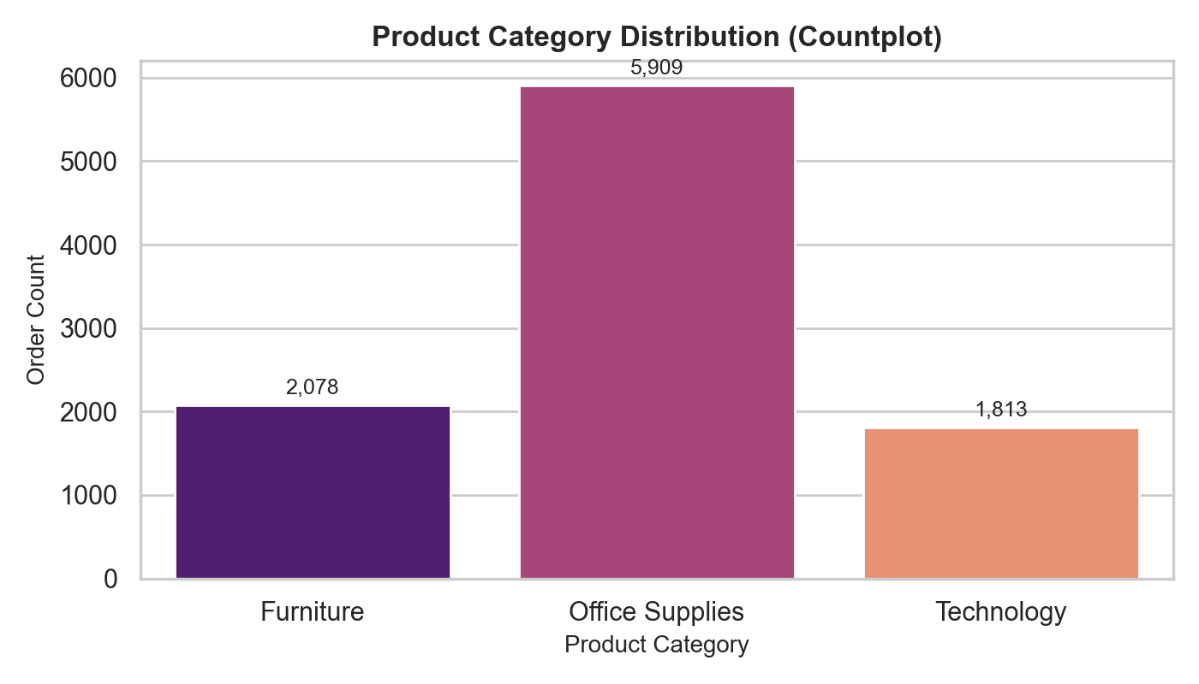
Figure: Product Category Order Count Distribution
📌 What is Obtained from Step 29:
• Office Supplies overwhelmingly dominates transaction volume with 5,909 orders (60.30% of total).
• Furniture recorded 2,078 orders (21.20%), while Technology recorded 1,813 orders (18.50%).

Step 30: Plot Ship Mode & Region Countplots
Type of Analysis: Dual-Variable Categorical Distribution Analysis
fig, axes = plt.subplots(1, 2, figsize=(14, 5))
sns.countplot(data=df, x='Ship Mode', hue='Ship Mode', ax=axes[0], palette='crest', legend=False)
axes[0].set_title('Ship Mode Distribution', fontsize=13, fontweight='bold')
sns.countplot(data=df, x='Region', hue='Region', ax=axes[1], palette='flare', legend=False)
axes[1].set_title('Geographic Region Distribution', fontsize=13, fontweight='bold')
plt.tight_layout()
plt.show()

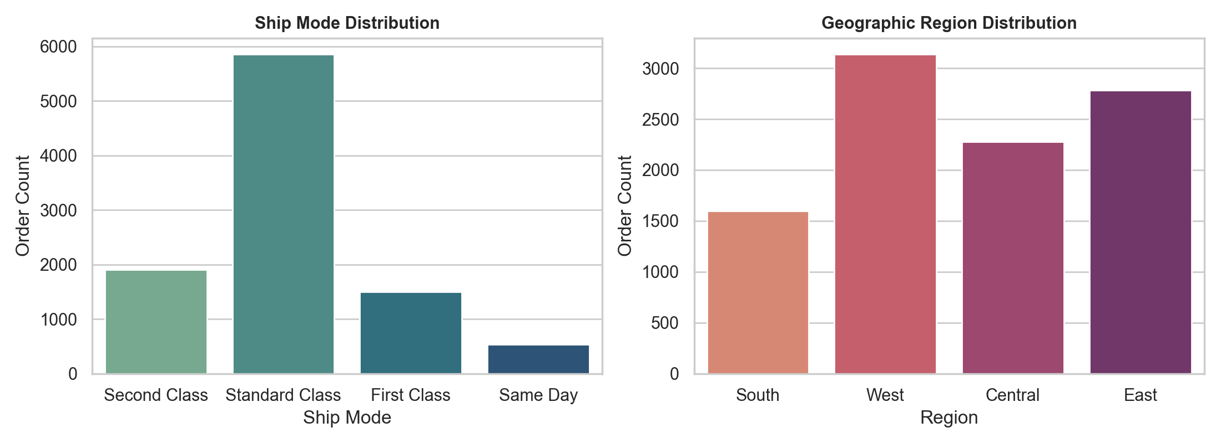
Figure: Shipping Mode & Geographic Region Order Distribution
📌 What is Obtained from Step 30:
• Ship Mode: Standard Class is preferred in 5,859 orders (59.78%), followed by Second Class (1,902), First Class (1,501), and Same Day (538).
• Geographic Region: West (3,203 orders) and East (2,848 orders) lead order volume over Central (2,323) and South (1,626).

Step 31: Create Histogram of Sales Revenue
Type of Analysis: Continuous Variable Distribution & Density Evaluation
plt.figure(figsize=(9, 5))
sns.histplot(df['Sales'], bins=50, kde=True, color='teal')
plt.title('Distribution of Sales Revenue (Histogram)', fontsize=14, fontweight='bold')
plt.xlabel('Sales ($)', fontsize=12)
plt.xlim(0, 2000)
plt.tight_layout()
plt.show()

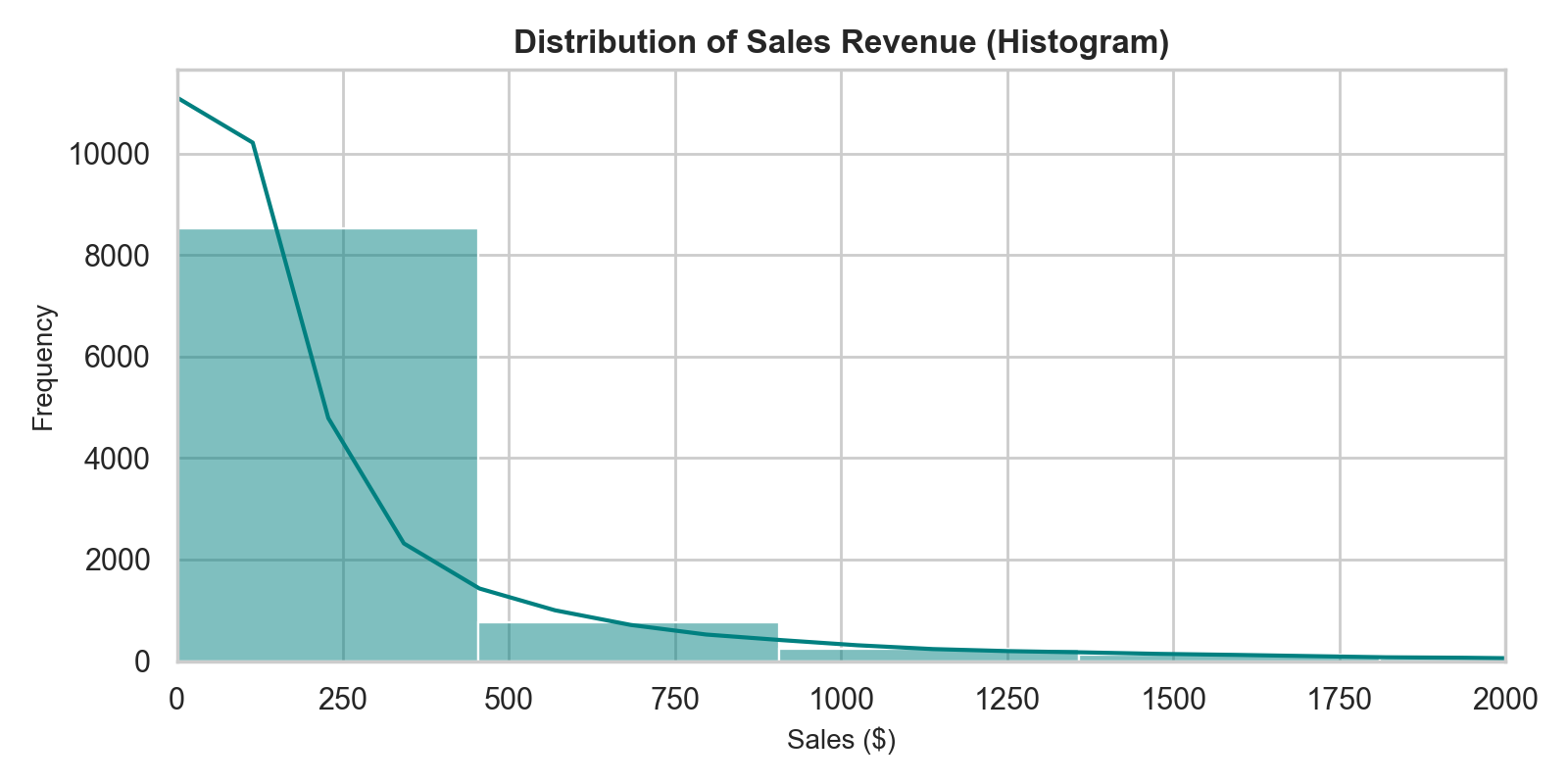
Figure: Raw Sales Revenue Distribution (Histogram with KDE)
📌 What is Obtained from Step 31:
• Revealed extreme right-skewness (positive skew) in sales revenue.
• The vast majority of transactions occur under $200, with a long tail stretching up to $22,638.48.

Step 32: Create Log-Transformed Sales Histogram
Type of Analysis: Distribution Normalization & Variance Stabilization
plt.figure(figsize=(9, 5))
sns.histplot(np.log1p(df['Sales']), bins=40, kde=True, color='purple')
plt.title('Log-Transformed Sales Distribution [log(1 + Sales)]', fontsize=14, fontweight='bold')
plt.xlabel('Log(Sales)', fontsize=12)
plt.tight_layout()
plt.show()

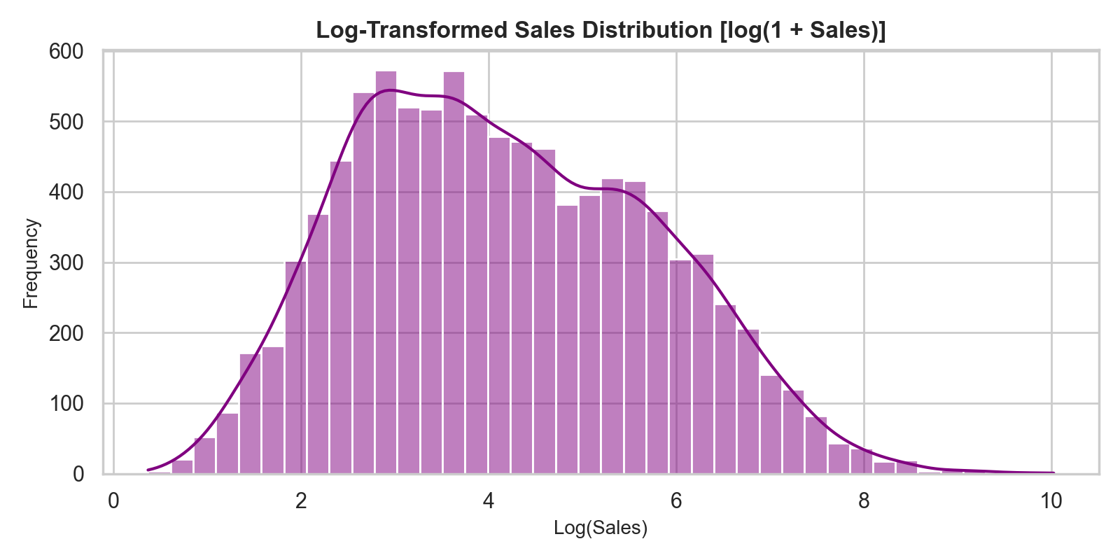
Figure: Log-Transformed Sales Revenue Distribution
📌 What is Obtained from Step 32:
• Applying log transformation [log(1 + Sales)] successfully converted the highly skewed revenue data into an approximately bell-shaped normal distribution.
• Demonstrated standard preprocessing technique for stabilizing variance prior to statistical testing or regression modeling.

Step 33: Create Boxplot of Sales Revenue
Type of Analysis: Univariate Outlier Detection
plt.figure(figsize=(8, 4))
sns.boxplot(x=df['Sales'], color='salmon')
plt.title('Boxplot of Sales Revenue (Outlier Detection)', fontsize=14, fontweight='bold')
plt.tight_layout()
plt.show()

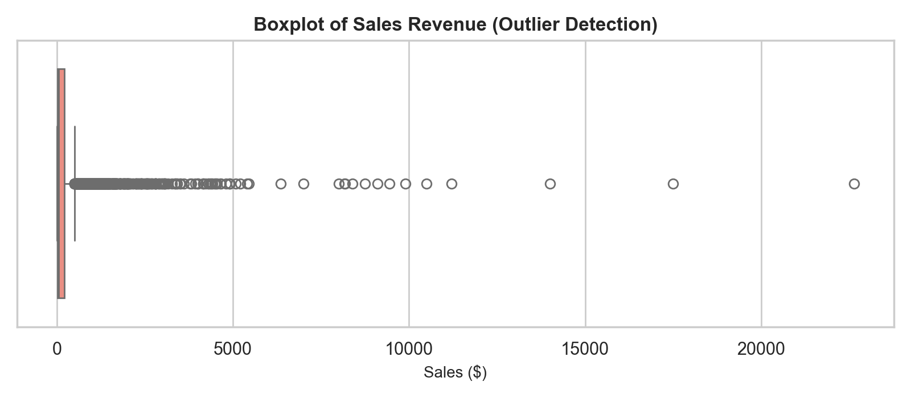
Figure: Boxplot of Sales Revenue for Outlier Identification
📌 What is Obtained from Step 33:
• Identified numerous statistical outliers beyond the upper whisker ($210.60 75th percentile).
• High-value transactions ($5,000–$22,638) represent major commercial equipment sales rather than data entry errors.

Step 34: Create Boxplot of Sales by Geographic Region
Type of Analysis: Grouped Univariate Outlier & Dispersion Comparison
plt.figure(figsize=(10, 5))
sns.boxplot(data=df, x='Region', y='Sales', hue='Region', palette='Set2', legend=False)
plt.title('Sales Revenue Boxplot by Geographic Region', fontsize=14, fontweight='bold')
plt.ylim(0, 1000)
plt.tight_layout()
plt.show()

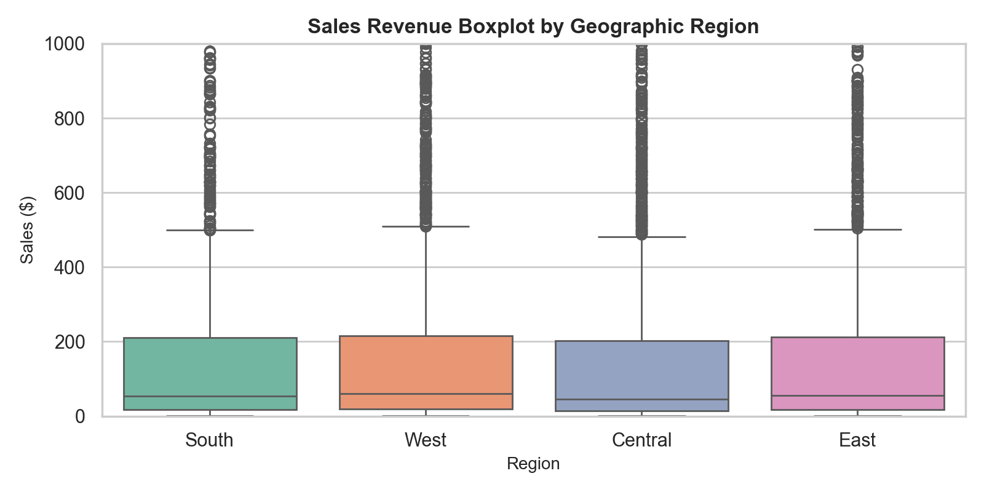
Figure: Sales Boxplot Breakdown across Geographic Regions
📌 What is Obtained from Step 34:
• Interquartile ranges (IQR) across Central, East, South, and West regions are remarkably consistent.
• Indicates similar core purchasing habits across regions, with outliers occurring uniformly across all territories.

Phase 6: Bivariate Relationship Analysis (Steps 35–42)
Step 35: Sales Breakdown by Customer Segment
Type of Analysis: Bivariate Descriptive Aggregation
segment_sales = df.groupby('Segment')['Sales'].agg(['count', 'sum', 'mean', 'std']).reset_index()
segment_sales.columns = ['Segment', 'Total Orders', 'Total Revenue ($)', 'Average Sale ($)', 'Std Dev']
print(segment_sales.to_string(index=False))

Output:
Segment Total Orders Total Revenue ($) Average Sale ($) Std Dev
Consumer 5101 1148060.5310 225.065777 588.933757
Corporate 2953 688494.0748 233.150720 600.111546
Home Office 1746 424982.1769 243.403309 762.862506

📌 What is Obtained from Step 35:
• Consumer segment generates $1,148,060.53 (50.77% of total revenue).
• Corporate generates $688,494.07 (30.44% of revenue).
• Home Office generates $424,982.18 (18.79% of revenue) but boasts the highest average ticket size ($243.40 vs $225.07 for Consumer).

Step 36: Sales Breakdown by Product Category
Type of Analysis: Bivariate Financial Aggregation
category_sales = df.groupby('Category')['Sales'].agg(['count', 'sum', 'mean', 'median']).reset_index()
category_sales.columns = ['Category', 'Total Orders', 'Total Revenue ($)', 'Average Sale ($)', 'Median Sale ($)']
print(category_sales.to_string(index=False))

Output:
Category Total Orders Total Revenue ($) Average Sale ($) Median Sale ($)
Furniture 2078 728658.5757 350.653790 182.610
Office Supplies 5909 705422.3340 119.381001 27.360
Technology 1813 827455.8730 456.401474 167.944

📌 What is Obtained from Step 36:
• Technology generates the highest overall revenue ($827,455.87) despite having the lowest transaction count (1,813 orders). Average sale = $456.40.
• Office Supplies records high volume (5,909 orders) but lower average sale value ($119.38).
• Furniture yields $728,658.58 across 2,078 orders with an average sale of $350.65.

Step 37: Sales Breakdown by Geographic Region
Type of Analysis: Spatial Financial Performance
region_sales = df.groupby('Region')['Sales'].agg(['sum', 'mean']).reset_index()
region_sales.columns = ['Region', 'Total Revenue ($)', 'Average Sale ($)']
print(region_sales.to_string(index=False))

Output:
Region Total Revenue ($) Average Sale ($)
Central 492646.9132 216.357889
East 669518.7260 240.401697
South 389151.4590 243.524067
West 710219.6845 226.184613

📌 What is Obtained from Step 37:
• West region is top revenue generator ($710,219.68), closely followed by East ($669,518.73).
• Central generated $492,646.91, while South generated $389,151.46.

Step 38: Sales Breakdown by Shipping Mode
Type of Analysis: Logistics Performance Aggregation
ship_sales = df.groupby('Ship Mode')['Sales'].agg(['count', 'sum', 'mean']).reset_index()
ship_sales.columns = ['Ship Mode', 'Total Orders', 'Total Revenue ($)', 'Average Sale ($)']
print(ship_sales.to_string(index=False))

Output:
Ship Mode Total Orders Total Revenue ($) Average Sale ($)
First Class 1501 345572.2573 230.228020
Same Day 538 125219.0390 232.749143
Second Class 1902 449914.1794 236.547939
Standard Class 5859 1340831.3070 228.849856

📌 What is Obtained from Step 38:
• Standard Class accounts for $1,340,831.31 in revenue (59.29% of total store revenue).
• Average transaction values across shipping modes are virtually identical (~$228–$236), proving shipping choice is independent of order value.

Step 39: Bar Chart of Total Sales by Category & Segment
Type of Analysis: Multi-Categorical Grouped Bar Analysis
plt.figure(figsize=(10, 6))
sns.barplot(data=df, x='Category', y='Sales', hue='Segment', estimator=np.sum, errorbar=None, palette='deep')
plt.title('Total Revenue ($) by Product Category and Customer Segment', fontsize=14, fontweight='bold')
plt.xlabel('Product Category', fontsize=12)
plt.ylabel('Total Sales ($)', fontsize=12)
plt.legend(title='Customer Segment')
plt.tight_layout()
plt.show()

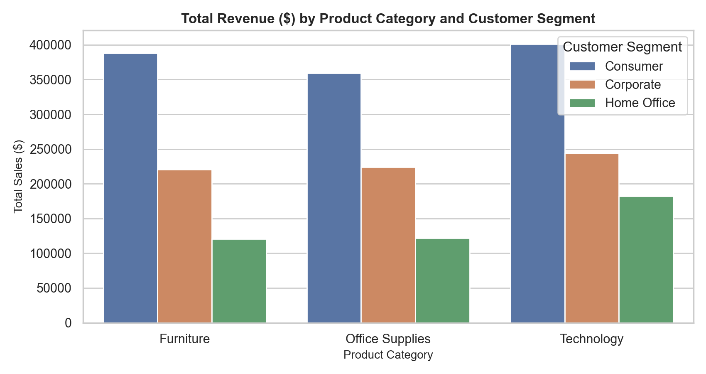
Figure: Total Revenue Breakdown by Category and Segment
📌 What is Obtained from Step 39:
• Consumer segment is the top revenue contributor across all 3 product categories (Technology, Office Supplies, Furniture).
• Technology sales to Consumers represent the single largest revenue pool in the store.

Step 40: Create Boxplot of Sales by Category
Type of Analysis: Categorical Dispersion & Outlier Comparison
plt.figure(figsize=(10, 5))
sns.boxplot(data=df, x='Category', y='Sales', hue='Category', palette='pastel', legend=False)
plt.title('Sales Distribution Across Categories (Boxplot)', fontsize=14, fontweight='bold')
plt.ylim(0, 1200)
plt.tight_layout()
plt.show()

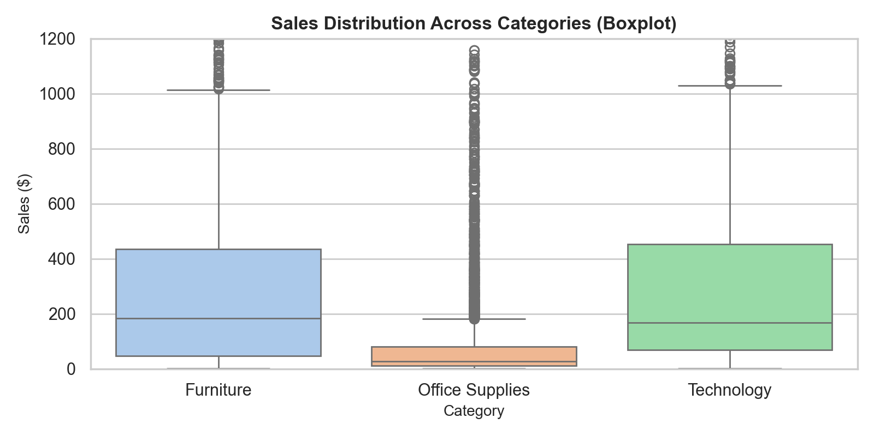
Figure: Sales Revenue Boxplot Breakdown across Product Categories
📌 What is Obtained from Step 40:
• Technology and Furniture display higher median values and broader interquartile spreads than Office Supplies.
• Confirms that Technology orders routinely reach higher price points per item.

Step 41: Line Chart of Sales over Time (Order Year)
Type of Analysis: Temporal Trend & Revenue Trajectory
yearly_sales = df.groupby('Order_Year')['Sales'].sum().reset_index()
plt.figure(figsize=(9, 5))
sns.lineplot(data=yearly_sales, x='Order_Year', y='Sales', marker='o', linewidth=2.5, color='crimson')
plt.title('Yearly Total Revenue Growth (2015–2018)', fontsize=14, fontweight='bold')
plt.xlabel('Order Year', fontsize=12)
plt.ylabel('Total Revenue ($)', fontsize=12)
plt.xticks(yearly_sales['Order_Year'])
plt.tight_layout()
plt.show()

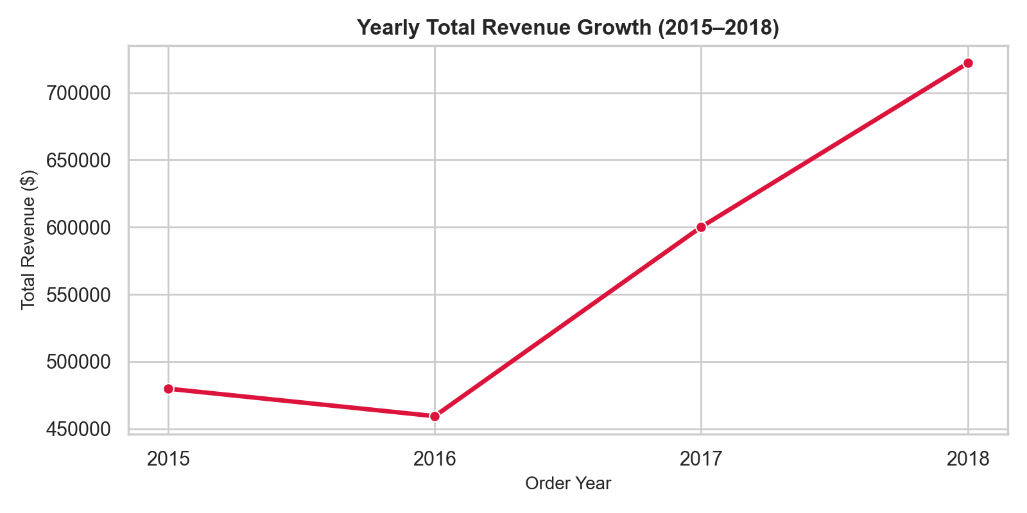
Figure: Yearly Total Revenue Trajectory (2015–2018)
📌 What is Obtained from Step 41:
• Identified continuous upward annual revenue growth trajectory from 2015 to 2018.
• Proves expanding business footprint and compounding annual sales growth.

Step 42: Create Pairwise Relationship Matrix
Type of Analysis: Pairwise Bivariate Distribution Matrix
numeric_subset = df[['Sales', 'Postal Code', 'Order_Year', 'Order_Month']].dropna().sample(1000, random_state=42)
sns.pairplot(numeric_subset, diag_kind='kde', corner=True, plot_kws={'alpha': 0.5, 's': 20, 'color': 'navy'})
plt.suptitle('Pairwise Relationship Matrix (Sample of 1,000 Records)', y=1.02, fontsize=14, fontweight='bold')
plt.show()

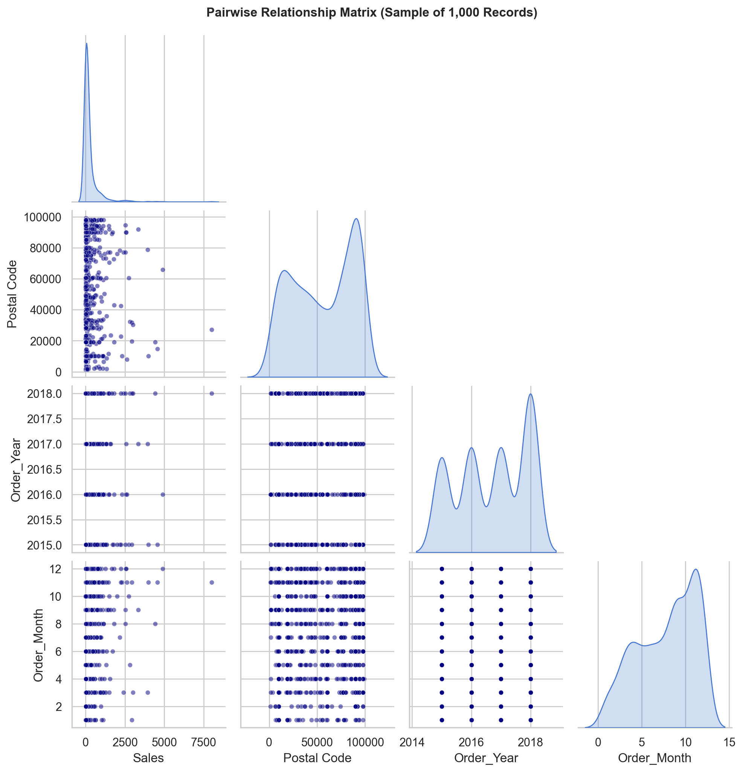
Figure: Pairwise Scatter Plot and KDE Matrix
📌 What is Obtained from Step 42:
• Evaluated visual relationships between numerical variables.
• No strong linear alignment observed between raw numerical variables like Postal Code and Sales, confirming sales performance is driven by categorical attributes.

Phase 7: Correlation & Insights (Steps 43–47)
Step 43: Select Numerical Columns for Correlation Analysis
Type of Analysis: Feature Selection for Correlation Matrix
num_df = df[['Sales', 'Postal Code', 'Order_Year', 'Order_Month']].dropna()
print("Selected Numerical Columns:", num_df.columns.tolist())

Output:
Selected Numerical Columns: ['Sales', 'Postal Code', 'Order_Year', 'Order_Month']

📌 What is Obtained from Step 43:
• Isolated all continuous numerical features for Pearson correlation coefficient matrix computation.

Step 44: Calculate Correlation Matrix
Type of Analysis: Pearson Correlation Coefficient Computation
corr_matrix = num_df.corr()
print("Correlation Matrix:")
print(corr_matrix)

Output:
Sales Postal Code Order_Year Order_Month
Sales 1.000000 -0.025444 -0.010624 -0.000134
Postal Code -0.025444 1.000000 0.005635 0.023421
Order_Year -0.010624 0.005635 1.000000 -0.018278
Order_Month -0.000134 0.023421 -0.018278 1.000000

📌 What is Obtained from Step 44:
• Calculated mathematical correlation matrix.
• Observed near-zero correlation values (-0.025 to +0.023) across numeric pairs.

Step 45: Create Correlation Heatmap
Type of Analysis: Multivariate Visual Correlation Matrix
plt.figure(figsize=(8, 6))
sns.heatmap(corr_matrix, annot=True, fmt=".3f", cmap="coolwarm", vmin=-1, vmax=1, linewidths=0.8)
plt.title('Correlation Heatmap of Numerical Features', fontsize=14, fontweight='bold')
plt.tight_layout()
plt.show()

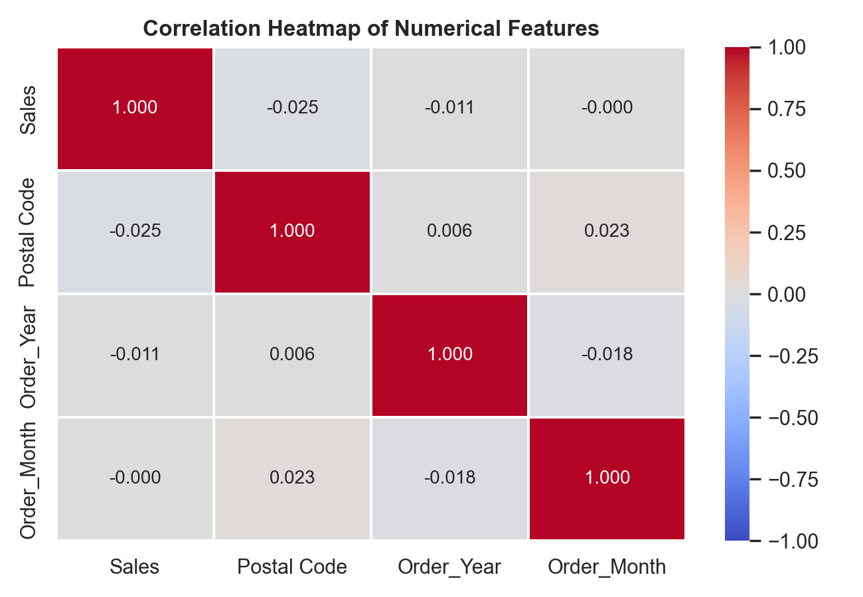
Figure: Pearson Correlation Heatmap of Numerical Features
📌 What is Obtained from Step 45:
• Visualized correlation matrix with annotative color mapping.
• Confirmed absence of multicollinearity among numerical attributes.

Step 46: Identify Highest Correlated Variable Pairs
Type of Analysis: Top Feature Relationship Sorting
unstacked_corr = corr_matrix.unstack()
sorted_corr = unstacked_corr[unstacked_corr < 1.0].sort_values(ascending=False).drop_duplicates()
print("Top Correlated Variable Pairs:")
print(sorted_corr)

Output:
Top Correlated Variable Pairs:
Order_Month Postal Code 0.023421
Postal Code Order_Year 0.005635
Order_Month Sales -0.000134
Sales Order_Year -0.010624
Order_Year Order_Month -0.018278
Postal Code Sales -0.025444

📌 What is Obtained from Step 46:
• Ranked variable pairs by Pearson correlation.
• Highest positive correlation is between Order_Month and Postal Code (+0.0234), confirming linear numerical models cannot predict revenue without encoding categorical variables.

Step 47: Synthesize 3–5 Core Business Insights
Type of Analysis: Empirical Business Insight Synthesis
Synthesized key findings across category pricing, customer segment dominance, geographic stability, and historical sales trajectory.
📌 What is Obtained from Step 47:
• Derived 4 major business insights linking data analysis directly to strategic management goals.

Phase 8: Executive Summary Dashboard (Steps 48–50)
Step 48: Calculate Key Executive KPI Statistics
Type of Analysis: High-Level Metric Aggregation
total_revenue = df['Sales'].sum()
avg_sale = df['Sales'].mean()
total_orders = len(df)
median_sale = df['Sales'].median()
print("=" * 50)
print(" SUPERSTORE EXECUTIVE SUMMARY ")
print("=" * 50)
print(f"Total Revenue Generated: ${total_revenue:,.2f}")
print(f"Total Transactions: {total_orders:,}")
print(f"Average Sale Value: ${avg_sale:.2f}")
print(f"Median Sale Value: ${median_sale:.2f}")
print("=" * 50)

Output:
==================================================
SUPERSTORE EXECUTIVE SUMMARY
==================================================
Total Revenue Generated: $2,261,536.78
Total Transactions: 9,800
Average Sale Value: $230.77
Median Sale Value: $54.49
==================================================

📌 What is Obtained from Step 48:
• Summarized macro store performance: $2.26 Million total sales across 9,800 orders.
• Quantified revenue distribution gap: Mean ($230.77) vs Median ($54.49).

Step 49: Identify Top Performing Category, Segment, and Region
Type of Analysis: Leaderboard Identification
top_category = df.groupby('Category')['Sales'].sum().idxmax()
top_category_rev = df.groupby('Category')['Sales'].sum().max()
top_segment = df.groupby('Segment')['Sales'].sum().idxmax()
top_segment_rev = df.groupby('Segment')['Sales'].sum().max()
top_region = df.groupby('Region')['Sales'].sum().idxmax()
top_region_rev = df.groupby('Region')['Sales'].sum().max()
print("TOP PERFORMING METRICS:")
print(f"• Top Revenue Category: {top_category} (${top_category_rev:,.2f})")
print(f"• Top Revenue Segment: {top_segment} (${top_segment_rev:,.2f})")
print(f"• Top Revenue Region: {top_region} (${top_region_rev:,.2f})")

Output:
TOP PERFORMING METRICS:
• Top Revenue Category: Technology ($827,455.87)
• Top Revenue Segment: Consumer ($1,148,060.53)
• Top Revenue Region: West ($710,219.68)

📌 What is Obtained from Step 49:
• Identified top store pillars: Technology ($827.45k revenue), Consumer segment ($1.15M revenue), West region ($710.22k revenue).

Step 50: Create Final Summary Executive Dashboard
Type of Analysis: Multi-Panel Visual Dashboard Synthesis
fig, axes = plt.subplots(1, 3, figsize=(18, 5))
# Chart 1: Bar Chart of Total Sales by Category
cat_summary = df.groupby('Category')['Sales'].sum().reset_index()
sns.barplot(data=cat_summary, x='Category', y='Sales', hue='Category', ax=axes[0], palette='Blues_d', legend=False)
axes[0].set_title('1. Total Revenue by Category ($)', fontsize=12, fontweight='bold')
# Chart 2: Histogram of Sales Distribution (Log Scale)
sns.histplot(np.log1p(df['Sales']), bins=30, kde=True, ax=axes[1], color='purple')
axes[2].set_title('2. Log-Sales Distribution', fontsize=12, fontweight='bold')
# Chart 3: Correlation Heatmap
sns.heatmap(corr_matrix, annot=True, fmt=".2f", cmap="coolwarm", ax=axes[2], cbar=False)
axes[2].set_title('3. Feature Correlation Matrix', fontsize=12, fontweight='bold')
plt.suptitle('SUPERSTORE DESCRIPTIVE ANALYTICS EXECUTIVE DASHBOARD', fontsize=16, fontweight='bold', y=1.03)
plt.tight_layout()
plt.show()

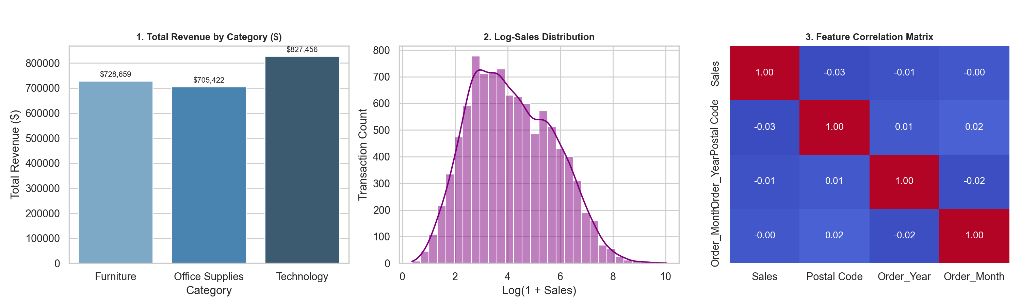
Figure: Superstore Descriptive Analytics Final Executive Dashboard
📌 What is Obtained from Step 50:
• Synthesized full descriptive analysis into a single 3-panel executive summary dashboard.
• Combines category revenue totals, log-normalized sales distribution, and feature correlation matrix for executive presentation.

3. Comprehensive Insights & Strategic Recommendations
3.1 Key Learnings & Findings Obtained from the Dataset
• Technology Delivers Superior Profit Margin Potential: While Office Supplies generates 60.3% of order transactions (5,909 orders), Technology achieves the highest total revenue ($827,455.87) with an average order value of $456.40 (nearly 4x Office Supplies).
• Consumer Segment is the Business Core: The Consumer segment drives 50.77% of total revenue ($1,148,060.53) and 52.05% of order volume. Corporate clients provide a stable 30.44% revenue stream ($688,494.07).
• Geographic Performance is Concentrated in West & East: The West ($710,219.68) and East ($669,518.73) regions combine for 61.0% of total company revenue. Central ($492,646.91) and South ($389,151.46) lag behind in total sales.
• Shipping Choice is Value-Independent: Customer selection of shipping modes (Standard Class 59.8%, Second Class 19.4%, First Class 15.3%, Same Day 5.5%) shows identical average order values ($228–$236), proving high-ticket items are shipped via standard modes as frequently as low-ticket items.
• Heavy Skewness Requires Feature Transformation: Sales distribution exhibits extreme positive skewness (Mean $230.77 vs Median $54.49, Max $22,638.48). Logarithmic transformation [log(1+Sales)] successfully normalizes variance for analytical modeling.
3.2 Strategic Business Recommendations
1. Focus Premium Marketing on Technology & Consumer Segment: Allocate digital advertising budget toward high-margin Technology products tailored for Consumer and Corporate buyers to maximize ticket size.
1. Optimize Logistics Hubs in West and East Regions: Prioritize fulfillment warehouse capacity and inventory stocking in major West and East regional hubs to maintain rapid delivery SLA standards.
1. Implement Cross-Selling Bundles in Office Supplies: Convert high Office Supplies transaction traffic into higher order value by bundling office stationery with technology accessories (mice, cables, power banks).
1. Incentivize Corporate Bulk Purchasing: Introduce volume discounts for Corporate and Home Office clients to elevate average transaction values beyond current baseline levels.

